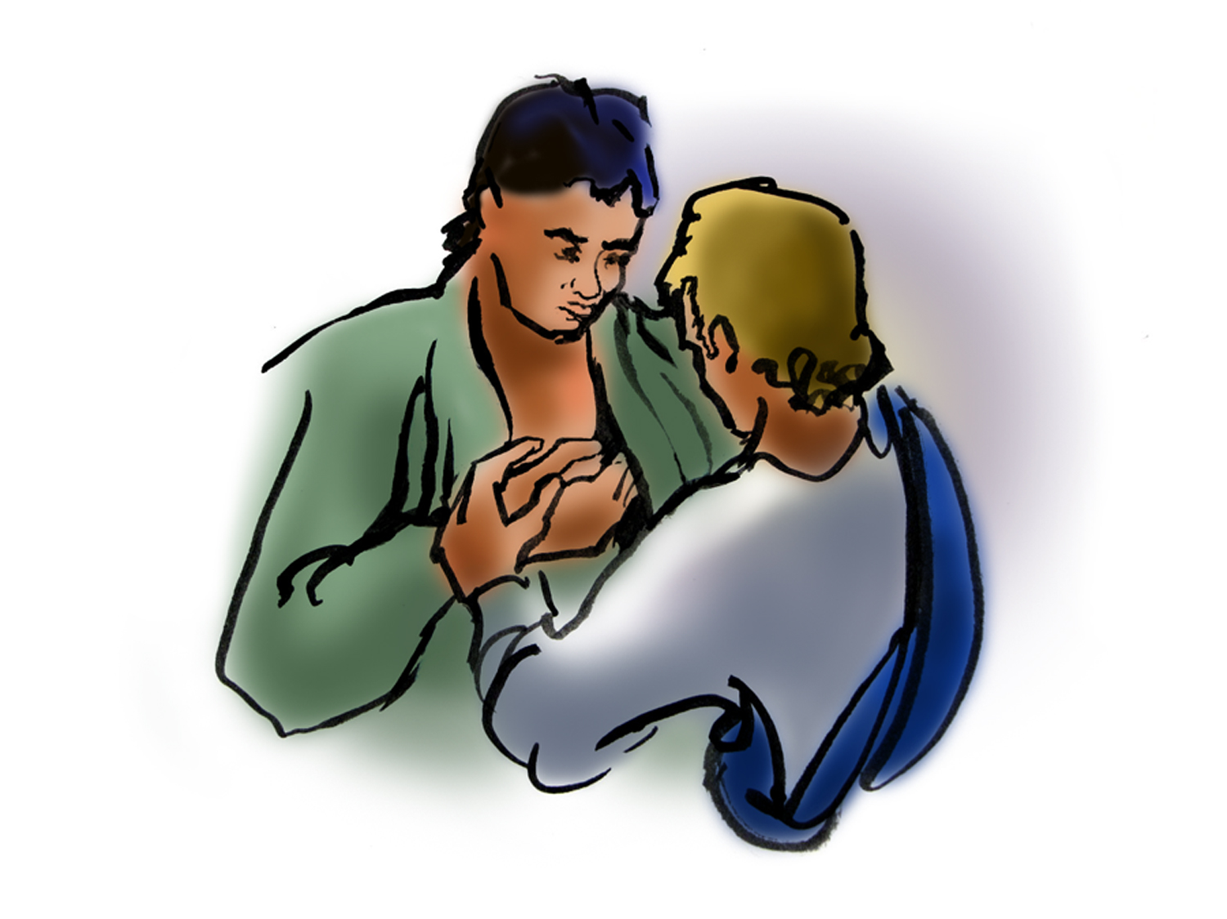

St. Paul Lutheran Church, ELCA

Pontiac, IL
April 24, 2022

Second Sunday of Easter

Introduction
In spite of all we have heard and all we have seen, it is often hard to believe. Because it is hard to believe, we will invest ourselves in the Easter mystery for fifty days (a week of weeks). Because it is hard to believe, John the evangelist will provide sign after sign celebrating Jesus’ victory over death. Because it is hard to believe, the risen Jesus will return to us again and again in the mystery of holy communion, inviting us to touch and taste his presence, and offering us his peace.

Prelude

Welcome

Thanksgiving for Baptism

All may make the sign of the cross, the sign marked at baptism, as the presiding minister begins.

L: Alleluia! Chris is risen.
A: Christ is risen indeed. Alleluia!

L: In the waters of baptism,
we have passed over from death to life with Jesus Christ,
and we are a new creation.
for this saving mystery, and for this water, let us bless God,
who was, who is, and who is to come.

Water may be poured into the font as the presiding minister gives thanks.

L: We thank you, God, for your river of life,
flowing freely from your throne:
through the earth,
Through the city,
through every living thing.

You rescued Noah and his family from the flood;
You opened wide the sea for the Israelites.
Now in these waters you flood us with mercy
and our sin is drowned forever.
You open the gate of righteousness
and we pass safely through.

In Jesus Christ, you calm and trouble the waters.
You nourish us and enclose us in safety.
You call us forth and send us out.
In lush and barren places, you are with us.
You have become our salvation.

Now breathe upon this water
and awaken your church once more.
Claim us again as your beloved and holy people.
Quench our thirst; cleanse our hearts and wipe away every tear.

To you, our Beginning and our End,
our Shepherd and Lamb,
be honor, glory, praise, and thanksgiving,
now and forever
A: Amen.

Gathering Hymn “I Come with Joy” ELW 482

Greeting

L: Alleluia! Christ is risen!
A: Christ is risen indeed! Alleluia

L: The grace of our Lord Jesus Christ, the love of God, and the communion of the
Holy Spirit be with you all.
A: And also with you.

Prayer of the Day

L: O God of life, you reach out to us amid our fears with the wounded hands of your risen Son. By your Spirit’s breath revive our faith in your mercy, and strengthen us to be the body of your Son, Jesus Christ, our Savior and Lord, who lives and reigns with you and the Holy Spirit, one God, now and forever.
A: Amen.

Children’s Message

HEARING THE WORD OF GOD

Acts 5: 27-32

L: A reading from Acts.

²⁷When they had brought [the apostles,] they had them stand before the council. The high priest questioned them, ²⁸saying, “We gave you strict orders not to teach in this name, yet here you have filled Jerusalem with your teaching, and you are determined to bring this man’s blood on us.” ²⁹But Peter and the apostles answered, “We must obey God rather than any human authority. ³⁰The God of our ancestors raised up Jesus, whom you had killed by hanging him on a tree. ³¹God exalted him at his right hand as Leader and Savior that he might give repentance to Israel and forgiveness of sins. ³²And we are witnesses to these things, and so is the Holy Spirit whom God has given to those who obey him.”

L: Word of God, word of life.
A: Thanks be to God.
________________________________________________________________________________

Psalm 118: 14-29

L: A reading from Psalm.

¹⁴The Lord is my strength and my song,
and has become my salvation.
¹⁵Shouts of rejoicing and salvation echo in the tents of the righteous:
“The right hand of the Lord acts valiantly!
¹⁶The right hand of the Lord is exalted!
The right hand of the Lord acts valiantly!”
¹⁷I shall not die, but live,
and declare the works of the Lord.
¹⁸The Lord indeed punished me sorely,
but did not hand me over to death.
¹⁹Open for me the gates of righteousness;
I will enter them and give thanks to the Lord.
²⁰“This is the gate of the Lord;
here the righteous may enter.”
²¹I give thanks to you, for you have answered me
and you have become my salvation.
²²The stone that the builders rejected
has become the chief cornerstone.
²³By the Lord has this been done;
it is marvelous in our eyes.
²⁴This is the day that the Lord has made;
let us rejoice and be glad in it.
²⁵Hosanna! O Lord, save us!
We pray to you, Lord, prosper our days!
²⁶Blessed is the one who comes in the name of the Lord;
we bless you from the house of the Lord.
²⁷The Lord is God and has given us light.
Form a procession with branches up to the corners of the altar.
²⁸You are my God, and I will thank you;
you are my God, and I will exalt you.
²⁹Give thanks to the Lord, for the Lord is good;
God’s mercy endures forever.

L: Holy wisdom; Holy Word.
A: Thanks be to God.

Second Reading – Revelation 1: 4-8

L: A reading from Revelation.

⁴John to the seven churches that are in Asia:
Grace to you and peace from him who is and who was and who is to come, and from the seven spirits who are before his throne, ⁵and from Jesus Christ, the faithful witness, the firstborn of the dead, and the ruler of the kings of the earth.
To him who loves us and freed us from our sins by his blood, ⁶and made us to be a kingdom, priests serving his God and Father, to him be glory and dominion forever and ever. Amen.
⁷Look! He is coming with the clouds; every eye will see him, even those who pierced him;
and on his account all the tribes of the earth will wail. So, it is to be. Amen.
⁸“I am the Alpha and the Omega,” says the Lord God, who is and who was and who is to come, the Almighty.

L: Word of God, word of life.
A: Thanks be to God.

Please rise, as you are able, for the reading of the Holy Gospel.
Gospel Acclamation Halle, Halle, Hallelujah

Gospel- John 20: 19-31

L: The Holy Gospel according to John.
A: Glory to you, O Lord.

¹⁹When it was evening on that day, the first day of the week, and the doors of the house where the disciples had met were locked for fear of the Jews, Jesus came and stood among them and said, “Peace be with you.” ²⁰After he said this, he showed them his hands and his side. Then the disciples rejoiced when they saw the Lord. ²¹Jesus said to them again, “Peace be with you. As the Father has sent me, so I send you.” ²²When he had said this, he breathed on them and said to them, “Receive the Holy Spirit. ²³If you forgive the sins of any, they are forgiven them; if you retain the sins of any, they are retained.”
²⁴But Thomas (who was called the Twin), one of the twelve, was not with them when Jesus came. ²⁵So the other disciples told him, “We have seen the Lord.” But he said to them, “Unless I see the mark of the nails in his hands, and put my finger in the mark of the nails and my hand in his side, I will not believe.”
²⁶A week later his disciples were again in the house, and Thomas was with them. Although the doors were shut, Jesus came and stood among them and said, “Peace be with you.” ²⁷Then he said to Thomas, “Put your finger here and see my hands. Reach out your hand and put it in my side. Do not doubt but believe.” ²⁸Thomas answered him, “My Lord and my God!” ²⁹Jesus said to him, “Have you believed because you have seen me? Blessed are those who have not seen and yet have come to believe.”
³⁰Now Jesus did many other signs in the presence of his disciples, which are not written in this book. ³¹But these are written so that you may come to believe that Jesus is the Messiah, the Son of God, and that through believing you may have life in his name.

L: The gospel of the Lord.
A: Praise to you, O Christ.

Sermon Pastor John Sipf

Hymn of the Day “Thine the Amen” ELW 826

Apostles’ Creed

I believe in God, the Father almighty,
creator of heaven and earth.
I believe in Jesus Christ, God’s only Son, our Lord,
who was conceived by the Holy Spirit,
born of the virgin Mary,
suffered under Pontius Pilate,
was crucified, died, and was buried;
he descended to the dead.
On the third day he rose again;
he ascended into heaven,
he is seated at the right hand of the Father,
and he will come to judge the living and the dead.
I believe in the Holy Spirit,
the holy catholic church,
the communion of saints,
the forgiveness of sins,
the resurrection of the body,
and the life everlasting. Amen.

Prayers of Intercession

Each petition will end “God, in your mercy” and the congregation will respond “Hear our prayer.”

Sharing the Peace

L: The peace of Christ be with you always.
A: And also with you.

You are invited to share a sign of God’s peace with your neighbors by turning to the people near you saying, “Peace be with you.”

Offering

Offerings can also be sent by mail or given online. You can send a check to St. Paul Lutheran Church 210 Deerfield Rd Pontiac, IL 61764 or give online at stpaulpontiac.org

Offering Special Music

Offering Prayer

L: Living God,
you gather the wolf and the lamb to feed together
in your peaceable reign,
and you welcome us all at your table.
Reach out to us through this meal,
and show us your wounded and risen body,
that we may be nourished and believe
in Jesus Christ, our Savior and Lord.
A: Amen.

MEAL

All are welcome at Christ’s table.

Communion is distributed in front of the altar. The individual cups are filled with wine. The prepackaged cups are juice. If you prefer not to receive communion you may come forward with your hands crossed over your chest to receive a blessing or you may remain in your seat.

Great Thanksgiving

L: The Lord be with you.
A: And also with you.

L: Lift up your hearts.
A: We lift them to the Lord.

L: Let us give thanks to the Lord our God.
A: It is right to give our thanks and praise.

Preface
L: It is indeed right, our duty and our joy,
that we should at all times and in all places
offer thanks and praise to you, O Lord,
holy Father, almighty and ever living God.
But chiefly we are bound to praise you for the glorious
Resurrection of our Lord; for he is the true Passover Lamb
Who gave himself to take away our sin,
Who by his death has destroyed death;
And by his rising has brought us to eternal life.
And so with Mary Magdalene and Peter and
All the witnesses of the resurrection,
With earth and sea and all their
Creatures, and with angels and archangels,
Cherubim and seraphim,
We praise your name and join their unending hymn:

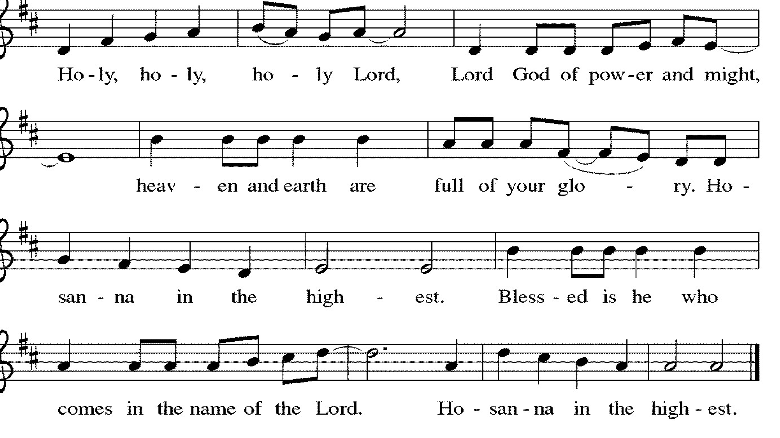

Thanksgiving at the Table

L: Holy, living and loving God,
We praise you for creating the heavens and the earth.
We give you thanks for Jesus who, living among us,
Healed the sick, fed the hungry, and with a love stronger
Than death, gave his life for others.

In the night in which he was betrayed,
our Lord Jesus took bread, and gave thanks;
broke it, and gave it to his disciples, saying:
Take and eat; this is my body, given for you.
Do this for the remembrance of me.

Again, after supper, he took the cup, gave thanks,
and gave it for all to drink, saying:
This cup is the new covenant in my blood,
shed for you and for all people for the forgiveness of sin.
Do this for the remembrance of me.

Remembering, therefore, his life-
Giving death and glorious resurrection,
We await your promised life for all this
Dying world. Breathe your Spirit on us
And on this bread and cup:
Carry us in your arms from death to life,
That we may live as your chosen ones,
Clothed in the righteousness of Christ.

A: Through him all glory and honor is yours,
Almighty Father, with the Holy Spirit,
In your holy church, both now and forever.
Amen.

Lord's Prayer

L: Gathered into one by the Holy Spirit, let us pray as Jesus taught us,
A: Our Father, who art in heaven, hallowed be thy name, thy kingdom come, thy will be done, on earth as it is in heaven. Give us this day our daily bread; and forgive us our trespasses, as we forgive those who trespass against us; and lead us not into temptation but deliver us from evil. For thine is the kingdom and the power, and the glory, forever and ever. Amen.

Invitation to Communion

L: The risen Christ dwells with us here. All who are hungry, all who are thirsty, come.

Communion Songs Music Video

Prayer after Communion
L: We give you thanks, generous God,
For in this bread and cup
we have tasted the new heaven and earth,
where hunger and thirst are no more.
Send us from this table as witness to the resurrection,
that through our lives, all may know life in Jesus’ name.

A: Amen.

SENT FOR WORK AND WITNESS

Announcements

Blessing

L: God, the Author of life,
Christ, the living Cornerstone,
and the life-giving Spirit of adoption,
☩ bless you now and forever.
A: Amen

Sending Hymn “Hallelujah! We Sing Your Praises” ELW 535

Dismissal

L: Alleluia! Christ is risen.
A: Christ is risen indeed. Alleluia!
L: Go in peace. Tell what God has done.
A: Thanks be to God.

Postlude

Licensing information for this Worship Service:
CCLI Copyright License A 2440181 9/30/2021 + Streaming License A 20530290 5/31/2022
Sundays and Seasons License Sundays and Seasons v.20200325.1254

Worship Participants

Presiding Minister: Pastor John Sipf
Worship Steward: Pat Lund
Musician: Sara Solberg
Lector: Blayne Dixon
Usher: Tom Harms
Communion Prep: Marty & Shelly Heller
Comm. Asst: Marty & Shelly Heller
Hospitality: Tonya Johnson-Wilcox & Shelly Heller
Counters: Cody Leach & Jake Dixon

