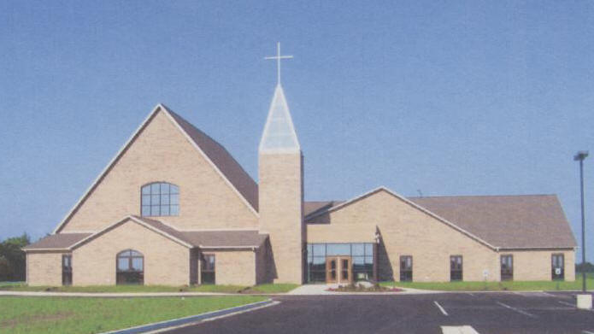

***The Messenger***

April 2019

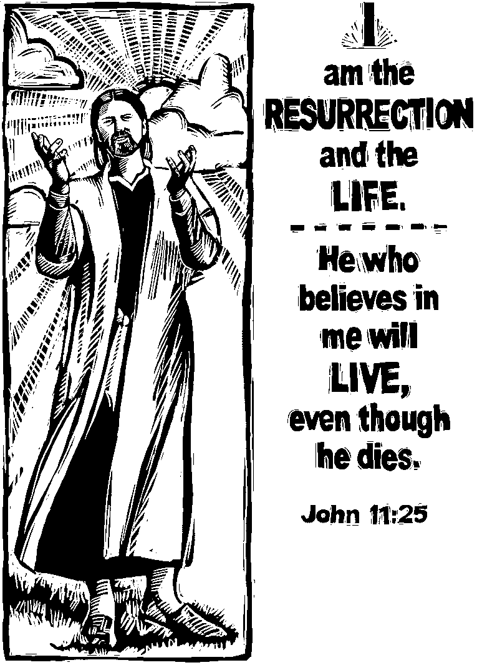There are no more powerful words in all of history than these, these three little words. These words changed the world; they have come to define how we mark time and divide history. From twelve ordinary men we have learned the power of these words and they have brought a new way of understanding our world and ourselves. However Jesus leaves the church a mission with these words. He said to those twelve who gathered to follow him as he says to the church today it is time to be the Church. Luke tells us the direction of the Easter church in . . .

Acts 2:42-47

42 They devoted themselves to the apostles' teaching and to the fellowship, to the breaking of bread and to prayer.

43 Everyone was filled with awe, and many wonders and miraculous signs were done by the apostles.

44 All the believers were together and had everything in common.

45 Selling their possessions and goods, they gave to anyone as he had need.

46 Every day they continued to meet together in the temple courts. They broke bread in their homes and ate together with glad and sincere hearts,

47 praising God and enjoying the favor of all the people. And the Lord added to their number daily those who were being saved. (NIV)

The Church is about what Christ can do through us it is about what we can do together. We are called not to horde the gifts God has given us but to share them. We are called in three words to not make the church about a place where I get what I want but a place that moves out into the world in a unity. These three words invite the Church to see the hurt and needs of others and together we bring the cups of cold water that we have in our resources. These three words invite us not to demonize people but to see Christ in them and to invite them to the feast where Christ is the host and the feast itself. In these three words we seek to have Christ do wonders and miraculous signs through us as a community.

These three words enabled the church to become a group of people who gather to worship Christ because he is risen and that changes us and the way we view the world. These three words make worship the opportunity to joyfully add our voice to the voices of our brothers and sisters to praise this awesome God. These three words invite the church to meet day after day to break bread together with glad and sincere hearts. These three words invite us to learn the apostles’ teaching that we might be filled with awe.

These three words invite us to grow in our worship, prayer, and study. As we live out these three words the world will look with favor on us and see a church that builds up our community and the world. The three greatest words in all of history are “Jesus is Risen”. This Easter pray that Jesus rises in our hearts and that we become the passionate church that can carry out his mission.

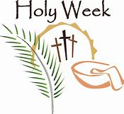

April 14th is Passion Sunday and will have a dramatic reading of the passion in the Gospel of Luke. April 14th will be Maundy Thursday service of Holy communion and stripping of the Altar. April 15th Good Friday will be the stations of the cross called the way of the cross. April 21st will be our celebration of the Resurrection of the Lord with a 9:00an Easter Breakfast and Easter Egg hunt followed by our Easter Celebration. April 28th will be our service of Confirmation

**Opportunities to Serve**

**April Birthdays**

April 1 – Julie Mehlberg

April 5 – Emma Walsberg

April 5 – Julie Knudson

April 6 – Michelle Harms

April 8 – Lindsey Armetta

April 12 – Carolyn Austin

April 13 – Darla Dixon

April 13 – Keagan Leach

April 16 – Sam Lambert, Jr.

April 17 – Gerald Buckler

April 19 – Darlene Leach

April 19 – Scott Highland

April 21 – Doris Jean Brown

April 23 – Jimm Edinger

April 27 – Louis Kehinde

**April Anniversaries**

None

Boys and Girls Club Ministry!

Fourth Fridays of Each month

3:15-4:15 @Boys & Girls Club

Play Games and Enjoy Treats!

See Julie Mehlberg for more information!

Come Join Us!!





Thank you for continuing to remember the Food Pantry.



[](http://www.google.com/imgres?hl=en&tbo=d&biw=1920&bih=955&tbm=isch&tbnid=xwELvZfmR_odoM:&imgrefurl=http://www.stlukerichmond.org/Pages/TimeandTalents.aspx&docid=iipBMrcnyTy0AM&imgurl=http://www.stlukerichmond.org/siteimages/Altar_Flowers.jpg&w=372&h=298&ei=AOu8UNSOK42ByAGjhYHwBA&zoom=1&iact=hc&vpx=569&vpy=156&dur=1135&hovh=201&hovw=251&tx=90&ty=112&sig=104538642006477646809&page=1&tbnh=137&tbnw=171&start=0&ndsp=58&ved=1t:429,r:4,s:0,i:149)

Ginger Bauknecht is the flower chairperson for the month of **April**. If you would like to donate flowers on a particular Sunday in memory of or in honor of someone, please sign your name on the Flower Chart located on the kiosk, and write a check, payable to St. Paul Lutheran Church, for $25.00, noting on the check that it is for altar flowers, and County Market will deliver the flowers to the church. If you have questions, contact Pat.

**Please do not take the vase home when your weeks are completed. The vase belongs to County Market. Thank you!**

**Graduate Recognition**

We will recognize graduates on Sunday, May 19th. Please call or e-mail the office if you have a graduate of 8th grade, high school or college. Our e-mail is: st.paulpontiac@gmail.com, the phone is: 815-842-2095.



**Reminder:**

**Health and Wellness Sunday is the third Sunday of each month.**

Mary Leach or one of our many parish nurses will be on hand before and after worship on these Sundays to check blood pressures, blood sugars, and help you form questions for your health professional should you have need.



***Our Mission Statement:***

*The People of St. Paul*

*Gather to worship,*

*Reach out,*

*and serve the Lord.*



**Prayer Chain and Prayer Requests…..**

Just a reminder that if you would like to have someone added to our prayer chain, please contact Pastor Wayne and Julie Mehlberg. If your prayers are answered, we would appreciate knowing that as well, so names can be removed when it is appropriate. Thank you in advance!



**Lenten Schedule:**

* **March 6 - Ash Wednesday** 
  + 11:00 AM and 6:30 PM services
  + 12:00-1:00 PM -“Ashes on the Go”

You are invited to drive in the parking lot for a blessing and imposition of ashes if you are unable to attend either of the two services.

* **March 13, 20, 27, April 3, 10** – Light supper at 5:30 and Holden Evening Prayer from 6:00-6:30 PM
* **April 18** – Maundy Thursday at 6:30 PM
* **April 19** – Good Friday at 6:30 PM
  + Stations of the Cross Service
* **April 21** – Easter Worship at 10:00 AM

Breakfast/Egg Hunt at 9:00 AM

**\*\*\*\*\* Please note Ash Wednesday, Maundy Thursday**

**And Good Friday evening services begin at 6:30.**

**2019 Lenten Journey: BUILD!**

Let’s BUILD! Take some time this Lenten season to meditate on the Lenten disciplines and set aside one hour on Wednesday night for fellowship and a time of worship!

**“Tons of Points for a Ton of Good 2.0”**

Sign up for our **team challenge** for “works of love” which will involve a friendly competition of food collection for the food pantry! A list of points and food needed will be shared! Renew old and new relationships by joining a team this Lenten Season!



The Bibles & Bagels group will meet on Thursday, April 11th at 9:30 am at Edinger’s Filling Station. Any woman who would like to attend an informal bible study is welcome to come to this meeting.

**Want to be an EME?** That is an Extraordinary Minister of The Eucharist. Since Pastor Wayne is only ¾ time, he could use help taking communion to shut-ins he would like 3-6 people to volunteer to take communion on Sundays after church to our shut-ins. You will be provided with a communion liturgy and a communion kit. Also if you could write down the names of people you think might benefit from this ministry and give it to Pastor Wayne, this would be much appreciated.



The Rebecca Circle will meet on Thursday, April 18th at 1:30 p.m. in the fellowship hall. Marian Brown will be the hostess. Lucy Kehinde will give the devotions. Carol Thorson will be giving the lesson, “Meetings with Jesus- Seeing the Risen Christ, Coming to Faith.” In this session we will walk with Mary Magdalene, the Beloved Disciple, Thomas and others as they encounter the risen Lord. Mil Girard will be giving the offering meditation. If you would like to join us for this time of fellowship and Bible study, we would invite you to join us at this meeting.



While it has always been the desire of St. Paul to celebrate and support the congregation as members celebrate marriage or the arrival of a new baby, the council also recognized the need for changed as we continue to grow and welcome new members. In order to be a more inclusive community of believers, the council has decided that wedding and baby showers are best handled privately by an individual in the congregation rather than having church-sponsored showers. If an individual would like to use our facility to host a private shower, he or she should contact the administrative assistant to confirm a date on the church calendar and complete a facility-use sheet.





Anyone who has pictures that can be shared on Facebook, please text or email Jake or Blayne Dixon. Please use the church directory for their numbers and email! Thanks for sharing! Let’s get “social!”



Please join us for Family Fun & Fellowship on Sunday, April 14th at 2:00 p.m. “Bring a Guest” we will be enjoying Euchre and Games. Remember to bring a donation for the Food Pantry of Pancake Mix and syrup.



**LEO (Let’s Eat Out!)** will begin in January. The 3rd Wednesday of each month anyone **not** wanting to cook supper is welcome to join other church members in eating out. Each month we will pick a different place. All are welcome! The more the merrier. The next outing will beon April 17th at 5:30 PM at the Family Kitchen.

**Reminder…**

If you are using the church facility for a church-related meeting, please remember to add it on the calendar in the office or let the Administrative Assistant know. All other functions or community-service organizations please fill out a Facility Use Sheet. Thank you!



**Council 2019**

President – Sara Solberg

Vice President – Julie Mehlberg

Secretary – Lori Bristow

Building Community – Mary Leach

Finance and Stewardship – Jake Dixon

Lifelong Learning – Tonya Wilcox

Worship and Music – Shelly Heller



**Helping Hands Ministry!**

As a part of our Lay Caring Team, we have volunteers who can make meals for you in time of need. Please let Pastor or Julie Mehlberg know if you would like help in some way!

**Celebrate Seniors Sunday!!!**

**May 5, 2019**

**8:30am**

Anyone 65 or older and young at heart please join us for a Celebration Breakfast and a short program! For planning purposes, please sign up on the kiosk in the gathering area by April 21st. Hope to see you on May 5th!

C:\Users\John\AppData\Local\Microsoft\Windows\Temporary Internet Files\Content.IE5\N68H9N7L\MC900445254[1].wmf



Hands At Work - Prayer Shawl Ministry will begin meeting on the first Thursday of each month beginning April 4th at 6:00 pm.

Compassion and the love of knitting/crocheting have been combined into a prayerful ministry and spiritual practice which reaches out to those in need of comfort and solace, as well as in celebration and joy. Many blessings are prayed into every stitch.

Prayer shawls/covers are available in the gathering space to anyone and for anyone in need of comfort, prayer and hope.  We have recently added prayer blankets to allow greater gifting for all genders and needs.  There is no cost for the shawls.  They are donated freely with love and prayer for all of God's people. Questions may be directed to Kathy Rygh at [kathyrygh@gmail.com](mailto:kathyrygh@gmail.com).

"Shawls ... made for centuries universal and embracing, symbolic of an inclusive, unconditionally loving, God.  They wrap, enfold, comfort, cover, give solace,

mother, hug, shelter and beautify. Those who have received these shawls have been uplifted and affirmed, as if given wings to fly above their troubles..." ~ Janet Severi Bristow



The Northeast Conference WELCA Spring Gathering will be held on Saturday, April 6th at the Trinity Lutheran Church, Fairbury, Illinois. Registration will be from 9:00 – 9:30 a.m. A Continental breakfast will be served. The cost is $10.00 for this event. Please sign up on the sign-up sheet which is located on the kiosk.

**April 2019**

|  |  |  |  |  |  |  |
| --- | --- | --- | --- | --- | --- | --- |
| **Sun** | **Mon** | ***Tue*** | **Wed** | **Thu** | **Fri** | **Sat** |
|  | 1 | 2 | 3 | 4 | 5 | 6 |
|  |  |  | **5:30 p.m**. supper  **6:00 p.m.** Holden Evening Prayer | Prayer Shawl Ministry **6-8 p.m**. |  | Roadside Clean-Up  **9:00 a.m**.  NE Conf. WELCA Spring Gathering 9-9:30 a.m. |
| 7 | 8 | 9 | 10 | 11 | 12 | 13 |
| **9a.m.** Adult Sunday School  Conf. Class  **10a.m.** Worship  *“Around the Rail”*  *Communion*  Baptism  Parish hall in use |  | Administration Team Meeting at **noon** | **5:30 p.m**. supper  **6:00 p.m.** Holden Evening Prayer | Bibles & Bagels  **9:30 a.m.** |  |  |
| 14 | 15 | 16 | 17 | 18 | 19 | 20 |
| **9a.m.** Adult Sunday School  Conf. Class  **10a.m.** Worship-  Palm Sunday  ***“Red bag offering”***  Family Fun & Fellowship 2:00 p.m. | Council meeting **6:00 p.m.** |  | LEO  **5:30 p.m**.  Family Kitchen | Rebecca Circle **1:30 p.m.**  Maundy Thursday service **6:30** **p.m.** | Boys & Girls Club **3:15 p.m.**  Good Friday service **6:30 p.m.** |  |
| 21 | 22 | 23 | 24 | 25 | 26 | 27 |
| **9a.m.**  Breakfast- Easter Egg Hunt- Adult  Sunday School  Conf. Class  **10a.m.** Worship  ***Easter*** |  |  |  |  |  | Parish Hall in use baby shower  **12-5 p.m**. |
| 28 | 29 | 30 |  |  |  |  |
| **9a.m.** Adult Sunday School  Conf. Class  **10a.m**.  Worship |  |  |  |  |  |  |

**April Servers**

**APRIL 7, 2019**

Minister— Pastor Wayne

Steward—B. Solberg

Musician—S. Solberg

Lector—R. Erickson

Psalms—K. Delheimer

Acolyte—K. Delheimer

Ushers—S & E Lambert

Greeters –S & J Rapp

Prayers –S. Solberg

Comm. Prep—C. Thorson

Comm. Asst—C. Thorson & M. Miller

Guest Amb.—Ji Rapp

Hospitality—A. Klein & D. Lewis

Counters – J. Harrison & M. Miller

**APRIL 21, 2019—EASTER**

Minister—Pastor Wayne

Steward—J. Mehlberg

Musician—ALL

Lector—J. Mills

Psalms—T. Hendershott

Acolyte—T. Hendershott

Ushers—J. Heller & M. Heller

Greeters—M. Girard & M. Mackinson

Prayers –P. Lund

Comm. Prep—D & M Leach

Comm. Asst—D & M Leach

Guest Amb.—Je Rapp

Hospitality—*Easter Breakfast*

Counters – M. Heller & C. Leach

* **PLEASE NOTE THAT IT IS NOW YOUR RESPONSIBILITY TO FIND YOUR OWN SUBSTITUTE IF FOR ANY REASON YOU ARE UNABLE TO SERVE ON THE DATE ASSIGNED. IF YOU ARE FILLING IN FOR SOMEEONE, PLEASE BE SURE THAT YOU LET THE WORSHIP STEWARD KNOW WHO YOU ARE FILLING IN FOR AND WHAT POSITION YOU ARE FILLING. THANK YOU.**

April 14, 2019 - PALM SUNDAY

Minister— Pastor Wayne  
Steward— M .Mackinson  
Musician— J. Mehlberg  
Lector— L. Bristow  
Psalms— S. Edinger  
Acolyte— S. Edinger   
Ushers— D & M Leach  
Greeters—S & E Lambert

Prayers— J. Mehlberg

Comm. Prep— B. Edinger  
Comm. Asst— B. Edinger & Ji Rapp

Guest Amb.—L. Kehinde

Hospitality—Ji Rapp & B Dixon

Counters – M. Mackinson & J. Dixon

**APRIL 28, 2019 - CONFIRMATION**

Minister—Pastor Wayne

Steward—P. Lund

Musician—S. Erickson

Lector—Confirmands

Psalms—Confirmands

Acolyte—M. Wilcox

Ushers—J & L Bristow

Greeters—T & L Leach

Prayers—Je Rapp

Comm. Prep—K. Lambert

Comm. Asst—K & S Lambert

Guest Amb.—P. Lund

Hospitality—Confirmation Families

Counters – Ji. Rapp & D. Leach