St. Paul Lutheran Church, ELCA
Pontiac, IL
Sixth Sunday after Epiphany
February 17, 2019
The people of St. Paul
gather to worship,
reach out and serve the Lord.

Fifth Sunday after Epiphany

February 10, 2019

Introduction
Blessings and curses abound on the sixth Sunday after Epiphany. We would do well to listen closely to whom the “blessed ares” and the “woe tos” are directed and to find our place in the crowd among those who desire to touch Jesus. The risen Christ stands among us in the mystery of the holy supper with an invitation to live in him and the power to heal us all.
Presiding Minister: Pastor Wayne Shelksohn
Worship Steward: Mark Mackinson
Musician: Sara Solberg
Lector: Lori Bristow
Psalms: Maverick Wilcox
Acolyte: Maverick Wilcox
Ushers: Tom & Linda Harms
Greeters: Larry & Tracy Leach
Prayers: Kathy Rygh
Communion Prep: Sandy Erickson
Communion Assist: Mark Mackinson & Sandy Erickson
Guest Ambassador: Lucy Kehinde
Hospitality: Jessica Mills & Jan Cahill
Counters: Marvin Miller & Cody Leach

Flowers on the altar are given by Carl and Gail Thorson.

Holy Communion Instructions

We believe that Jesus is truly present in the bread and wine and offers to us the forgiveness of sin and new life in the community through this sacrament. All who believe in the presence of Christ in, with, and under the elements of bread and wine are welcome to the table. Those who do not commune may come forward with their arms crossed over their chests to receive a blessing. Communion today will be by intinction. You may dip your wafer into either the darker colored liquid--the wine, or the lighter colored grape juice.

GATHERING FOR WORSHIP
Prelude
Welcome
Prepare for Worship
Gathering Hymn ELW 723

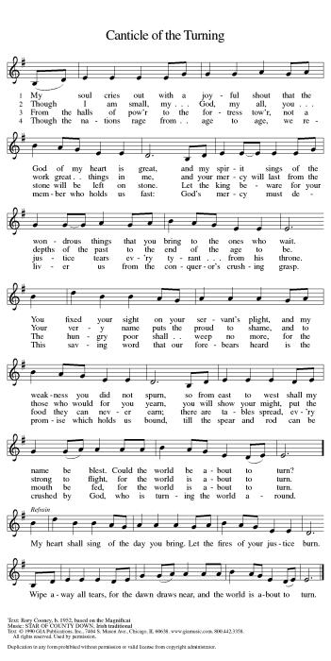
Confession and Forgiveness

L: Blessed be the ☩ holy Trinity, one God, Who creates us and forms us, who redeems us and calls us,
who unites us and sends us.
A: Amen.

L: Gathered in God’s presence, let us confess our sin.
A: Amen.

Silence for reflection and self-examination.

L: Mighty and loving God,
We confess that we are captive to sin and cannot free ourselves. We seek our own way.
We divide the body of Christ. In your mercy, cleanse us and heal us. Let the words of our mouths, the thoughts of our hearts, and everything we do be filled with faith, hope, and love.
Amen.

L: Hear the voice of Jesus: “The Spirit of the Lord is upon me to proclaim release to the captives.”
In the name of ☩ Jesus Christ, I proclaim to you that your sins are forgiven and you are released.
The joy of the Lord is your strength, and the gifts of the Holy Spirit are yours forever.
A: Amen.

Greeting

L: The grace of our Lord Jesus Christ, the love of God, and the communion of the Holy Spirit be with you all.
A: And also with you.

Prayer of the Day

L: Living God, in Christ you make all things new. Transform the poverty of our nature by the riches of your grace, and in the renewal of our lives make known your glory, through Jesus Christ, our Savior and Lord.
A: Amen.

HEARING THE WORD OF GOD

First Reading– Jeremiah 17: 5-10

L: A reading from 17th Chapter of Jeremiah found on page 705 in your pew Bible, beginning at the fifth verse.

L: The Word of the Lord.
A: Thanks be to God.

Psalm 1
L: A reading from Psalm 1

L: Happy are they who have not walked in the counsel of the wicked, nor lingered in the way of sinners, nor sat in the seats of the scornful!
A: Their delight is in the law of the Lord, and they meditate on God’s teaching day and night.
L: They are like trees planted by streams of water, bearing fruit in due season, with leaves that do not wither; everything they do shall prosper.
A: It is not so with the wicked; they are like chaff which the wind blows away.
L: Therefore the wicked shall not stand upright when judgment comes, nor the sinner in the council of the
righteous.
A: For the Lord knows the way of the righteous, but the way of the wicked shall be destroyed.

L: Holy wisdom, Holy word.
A: Thanks be to God.

Second Reading–1 Corinthians 15: 12-20

L: A reading from the 15th Chapter of first Corinthians found on page 1050 in your pew Bible, beginning at the 12th verse.

L: The Word of the Lord.
A: Thanks be to God.

Please rise as you are able for the reading of the Holy Gospel.

Gospel–Luke 6: 17-26

L: A reading from the 6th Chapter of Luke found on page 941 in your pew Bible, beginning at the 17th verse.
A: Glory to you, O Lord.

L: The good news of the Lord.
A: Praise to you, O, Christ.

Message Pastor Wayne Shelksohn
________________________________________________________________________________________

Hymn of the Day

APOSTLE’S CREED
I believe in God, the Father Almighty, Creator of heaven and earth, and in Jesus Christ, His only Son, our Lord,
who was conceived by the Holy Spirit, born of the Virgin Mary, suffered under Pontius Pilate, was crucified, died and was buried; He descended into hell; on the third day, He rose again from the dead; He ascended into heaven, and is seated at the right hand of God the Father Almighty; from there He will come to judge the living and the dead. I believe in the Holy Spirit, the Holy Catholic Church, the communion of Saints, the forgiveness of sins, the resurrection of the body, and life everlasting.
Amen.
Prayers of Intercession

Each petition will end “Lord, in your mercy” and the congregation will respond “Hear our Prayer.”

L: United as one body in Christ, let us pray for the church, the world, and all those in need.
A: Amen.

Pastor: Receive our prayers and fill us with the radiance of your love; through Jesus Christ our Lord.

Sharing the Peace

L: The peace of Christ be with you always.
A: And also with you.
You are invited to share a sign of God’s peace with your neighbors.

Offering–

As we continue with our offering, please sign the attendance book located at the end of each pew. Guests and visitors, please include your address and phone number.

Presentation of the Gifts
Please rise, as you are able, while the gifts are brought forward.

Offering Hymn Create in Me A Clean Heart ELW 185

Offering Prayer
L: God of all creation,
A: all you have made is good, and your love endures forever. You bring forth bread from the earth
and fruit from the vine. Nourish us with these gifts, that we might be for the world signs of your gracious presence in Jesus Christ, our Savior and Lord. Amen.

Installation of Church Council

Great Thanksgiving
L: The Lord be with you.
A: And also with you.
L: Lift up your hearts.
A: We lift them to the Lord.
L: Let us give thanks to the Lord our God.
A: It is right to give our thanks and praise

Preface
L: It is indeed right and salutary that we should at all times and in all places offer thanks and praise to you,

O Lord, holy Father, through Christ our Lord; who rose beyond the bounds of death, and, as he had promised, poured out your Spirit of life and power upon the chosen disciples. At this, the whole earth exults in boundless joy. And so, with the Church on earth and the hosts of heaven, we praise your name and join their unending hymn:

Words of Institution
Lord's Prayer

L: Gathered into one by the Holy Spirit, let us pray as Jesus taught us:

A: Our Father, who art in heaven, hallowed be thy name, thy kingdom come, thy will be done, on earth as it is in heaven. Give us this day our daily bread; and forgive us our trespasses, as we forgive those who trespass against us; and lead us not into temptation, but deliver us from evil.
For thine is the kingdom and the power, and the glory, forever and ever. Amen.

Invitation to Communion

L: Come to the table. Feast on God’s abundant life for you.

Communion Hymns ELW 479

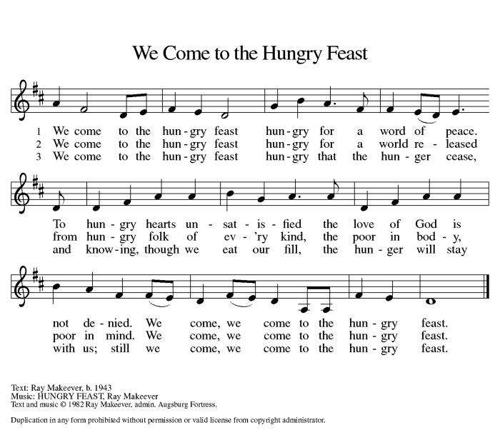

Communion Hymn ELW 479
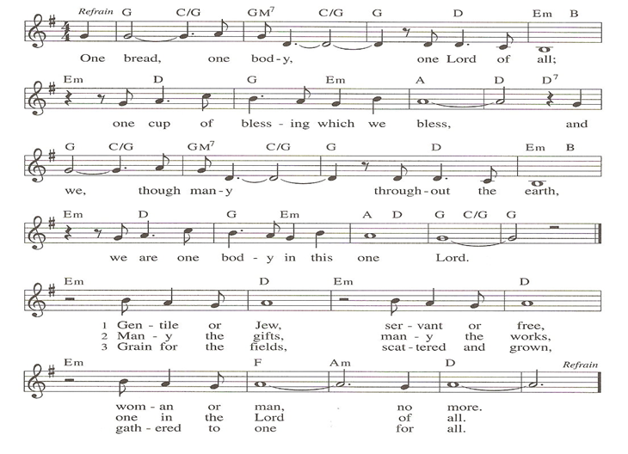
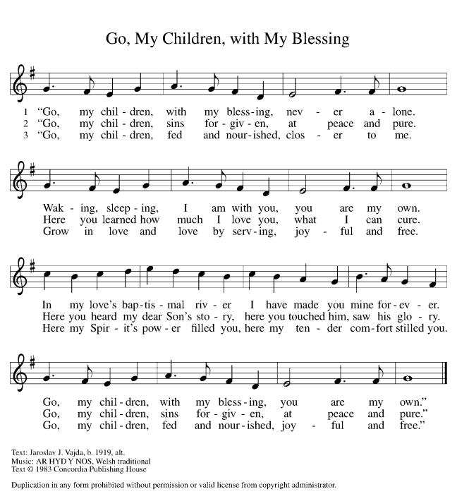

Prayer after Communion
L: We thank you, O God, that you have fed us at your banquet table, with bread and wine beyond compare, the very life of Christ for us. Send your Spirit with us now, that we may set the captive free,
use your gifts to build one another up, and everything reflect your glory revealed in Jesus Christ, our Savior and Lord.
A: Amen.

SENT FOR WORK AND WITNESS

Announcements
Blessing

L: The God of glory dwell in you richly, name you beloved, and shine brightly on your path; and the blessing of almighty God, the Father, the ☩ Son, and the Holy Spirit, be upon you and remain with you always.
A: Amen.

Dismissal

L: Go in peace. Christ is your light.
A: Thanks be to God.

Postlude

