St. Paul Lutheran Church, ELCA
Pontiac, IL
Seventh Sunday after Epiphany
February 24, 2019
The people of St. Paul
gather to worship,
reach out and serve the Lord.

Fifth Sunday after Epiphany

February 10, 2019

Introduction
Mercy. Mercy. Mercy. Joseph lives it in Egypt. Jesus preaches it in the gospel. The Spirit guides us into merciful lives with the power of forgiveness to reconcile what is fractured and divided. Such merciful living is the baptismal blessing of having put on Christ. It is the gift of the life-giving Spirit. It is a reflection of the glory of God revealed in the Christ.
Presiding Minister: Pastor Wayne Shelksohn
Worship Steward: Brad Solberg
Musician: Sara Solberg
Lector: Carol Thorson
Psalms: Ethan Schumm
Acolyte: Ethan Schumm
Ushers: Carl & Gail Thorson
Greeters: Mason Walsberg & Jeanne Rapp
Prayers: Jeanne Rapp
Communion Prep: Kris Lambert
Comm. Asst: Kathy Rygh & Kris Lambert
Guest Ambassador: Jill Rapp
Hospitality: Ginger Bauknecht, Gail Thorson & Dawn Boitnott
Counters: Jill Rapp & Marty Heller

Flowers on the altar are given by Carl and Gail Thorson.

Holy Communion Instructions

We believe that Jesus is truly present in the bread and wine and offers to us the forgiveness of sin and new life in the community through this sacrament. All who believe in the presence of Christ in, with, and under the elements of bread and wine are welcome to the table. Those who do not commune may come forward with their arms crossed over their chests to receive a blessing. Communion today will be by intinction. You may dip your wafer into either the darker colored liquid--the wine, or the lighter colored grape juice.

GATHERING FOR WORSHIP
Prelude
Welcome
Prepare for Worship
Gathering Hymn Love Divine, All Loves Excelling ELW 631

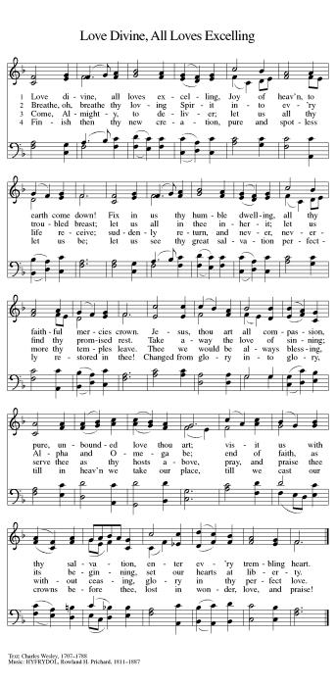

Confession and Forgiveness

L: Blessed be the ☩ holy Trinity, one God, Who creates us and forms us, who redeems us and calls us,
who unites us and sends us.
A: Amen.

L: Gathered in God’s presence, let us confess our sin.
A: Amen.

Silence for reflection and self-examination.

L: Mighty and loving God,
We confess that we are captive to sin and cannot free ourselves. We seek our own way.
We divide the body of Christ. In your mercy, cleanse us and heal us. Let the words of our mouths, the thoughts of our hearts, and everything we do be filled with faith, hope, and love.
Amen.

L: Hear the voice of Jesus: “The Spirit of the Lord is upon me to proclaim release to the captives.”
In the name of ☩ Jesus Christ, I proclaim to you that your sins are forgiven and you are released.
The joy of the Lord is your strength, and the gifts of the Holy Spirit are yours forever.
A: Amen.

Greeting

L: The grace of our Lord Jesus Christ, the love of God, and the communion of the Holy Spirit be with you all.
A: And also with you.

Prayer of the Day

L: O Lord Jesus, make us intstruments of your peace, that where there is hatred, we may sow love, where there is injury, pardon, and where there is despair, hope. Grant, O divine master, that we may seek to console, to understand, and to love in your name, for you live and reign with the Father and the Holy Spirit, one God, now and forever.
A: Amen.

HEARING THE WORD OF GOD

First Reading– Genesis 45: 3-11, 15

L: A reading from 45th Chapter of Genesis found on page 41 in your pew Bible, beginning at the third verse.

L: The Word of the Lord.
A: Thanks be to God.

Psalm 37
L: A reading from Psalm 37

L: Do not be provoked by evildoers; do not be jealous of those who do wrong.
A: For they shall soon wither like the grass, and like the green grass fade away.
L: Put your trust in the Lord and do good; dwell in the land and find safe pasture.
A: Take delight in the Lord, who shall give you your heart’s desire.
L: Commit your way to the Lord; put your trust in the Lord, and see what God will do.
A: The Lord will make your vindication as clear as the light and the justice of your case like the noonday sun.
L: Be still before the Lord and wait patiently. Do not be provoked by the one who prospers, the one who succeeds in evil schemes.
A: Refrain from anger, leave rage alone; do not be provoked; it leads only to evil.
L: For evildoers shall be cut off, but those who hope in the Lord shall possess the land.
A: In a little while the wicked shall be no more; even if you search out their place, they will not be there.
L: But the lowly shall possess the land; they will delight in abundance of peace.
A: But the deliverance of the righteous comes from you, O Lord; you are their stronghold in time of trouble.
L: You, O Lord, will help them and rescue them; you will rescue them from the wicked and deliver them, because in you they seek refuge.

L: Holy wisdom, Holy word.
A: Thanks be to God.

Second Reading–1 Corinthians 15: 35-38, 42-50

L: A reading from the 15th Chapter of first Corinthians found on page 1051 in your pew Bible, beginning at the 35th verse.

L: The Word of the Lord.
A: Thanks be to God.

Please rise as you are able for the reading of the Holy Gospel.

Gospel–Luke 6: 27-38

L: A reading from the 6th Chapter of Luke found on page 941 in your pew Bible, beginning at the 27th verse.
A: Glory to you, O Lord.

L: The good news of the Lord.
A: Praise to you, O, Christ.

Message Pastor Wayne Shelksohn
Hymn of the Day ELW 605
________________________________________________________________________________________
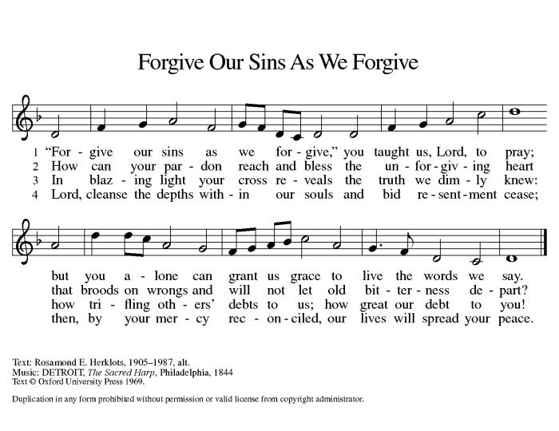

APOSTLE’S CREED
I believe in God, the Father almighty, creator of heaven and earth. I believe in Jesus Christ, his only Son, our Lord. He was conceived by the power of the Holy Spirit and born of the virgin Mary. He suffered under Pontius Pilate, was crucified, died, and was buried. He descended into hell. On the third day he rose again. He ascended into heaven, and is seated at the right hand of the Father. He will come again to judge the living and the dead. I believe in the Holy Spirit, the holy catholic Church, the communion of saints, the forgiveness of sins, the resurrection of the body, and the life everlasting. Amen.

Prayers of Intercession

Each petition will end “Lord, in your mercy” and the congregation will respond “Hear our Prayer.”

L: United as one body in Christ, let us pray for the church, the world, and all those in need.
A: Amen.

Pastor: Receive our prayers and fill us with the radiance of your love; through Jesus Christ our Lord.

Sharing the Peace

L: The peace of Christ be with you always.
A: And also with you.
You are invited to share a sign of God’s peace with your neighbors.

Offering–

As we continue with our offering, please sign the attendance book located at the end of each pew. Guests and visitors, please include your address and phone number.

Presentation of the Gifts
Please rise, as you are able, while the gifts are brought forward.

Offering Hymn Create in Me A Clean Heart ELW 185

Offering Prayer
L: God of all creation,
A: all you have made is good, and your love endures forever. You bring forth bread from the earth
and fruit from the vine. Nourish us with these gifts, that we might be for the world signs of your gracious presence in Jesus Christ, our Savior and Lord. Amen.

Great Thanksgiving
L: The Lord be with you.
A: And also with you.

L: Lift up your hearts.
A: We lift them to the Lord.

L: Let us give thanks to the Lord our God.
A: It is right to give our thanks and praise

Preface
L: It is indeed right and salutary that we should at all times and in all places offer thanks and praise to you,

O Lord, holy Father, through Christ our Lord; who rose beyond the bounds of death, and, as he had promised, poured out your Spirit of life and power upon the chosen disciples. At this, the whole earth exults in boundless joy. And so, with the Church on earth and the hosts of heaven, we praise your name and join their unending hymn:

Words of Institution

Lord's Prayer

L: Gathered into one by the Holy Spirit, let us pray as Jesus taught us:

A: Our Father, who art in heaven, hallowed be thy name, thy kingdom come, thy will be done, on earth as it is in heaven. Give us this day our daily bread; and forgive us our trespasses, as we forgive those who trespass against us; and lead us not into temptation, but deliver us from evil.
For thine is the kingdom and the power, and the glory, forever and ever. Amen.

Invitation to Communion

L: Come to the table. Feast on God’s abundant life for you.

Communion Hymn ELW 708

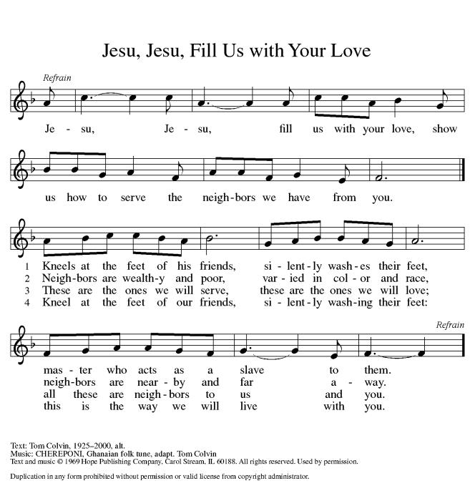

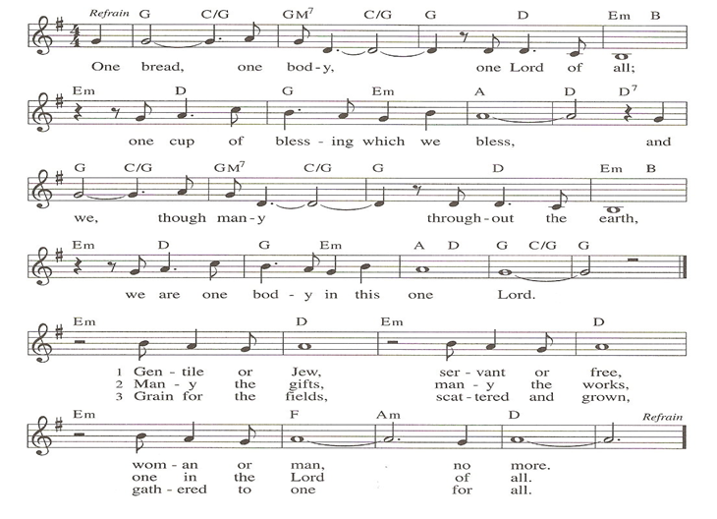
Communion Hymn ELW 485
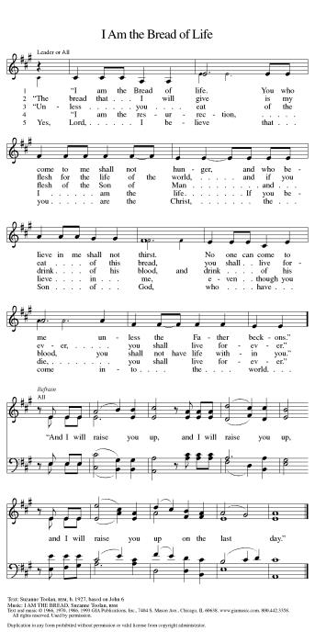

Prayer after Communion
L: We thank you, O God, that you have fed us at your banquet table, with bread and wine beyond compare, the very life of Christ for us. Send your Spirit with us now, that we may set the captive free,
use your gifts to build one another up, and everything reflect your glory revealed in Jesus Christ, our Savior and Lord.
A: Amen.

SENT FOR WORK AND WITNESS

Announcements
Blessing

L: The God of glory dwell in you richly, name you beloved, and shine brightly on your path; and the blessing of almighty God, the Father, the ☩ Son, and the Holy Spirit, be upon you and remain with you always.
A: Amen.

Dismissal

L: Go in peace. Christ is your light.
A: Thanks be to God.

Postlude

