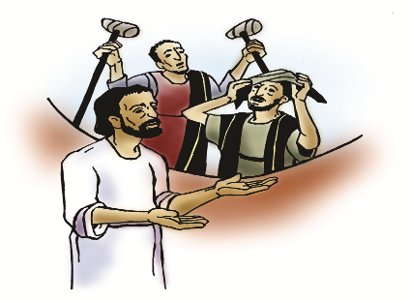

St. Paul Lutheran Church, ELCA

Pontiac, IL
December 11, 2022
Third Sunday of Advent

Flowers were donated this morning by Doug & Peggie Schneeman in memory of Katie, Corey, Sloan and Don & Katie Schneeman.
“Red bag” offering will be collected this morning and donated to “Local Needy Families”
Introduction
A note of joyful expectation marks today’s worship. Isaiah announces that the desert shall rejoice and blossom, and Jesus points to the unexpected and transforming signs of God’s reign. We wait with patience for the coming of the Lord, even as we rejoice at his presence among us this day: in word and holy supper, in church and in our homes, in silent reflection and in works of justice and love. We pray that God would open our eyes and ears to the wonders of Christ’s advent among us.

Prelude

Welcome

Announcements

Lighting of the Advent Wreath

Praise to you, O God, who holds our joy and sorrow.
You bring water to parched ground and life out of death.
Bless us as this light grows,
and send sorrow and sighing to flee away.
Give us strength and patience,
trusting that you are true to your promises.
Transform the lives of all who suffer
With your wonders near at hand.
Amen.

Gathering Hymns “While We Are Waiting, Come” Words only

While we are waiting, come; Come Savior quickly come;
While we are waiting, come. Come Savior quickly come.
Jesus, our Lord, Emmanuel, Jesus, our Lord, Emmanuel.
While we are waiting, come. While we are waiting, come.

With power and glory, come;
With power and glory, come.
Jesus, our Lord, Emmanuel,
While we are waiting, come.

“Come Thou Long Expected Jesus” ELW 254

Confession and Forgiveness

All may make the sign of the cross, the sign marked at baptism, as the presiding minister begins.

L: Blessed be the Lord, the God of Israel,
who alone does wondrous things.
Blessed be God’s name forever.
A: Amen.

L: Beloved, now is the time to wake from sleep.
Let us confront our sins,
And confess them to the one who is merciful and just.

Silence is kept for reflection.

L: God of new beginnings,
we confess that we have not welcomed your holy reign.
We have strayed from your paths.
We prepare for war instead of peace.
We dishonor one another and your creation.
Purify us with your refining fire
and set us again on your way of love,
that we may bear fruit worthy of repentance,
and welcome your coming among us.
Amen.

L: People of God,
a new thing is growing in our midst,
a tender branch,
a living sign.
By water and the Spirit you are joined to this wonder.
You have put on ☩ Christ,
and your sins have been washed away.
Rejoice in the way of the Lord.
A: Amen.

Greeting

L: The grace of our Lord Jesus Christ, the love of God, and the communion of the
Holy Spirit be with you all.
A: And also with you.

Prayer of the Day

L: Stir up the wills of all who look to you, Lord God, and strengthen our faith in your coming, that, transformed by grace, we may walk in your way; through Jesus Christ, our Savior and Lord, who lives and reigns with you and the Holy Spirit, one God, now and forever.
Amen.

Children’s Message – Dismissal to Children’s Chapel

HEARING THE WORD OF GOD

First Reading- Isaiah 35: 1-10

L: A reading from Isaiah.

¹The wilderness and the dry land shall be glad,
the desert shall rejoice and blossom;
like the crocus ²it shall blossom abundantly,
and rejoice with joy and singing.
The glory of Lebanon shall be given to it,
the majesty of Carmel and Sharon.
They shall see the glory of the Lord,
the majesty of our God.
³Strengthen the weak hands,
and make firm the feeble knees.
⁴Say to those who are of a fearful heart,
“Be strong, do not fear!
Here is your God.
He will come with vengeance,
with terrible recompense.
He will come and save you.”
⁵Then the eyes of the blind shall be opened,
and the ears of the deaf unstopped;
⁶then the lame shall leap like a deer,
and the tongue of the speechless sing for joy.
For waters shall break forth in the wilderness,
and streams in the desert;
⁷the burning sand shall become a pool,
and the thirsty ground springs of water;
the haunt of jackals shall become a swamp,
the grass shall become reeds and rushes.
⁸A highway shall be there,
and it shall be called the Holy Way;
the unclean shall not travel on it,
but it shall be for God’s people;
no traveler, not even fools, shall go astray.
⁹No lion shall be there,
nor shall any ravenous beast come up on it;
they shall not be found there,
but the redeemed shall walk there.
¹⁰And the ransomed of the Lord shall return,
and come to Zion with singing;
everlasting joy shall be upon their heads;
they shall obtain joy and gladness,
and sorrow and sighing shall flee away.

L: Word of God, word of life.
A: Thanks be to God.

Psalm 146: 5-10

L: A reading from Psalm.

⁵Happy are they who have the God of Jacob for their help,
whose hope is in the Lord their God;
⁶who made heaven and earth, the seas, and all that is in them;
who keeps promises forever;
⁷who gives justice to those who are oppressed, and food to those who hunger.
The Lord sets the captive free.
⁸The Lord opens the eyes of the blind; the Lord lifts up those who are bowed down;
the Lord loves the righteous.
⁹The Lord cares for the stranger;
the Lord sustains the orphan and widow, but frustrates the way of the wicked.
¹⁰The Lord shall reign forever,
your God, O Zion, throughout all generations. Hallelujah!

L: Holy wisdom; Holy Word.
A: Thanks be to God.
Second Reading – James 5: 7-10

L: A reading from James.

⁷Be patient, therefore, beloved, until the coming of the Lord. The farmer waits for the precious crop from the earth, being patient with it until it receives the early and the late rains. ⁸You also must be patient. Strengthen your hearts, for the coming of the Lord is near. ⁹Beloved, do not grumble against one another, so that you may not be judged. See, the Judge is standing at the doors! ¹⁰As an example of suffering and patience, beloved, take the prophets who spoke in the name of the Lord.

L: Word of God, word of life.
A: Thanks be to God.

Please rise, as you are able, for the reading of the Holy Gospel.

Gospel Acclamation Halle, Halle, Hallelujah

Gospel- Matthew 11: 2-11

L: The Holy Gospel according to Matthew.
A: Glory to you, O Lord.

²When John heard in prison what the Messiah was doing, he sent word by his disciples ³and said to him, “Are you the one who is to come, or are we to wait for another?” ⁴Jesus answered them, “Go and tell John what you hear and see: ⁵the blind receive their sight, the lame walk, the lepers are cleansed, the deaf hear, the dead are raised, and the poor have good news brought to them. ⁶And blessed is anyone who takes no offense at me.”
⁷As they went away, Jesus began to speak to the crowds about John: “What did you go out into the wilderness to look at? A reed shaken by the wind? ⁸What then did you go out to see? Someone dressed in soft robes? Look, those who wear soft robes are in royal palaces. ⁹What then did you go out to see? A prophet? Yes, I tell you, and more than a prophet. ¹⁰This is the one about whom it is written,
‘See, I am sending my messenger ahead of you,
who will prepare your way before you.’
¹¹Truly I tell you, among those born of women no one has arisen greater than John the Baptist; yet the least in the kingdom of heaven is greater than he.”

L: The gospel of the Lord.
A: Praise to you, O Christ.

Sermon SAM Marcia Buchs

Hymn of the Day “All the Earth is Hopeful” ELW 266

Apostle’s Creed

I believe in God, the Father almighty,
creator of heaven and earth.
I believe in Jesus Christ, God’s only Son, our Lord,
who was conceived by the Holy Spirit,
born of the virgin Mary,
suffered under Pontius Pilate,
was crucified, died, and was buried;
he descended to the dead.
On the third day he rose again;
he ascended into heaven,
he is seated at the right hand of the Father,
and he will come to judge the living and the dead.
I believe in the Holy Spirit,
the holy catholic church,
the communion of saints,
the forgiveness of sins,
the resurrection of the body,
and the life everlasting. Amen.

Prayers of Intercession

Each petition will end “God, in your mercy,” and the congregation will respond “hear our prayer.”

Sharing the Peace

L: The peace of Christ be with you always.
A: And also with you.

You are invited to share a sign of God’s peace with your neighbors by turning to the people near you saying, “Peace be with you.”

Offering

Offerings can also be sent by mail or given online. You can send a check to St. Paul Lutheran Church 210 Deerfield Rd Pontiac, IL 61764 or give online at stpaulpontiac.org

Offering “Special Music”

Offering Prayer

L: Eternal God,
you make the desert bloom
and send springs of water to thirsty ground.
Receive these simple gifts of bread, wine, and money,
and make us messengers of your mercy and love
for all in need of your healing and justice.
We ask this through Christ our Savior.
A: Amen.

MEAL

All are welcome at Christ’s table.
Communion is distributed in front of the altar. The prepackaged cups are juice. If you prefer not to receive communion you may come forward with your hands crossed over your chest to receive a blessing or you may remain in your seat.

Great Thanksgiving

L: The Lord be with you.
A: And also with you.

L: Lift up your hearts.
A: We lift them to the Lord.

L: Let us give thanks to the Lord our God.
A: It is right to give our thanks and praise.

Preface

L: It is indeed right, our duty and our joy,
that we should at all times and in all places
offer thanks and praise to you, O Lord,
holy Father, almighty and ever living God.
But chiefly we are bound to praise you for the glorious
Resurrection of our Lord; for he is the true Passover Lamb
Who gave himself to take away our sin,
Who by his death has destroyed death;
And by his rising has brought us to eternal life.
And so with Mary Magdalene and Peter and
All the witnesses of the resurrection,
With earth and sea and all their
Creatures, and with angels and archangels,
Cherubim and seraphim,
We praise your name and join their unending hymn:

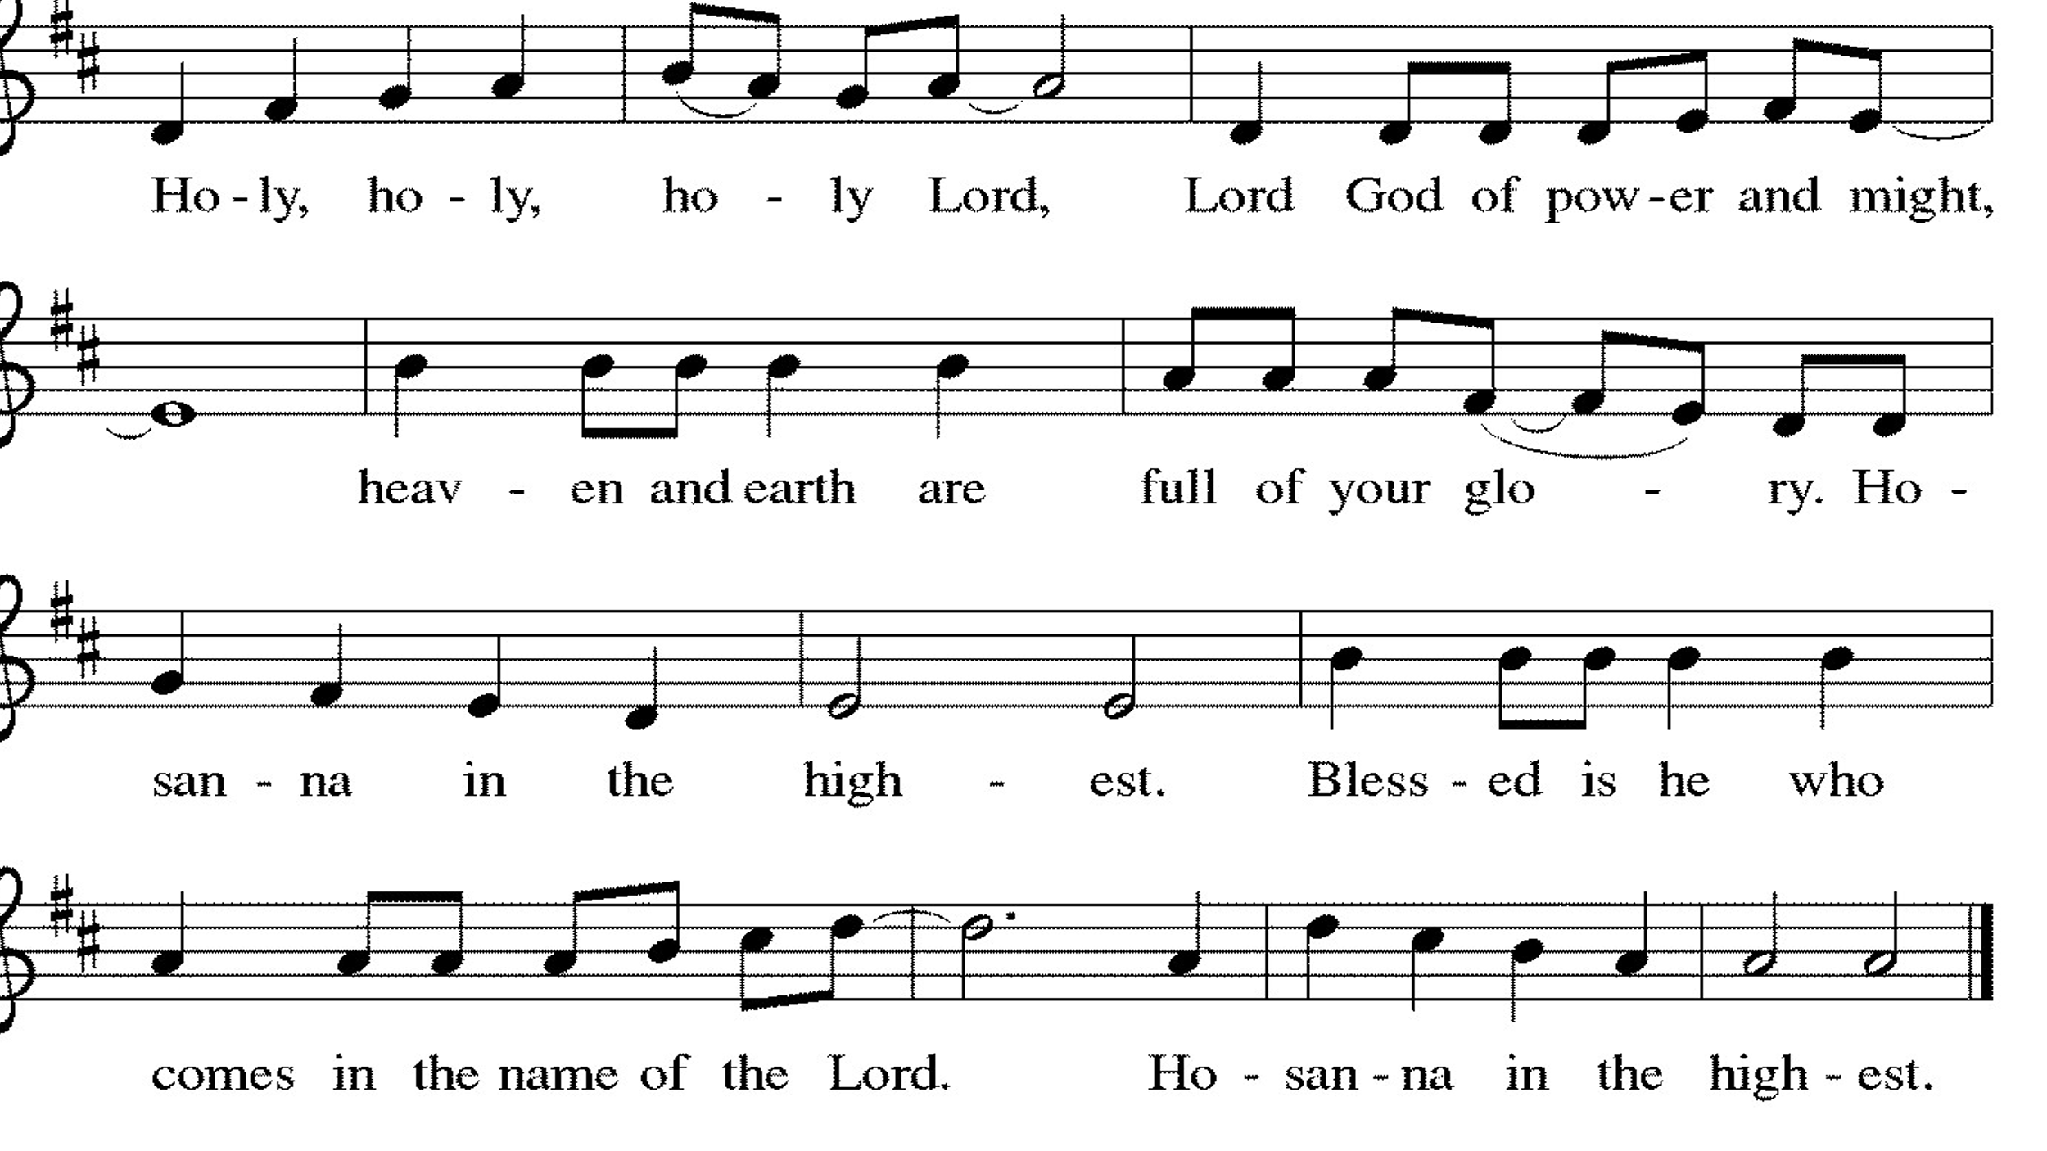

Thanksgiving at the Table

L: Holy, living and loving God,
We praise you for creating the heavens and the earth.
We give you thanks for Jesus who, living among us,
Healed the sick, fed the hungry, and with a love stronger
Than death, gave his life for others.

In the night in which he was betrayed,
our Lord Jesus took bread, and gave thanks;
broke it, and gave it to his disciples, saying:
Take and eat; this is my body, given for you.
Do this for the remembrance of me.

Again, after supper, he took the cup, gave thanks,
and gave it for all to drink, saying:
This cup is the new covenant in my blood,
shed for you and for all people for the forgiveness of sin.
Do this for the remembrance of me.

Remembering, therefore, his life-
Giving death and glorious resurrection,
We await your promised life for all this
Dying world. Breathe your Spirit on us
And on this bread and cup:
Carry us in your arms from death to life,
That we may live as your chosen ones,
Clothed in the righteousness of Christ.

A: Through him all glory and honor is yours,
Almighty Father, with the Holy Spirit,
In your holy church, both now and forever.
Amen.

Lord’s Prayer

L: Gathered into one by the Holy Spirit, let us pray as Jesus taught us,
A: Our Father, who art in heaven, hallowed be thy name, thy kingdom come, thy will be done, on earth as it is in heaven. Give us this day our daily bread; and forgive us our trespasses, as we forgive those who trespass against us; and lead us not into temptation but deliver us from evil. For thine is the kingdom and the power, and the glory, forever and ever. Amen.

Invitation to Communion

L: Be strong, do not Fear! Here is your God, who has come to save you.

Communion- Music Video “Breath of Heaven ” by Amy Grant

Prayer after Communion

L: Faithful God,
in this meal you have remembered your mercy,
bringing heaven to earth in the body and blood of Christ.
As we wait for the day when all your promises will be fulfilled,
sustain us and strengthen us by this holy mystery.
Guide us toward your promised future,
coming to birth in Jesus Christ our Savior and Lord
A: Amen.

SENT FOR WORK AND WITNESS

Blessing

L: God the eternal Word,
who dwells with us in Jesus,
and who holds us in the grace of the Holy Spirit,
☩ bless you now and forever.
A: Amen

Sending Hymn “He Came Down” ELW 253

Dismissal

L: Go in peace. Christ is near.
A: Thanks be to God.

Postlude

Licensing information for this Worship Service:
CCLI Copyright License A 2440181 5/31/23 + Streaming Plus License A 211196712 5/31/23
Sundays and Seasons License Sundays and Seasons v.20200325.1254

Worship Participants

Presiding Minister: SAM Marcia Buchs
Worship Steward: John Mehlberg
Greeter: Sara Solberg
Musician: Sandy Erickson
Lector: Brad Solberg
Usher: Mark Mackinson
Communion Prep: Marian Brown
Comm. Asst: Marty & Shelly Heller
Livestream: Louis Kehinde
Hospitality: Tonya Johnson-Wilcox & Shelly Heller
Counters: Cody Leach & Jake Dixon

