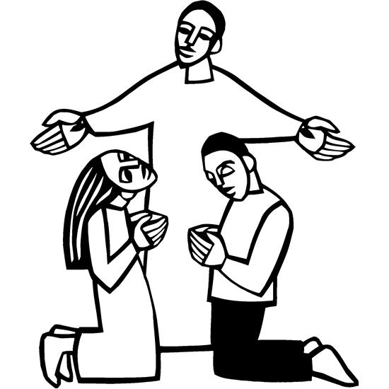

St. Paul Lutheran Church, ELCA

Pontiac, IL
September 10, 2023

15th Sunday after Pentecost

Flowers were donated this morning by the Hellers in honor of Jake, Meghan & Jordan’s birthdays.
Introduction
Conflict is a part of relationships and life in community. Jesus’ words in today's gospel are often used in situations having to do with church discipline. The prophet Ezekiel tells of warning the wicked to turn from their ways, and Paul reminds us that love is the fulfilling of the law. We gather in the name of Christ, assured that he is present among us with gifts of peace and reconciliation.

Prelude
Welcome and Announcements

Confession and Forgiveness

All may make the sign of the cross, the sign marked at baptism, as the presiding minister begins.

L: In the name of the ☩ triune God, who loves us into being, calls us to community, and inspires us to love.
A: Amen.
L: Confronted by the law and called to life in the gospel, let us confess our sin before God and one another.
Silence is kept for reflection.
L: God of love and community,
A: we confess that we have not loved as God has loved us. We look to ourselves to fulfill your law. We seek to satisfy our own desires. We turn away from our neighbors and live for ourselves alone. Teach us again your statutes and help us to love your will, that in and through us your beloved community is made known.
L: Beloved of God, love is the fulfillment of the law, and in ☩ Jesus, God’s love for you is made known. Through Jesus your sins are forgiven, and you are drawn into God’s love and life. Live fully, knowing that God loves you.
A: Amen.

Gathering Hymn - “We are Called” ELW 720 verses 1 and 2

Greeting
L: The grace of our Lord Jesus Christ, the love of God, and the communion of the Holy Spirit be with you all.
A: And also with you.

Prayer of the Day
L: O Lord God, enliven and preserve your church with your perpetual mercy. Without your help, we mortals will fail; remove far from us everything that is harmful and lead us toward all that gives life and salvation, through Jesus Christ, our Savior and Lord.
A: Amen.

Children’s Message – Dismissal to Children’s Chapel

HEARING THE WORD OF GOD

Please rise, as you are able, for the reading of the Holy Gospel.

Gospel Acclamation (to be sung) “ Halle, Halle, Hallelujah”
Halle, halle, hallelujah. Halle, halle, hallelujah. Halle, halle, hallelujah. Hallelujah. Hallelujah.

Gospel- Matthew 18: 15-20
L: The Holy Gospel according to Matthew.
A: Glory to you, O Lord.
[Jesus said to the disciples:] ¹⁵“If another member of the church sins against you, go and point out the fault when the two of you are alone. If the member listens to you, you have regained that one. ¹⁶But if you are not listened to, take one or two others along with you, so that every word may be confirmed by the evidence of two or three witnesses. ¹⁷If the member refuses to listen to them, tell it to the church; and if the offender refuses to listen even to the church, let such a one be to you as a Gentile and a tax collector. ¹⁸Truly I tell you, whatever you bind on earth will be bound in heaven, and whatever you loose on earth will be loosed in heaven. ¹⁹Again, truly I tell you, if two of you agree on earth about anything you ask, it will be done for you by my Father in heaven. ²⁰For where two or three are gathered in my name, I am there among them.”
L: The gospel of the Lord.
A: Praise to you, O Christ.

Sermon SAM Marcia Buchs

Hymn of the Day “Here I Am, Lord” ELW 574 verses 1 and 2

Apostle’s Creed
L: Let us confess our faith in the words of the Apostle’s Creed.
A: I believe in God, the Father almighty, creator of heaven and earth. I believe in Jesus Christ, God’s only Son, our Lord, who was conceived by the Holy Spirit, born of the virgin Mary, suffered under Pontius Pilate, was crucified, died, and was buried; he descended to the dead. On the third day he rose again; he ascended into heaven, he is seated at the right hand of the Father, and he will come to judge the living and the dead. I believe in the Holy Spirit, the holy catholic church, the communion of saints, the forgiveness of sins, the resurrection of the body, and the life everlasting. Amen.

Prayers of Intercession
Each petition will end “God, we pray,” and the congregation will respond “open our hands in love.”

Sharing the Peace
L: The peace of Christ be with you always.
A: And also with you.

You are invited to share a sign of God’s peace with your neighbors by turning to the people near you saying, “Peace be with you.”

Offering Special Music
Offerings can also be sent by mail or given online. You can send a check to St. Paul Lutheran Church 210 Deerfield Rd Pontiac, IL 61764 or give online at stpaulpontiac.org

Offering Prayer
L: Holy God, giver of all good things, receive the gifts we bring, fruit of the earth and the work of human hands, that they may be used to your purposes for life and love in the world.
A: Amen.

MEAL
All are welcome at Christ’s table. Communion is distributed in front of the altar by intinction. Please dip the wafer into the lighter colored liquid which is grape juice or the darker liquid which is wine. If you prefer not to receive communion you may come forward with your hands crossed over your chest to receive a blessing or you may remain in your seat.

Great Thanksgiving
L: The Lord be with you.
A: And also with you.

L: Lift up your hearts.
A: We lift them to the Lord.

L: Let us give thanks to the Lord our God.
A: It is right to give our thanks and praise.

Word of Institution

L: Sitting at dinner with friends and knowing one among them would break the bonds of love, our Lord Jesus took bread and gave thanks; broke it; and gave it to his disciples saying: Take and eat; this is my body given for you. Do this for the remembrance of me.

In the same way after supper, he took the cup, gave thanks, and gave it for all to drink, saying: This cup is the new covenant in my blood, shed for you and for all people for the forgiveness of sins. Do this for the remembrance of me.

L: All honor and praise and glory to you, God of creative, dirty hands, God of holy, wounded hands, God who strengthens and guides our hands, now and forever.
A: Amen.

Lord’s Prayer
L: Gathered into one by the Holy Spirit, let us pray as Jesus taught us,
A: Our Father, who art in heaven, hallowed be thy name, thy kingdom come, thy will be done, on earth as it is in heaven. Give us this day our daily bread; and forgive us our trespasses, as we forgive those who trespass against us; and lead us not into temptation but deliver us from evil. For thine is the kingdom and the power, and the glory, forever and ever. Amen.

Invitation to Communion
L: All people are called to Christ’s table. Come, eat what is good.

Communion Music Video – ”Beautiful Things” by Gungor

Prayer after Communion
L: Holy Jesus, in this meal you have fed and nourished us to work in your beloved world. Send us now, filled with yourself and strengthened by your Spirit to live your love for others.
A: Amen.

Celebration of Vocation and Blessing of Hands for Ministry
L: We are called to proclaim the good news:
A: God is at work!
L: This good news is not left in some history long ago or a place far away:
A: God is at work in the world still today!
L: In us and through us, God is glorified in our work. When we offer a helping hand, God is praised. When we share of our abundance, God is known in the world.
A: God is at work in us!
L: In our service today, and in our daily lives, let us live out what God has called us to in baptism. A: God is at work through our hands!
L: God bless your hands and your work, that through you God’s love may be known.
A: Amen.

SENT FOR WORK AND WITNESS
Blessing

L: God who sets forth the law of love, Jesus who fulfills the law for you, and the Spirit through whom you are called to love, ☩ bless you this day, that you may be God’s hands and heart and voice at work in the world!
A: Amen.
Sending Hymn - “Here I Am, Lord” ELW 574 verse 3

Dismissal
L: Go in peace. You are God’s hands at work in the world!
A: Thanks be to God!

Licensing information for this Worship Service:
CCLI Copyright License A 2440181 5/31/23 + Streaming Plus License A 211196712 5/31/23
Sundays and Seasons License Sundays and Seasons v.20200325.1254

Worship Participants
Presiding Minister: SAM Marcia Buchs
Worship Steward: Marty Heller
Musician: Sandy Erickson
Lector: Julie Mehlberg
Greeter: Dawn Boitnott & Pat Lund
Usher: Marty & Shelly Heller
Communion Prep: Ginger Bauknecht
Comm. Asst: Mark Mackinson & Doug Oliver
Livestream: Louis Kehinde
Hospitality: Lunch Provided for God’s Work Our Hands Day
Counters: Carrie Lueker & Marvin Miller

