St. Paul Lutheran Church, ELCA

Pontiac, IL
January 22, 2023
Third Sunday after Epiphany

Introduction
Jesus begins his public ministry by calling fishers to leave their nets and follow him. In Jesus the kingdom of God has come near. We who have walked in darkness have seen a great light. We see this light most profoundly in the cross—as God suffers with us and all who are oppressed by sickness, sin, or evil. Light dawns for us as we gather around the word, the font, and the holy table. We are then sent to share the good news that others may be “caught” in the net of God’s grace and mercy.

Prelude

Welcome

Announcements

Gathering Hymn “
Surely the Presence of the he Lord is in this Place”

Gathering Hymns

“Surely the Presence of the Lord is in this Place” Words only

Verse
In the midst of His children the Lord said He would be.
It doesn’t take very many, it can be just two or three.
And I feel that same sweet Spirit that I’ve felt oft times before;
Surely I can say I’ve been with the Lord.
Refrain
Surely the Presence of the Lord is in this place,
I can feel His Mighty Power and His grace.
I can feel the brush of angel wings, I see Glory on each face.
Surely the Presence of the Lord is in this place.
Verse
There’s a holy hush around us, as God’s Glory fills the place.
I’ve touched the hem of His garment, I can almost see His face.
And my heart is overflowing with the fullness of His joy;
I know without a doubt that I’ve been with the Lord.
Refrain
Surely the Presence of the Lord is in this place,
I can feel His Mighty Power and His grace.
I can feel the brush of angel wings, I see Glory on each face.
Surely the Presence of the Lord is in this place.
Surely the Presence of the lord is in this place.

“Shine, Jesus Shine” ELW 671

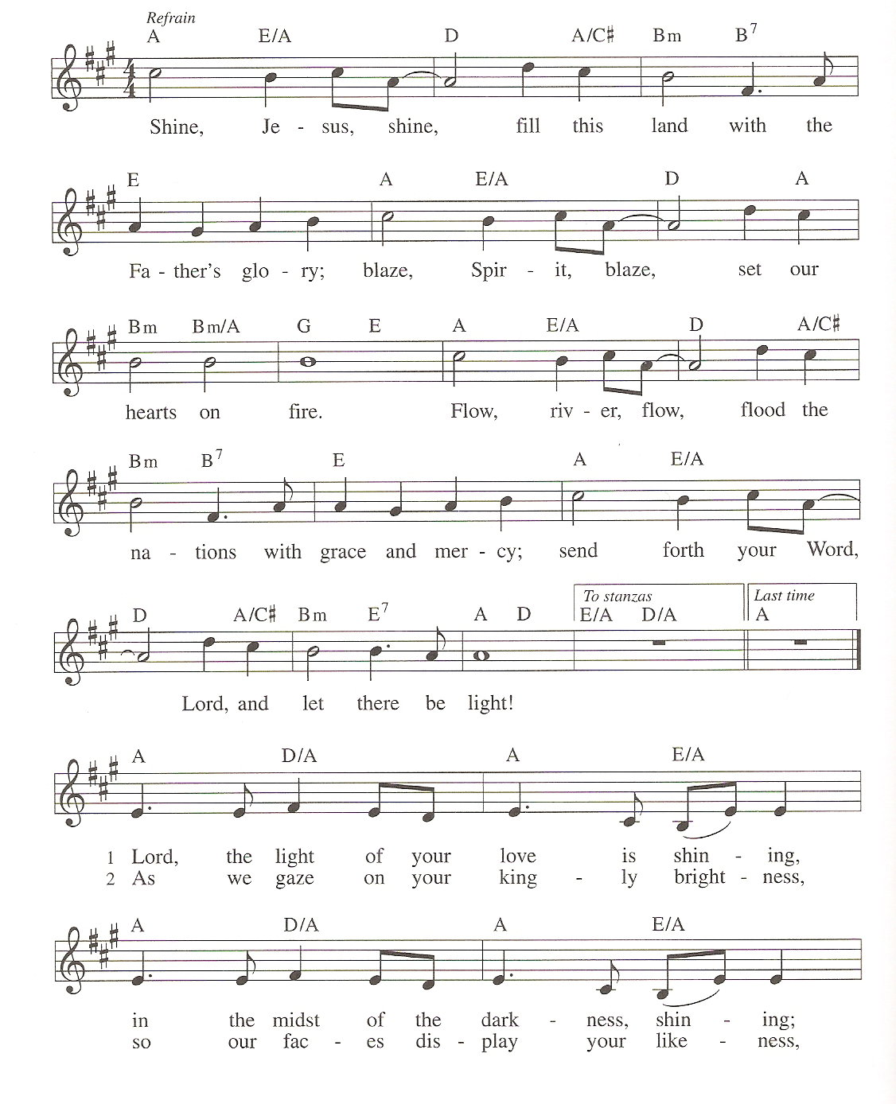
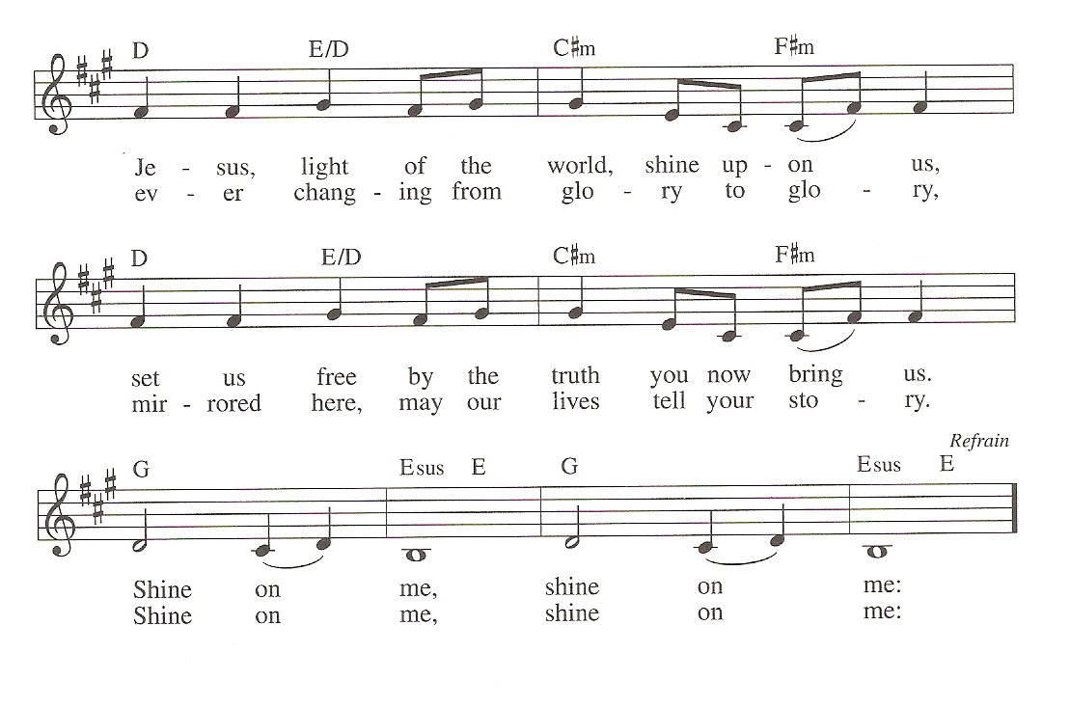
Confession and Forgiveness

All may make the sign of the cross, the sign marked at baptism, as the presiding minister begins.

L: Blessed be the holy Trinity, ☩ one God,
Who make all things new,
Whose mercy endures forever.
A: Amen.

L: Trusting in God’s mercy, let us confess our sin.

Silence is kept for reflection.

L: Holy One, source of our renewal,
we confess that we are wrapped up in sin,
and cannot free ourselves.
We have not practiced your righteousness.
Our hearts have turned away from you.
For the sake of the world you so love,
forgive us,
that we may be reconciled to one another
for the glory of your holy name.
Amen.

L: Thus says our God:
“The former things have come to pass
and new things I now declare.”
God’s mercy makes us new.
We are forgiven in the name of ☩ Christ our Savior.
Amen.

Greeting

L: The grace of our Lord Jesus Christ, the love of God, and the communion of the
Holy Spirit be with you all.
A: And also with you.

Prayer of the Day

L: Lord God, your lovingkindness always goes before us and follows after us. Summon us into your light, and direct our steps in the ways of goodness that come through the cross of your Son, Jesus Christ, our Savior and Lord.
Amen.

Children’s Message-Dismissal to Children’s Chapel

HEARING THE WORD OF GOD

First Reading- Isaiah 9: 1-4

L: A reading from Isaiah.

¹There will be no gloom for those who were in anguish. In the former time [the Lord] brought into contempt the land of Zebulun and the land of Naphtali, but in the latter time he will make glorious the way of the sea, the land beyond the Jordan, Galilee of the nations.
²The people who walked in darkness
have seen a great light;
those who lived in a land of deep darkness—
on them light has shined.
³You have multiplied the nation,
you have increased its joy;
they rejoice before you
as with joy at the harvest,
as people exult when dividing plunder.
⁴For the yoke of their burden,
and the bar across their shoulders,
the rod of their oppressor,
you have broken as on the day of Midian.

L: Word of God, word of life.
A: Thanks be to God.

Psalm 27; 1, 4-9

L: A reading from Psalm 27

The Lord is my light and my salvation; whom then | shall I fear?
The Lord is the stronghold of my life; of whom shall I | be afraid?
⁴One thing I ask of the Lord; one | thing I seek;
that I may dwell in the house of the Lord all the days of my life; to gaze upon the beauty of the Lord and to seek God | in the temple.
⁵For in the day of trouble God will | give me shelter,
hide me in the hidden places of the sanctuary, and raise me high up- | on a rock.
⁶Even now my head is lifted up above my enemies | who surround me.
Therefore I will offer sacrifice in the sanctuary, sacrifices of rejoicing; I will sing and make music | to the Lord. R
⁷Hear my voice, O Lord, | when I call;
have mercy on me and | answer me.
⁸My heart speaks your message— | “Seek my face.”
Your face, O Lord, | I will seek.
⁹Hide not your face from me, turn not away from your ser- | vant in anger.
Cast me not away—you have been my helper; forsake me not, O God of | my salvation. R:

L: Holy wisdom; Holy Word.
A: Thanks be to God.
Second Reading – Corinthians 1: 10-18

L: A reading from Corinthians.

¹⁰Now I appeal to you, brothers and sisters, by the name of our Lord Jesus Christ, that all of you be in agreement and that there be no divisions among you, but that you be united in the same mind and the same purpose. ¹¹For it has been reported to me by Chloe’s people that there are quarrels among you, my brothers and sisters. ¹²What I mean is that each of you says, “I belong to Paul,” or “I belong to Apollos,” or “I belong to Cephas,” or “I belong to Christ.” ¹³Has Christ been divided? Was Paul crucified for you? Or were you baptized in the name of Paul? ¹⁴I thank God that I baptized none of you except Crispus and Gaius, ¹⁵so that no one can say that you were baptized in my name. ¹⁶(I did baptize also the household of Stephanas; beyond that, I do not know whether I baptized anyone else.) ¹⁷For Christ did not send me to baptize but to proclaim the gospel, and not with eloquent wisdom, so that the cross of Christ might not be emptied of its power.
¹⁸For the message about the cross is foolishness to those who are perishing, but to us who are being saved it is the power of God.

L: Word of God, word of life.
A: Thanks be to God.

Please rise, as you are able, for the reading of the Holy Gospel.

Gospel Acclamation

Gospel- Matthew 4: 12-23

L: The Holy Gospel according to John.
A: Glory to you, O Lord.

¹²Now when Jesus heard that John had been arrested, he withdrew to Galilee. ¹³He left Nazareth and made his home in Capernaum by the sea, in the territory of Zebulun and Naphtali, ¹⁴so that what had been spoken through the prophet Isaiah might be fulfilled:
¹⁵“Land of Zebulun, land of Naphtali,
on the road by the sea, across the Jordan, Galilee of the Gentiles—
¹⁶the people who sat in darkness
have seen a great light,
and for those who sat in the region and shadow of death
light has dawned.”
¹⁷From that time Jesus began to proclaim, “Repent, for the kingdom of heaven has come near.”
¹⁸As he walked by the Sea of Galilee, he saw two brothers, Simon, who is called Peter, and Andrew his brother, casting a net into the sea—for they were fishermen. ¹⁹And he said to them, “Follow me, and I will make you fish for people.” ²⁰Immediately they left their nets and followed him. ²¹As he went from there, he saw two other brothers, James son of Zebedee and his brother John, in the boat with their father Zebedee, mending their nets, and he called them. ²²Immediately they left the boat and their father, and followed him.
²³Jesus went throughout Galilee, teaching in their synagogues and proclaiming the good news of the kingdom and curing every disease and every sickness among the people.

L: The gospel of the Lord.
A: Praise to you, O Christ.

Sermon Pastor Wayne Shelksohn

Hymn of the Day “Will you Come and Follow Me” ELW 798

Apostle’s Creed

I believe in God, the Father almighty,
creator of heaven and earth.
I believe in Jesus Christ, God’s only Son, our Lord,
who was conceived by the Holy Spirit,
born of the virgin Mary,
suffered under Pontius Pilate,
was crucified, died, and was buried;
he descended to the dead.
On the third day he rose again;
he ascended into heaven,
he is seated at the right hand of the Father,
and he will come to judge the living and the dead.
I believe in the Holy Spirit,
the holy catholic church,
the communion of saints,
the forgiveness of sins,
the resurrection of the body,
and the life everlasting. Amen.

Prayers of Intercession

Each petition will end “Merciful God,” and the congregation will respond “receive our prayer.”

Sharing the Peace

L: The peace of Christ be with you always.
A: And also with you.

You are invited to share a sign of God’s peace with your neighbors by turning to the people near you saying, “Peace be with you.”

Offering

Offerings can also be sent by mail or given online. You can send a check to St. Paul Lutheran Church 210 Deerfield Rd Pontiac, IL 61764 or give online at stpaulpontiac.org

Offering “Special Music”

Offering Prayer

L: Liberating God,
you break the bonds of injustice
and let the oppressed go free.
Receive these offerings in thanksgiving
for all your works of merciful power,
and shape us as people of your justice and freedom.
You we magnify and adore, through Jesus our Savior,
A: Amen.
MEAL

All are welcome at Christ’s table.
Communion is distributed in front of the altar. The prepackaged cups are juice. If you prefer not to receive communion you may come forward with your hands crossed over your chest to receive a blessing or you may remain in your seat.

Great Thanksgiving

L: The Lord be with you.
A: And also with you.

L: Lift up your hearts.
A: We lift them to the Lord.
L: Let us give thanks to the Lord our God.
A: It is right to give our thanks and praise.
Preface

L: It is indeed right, our duty and our joy,
that we should at all times and in all places
offer thanks and praise to you, O Lord,
holy Father, almighty and ever living God.
But chiefly we are bound to praise you for the glorious
Resurrection of our Lord; for he is the true Passover Lamb
Who gave himself to take away our sin,
Who by his death has destroyed death;
And by his rising has brought us to eternal life.
And so with Mary Magdalene and Peter and
All the witnesses of the resurrection,
With earth and sea and all their
Creatures, and with angels and archangels,
Cherubim and seraphim,
We praise your name and join their unending hymn:

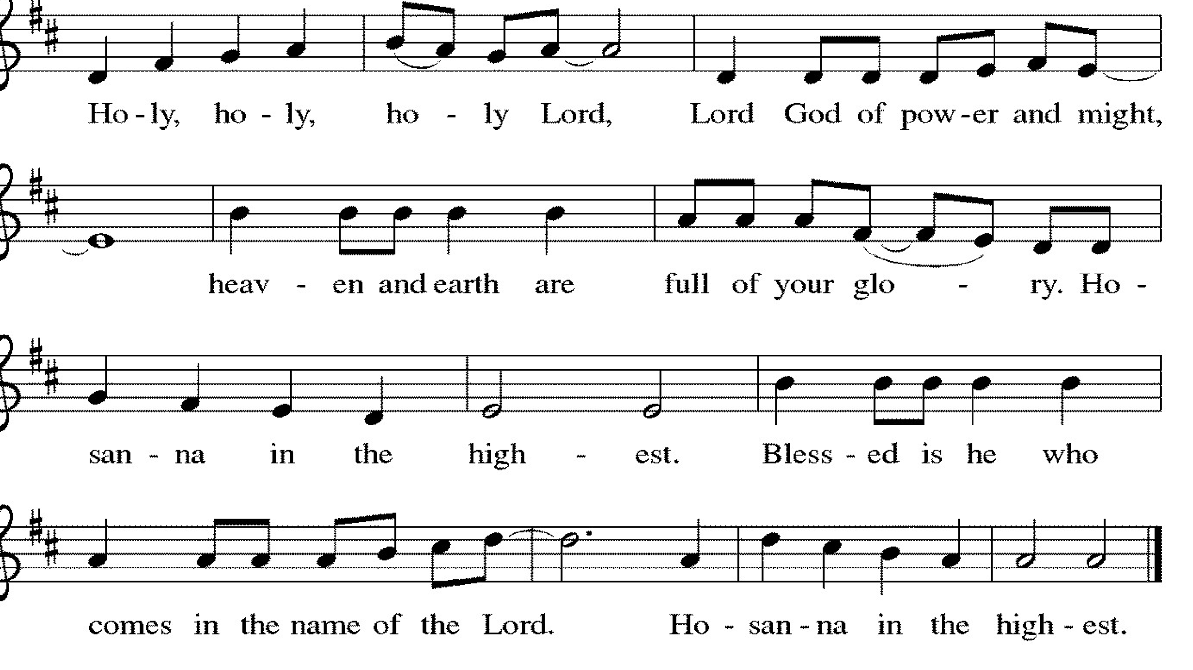

Thanksgiving at the Table

L: Holy, living and loving God,
We praise you for creating the heavens and the earth.
We give you thanks for Jesus who, living among us,
Healed the sick, fed the hungry, and with a love stronger
Than death, gave his life for others.

In the night in which he was betrayed,
our Lord Jesus took bread, and gave thanks;
broke it, and gave it to his disciples, saying:
Take and eat; this is my body, given for you.
Do this for the remembrance of me.

Again, after supper, he took the cup, gave thanks,
and gave it for all to drink, saying:
This cup is the new covenant in my blood,
shed for you and for all people for the forgiveness of sin.
Do this for the remembrance of me.

Remembering, therefore, his life-
Giving death and glorious resurrection,
We await your promised life for all this
Dying world. Breathe your Spirit on us
And on this bread and cup:
Carry us in your arms from death to life,
That we may live as your chosen ones,
Clothed in the righteousness of Christ.

A: Through him all glory and honor is yours,
Almighty Father, with the Holy Spirit,
In your holy church, both now and forever.
Amen.

Lord’s Prayer

L: Gathered into one by the Holy Spirit, let us pray as Jesus taught us,
A: Our Father, who art in heaven, hallowed be thy name, thy kingdom come, thy will be done, on earth as it is in heaven. Give us this day our daily bread; and forgive us our trespasses, as we forgive those who trespass against us; and lead us not into temptation but deliver us from evil. For thine is the kingdom and the power, and the glory, forever and ever. Amen.

Invitation to Communion

L: Come and taste the joy of God!

Communion- Music Video “Who You Are To Me ” by Chris Tomlin and Lady A

Prayer after Communion

L: Holy One,
we thank you for the healing
that springs forth abundantly from this table.
Renew our strength to do justice,
love kindness,
and journey humbly with you.
A: Amen.

SENT FOR WORK AND WITNESS

Blessing

L: The God who faithfully brings forth justice
and breaks the oppressor’s rod
☩ bless, strengthen, and uphold you,
today and always.
A: Amen

Sending Hymn “Christ Be our Light” (vs. 1, 2 & 5) ELW 715

Dismissal

L: Go in peace. Follow the way of Jesus.
A: Thanks be to God.

Postlude

Licensing information for this Worship Service:
CCLI Copyright License A 2440181 5/31/23 + Streaming Plus License A 211196712 5/31/23
Sundays and Seasons License Sundays and Seasons v.20200325.1254

Worship Participants

Presiding Minister: SAM Marcia Buchs
Worship Steward: Brad Solberg
Greeter: Sara Solberg
Musician: Julie Mehlberg
Lector: Sara Solberg
Usher: Ted Bauknecht
Communion Prep: Pat Lund
Comm. Asst: Brad & Sara Solberg
Livestream: Louis Kehinde
Hospitality: Gail Thorson
Counters: Carrie Lueker & Marvin Miller

