St. Paul Lutheran Church, ELCA

Pontiac, IL
January 8, 2023
Baptism of our Lord

“Red bag offering will be collected and donated to “Vision for Mission”
Introduction
In the waters of the Jordan, Jesus is revealed as the beloved Son of God. Through this great epiphany, Jesus fulfills all righteousness and becomes the servant of God who will bring forth justice and be a light to the nations. In the waters of baptism we too are washed by the Word, anointed by the Spirit, and named God’s beloved children. Our baptismal mission is to proclaim good news to all who are oppressed or in need of God’s healing.

Prelude

Welcome

Announcements

Gathering Hymns “Here I Am to Worship” words only

Verse Refrain
Light of the world, You stepped down into darkness Here I am to worship, here I am to bow
Opened my eyes, let me see. down,
Beauty that made this heart adore You, Here I am to say that You’re my God.
hope of a life spent with You. You’re altogether lovely, altogether worthy,
Altogether wonderful to me.
Refrain Tag
Here I am to worship, here I am to bow down, And I’ll never know how much it cost to see
Here I am to say that You’re my God. my sin upon that cross.
You’re altogether lovely, altogether worthy, And I’ll never know how much it cost to see
Altogether wonderful to me. my sin upon that cross.
Verse Refrain
King of all days, oh so highly exalted, Here I am to worship, here I am to bow
Glorious in heaven above. down,
Humbly You came to the earth You created, Here I am to say that You’re my God.
All for love’s sake became poor You’re altogether lovely, altogether worthy,
Altogether wonderful to me.

“Of the Father’s Love Begotten” ELW 295

Confession and Forgiveness

All may make the sign of the cross, the sign marked at baptism, as the presiding minister begins.

L: Blessed be the holy Trinity, ☩ one God,
Who make all things new,
Whose mercy endures forever.
A: Amen.

L: Trusting in God’s mercy, let us confess our sin.

Silence is kept for reflection.

L: Holy One, source of our renewal,
we confess that we are wrapped up in sin,
and cannot free ourselves.
We have not practiced your righteousness.
Our hearts have turned away from you.
For the sake of the world you so love,
forgive us,
that we may be reconciled to one another
for the glory of your holy name.
Amen.

L: Thus says our God:
“The former things have come to pass
and new things I now declare.”
God’s mercy makes us new.
We are forgiven in the name of ☩ Christ our Savior.
Amen.

Greeting

L: The grace of our Lord Jesus Christ, the love of God, and the communion of the
Holy Spirit be with you all.
A: And also with you.

Prayer of the Day

L: O God our Father, at the baptism of Jesus you proclaimed him your beloved Son and anointed him with the Holy Spirit. Make all who are baptized into Christ faithful to their calling to be your daughters and sons, and empower us all with your Spirit, through Jesus Christ, our Savior and Lord, who lives and reigns with you and the Holy Spirit, one God, now and forever.
Amen.

Children’s Message-Dismissal to Children’s Chapel

HEARING THE WORD OF GOD

First Reading- Numbers 6: 22-27

L: A reading from Numbers.

¹Here is my servant, whom I uphold,
my chosen, in whom my soul delights;
I have put my spirit upon him;
he will bring forth justice to the nations.
²He will not cry or lift up his voice,
or make it heard in the street;
³a bruised reed he will not break,
and a dimly burning wick he will not quench;
he will faithfully bring forth justice.
⁴He will not grow faint or be crushed
until he has established justice in the earth;
and the coastlands wait for his teaching.
⁵Thus says God, the Lord,
who created the heavens and stretched them out,
who spread out the earth and what comes from it,
who gives breath to the people upon it
and spirit to those who walk in it:
⁶I am the Lord, I have called you in righteousness,
I have taken you by the hand and kept you;
I have given you as a covenant to the people,
a light to the nations,
⁷to open the eyes that are blind,
to bring out the prisoners from the dungeon,
from the prison those who sit in darkness.
⁸I am the Lord, that is my name;
my glory I give to no other,
nor my praise to idols.
⁹See, the former things have come to pass,
and new things I now declare;
before they spring forth,
I tell you of them.

L: Word of God, word of life.
A: Thanks be to God.

Psalm 29

L: A reading from Psalm.

¹Ascribe to the Lord, you gods,
ascribe to the Lord glory and strength.
²Ascribe to the Lord the glory due God’s name;
worship the Lord in the beauty of holiness.
³The voice of the Lord is upon the waters; the God of glory thunders;
the Lord is upon the mighty waters.
⁴The voice of the Lord is a powerful voice;
the voice of the Lord is a voice of splendor.
⁵The voice of the Lord breaks the cedar trees;
the Lord breaks the cedars of Lebanon;
⁶the Lord makes Lebanon skip like a calf,
and Mount Hermon like a young wild ox.
⁷The voice of the Lord
bursts forth in lightning flashes.
⁸The voice of the Lord shakes the wilderness;
the Lord shakes the wilderness of Kadesh.
⁹The voice of the Lord makes the oak trees writhe and strips the forests bare.
And in the temple of the Lord all are crying, “Glory!”
¹⁰The Lord sits enthroned above the flood;
the Lord sits enthroned as king forevermore.
¹¹O Lord, give strength to your people;
give them, O Lord, the blessings of peace.

L: Holy wisdom; Holy Word.
A: Thanks be to God.
Second Reading – Acts 10: 34-43

L: A reading from Acts.

³⁴Peter began to speak to [Cornelius and his household]: “I truly understand that God shows no partiality, ³⁵but in every nation anyone who fears him and does what is right is acceptable to him. ³⁶You know the message he sent to the people of Israel, preaching peace by Jesus Christ—he is Lord of all. ³⁷That message spread throughout Judea, beginning in Galilee after the baptism that John announced: ³⁸how God anointed Jesus of Nazareth with the Holy Spirit and with power; how he went about doing good and healing all who were oppressed by the devil, for God was with him. ³⁹We are witnesses to all that he did both in Judea and in Jerusalem. They put him to death by hanging him on a tree; ⁴⁰but God raised him on the third day and allowed him to appear, ⁴¹not to all the people but to us who were chosen by God as witnesses, and who ate and drank with him after he rose from the dead. ⁴²He commanded us to preach to the people and to testify that he is the one ordained by God as judge of the living and the dead. ⁴³All the prophets testify about him that everyone who believes in him receives forgiveness of sins through his name.”

L: Word of God, word of life.
A: Thanks be to God.

Please rise, as you are able, for the reading of the Holy Gospel.

Gospel Acclamation

Gospel- Matthew 3: 13-17

L: The Holy Gospel according to Matthew.
A: Glory to you, O Lord.

¹³Then Jesus came from Galilee to John at the Jordan, to be baptized by him. ¹⁴John would have prevented him, saying, “I need to be baptized by you, and do you come to me?” ¹⁵But Jesus answered him, “Let it be so now; for it is proper for us in this way to fulfill all righteousness.” Then he consented. ¹⁶And when Jesus had been baptized, just as he came up from the water, suddenly the heavens were opened to him and he saw the Spirit of God descending like a dove and alighting on him. ¹⁷And a voice from heaven said, “This is my Son, the Beloved, with whom I am well pleased.”

L: The gospel of the Lord.
A: Praise to you, O Christ.

Sermon Pastor Wayne Shelksohn

Hymn of the Day “On Jordan’s Bank the Baptists Cry” ELW 249

Apostle’s Creed

I believe in God, the Father almighty,
creator of heaven and earth.
I believe in Jesus Christ, God’s only Son, our Lord,
who was conceived by the Holy Spirit,
born of the virgin Mary,
suffered under Pontius Pilate,
was crucified, died, and was buried;
he descended to the dead.
On the third day he rose again;
he ascended into heaven,
he is seated at the right hand of the Father,
and he will come to judge the living and the dead.
I believe in the Holy Spirit,
the holy catholic church,
the communion of saints,
the forgiveness of sins,
the resurrection of the body,
and the life everlasting. Amen.

Prayers of Intercession

Each petition will end “Merciful God,” and the congregation will respond “receive our prayer.”

Sharing the Peace

L: The peace of Christ be with you always.
A: And also with you.

You are invited to share a sign of God’s peace with your neighbors by turning to the people near you saying, “Peace be with you.”

Offering

Offerings can also be sent by mail or given online. You can send a check to St. Paul Lutheran Church 210 Deerfield Rd Pontiac, IL 61764 or give online at stpaulpontiac.org

Offering “Special Music”

Offering Prayer

L: Liberating God,
you break the bonds of injustice
and let the oppressed go free.
Receive these offerings in thanksgiving
for all your works of merciful power,
and shape us as people of your justice and freedom.
You we magnify and adore, through Jesus our Savior,
A: Amen.

MEAL

All are welcome at Christ’s table.
Communion is distributed in front of the altar. The prepackaged cups are juice. If you prefer not to receive communion you may come forward with your hands crossed over your chest to receive a blessing or you may remain in your seat.

Great Thanksgiving

L: The Lord be with you.
A: And also with you.

L: Lift up your hearts.
A: We lift them to the Lord.

L: Let us give thanks to the Lord our God.
A: It is right to give our thanks and praise.

Preface

L: It is indeed right, our duty and our joy,
that we should at all times and in all places
offer thanks and praise to you, O Lord,
holy Father, almighty and ever living God.
But chiefly we are bound to praise you for the glorious
Resurrection of our Lord; for he is the true Passover Lamb
Who gave himself to take away our sin,
Who by his death has destroyed death;
And by his rising has brought us to eternal life.
And so with Mary Magdalene and Peter and
All the witnesses of the resurrection,
With earth and sea and all their
Creatures, and with angels and archangels,
Cherubim and seraphim,
We praise your name and join their unending hymn:

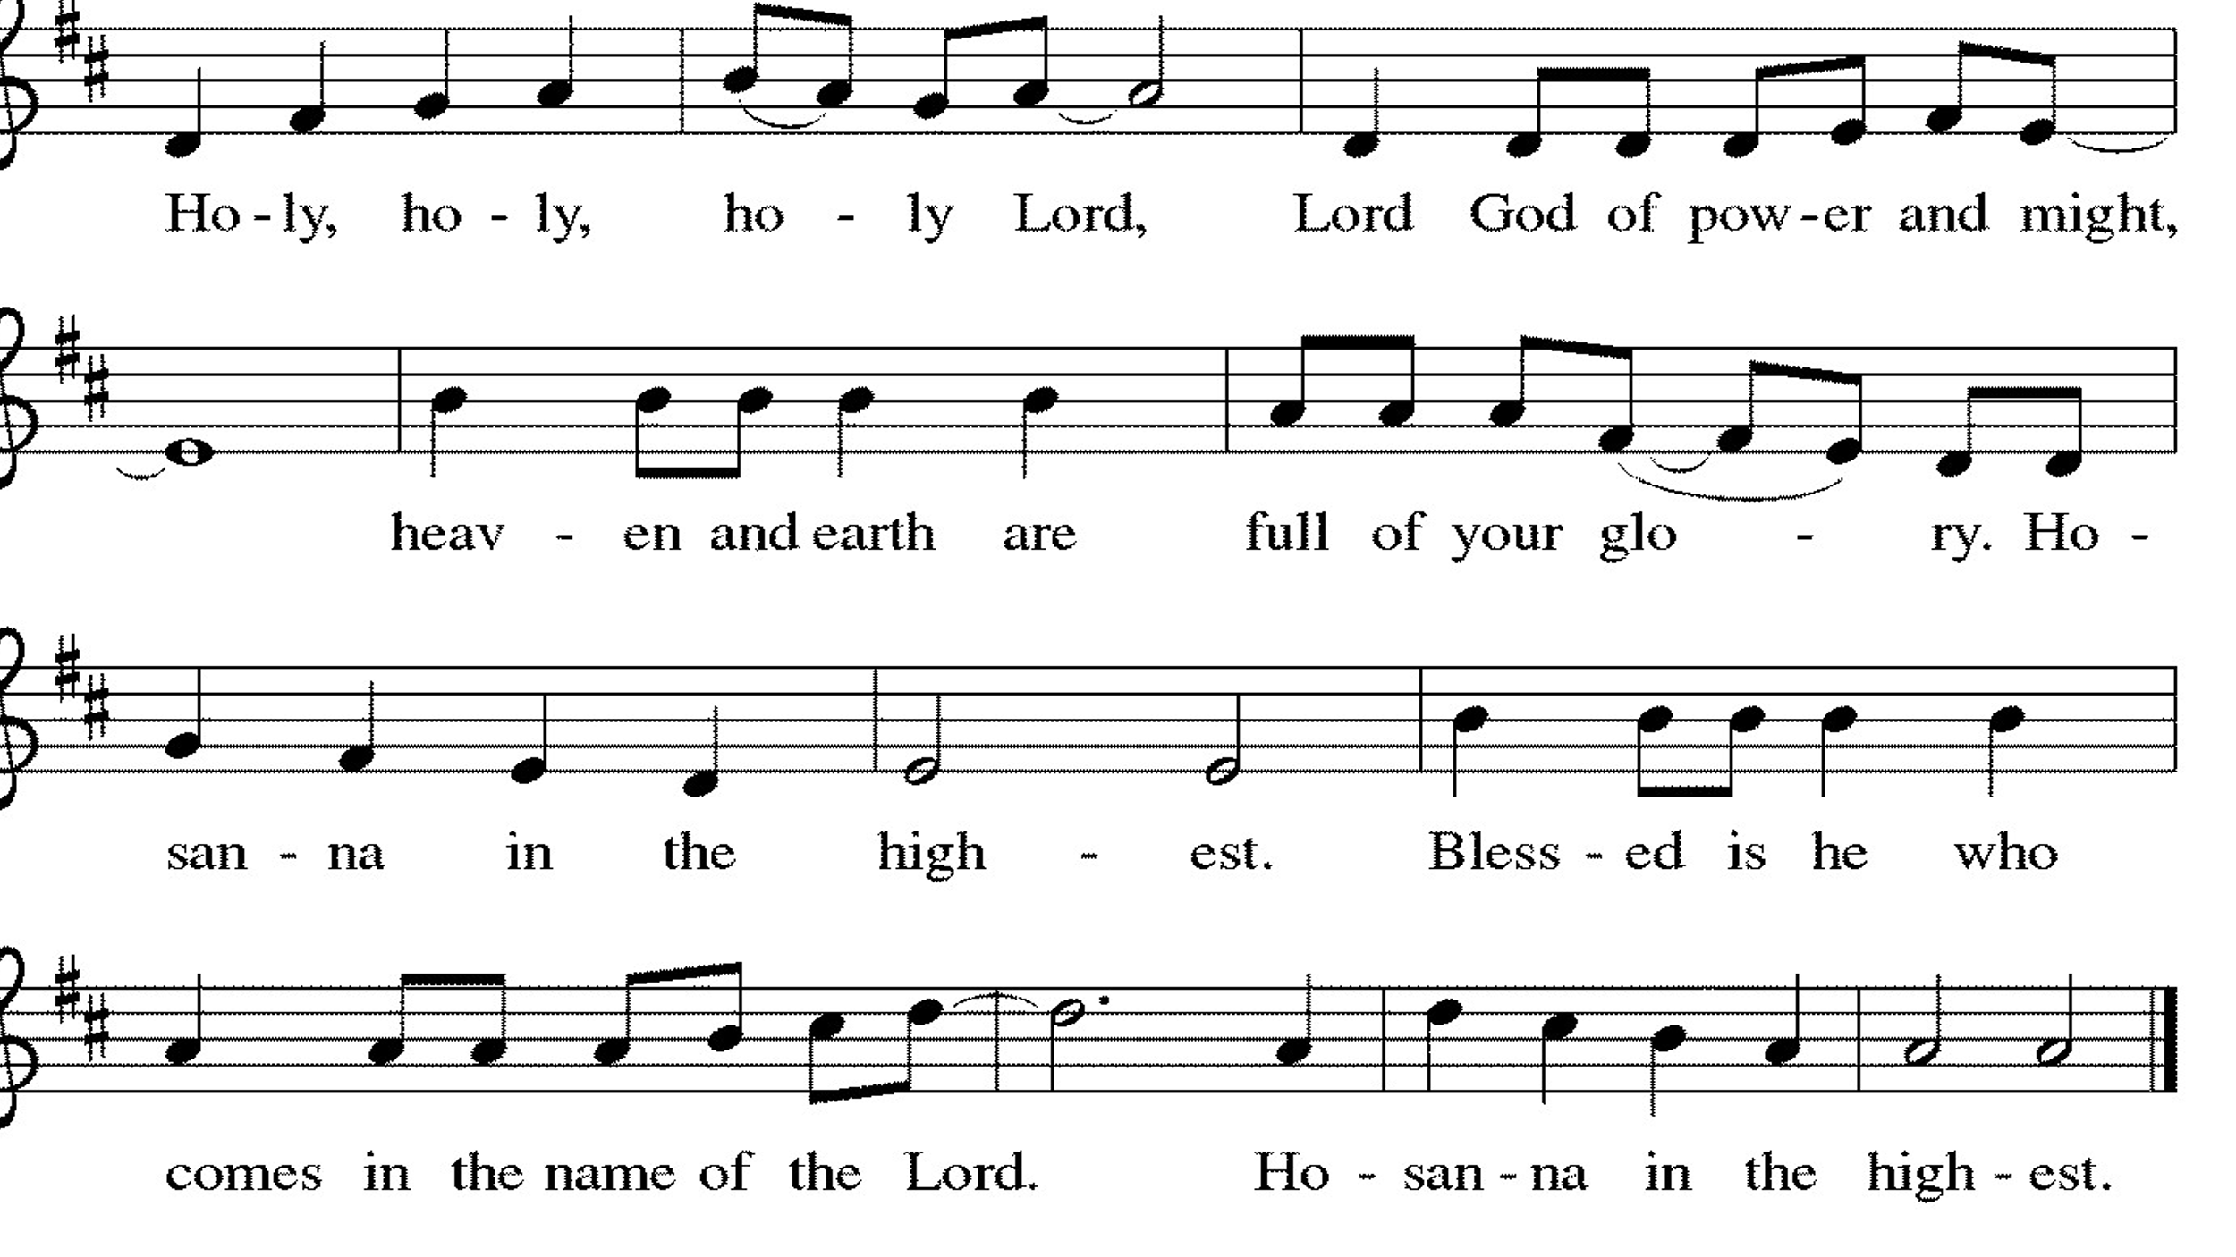

Thanksgiving at the Table

L: Holy, living and loving God,
We praise you for creating the heavens and the earth.
We give you thanks for Jesus who, living among us,
Healed the sick, fed the hungry, and with a love stronger
Than death, gave his life for others.

In the night in which he was betrayed,
our Lord Jesus took bread, and gave thanks;
broke it, and gave it to his disciples, saying:
Take and eat; this is my body, given for you.
Do this for the remembrance of me.

Again, after supper, he took the cup, gave thanks,
and gave it for all to drink, saying:
This cup is the new covenant in my blood,
shed for you and for all people for the forgiveness of sin.
Do this for the remembrance of me.

Remembering, therefore, his life-
Giving death and glorious resurrection,
We await your promised life for all this
Dying world. Breathe your Spirit on us
And on this bread and cup:
Carry us in your arms from death to life,
That we may live as your chosen ones,
Clothed in the righteousness of Christ.

A: Through him all glory and honor is yours,
Almighty Father, with the Holy Spirit,
In your holy church, both now and forever.
Amen.

Lord’s Prayer

L: Gathered into one by the Holy Spirit, let us pray as Jesus taught us,
A: Our Father, who art in heaven, hallowed be thy name, thy kingdom come, thy will be done, on earth as it is in heaven. Give us this day our daily bread; and forgive us our trespasses, as we forgive those who trespass against us; and lead us not into temptation but deliver us from evil. For thine is the kingdom and the power, and the glory, forever and ever. Amen.

Invitation to Communion

L: Come and taste the joy of God!

Communion- Music Video “Peace on Earth ” by Casting Crowns

Prayer after Communion

L: Holy One,
we thank you for the healing
that springs forth abundantly from this table.
Renew our strength to do justice,
love kindness,
and journey humbly with you.
A: Amen.

SENT FOR WORK AND WITNESS

Blessing

L: The God who faithfully brings forth justice
and breaks the oppressor’s rod
☩ bless, strengthen, and uphold you,
today and always.
A: Amen

Sending Hymn “Lord, I Lift Your Name on High” ELW 857

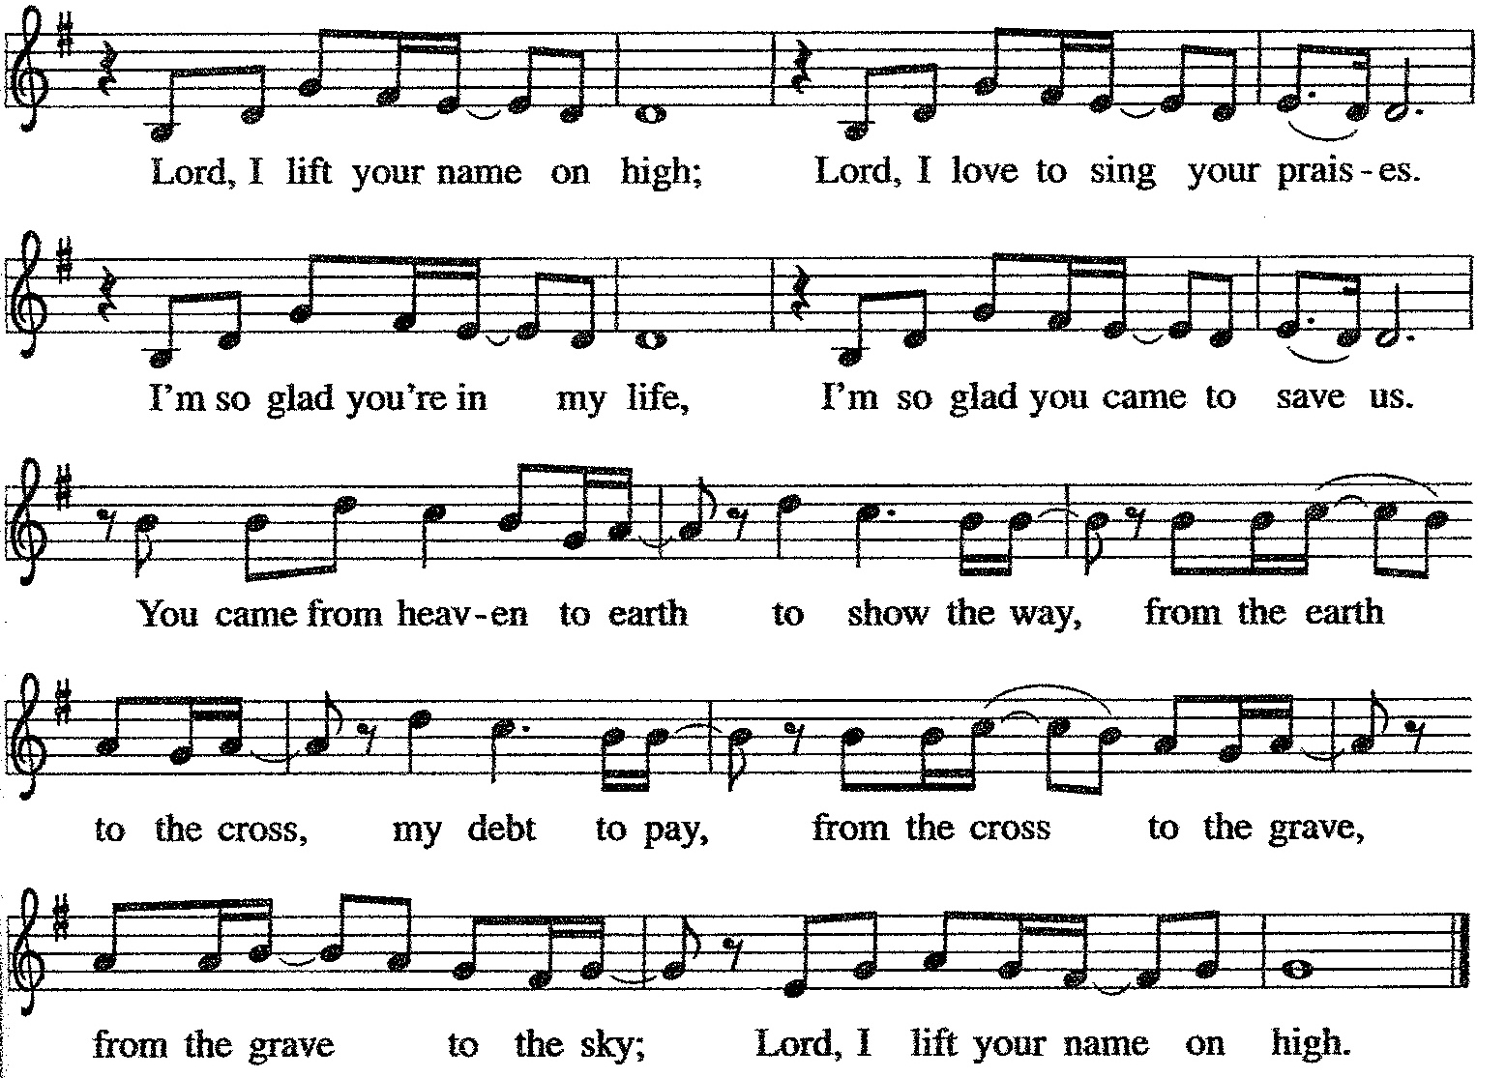

Dismissal

L: Go in peace. Follow the way of Jesus.
A: Thanks be to God.

Postlude

Licensing information for this Worship Service:
CCLI Copyright License A 2440181 5/31/23 + Streaming Plus License A 211196712 5/31/23
Sundays and Seasons License Sundays and Seasons v.20200325.1254

Worship Participants

Presiding Minister: Pastor Wayne Shelksohn
Worship Steward: Pat Lund
Greeter: Shelly Heller
Musician: Sandy Erickson
Lector: Nathan Joerndt
Usher: Mark Mackinson
Communion Prep: Jean Harrison & Mark Mackinson
Comm. Asst: Denny & Mary Leach
Livestream: Louis Kehinde
Hospitality: Sara Solberg & Pat Lund
Counters: Cody Leach & Jake Dixon

