St. Paul Lutheran Church, ELCA

Pontiac, IL
July 31, 2022

8th Sunday after Pentecost

Introduction
Today’s texts offer instruction and encouragement for all who are occasionally overwhelmed by the “unhappy business” of life. Jesus urges us to take care and be on guard against all kinds of greed. We who have died with Christ in holy baptism have also been raised with him and are encouraged to elevate our thinking, seeking the “things that are above.” To that end we seek the sustenance of the Lord’s supper and the encouragement of God’s word.

Prelude

Welcome

Announcements

Gathering Hymns “Here I am to Worship”

Verse
Light of the world, You stepped down into darkness
Opened my eyes, let me see.
Beauty that made this heart adore You,
hope of a life spent with You.
Refrain
Here I am to worship, here I am to bow down,
Here I am to say that You’re my God.
You’re altogether lovely, altogether worthy,
Altogether wonderful to me.
Verse
King of all days, oh so highly exalted,
Glorious in heaven above.
Humbly You came to the earth You created,
All for love’s sake became poor

Refrain
Here I am to worship, here I am to bow down,
Here I am to say that You’re my God.
You’re altogether lovely, altogether worthy,
Altogether wonderful to me.
Tag
And I’ll never know how much it cost to see my sin upon that cross.
And I’ll never know how much it cost to see my sin upon that cross.
Refrain
Here I am to worship, here I am to bow down,
Here I am to say that You’re my God.
You’re altogether lovely, altogether worthy,
Altogether wonderful to me.

“Be Thou My Vision” ELW 793

Confession and Forgiveness

All may make the sign of the cross, the sign marked at baptism, as the presiding minister begins.

L: Blessed be the Holy Trinity, ☩ one God, whose steadfast love endures forever.
A: Amen.

Let us confess our sin in the presence of God and of one another.

Silence is kept for reflection.

L: Merciful God,
we confess that we have not followed your path
but have chosen our own way.
instead of putting others before ourselves,
we long to take the best seats at the table.
when met by those in need,
we have too often passed by on the other side.
Set us again on the path of life.
Save us from ourselves
and free us to love our neighbors.
Amen.

L: Hear the good news!
God does not deal with us according to our sins
but delights in granting pardon and mercy.
In the name of ☩ Jesus Christ, your sins are forgiven.
You are free to love as God loves.
A: Amen.

Greeting

L: Alleluia! Christ is risen!
A: Christ is risen indeed! Alleluia

L: The grace of our Lord Jesus Christ, the love of God, and the communion of the
Holy Spirit be with you all.
A: And also with you.

Prayer of the Day

L: Benevolent God, you are the source, the guide, and the goal of our lives. Teach us to love what is worth loving to reject what is offensive to you, and to treasure what is precious in your sight, through Jesus Christ, our Savior and Lord.
Amen.

Children’s Message

HEARING THE WORD OF GOD

First Reading-Ecclesiastes 1: 2, 12-14, 18-23

L: A reading from Ecclesiastes.

¹²I, the Teacher, when king over Israel in Jerusalem, ¹³applied my mind to seek and to search out by wisdom all that is done under heaven; it is an unhappy business that God has given to human beings to be busy with. ¹⁴I saw all the deeds that are done under the sun; and see, all is vanity and a chasing after wind.
^{2:18}I hated all my toil in which I had toiled under the sun, seeing that I must leave it to those who come after me ¹⁹—and who knows whether they will be wise or foolish? Yet they will be master of all for which I toiled and used my wisdom under the sun. This also is vanity. ²⁰So I turned and gave my heart up to despair concerning all the toil of my labors under the sun, ²¹because sometimes one who has toiled with wisdom and knowledge and skill must leave all to be enjoyed by another who did not toil for it. This also is vanity and a great evil. ²²What do mortals get from all the toil and strain with which they toil under the sun? ²³For all their days are full of pain, and their work is a vexation; even at night their minds do not rest. This also is vanity.

L: Word of God, word of life.
A: Thanks be to God.
________________________________________________________________________________

Psalm 49: 1-12

L: A reading from Psalm.

¹Hear this, all you peoples;
give ear, all you who dwell in the world,
²you of high degree and low,
rich and poor together.
³My mouth shall speak of wisdom,
and my heart shall meditate on understanding.
⁴I will incline my ear to a proverb
and set forth my riddle upon the harp.
⁵Why should I be afraid in evil days,
when the wickedness of those at my heels surrounds me,
⁶the wickedness of those who put their trust in their own prowess,
and boast of their great riches?
⁷One can never redeem another,
or give to God the ransom for another’s life;
⁸for the ransom of a life is so great
that there would never be enough to pay it,
⁹in order to live forever and ever
and never see the grave.
¹⁰For we see that the wise die also; like the dull and stupid they perish
and leave their wealth to those who come after them.
¹¹Their graves shall be their homes forever, their dwelling places from generation to generation,
though they had named lands after themselves.
¹²Even though honored, they cannot live forever;
they are like the beasts that perish.

L: Holy wisdom; Holy Word.
A: Thanks be to God.

Second Reading – Colossians 3: 1-11

L: A reading from Colossians.

¹So if you have been raised with Christ, seek the things that are above, where Christ is, seated at the right hand of God. ²Set your minds on things that are above, not on things that are on earth, ³for you have died, and your life is hidden with Christ in God. ⁴When Christ who is your life is revealed, then you also will be revealed with him in glory.
⁵Put to death, therefore, whatever in you is earthly: fornication, impurity, passion, evil desire, and greed (which is idolatry). ⁶On account of these the wrath of God is coming on those who are disobedient. ⁷These are the ways you also once followed, when you were living that life. ⁸But now you must get rid of all such things—anger, wrath, malice, slander, and abusive language from your mouth. ⁹Do not lie to one another, seeing that you have stripped off the old self with its practices ¹⁰and have clothed yourselves with the new self, which is being renewed in knowledge according to the image of its creator. ¹¹In that renewal there is no longer Greek and Jew, circumcised and uncircumcised, barbarian, Scythian, slave and free; but Christ is all and in all!

L: Word of God, word of life.
A: Thanks be to God.

Please rise, as you are able, for the reading of the Holy Gospel.

Gospel Acclamation Halle, Halle, Hallelujah

Gospel- Luke 12: 13-21

L: The Holy Gospel according to Luke.
A: Glory to you, O Lord.

¹³Someone in the crowd said to [Jesus,] “Teacher, tell my brother to divide the family inheritance with me.” ¹⁴But he said to him, “Friend, who set me to be a judge or arbitrator over you?” ¹⁵And he said to them, “Take care! Be on your guard against all kinds of greed; for one’s life does not consist in the abundance of possessions.” ¹⁶Then he told them a parable: “The land of a rich man produced abundantly. ¹⁷And he thought to himself, ‘What should I do, for I have no place to store my crops?’ ¹⁸Then he said, ‘I will do this: I will pull down my barns and build larger ones, and there I will store all my grain and my goods. ¹⁹And I will say to my soul, Soul, you have ample goods laid up for many years; relax, eat, drink, be merry.’ ²⁰But God said to him, ‘You fool! This very night your life is being demanded of you. And the things you have prepared, whose will they be?’ ²¹So it is with those who store up treasures for themselves but are not rich toward God.”

L: The gospel of the Lord.
A: Praise to you, O Christ.

Sermon SAM Marcia Buchs

Hymn of the Day “All Depends on Our Possessing” ELW 589

Apostle’s Creed
I believe in God, the Father almighty,
creator of heaven and earth.
I believe in Jesus Christ, God’s only Son, our Lord,
who was conceived by the Holy Spirit,
born of the virgin Mary,
suffered under Pontius Pilate,
was crucified, died, and was buried;
he descended to the dead.
On the third day he rose again;
he ascended into heaven,
he is seated at the right hand of the Father,
and he will come to judge the living and the dead.
I believe in the Holy Spirit,
the holy catholic church,
the communion of saints,
the forgiveness of sins,
the resurrection of the body,
and the life everlasting. Amen.

Prayers of Intercession

Each petition will end “Merciful God,” and the congregation will respond “receive our prayer.”

Sharing the Peace

L: The peace of Christ be with you always.
A: And also with you.

You are invited to share a sign of God’s peace with your neighbors by turning to the people near you saying, “Peace be with you.”

Offering

Offerings can also be sent by mail or given online. You can send a check to St. Paul Lutheran Church 210 Deerfield Rd Pontiac, IL 61764 or give online at stpaulpontiac.org

Offering Special Music

Offering Prayer

L: God of abundance;
you have set before us a plentiful harvest.
As we feast on your goodness,
strengthen us to labor in your field,
and equip us to bear fruit for the good of all,
in the name of Jesus.
A: Amen.
MEAL

All are welcome at Christ’s table.
Communion is distributed in front of the altar. The individual cups are filled with wine. The prepackaged cups are juice. If you prefer not to receive communion you may come forward with your hands crossed over your chest to receive a blessing or you may remain in your seat.

Great Thanksgiving

L: The Lord be with you.
A: And also with you.

L: Lift up your hearts.
A: We lift them to the Lord.

L: Let us give thanks to the Lord our God.
A: It is right to give our thanks and praise.

Preface

L: It is indeed right, our duty and our joy,
that we should at all times and in all places
offer thanks and praise to you, O Lord,
holy Father, almighty and ever living God.
But chiefly we are bound to praise you for the glorious
Resurrection of our Lord; for he is the true Passover Lamb
Who gave himself to take away our sin,
Who by his death has destroyed death;
And by his rising has brought us to eternal life.
And so with Mary Magdalene and Peter and
All the witnesses of the resurrection,
With earth and sea and all their
Creatures, and with angels and archangels,
Cherubim and seraphim,
We praise your name and join their unending hymn:

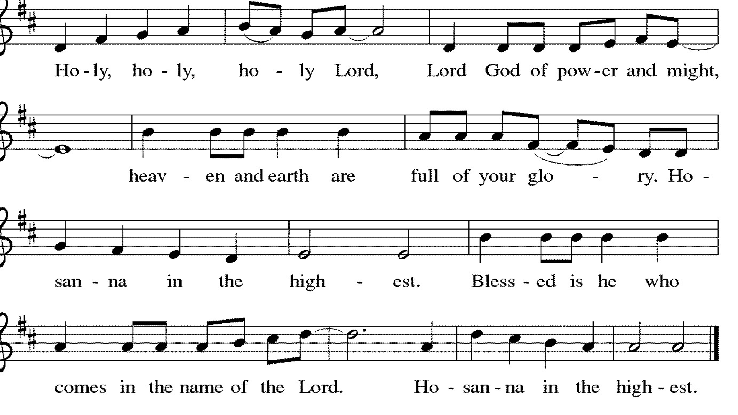

Thanksgiving at the Table

L: Holy, living and loving God,
We praise you for creating the heavens and the earth.
We give you thanks for Jesus who, living among us,
Healed the sick, fed the hungry, and with a love stronger
Than death, gave his life for others.

In the night in which he was betrayed,
our Lord Jesus took bread, and gave thanks;
broke it, and gave it to his disciples, saying:
Take and eat; this is my body, given for you.
Do this for the remembrance of me.

Again, after supper, he took the cup, gave thanks,
and gave it for all to drink, saying:
This cup is the new covenant in my blood,
shed for you and for all people for the forgiveness of sin.
Do this for the remembrance of me.

Remembering, therefore, his life-
Giving death and glorious resurrection,
We await your promised life for all this
Dying world. Breathe your Spirit on us
And on this bread and cup:
Carry us in your arms from death to life,
That we may live as your chosen ones,
Clothed in the righteousness of Christ.

A: Through him all glory and honor is yours,
Almighty Father, with the Holy Spirit,
In your holy church, both now and forever.
Amen.

Lord's Prayer

L: Gathered into one by the Holy Spirit, let us pray as Jesus taught us,
A: Our Father, who art in heaven, hallowed be thy name, thy kingdom come, thy will be done, on earth as it is in heaven. Give us this day our daily bread; and forgive us our trespasses, as we forgive those who trespass against us; and lead us not into temptation but deliver us from evil. For thine is the kingdom and the power, and the glory, forever and ever. Amen.

Invitation to Communion

L: In Christ’s presence there is fullness of joy. Come to the banquet.

Communion- Music Video “Me on Your Mind” by Matthew West

Prayer after Communion

L: Life-giving God,
through this meal you have bandaged our wounds
and fed us with your mercy.
Now send us forth to live for others,
both friend and stranger,
that all may come to know your love.
This we pray in the name of Jesus.

A: Amen.

SENT FOR WORK AND WITNESS

Blessing

L: The God of peace,
Father, ☩ Son, and Holy Spirit,
bless you, comfort you,
and show you the path of life
this day and always.
A: Amen

Sending Hymn “We are Marching in the Light of God” ELW 866

Dismissal

L: Go in peace. Love your neighbor.
A: Thanks be to God.

Postlude

Licensing information for this Worship Service:
CCLI Copyright License A 2440181 9/30/2021 + Streaming License A 20530290 5/31/2022
Sundays and Seasons License Sundays and Seasons v.20200325.1254

Worship Participants

Presiding Minister: SAM Marcia Buchs
Worship Steward: Brad Solberg
Musician: Sara Solberg
Lector: Judy Sykes
Usher: Mark Mackinson
Communion Prep: Sara Solberg
Comm. Asst: Nathan Joerndt & Marvin Miller
Livestream: Louis Kehinde
Hospitality: Julie Mehlberg & Emma Rapp
Counters: Jean Harrison & Marty Heller

