St. Paul Lutheran Church, ELCA

Pontiac, IL
July 3, 2022

4th Sunday after Pentecost

Flowers on the altar this week were donated by Sandy Erickson in memory of loved ones.
Introduction

God is the source of our nourishment. Jesus’ invitation to “take and eat . . . take and drink” is a repeated one. In holy communion, in the word read and proclaimed, in the assembly of the people of God, the dominion of God has come near. Rejoice! Your name is written in heaven.

Prelude

Welcome

Announcements

Gathering Hymns My Life is in You, Lord”

My life is in You, Lord, My strength is in You, Lord,
My hope is in You, Lord, In you, it’s in You.

My life is in You, Lord, My strength is in You, Lord,
My hope is in You, Lord, In You, it’s in You.

I will praise You with all of my life, I will praise You with all of my strength.
With all of my life, with all of my strength, All of my hope is in You!

My life is in You, Lord, My strength is in You, Lord,
My Hope is in You, Lord, In you, it’s in You.

My life is in You, Lord, My strength is in You, Lord,
My hope is in You, Lord, In You, it’s in You.

I will praise You with all of my life, I will praise You with all of my strength.
With all of my life, with all of my strength, All of my hope is in You!

My life is in You, Lord, My strength is in You, Lord,
My Hope is in You, Lord, In you, it’s in You.

My life is in You, Lord, My strength is in You, Lord,
My hope is in You, Lord, In You, it’s in You, in You!

“Ten Thousand Reasons” ACS 1097

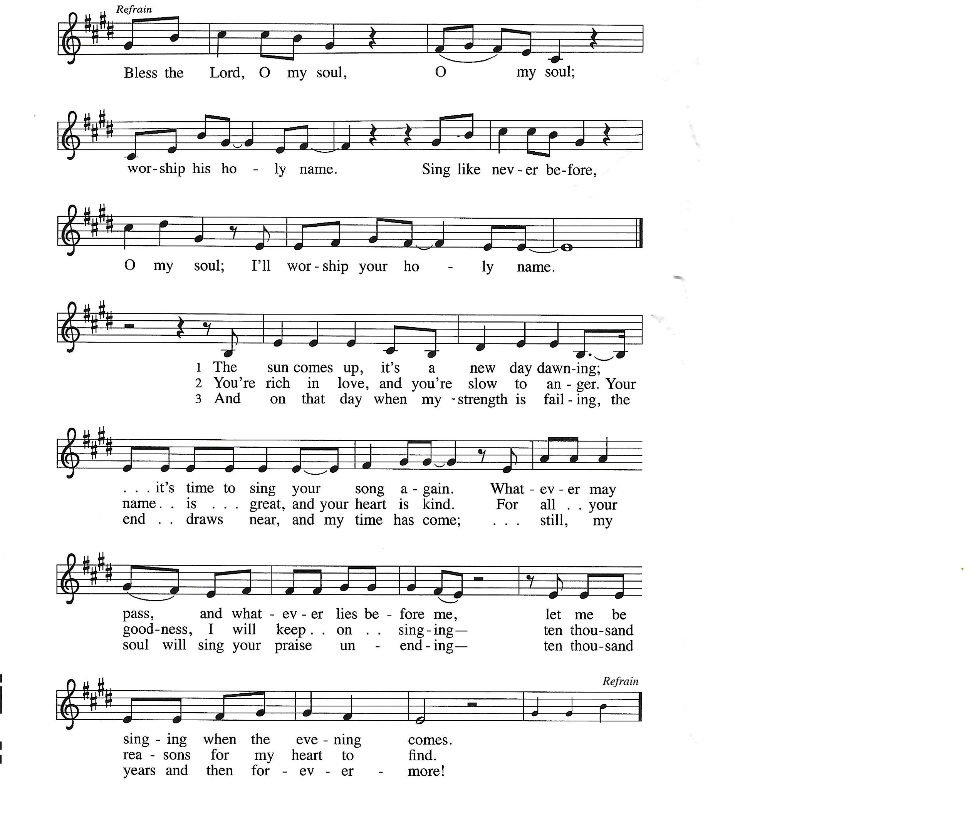

Confession and Forgiveness

All may make the sign of the cross, the sign marked at baptism, as the presiding minister begins.

L: Blessed be the Holy Trinity, ☩ one God, whose steadfast love endures forever.
A: Amen.

Let us confess our sin in the presence of God and of one another.

Silence is kept for reflection.

L: Merciful God,
we confess that we have not followed your path
but have chosen our own way.
instead of putting others before ourselves,
we long to take the best seats at the table.
when met by those in need,
we have too often passed by on the other side.
Set us again on the path of life.
Save us from ourselves
and free us to love our neighbors.
Amen.

L: Hear the good news!
God does not deal with us according to our sins
but delights in granting pardon and mercy.
In the name of ☩ Jesus Christ, your sins are forgiven.
You are free to love as God loves.
A: Amen.

Greeting

L: Alleluia! Christ is risen!
A: Christ is risen indeed! Alleluia

L: The grace of our Lord Jesus Christ, the love of God, and the communion of the
Holy Spirit be with you all.
A: And also with you.

Prayer of the Day

L: O God, the Father of our Lord Jesus, you are the city that shelters us, the mother who comforts us. With your Spirit, accompany us on our life’s journey, that we may spread your peace in all the world, through your Son, Jesus Christ, our Savior and Lord.
Amen.

Children’s Message

HEARING THE WORD OF GOD

First Reading-Isaiah 66: 10-14

L: A reading from Isaiah.

¹⁰Rejoice with Jerusalem, and be glad for her,
all you who love her;
rejoice with her in joy,
all you who mourn over her—
¹¹that you may nurse and be satisfied
from her consoling breast;
that you may drink deeply with delight
from her glorious bosom.
¹²For thus says the Lord:
I will extend prosperity to her like a river,
and the wealth of the nations like an overflowing stream;
and you shall nurse and be carried on her arm,
and dandled on her knees.
¹³As a mother comforts her child,
so I will comfort you;
you shall be comforted in Jerusalem.
¹⁴You shall see, and your heart shall rejoice;
your bodies shall flourish like the grass;
and it shall be known that the hand of the Lord is with his servants,
and his indignation is against his enemies.

L: Word of God, word of life.
A: Thanks be to God.
________________________________________________________________________________

Psalm 66: 1-9

L: A reading from Psalm.

¹Be joyful in God, all you lands;
be joyful, all the earth.
²Sing the glory of God’s name;
sing the glory of God’s praise.
³Say to God, “How awesome are your deeds!
Because of your great strength your enemies cringe before you.
⁴All the earth bows down before you,
sings to you, sings out your name.”
⁵Come now and see the works of God,
how awesome are God’s deeds toward all people.
⁶God turned the sea into dry land, so that they went through the water on foot,
and there we rejoiced in God.
⁷Ruling forever in might, God keeps watch over the nations;
let no rebels exalt themselves.
⁸Bless our God, you peoples;
let the sound of praise be heard.
⁹Our God has kept us among the living
and has not allowed our feet to slip.

L: Holy wisdom; Holy Word.
A: Thanks be to God.

Second Reading – Galatians 6: (1-6), 7-16

L: A reading from Galatians.

[¹My friends, if anyone is detected in a transgression, you who have received the Spirit should restore such a one in a spirit of gentleness. Take care that you yourselves are not tempted. ²Bear one another’s burdens, and in this way you will fulfill the law of Christ. ³For if those who are nothing think they are something, they deceive themselves. ⁴All must test their own work; then that work, rather than their neighbor’s work, will become a cause for pride. ⁵For all must carry their own loads.
⁶Those who are taught the word must share in all good things with their teacher.]
⁷Do not be deceived; God is not mocked, for you reap whatever you sow. ⁸If you sow to your own flesh, you will reap corruption from the flesh; but if you sow to the Spirit, you will reap eternal life from the Spirit. ⁹So let us not grow weary in doing what is right, for we will reap at harvest time, if we do not give up. ¹⁰So then, whenever we have an opportunity, let us work for the good of all, and especially for those of the family of faith.
¹¹See what large letters I make when I am writing in my own hand! ¹²It is those who want to make a good showing in the flesh that try to compel you to be circumcised—only that they may not be persecuted for the cross of Christ. ¹³Even the circumcised do not themselves obey the law, but they want you to be circumcised so that they may boast about your flesh. ¹⁴May I never boast of anything except the cross of our Lord Jesus Christ, by which the world has been crucified to me, and I to the world. ¹⁵For neither circumcision nor uncircumcision is anything; but a new creation is everything! ¹⁶As for those who will follow this rule—peace be upon them, and mercy, and upon the Israel of God.

L: Word of God, word of life.
A: Thanks be to God.

Please rise, as you are able, for the reading of the Holy Gospel.

Gospel Acclamation Halle, Halle, Hallelujah

Gospel- Luke 10: 1-11, 16-20

L: The Holy Gospel according to Luke.
A: Glory to you, O Lord.

¹After this the Lord appointed seventy others and sent them on ahead of him in pairs to every town and place where he himself intended to go. ²He said to them, “The harvest is plentiful, but the laborers are few; therefore ask the Lord of the harvest to send out laborers into his harvest. ³Go on your way. See, I am sending you out like lambs into the midst of wolves. ⁴Carry no purse, no bag, no sandals; and greet no one on the road. ⁵Whatever house you enter, first say, ‘Peace to this house!’ ⁶And if anyone is there who shares in peace, your peace will rest on that person; but if not, it will return to you. ⁷Remain in the same house, eating and drinking whatever they provide, for the laborer deserves to be paid. Do not move about from house to house. ⁸Whenever you enter a town and its people welcome you, eat what is set before you; ⁹cure the sick who are there, and say to them, ‘The kingdom of God has come near to you.’ ¹⁰But whenever you enter a town and they do not welcome you, go out into its streets and say, ¹¹‘Even the dust of your town that clings to our feet, we wipe off in protest against you. Yet know this: the kingdom of God has come near.’ ”
¹⁶“Whoever listens to you listens to me, and whoever rejects you rejects me, and whoever rejects me rejects the one who sent me.”
¹⁷The seventy returned with joy, saying, “Lord, in your name even the demons submit to us!” ¹⁸He said to them, “I watched Satan fall from heaven like a flash of lightning. ¹⁹See, I have given you authority to tread on snakes and scorpions, and over all the power of the enemy; and nothing will hurt you. ²⁰Nevertheless, do not rejoice at this, that the spirits submit to you, but rejoice that your names are written in heaven.”

L: The gospel of the Lord.
A: Praise to you, O Christ.

Sermon Pastor Wayne Shelksohn

Hymn of the Day “Lift Every Voice and Sing” ELW 841

Apostle’s Creed
I believe in God, the Father almighty,
creator of heaven and earth.
I believe in Jesus Christ, God’s only Son, our Lord,
who was conceived by the Holy Spirit,
born of the virgin Mary,
suffered under Pontius Pilate,
was crucified, died, and was buried;
he descended to the dead.
On the third day he rose again;
he ascended into heaven,
he is seated at the right hand of the Father,
and he will come to judge the living and the dead.
I believe in the Holy Spirit,
the holy catholic church,
the communion of saints,
the forgiveness of sins,
the resurrection of the body,
and the life everlasting. Amen.

Prayers of Intercession

Each petition will end “God of Grace,” and the congregation will respond “Hear our prayer.”

Sharing the Peace

L: The peace of Christ be with you always.
A: And also with you.

You are invited to share a sign of God’s peace with your neighbors by turning to the people near you saying, “Peace be with you.”

Offering

Offerings can also be sent by mail or given online. You can send a check to St. Paul Lutheran Church 210 Deerfield Rd Pontiac, IL 61764 or give online at stpaulpontiac.org

Offering Special Music

Offering Prayer

L: God of abundance;
you have set before us a plentiful harvest.
As we feast on your goodness,
strengthen us to labor in your field,
and equip us to bear fruit for the good of all,
in the name of Jesus.
A: Amen.

MEAL

All are welcome at Christ’s table.
Communion is distributed in front of the altar. The individual cups are filled with wine. The prepackaged cups are juice. If you prefer not to receive communion you may come forward with your hands crossed over your chest to receive a blessing or you may remain in your seat.

Great Thanksgiving

L: The Lord be with you.
A: And also with you.

L: Lift up your hearts.
A: We lift them to the Lord.

L: Let us give thanks to the Lord our God.
A: It is right to give our thanks and praise.

Preface

L: It is indeed right, our duty and our joy,
that we should at all times and in all places
offer thanks and praise to you, O Lord,
holy Father, almighty and ever living God.
But chiefly we are bound to praise you for the glorious
Resurrection of our Lord; for he is the true Passover Lamb
Who gave himself to take away our sin,
Who by his death has destroyed death;
And by his rising has brought us to eternal life.
And so with Mary Magdalene and Peter and
All the witnesses of the resurrection,
With earth and sea and all their
Creatures, and with angels and archangels,
Cherubim and seraphim,
We praise your name and join their unending hymn:

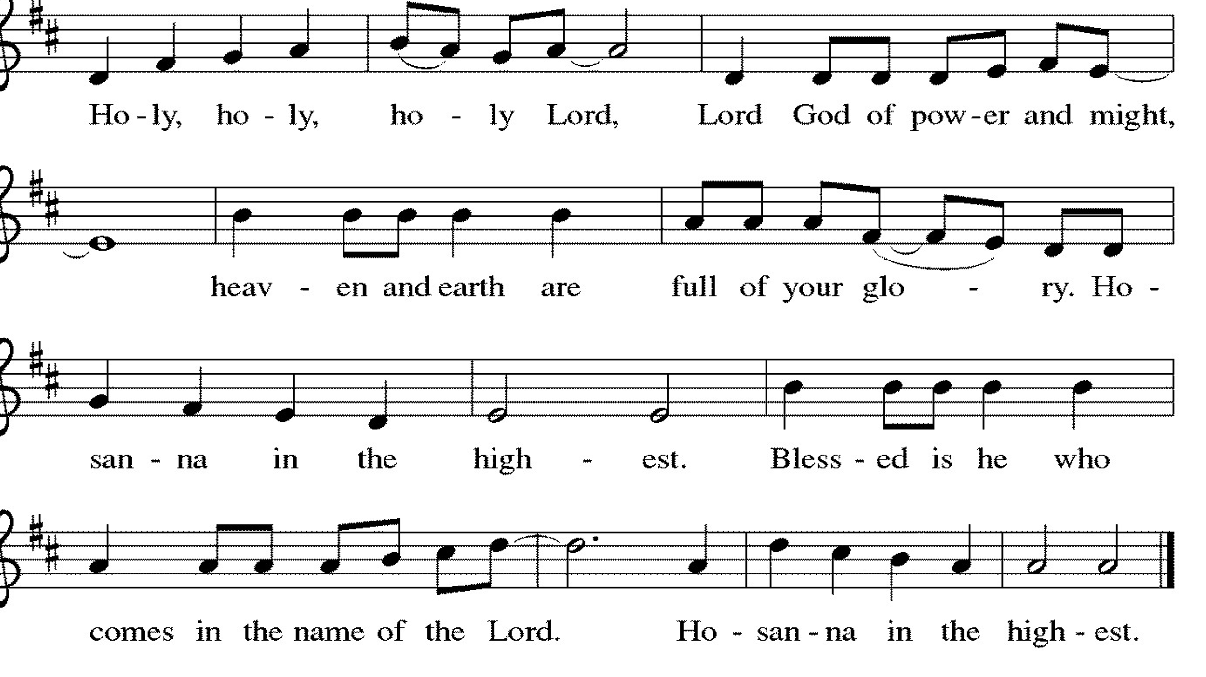

Thanksgiving at the Table

L: Holy, living and loving God,
We praise you for creating the heavens and the earth.
We give you thanks for Jesus who, living among us,
Healed the sick, fed the hungry, and with a love stronger
Than death, gave his life for others.

In the night in which he was betrayed,
our Lord Jesus took bread, and gave thanks;
broke it, and gave it to his disciples, saying:
Take and eat; this is my body, given for you.
Do this for the remembrance of me.

Again, after supper, he took the cup, gave thanks,
and gave it for all to drink, saying:
This cup is the new covenant in my blood,
shed for you and for all people for the forgiveness of sin.
Do this for the remembrance of me.

Remembering, therefore, his life-
Giving death and glorious resurrection,
We await your promised life for all this
Dying world. Breathe your Spirit on us
And on this bread and cup:
Carry us in your arms from death to life,
That we may live as your chosen ones,
Clothed in the righteousness of Christ.

A: Through him all glory and honor is yours,
Almighty Father, with the Holy Spirit,
In your holy church, both now and forever.
Amen.

Lord's Prayer

L: Gathered into one by the Holy Spirit, let us pray as Jesus taught us,
A: Our Father, who art in heaven, hallowed be thy name, thy kingdom come, thy will be done, on earth as it is in heaven. Give us this day our daily bread; and forgive us our trespasses, as we forgive those who trespass against us; and lead us not into temptation but deliver us from evil. For thine is the kingdom and the power, and the glory, forever and ever. Amen.

Invitation to Communion

L: In Christ’s presence there is fullness of joy. Come to the banquet.

Communion- Music Video “Run to the Father” by Matt Maher

Prayer after Communion

L: Life-giving God,
through this meal you have bandaged our wounds
and fed us with your mercy.
Now send us forth to live for others,
both friend and stranger,
that all may come to know your love.
This we pray in the name of Jesus.

A: Amen.

SENT FOR WORK AND WITNESS

Blessing

L: The God of peace,
Father, ☩ Son, and Holy Spirit,
bless you, comfort you,
and show you the path of life
this day and always.
A: Amen

Sending Hymn “O Beautiful for Spacious Skies” (Verses 1 and 3) ELW 888

Dismissal

L: Go in peace. Love your neighbor.
A: Thanks be to God.

Postlude

Licensing information for this Worship Service:
CCLI Copyright License A 2440181 9/30/2021 + Streaming License A 20530290 5/31/2022
Sundays and Seasons License Sundays and Seasons v.20200325.1254

Worship Participants

Presiding Minister: Pastor Wayne Shelksohn
Worship Steward: John Mehlberg
Musician: Julie Mehlberg
Lector: Nathan Joerndt
Usher: Mark Mackinson
Communion Prep Marian Brown & Jeanne Rapp
Comm. Asst: Mark Mackinson & Judy Sykes
Livestream Louis Kehinde
Hospitality: Rosemary Sutton & Sandy Erickson
Counters: Denny Leach & Marty Heller

