St. Paul Lutheran Church, ELCA

Pontiac, IL
October 30, 2022

21st Sunday after Pentecost

.
Introduction
“God loves us all, both big and small,” a child’s verse declares. The sins of the world are covered. We are able to stand tall before God our righteous judge because in the person of Jesus “salvation has come to this house”—to our house today. In Christ Jesus God seeks us out to save us.

Prelude

Welcome

Announcements

Gathering Hymns “Open the Eyes of my Heart” Words only

“Open the Eyes of my Heart”
Open the eyes of my heart, Lord;
Open the eyes of my heart;
I want to see You,
I want to see You;
Open the eyes of my heart, Lord;
Open the eyes of my heart;
I want to see You,
I want to see You.

To see You high and lifted up,
Shining in the light of Your glory;
Pour out Your pow’r and love,
As we sing holy, holy, holy.

Holy, holy, holy;
Holy, holy, holy;
Holy, holy, holy; I want to see You.

Open the eyes of my heart, Lord;
Open the eyes of my heart;
I want to see You,
I want to see You;
I want to see You.
I want to see You.

High and lifted up,
Shining in the light of Your glory;
Pour out Your pow’r and love,
As we sing holy, holy, holy.

“We All Are One in Mission” ELW 576

Confession and Forgiveness

All may make the sign of the cross, the sign marked at baptism, as the presiding minister begins.

L: Blessed be the Holy Trinity, ☩ one God, who is eager to forgive
And who loves us beyond our days.
A: Amen.

L: Dear friends, together let us acknowledge our failure to love this world as Jesus does.

Silence is kept for reflection.

L: God of mercy and forgiveness,
we confess that sin still has a hold on us.
We have harmed your good creation.
We have failed to do justice,
love kindness,
and walk humbly with you.
Turn us in a new direction.
Show us the path that leads to life.
Be our refuge and strength on the journey,
through Jesus Christ, our redeemer and friend.
Amen.

L: Beloved of God:
your sins are forgiven ☩ and you are made whole
God points the way to new life in Christ,
who meets us on the road.
Journey now in God’s abiding love
through the power of the Holy Spirit.
A: Amen.

Greeting

L: Alleluia! Christ is risen!
A: Christ is risen indeed! Alleluia

L: The grace of our Lord Jesus Christ, the love of God, and the communion of the
Holy Spirit be with you all.
A: And also with you.

Prayer of the Day

L: Merciful God, gracious and benevolent, through your Son you invite all the world to a meal of mercy. Grant that we may eagerly follow his call and bring us with all your saints into your life of justice and joy, through Jesus Christ, our Savior and Lord.
Amen.

Children’s Message

HEARING THE WORD OF GOD

First Reading- Isaiah 1: 10-18

L: A reading from Isaiah.

¹⁰Hear the word of the Lord,
you rulers of Sodom!
Listen to the teaching of our God,
you people of Gomorrah!
¹¹What to me is the multitude of your sacrifices?
says the Lord;
I have had enough of burnt offerings of rams
and the fat of fed beasts;
I do not delight in the blood of bulls,
or of lambs, or of goats.
¹²When you come to appear before me,
who asked this from your hand?
Trample my courts no more;
¹³bringing offerings is futile;
incense is an abomination to me.
New moon and sabbath and calling of convocation—
I cannot endure solemn assemblies with iniquity.
¹⁴Your new moons and your appointed festivals
my soul hates;
they have become a burden to me,
I am weary of bearing them.
¹⁵When you stretch out your hands,
I will hide my eyes from you;
even though you make many prayers,
I will not listen;
your hands are full of blood.
¹⁶Wash yourselves; make yourselves clean;
remove the evil of your doings
from before my eyes;
cease to do evil,
¹⁷learn to do good;
seek justice,
rescue the oppressed,
defend the orphan,
plead for the widow.
¹⁸Come now, let us argue it out,
says the Lord:
though your sins are like scarlet,
they shall be like snow;
though they are red like crimson,
they shall become like wool.

L: Word of God, word of life.
A: Thanks be to God.

Psalm 32: 1-7

L: A reading from Psalm.

¹Happy are they whose transgressions are forgiven,
and whose sin is put away!
²Happy are they to whom the Lord imputes no guilt,
and in whose spirit there is no guile!
³While I held my tongue, my bones withered away,
because of my groaning all day long.
⁴For your hand was heavy upon me day and night;
my moisture was dried up as in the heat of summer.
⁵Then I acknowledged my sin to you and did not conceal my guilt.
I said, “I will confess my transgressions to the Lord.” Then you forgave me the guilt of my sin.
⁶Therefore all the faithful will make their prayers to you in time of trouble;
when the great waters overflow, they shall not reach them.
⁷You are my hiding-place; you preserve me from trouble;
you surround me with shouts of deliverance.

L: Holy wisdom; Holy Word.
A: Thanks be to God.

Second Reading – 2 Thessalonians 1: 1-4, 11-12

L: A reading from 2 Thessalonians.

¹Paul, Silvanus, and Timothy,
To the church of the Thessalonians in God our Father and the Lord Jesus Christ:
²Grace to you and peace from God our Father and the Lord Jesus Christ.
³We must always give thanks to God for you, brothers and sisters, as is right, because your faith is growing abundantly, and the love of every one of you for one another is increasing. ⁴Therefore we ourselves boast of you among the churches of God for your steadfastness and faith during all your persecutions and the afflictions that you are enduring.
¹¹To this end we always pray for you, asking that our God will make you worthy of his call and will fulfill by his power every good resolve and work of faith, ¹²so that the name of our Lord Jesus may be glorified in you, and you in him, according to the grace of our God and the Lord Jesus Christ.

L: Word of God, word of life.
A: Thanks be to God.

Please rise, as you are able, for the reading of the Holy Gospel.

Gospel Acclamation Halle, Halle, Hallelujah

Gospel- Luke 19: 1-10

L: The Holy Gospel according to Luke.
A: Glory to you, O Lord.

¹[Jesus] entered Jericho and was passing through it.²A man was there named Zacchaeus; he was a chief tax collector and was rich. ³He was trying to see who Jesus was, but on account of the crowd he could not, because he was short in stature. ⁴So he ran ahead and climbed a sycamore tree to see him, because he was going to pass that way. ⁵When Jesus came to the place, he looked up and said to him, “Zacchaeus, hurry and come down; for I must stay at your house today.” ⁶So he hurried down and was happy to welcome him. ⁷All who saw it began to grumble and said, “He has gone to be the guest of one who is a sinner.” ⁸Zacchaeus stood there and said to the Lord, “Look, half of my possessions, Lord, I will give to the poor; and if I have defrauded anyone of anything, I will pay back four times as much.” ⁹Then Jesus said to him, “Today salvation has come to this house, because he too is a son of Abraham. ¹⁰For the Son of Man came to seek out and to save the lost.”

L: The gospel of the Lord.
A: Praise to you, O Christ.

Sermon SAM Marcia Buchs

Hymn of the Day “A Mighty Fortress is our God” ELW 504

Apostle’s Creed

I believe in God, the Father almighty,
creator of heaven and earth.
I believe in Jesus Christ, God’s only Son, our Lord,
who was conceived by the Holy Spirit,
born of the virgin Mary,
suffered under Pontius Pilate,
was crucified, died, and was buried;
he descended to the dead.
On the third day he rose again;
he ascended into heaven,
he is seated at the right hand of the Father,
and he will come to judge the living and the dead.
I believe in the Holy Spirit,
the holy catholic church,
the communion of saints,
the forgiveness of sins,
the resurrection of the body,
and the life everlasting. Amen.

Prayers of Intercession

Each petition will end “Hear us, O God,” and the congregation will respond “Your mercy is great.

Sharing the Peace

L: The peace of Christ be with you always.
A: And also with you.

You are invited to share a sign of God’s peace with your neighbors by turning to the people near you saying, “Peace be with you.”

Offering

Offerings can also be sent by mail or given online. You can send a check to St. Paul Lutheran Church 210 Deerfield Rd Pontiac, IL 61764 or give online at stpaulpontiac.org

Offering “Beautiful Savior” by Gerald Buckler

Offering Prayer

L: Gracious God;
in your great love you richly provide for our needs.
Make of these gifts a banquet of blessing,
and make us ready to share with all in need;
through Jesus Christ, who sets a table for all.
A: Amen.

MEAL

All are welcome at Christ’s table.
Communion is distributed in front of the altar. The prepackaged cups are juice. If you prefer not to receive communion you may come forward with your hands crossed over your chest to receive a blessing or you may remain in your seat.

Great Thanksgiving

L: The Lord be with you.
A: And also with you.

L: Lift up your hearts.
A: We lift them to the Lord.

L: Let us give thanks to the Lord our God.
A: It is right to give our thanks and praise.

Preface

L: It is indeed right, our duty and our joy,
that we should at all times and in all places
offer thanks and praise to you, O Lord,
holy Father, almighty and ever living God.
But chiefly we are bound to praise you for the glorious
Resurrection of our Lord; for he is the true Passover Lamb
Who gave himself to take away our sin,
Who by his death has destroyed death;
And by his rising has brought us to eternal life.
And so with Mary Magdalene and Peter and
All the witnesses of the resurrection,
With earth and sea and all their
Creatures, and with angels and archangels,
Cherubim and seraphim,
We praise your name and join their unending hymn:

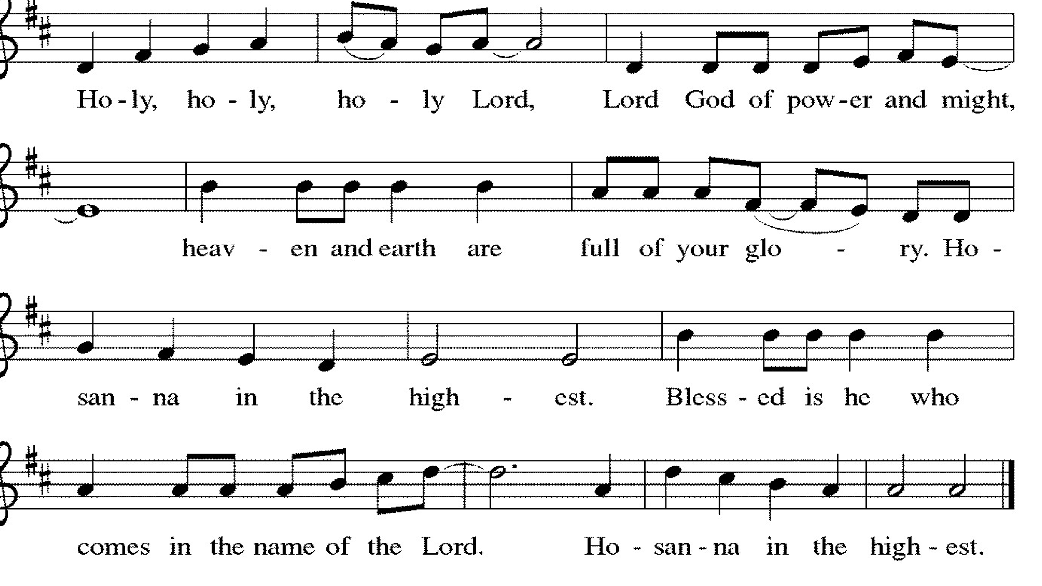

Thanksgiving at the Table

L: Holy, living and loving God,
We praise you for creating the heavens and the earth.
We give you thanks for Jesus who, living among us,
Healed the sick, fed the hungry, and with a love stronger
Than death, gave his life for others.

In the night in which he was betrayed,
our Lord Jesus took bread, and gave thanks;
broke it, and gave it to his disciples, saying:
Take and eat; this is my body, given for you.
Do this for the remembrance of me.

Again, after supper, he took the cup, gave thanks,
and gave it for all to drink, saying:
This cup is the new covenant in my blood,
shed for you and for all people for the forgiveness of sin.
Do this for the remembrance of me.

Remembering, therefore, his life-
Giving death and glorious resurrection,
We await your promised life for all this
Dying world. Breathe your Spirit on us
And on this bread and cup:
Carry us in your arms from death to life,
That we may live as your chosen ones,
Clothed in the righteousness of Christ.

A: Through him all glory and honor is yours,
Almighty Father, with the Holy Spirit,
In your holy church, both now and forever.
Amen.

Lord’s Prayer

L: Gathered into one by the Holy Spirit, let us pray as Jesus taught us,
A: Our Father, who art in heaven, hallowed be thy name, thy kingdom come, thy will be done, on earth as it is in heaven. Give us this day our daily bread; and forgive us our trespasses, as we forgive those who trespass against us; and lead us not into temptation but deliver us from evil. For thine is the kingdom and the power, and the glory, forever and ever. Amen.

Invitation to Communion

L: Christ invites you to this table. Come, taste and see.

Communion- Music Video “Remembrance” by Matt Maher

Prayer after Communion

L: God of the abundant table,
you have refreshed our hearts in this meal
with bread for the journey.
Give us your grace on the road
that we might serve our neighbors with joy;
for the sake of Jesus Christ, our Lord.
A: Amen.

SENT FOR WORK AND WITNESS

Blessing

L: God, who gives life to all things
and frees us from despair,
bless you with truth and peace.
and may the holy Trinity ☩ one God,
guide you always in faith, hope and love.
A: Amen

Sending Hymn “Take My Life, That I May Be” ELW 583

Dismissal

L: Go in peace with Christ beside you.
A: Thanks be to God.

Postlude

Licensing information for this Worship Service:
CCLI Copyright License A 2440181 5/31/23 + Streaming Plus License A 211196712 5/31/23
Sundays and Seasons License Sundays and Seasons v.20200325.1254

Worship Participants

Presiding Minister: SAM Marcia Buchs
Worship Steward: Pat Lund
Greeter: Karen Hoegger
Musician: Sandy Erickson
Lector: Judy Sykes
Ushers: Denny & Mary Leach
Communion Prep: Sara Solberg
Comm. Asst: Nathan Joerndt & Marvin Miller
Livestream: Louis Kehinde
Hospitality: Julie Mehlberg & Emma Rapp
Counters: Denny Leach & Marty Heller

