St. Paul Lutheran Church, ELCA

Pontiac, IL
October 9, 2022

18th Sunday after Pentecost

Flowers on the altar were donated by Ted & Ginger Bauknecht.
“Red bag” offering will be collected and donated to the “Boy’s & Girl’s Club.
Introduction
It’s a miracle! Multiple miracles! The waters of holy baptism have healed us. The body and blood of Jesus in holy communion have made us clean. We have died with Christ and been raised with him. For all this we have returned to offer thanks. From this place we are sent on our way rejoicing to share the good news.

Prelude

Welcome

Announcements

Gathering Hymns “How Great is our God” Words only

V1. The splendor of the King, Chorus:
Clothed in majesty; How great is our God!
Let all the earth rejoice, Sing with me; how great is our God!
He wraps Himself in light, And all will see how great,
Darkness tries to hide, How great is our God!
And trembles at His voice,
And trembles at His voice.

Chorus: How great is our God! How great is our God! Sing with me; how great is our God! Sing with me; how great is our God! And all will see how great, And all will see how great, How great is our God! How great is our God! How great, how great is our God!

V2. And age to age He stands,
And time is in His hands;
Beginning and the End
Beginning and the end.
The God-head, three in one,
Father, Spirit, Son,
The Lion and the Lamb,
The Lion and the Lamb,

“Savior Like a Shepherd Lead Us” ELW 789

Confession and Forgiveness

All may make the sign of the cross, the sign marked at baptism, as the presiding minister begins.

L: Blessed be the Holy Trinity, ☩ one God, who is eager to forgive
And who loves us beyond our days.
A: Amen.

L: Dear friends, together let us acknowledge our failure to love this world as Jesus does.

Silence is kept for reflection.

L: God of mercy and forgiveness,
we confess that sin still has a hold on us.
We have harmed your good creation.
We have failed to do justice,
love kindness,
and walk humbly with you.
Turn us in a new direction.
Show us the path that leads to life.
Be our refuge and strength on the journey,
through Jesus Christ, our redeemer and friend.
Amen.

L: Beloved of God:
your sins are forgiven ☩ and you are made whole
God points the way to new life in Christ,
who meets us on the road.
Journey now in God’s abiding love
through the power of the Holy Spirit.
A: Amen.

Greeting

L: Alleluia! Christ is risen!
A: Christ is risen indeed! Alleluia

L: The grace of our Lord Jesus Christ, the love of God, and the communion of the
Holy Spirit be with you all.
A: And also with you.

Prayer of the Day

L: Almighty and most merciful God, your bountiful goodness fills all creation. Keep us safe from all that may hurt us, that, whole and well in body and spirit, we may with grateful hearts accomplish all that you would have us do, through Jesus Christ, our Savior and Lord.
Amen.

Children’s Message

HEARING THE WORD OF GOD

First Reading- 2 Kings 5: 1-3, 7-15c

L: A reading from 2 Kings.

¹Naaman, commander of the army of the king of Aram, was a great man and in high favor with his master, because by him the Lord had given victory to Aram. The man, though a mighty warrior, suffered from leprosy. ²Now the Arameans on one of their raids had taken a young girl captive from the land of Israel, and she served Naaman’s wife. ³She said to her mistress, “If only my lord were with the prophet who is in Samaria! He would cure him of his leprosy.” ⁷When the king of Israel read the letter, he tore his clothes and said, “Am I God, to give death or life, that this man sends word to me to cure a man of his leprosy? Just look and see how he is trying to pick a quarrel with me.”
⁸But when Elisha the man of God heard that the king of Israel had torn his clothes, he sent a message to the king, “Why have you torn your clothes? Let him come to me, that he may learn that there is a prophet in Israel.” ⁹So Naaman came with his horses and chariots, and halted at the entrance of Elisha’s house. ¹⁰Elisha sent a messenger to him, saying, “Go, wash in the Jordan seven times, and your flesh shall be restored and you shall be clean.” ¹¹But Naaman became angry and went away, saying, “I thought that for me he would surely come out, and stand and call on the name of the Lord his God, and would wave his hand over the spot, and cure the leprosy! ¹²Are not Abana and Pharpar, the rivers of Damascus, better than all the waters of Israel? Could I not wash in them, and be clean?” He turned and went away in a rage. ¹³But his servants approached and said to him, “Father, if the prophet had commanded you to do something difficult, would you not have done it? How much more, when all he said to you was, ‘Wash, and be clean’?” ¹⁴So he went down and immersed himself seven times in the Jordan, according to the word of the man of God; his flesh was restored like the flesh of a young boy, and he was clean.
^{15a-c}Then he returned to the man of God, he and all his company; he came and stood before him and said, “Now I know that there is no God in all the earth except in Israel.”

L: Word of God, word of life.
A: Thanks be to God.

Psalm 111

L: A reading from Psalm.

¹Hallelujah! I will give thanks to the Lord with my whole heart,
in the assembly of the upright, in the congregation.
²Great are your works, O Lord,
pondered by all who delight in them.
³Majesty and splendor mark your deeds,
and your righteousness endures forever.
⁴You cause your wonders to be remembered;
you are gracious and full of compassion.
⁵You give food to those who fear you,
remembering forever your covenant.
⁶You have shown your people the power of your works
in giving them the lands of the nations.
⁷The works of your hands are faithfulness and justice;
all of your precepts are sure.
⁸They stand fast forever and ever,
because they are done in truth and equity.
⁹You sent redemption to your people and commanded your covenant forever;
holy and awesome is your name.
¹⁰The fear of the Lord is the beginning of wisdom;

L: Holy wisdom; Holy Word.
A: Thanks be to God.
Second Reading – 2 Timothy 2: 8-15

L: A reading from 2 Timothy.

⁸Remember Jesus Christ, raised from the dead, a descendant of David—that is my
gospel, ⁹for which I suffer hardship, even to the point of being chained like a criminal. But the
word of God is not chained. ¹⁰Therefore I endure everything for the sake of the elect, so that
they may also obtain the salvation that is in Christ Jesus, with eternal glory. ¹¹The saying is
sure:
If we have died with him, we will also live with him;
¹²if we endure, we will also reign with him;
if we deny him, he will also deny us;
¹³ if we are faithless, he remains faithful—
for he cannot deny himself.
¹⁴Remind them of this, and warn them before God that they are to avoid wrangling over words,
which does no good but only ruins those who are listening. ¹⁵Do your best to present yourself
to God as one approved by him, a worker who has no need to be ashamed, rightly explaining
the word of truth.

L: Word of God, word of life.
A: Thanks be to God.

Please rise, as you are able, for the reading of the Holy Gospel.

Gospel Acclamation Halle, Halle, Hallelujah

Gospel- Luke 17: 11-19

L: The Holy Gospel according to Luke.
A: Glory to you, O Lord.

¹¹On the way to Jerusalem Jesus was going through the region between Samaria and Galilee. ¹²As he entered a village, ten lepers approached him. Keeping their distance, ¹³they called out, saying, “Jesus, Master, have mercy on us!” ¹⁴When he saw them, he said to them, “Go and show yourselves to the priests.” And as they went, they were made clean. ¹⁵Then one of them, when he saw that he was healed, turned back, praising God with a loud voice. ¹⁶He prostrated himself at Jesus’ feet and thanked him. And he was a Samaritan. ¹⁷Then Jesus asked, “Were not ten made clean? But the other nine, where are they? ¹⁸Was none of them found to return and give praise to God except this foreigner?” ¹⁹Then he said to him, “Get up and go on your way; your faith has made you well.”

L: The gospel of the Lord.
A: Praise to you, O Christ.

Sermon Pastor Wayne Shelksohn

Hymn of the Day “O Christ the Healer We Have Come” ELW 610

Apostle’s Creed

I believe in God, the Father almighty,
creator of heaven and earth.
I believe in Jesus Christ, God’s only Son, our Lord,
who was conceived by the Holy Spirit,
born of the virgin Mary,
suffered under Pontius Pilate,
was crucified, died, and was buried;
he descended to the dead.
On the third day he rose again;
he ascended into heaven,
he is seated at the right hand of the Father,
and he will come to judge the living and the dead.
I believe in the Holy Spirit,
the holy catholic church,
the communion of saints,
the forgiveness of sins,
the resurrection of the body,
and the life everlasting. Amen.

Prayers of Intercession

Each petition will end “Hear us, O God,” and the congregation will respond “Your mercy is great.

Sharing the Peace

L: The peace of Christ be with you always.
A: And also with you.

You are invited to share a sign of God’s peace with your neighbors by turning to the people near you saying, “Peace be with you.”

Offering

Offerings can also be sent by mail or given online. You can send a check to St. Paul Lutheran Church 210 Deerfield Rd Pontiac, IL 61764 or give online at stpaulpontiac.org

Offering Special Music by Gerald Buckler

Offering Prayer

L: Gracious God;
in your great love you richly provide for our needs.
Make of these gifts a banquet of blessing,
and make us ready to share with all in need;
through Jesus Christ, who sets a table for all.
A: Amen.

MEAL

All are welcome at Christ’s table.
Communion is distributed in front of the altar. The individual cups are filled with wine. The prepackaged cups are juice. If you prefer not to receive communion you may come forward with your hands crossed over your chest to receive a blessing or you may remain in your seat.

Great Thanksgiving

L: The Lord be with you.
A: And also with you.

L: Lift up your hearts.
A: We lift them to the Lord.

L: Let us give thanks to the Lord our God.
A: It is right to give our thanks and praise.

Preface

L: It is indeed right, our duty and our joy,
that we should at all times and in all places
offer thanks and praise to you, O Lord,
holy Father, almighty and ever living God.
But chiefly we are bound to praise you for the glorious
Resurrection of our Lord; for he is the true Passover Lamb
Who gave himself to take away our sin,
Who by his death has destroyed death;
And by his rising has brought us to eternal life.
And so with Mary Magdalene and Peter and
All the witnesses of the resurrection,
With earth and sea and all their
Creatures, and with angels and archangels,
Cherubim and seraphim,
We praise your name and join their unending hymn:

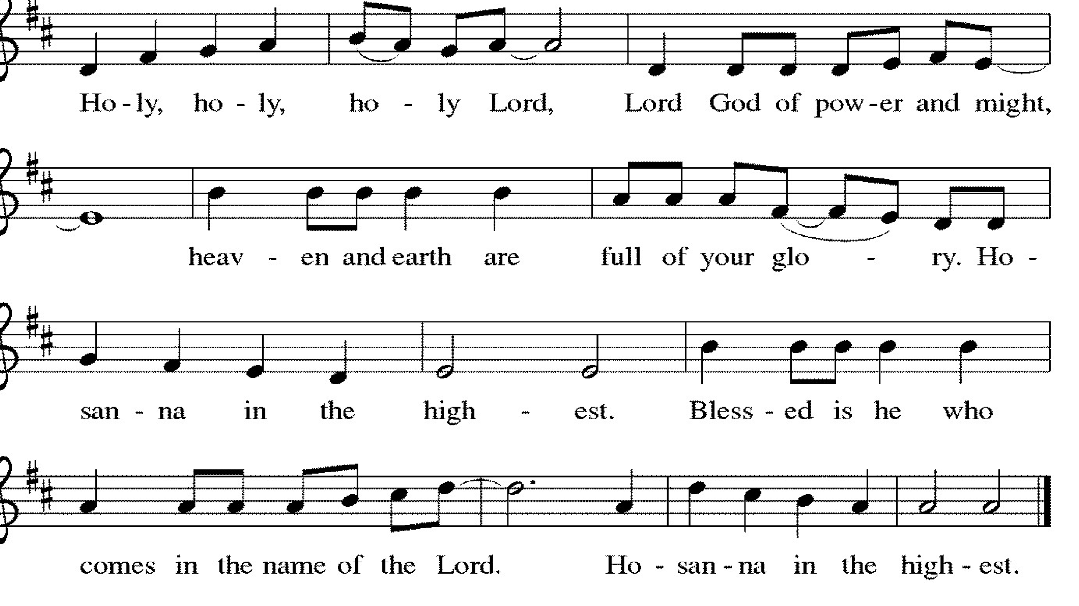

Thanksgiving at the Table

L: Holy, living and loving God,
We praise you for creating the heavens and the earth.
We give you thanks for Jesus who, living among us,
Healed the sick, fed the hungry, and with a love stronger
Than death, gave his life for others.

In the night in which he was betrayed,
our Lord Jesus took bread, and gave thanks;
broke it, and gave it to his disciples, saying:
Take and eat; this is my body, given for you.
Do this for the remembrance of me.

Again, after supper, he took the cup, gave thanks,
and gave it for all to drink, saying:
This cup is the new covenant in my blood,
shed for you and for all people for the forgiveness of sin.
Do this for the remembrance of me.

Remembering, therefore, his life-
Giving death and glorious resurrection,
We await your promised life for all this
Dying world. Breathe your Spirit on us
And on this bread and cup:
Carry us in your arms from death to life,
That we may live as your chosen ones,
Clothed in the righteousness of Christ.

A: Through him all glory and honor is yours,
Almighty Father, with the Holy Spirit,
In your holy church, both now and forever.
Amen.

Lord’s Prayer

L: Gathered into one by the Holy Spirit, let us pray as Jesus taught us,
A: Our Father, who art in heaven, hallowed be thy name, thy kingdom come, thy will be done, on earth as it is in heaven. Give us this day our daily bread; and forgive us our trespasses, as we forgive those who trespass against us; and lead us not into temptation but deliver us from evil. For thine is the kingdom and the power, and the glory, forever and ever. Amen.

Invitation to Communion

L: Christ invites you to this table. Come, taste and see.

Communion- Music Video “Reckless Love” by Cory Asbury

Prayer after Communion

L: God of the abundant table,
you have refreshed our hearts in this meal
with bread for the journey.
Give us your grace on the road
that we might serve our neighbors with joy;
for the sake of Jesus Christ, our Lord.
A: Amen.

SENT FOR WORK AND WITNESS

Blessing

L: God, who gives life to all things
and frees us from despair,
bless you with truth and peace.
and may the holy Trinity ☩ one God,
guide you always in faith, hope and love.
A: Amen

Sending Hymn “Sent Forth by God’s Blessing” ELW 547

Dismissal

L: Go in peace with Christ beside you.
A: Thanks be to God.

Postlude

Licensing information for this Worship Service:
CCLI Copyright License A 2440181 5/31/23 + Streaming Plus License A 211196712 5/31/23
Sundays and Seasons License Sundays and Seasons v.20200325.1254

Worship Participants

Presiding Minister: Wayne Shelksohn
Worship Steward: Marty Heller
Greeter: Shelly Heller
Musician: Sandy Erickson
Lector: Nathan Joerndt
Usher: Mark Mackinson
Communion Prep: Jean Harrison & Mark Mackinson
Comm. Asst: Denny & Mary Leach
Livestream: Louis Kehinde
Hospitality: Rosemary Sutton & Sandy Erickson
Counters: Jean Harrison & Marvin Miller

