St. Paul Lutheran Church, ELCA
Pontiac, IL
Thankoffering Service
November 14, 2021

We gather to worship, reach out, and serve the Lord.

Welcome

Welcome to St. Paul Lutheran Church. Whether you have worshipped with us many times or this is your first time, there is a place for you here. Your presence among us is a gift.

Introduction to the day
Jeanne:
As we make our Thankofferings today, we share in a tradition that goes back to the 1800s or even earlier. Then, when it seemed that there was not enough money to carry out the work of the church, the women would act together as “cent” or “mite” societies. Each woman would set aside offerings at home throughout the year in thanksgiving for blessings received. And on occasion, the women would come together as we do today, joining their offerings together to support ministry of many kinds. When Women of the ELCA was formed in 1987, we committed to continue this tradition of giving in gratitude for blessings. Each year, in thousands of congregations, Thankofferings are given to support the life-changing ministries of Women of the ELCA. Together, we do more than we could ever do apart. In gratitude for all God has given to us, and with hope for all that is to come, we give our thankoffering.
GATHERING

Betsy:

THANKSGIVING FOR BAPTISM

Blessed be the holy Trinity + one God, the fountain of living water, the rock who gave us birth, our light and our salvation.
Amen.

Joined to Christ in the waters of baptism,
we are clothed with God’s mercy and forgiveness.
Let us give thanks for the gracious gift of baptism.

Blessed are you, O God, maker and ruler of all things.
Your voice thundered over the waters at creation.
You water the mountains and send springs
into the valleys
to refresh and satisfy all living things.
Tami:
Through the waters of the flood
You carried those in the ark to safety.
Through the sea you led your people Israel from slavery to freedom.
In the wilderness you nourished them with water from the rock,
and you brought them across the river Jordan to the promised land.
By the baptism of his death and resurrection,
your Son Jesus has carried us to safety and freedom.
The floods shall not overwhelm us,
and the deep shall not swallow us up,
for Christ has brought us over to the land of promise.
He sends us to make disciples,
baptizing in the name of the Father,
and the Son, and of the Holy Spirit.

Pour out your Holy Spirit.
wash away sin in this cleansing water; clothe the baptized with Christ.
and claim your daughters and sons, no longer slave and free,
no longer male and female,
but one with all the baptized in Christ Jesus, who lives and reigns with you
in the unity of the Holy Spirit, one God, now and forever.
Amen.

Gathering Hymn Christ be Our Light ELW 715

Greeting

L: The grace of our Lord Jesus Christ, the love of God, and the communion of the
Holy Spirit be with you all.
A: And also with you.

Prayer of the Day

L: O God of justice and love, you light our way through life with the words of your Son. Give us the light we need, and awaken us to the needs of others, through Jesus Christ, our Savior and Lord.
Amen.

Children’s Message

WORD
Judy:
Reading – Micah 6: 1-8

L: A reading from Micah.

¹ Hear what the Lord is saying:
Arise, lay out the lawsuit before the mountains;
let the hills hear your voice!
² Hear, mountains, the lawsuit of the Lord!
Hear, eternal foundations of the earth!
The Lord has a lawsuit against his people;
with Israel he will argue.
³ “My people, what did I ever do to you?
How have I wearied you? Answer me!
⁴ I brought you up out of the land of Egypt;
I redeemed you from the house of slavery.
I sent Moses, Aaron, and Miriam before you.
⁵ My people, remember what Moab’s King Balak had planned,
and how Balaam, Beor’s son, answered him!
Remember everything^{[a]} from Shittim to Gilgal,
that you might learn to recognize the righteous acts of the Lord!”
⁶ With what should I approach the Lord
and bow down before God on high?
Should I come before him with entirely burned offerings,
with year-old calves?
⁷ Will the Lord be pleased with thousands of rams,
with many torrents of oil?
Should I give my oldest child for my crime;
the fruit of my body for the sin of my spirit?
⁸ He has told you, human one, what is good and
what the Lord requires from you:
to do justice, embrace faithful love, and walk humbly with your God.

L: Word of God, Word of life.
A: Thanks be to God.

Dawn:

Reading – Psalm 15

A reading from Psalms.

1 Lord, who may dwell in your tabernacle?
Who may abide upon your holy hill?
2 Those who lead a blameless life and do what is right,
who speak the truth from their heart.
3 they do not slander with the tongue; they do no evil to their friends;
they do not cast discredit upon a neighbor.
4 In their sight the wicked are rejected, but they honor those who fear the Lord.
They have sworn upon their health and do not take back their word.
5 They do not give their money in hope of gain, nor do they take bribes against the innocent.
Those who do these things shall not be moved.

L: Holy Wisdom, Holy Word.
A: Thanks be to God.
Dawn:

Reading – 1 Corinthians 1: 18-31

A reading from 1 Corinthians.

¹⁸ The message of the cross is foolishness to those who are being destroyed. But it is the power of God for those of us who are being saved. ¹⁹ It is written in scripture: I will destroy the wisdom of the wise, and I will reject the intelligence of the intelligent.^{[a]} ²⁰ Where are the wise? Where are the legal experts? Where are today’s debaters? Hasn’t God made the wisdom of the world foolish? ²¹ In God’s wisdom, he determined that the world wouldn’t come to know him through its wisdom. Instead, God was pleased to save those who believe through the foolishness of preaching. ²² Jews ask for signs, and Greeks look for wisdom, ²³ but we preach Christ crucified, which is a scandal to Jews and foolishness to Gentiles. ²⁴ But to those who are called—both Jews and Greeks—Christ is God’s power and God’s wisdom. ²⁵ This is because the foolishness of God is wiser than human wisdom, and the weakness of God is stronger than human strength.
²⁶ Look at your situation when you were called, brothers and sisters! By ordinary human standards not many were wise, not many were powerful, not many were from the upper class. ²⁷ But God chose what the world considers foolish to shame the wise. God chose what the world considers weak to shame the strong. ²⁸ And God chose what the world considers low-class and low-life—what is considered to be nothing—to reduce what is considered to be something to nothing. ²⁹ So no human being can brag in God’s presence. ³⁰ It is because of God that you are in Christ Jesus. He became wisdom from God for us. This means that he made us righteous and holy, and he delivered us. ³¹ This is consistent with what was written: The one who brags should brag in the Lord!

L: Word of God, Word of life.
A: Thanks be to God.

Please rise as you are able for the reading of the Holy Gospel.

Gospel Acclamation

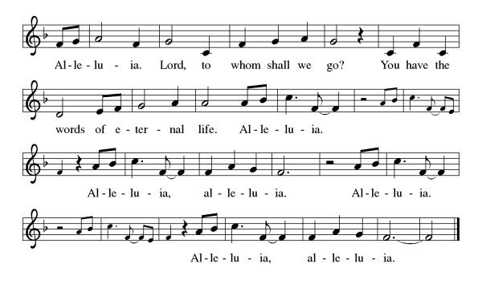

Sue:
Matthew 5: 13-16

L: The Holy Gospel according to Matthew.
A: Glory to you, O Lord.

13 “You are the salt of the earth. But if salt loses its saltiness, how will it become salty again? It’s good for nothing except to be thrown away and trampled under people’s feet. 14 You are the light of the world. A city on top of a hill can’t be hidden. 15 Neither do people light a lamp and put it under a basket. Instead, they put it on top of a lampstand, and it shines on all who are in the house. 16 In the same way, let your light shine before people, so they can see the good things you do and praise your Father who is in heaven.

L: The gospel of the Lord.
A: Praise to you, O, Christ.

Sermon Pastor Mathew Berger

Hymn of the Day Jesu, Jesu Fill us with your Love ELW 708

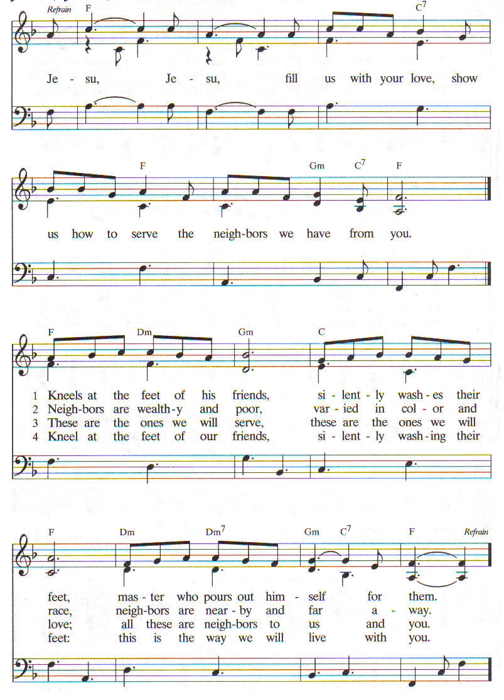

Apostles’ Creed

I believe in God, the Father almighty,
creator of heaven and earth.
I believe in Jesus Christ, God’s only Son, our Lord,
who was conceived by the Holy Spirit,
born of the virgin Mary,
suffered under Pontius Pilate,
was crucified, died, and was buried;
he descended to the dead.
On the third day he rose again;
he ascended into heaven,
he is seated at the right hand of the Father,
and he will come to judge the living and the dead.
I believe in the Holy Spirit,
the holy catholic church,
the communion of saints,
the forgiveness of sins,
the resurrection of the body,
and the life everlasting. Amen.

Prayers of Intercession

Each petition ends “Christ, be our light.” The congregation is invited to respond, “Shine in your church gathered today.”

Sharing the Peace

L: The peace of Christ be with you always.
A: And also with you.

You are invited to share a sign of God’s peace with your neighbors by saying or typing, “Peace be with you.”

Offerings can be given by mail or online. You can send a check to St. Paul Lutheran Church 210 Deerfield Rd Pontiac, IL 61764. You can give online at http://www.stpaulpontiac.org/

Offering

Offerings can also be sent by mail or given online. You can send a check to St. Paul Lutheran Church 210 Deerfield Rd Pontiac, IL 61764 or give online at stpaulpontiac.org

Carrie: MEAL
Offering Prayer

L: God of grace, you have showered us with gifts of grace
And abundance, entrusting to us the ministries of
Women of the ELCA. Help us to grow in faith, affirm our
gifts, support one another in our callings, engage
in ministry an action, and promote healing and
wholeness in the church, the society, and the world.
Accept these gifts and our prayer that, nurtured by your
Word, filled with your Spirit, and fed at your table, we
May share with gladness all that you have shared with
us, until all creation is satisfied.

A: Amen.

Great Thanksgiving
L: The Lord be with you.
A: And also with you.
L: Lift up your hearts.
A: We lift them to the Lord.
L: Let us give thanks to the Lord our God.
A: It is right to give our thanks and praise.

Preface

It is indeed right, our duty and our joy,
that we should at all times and in all places
give thanks and praise to you, almighty and merciful God,
through our Savior Jesus Christ.
By the witness of your saints
you show us the hope of our calling
and strengthen us to run the race set before us,
that we may delight in your mercy and rejoice with them in glory.
And so, with all the saints,
with the choirs of angels and all the hosts of heaven,
we praise your name and join their unending hymn:

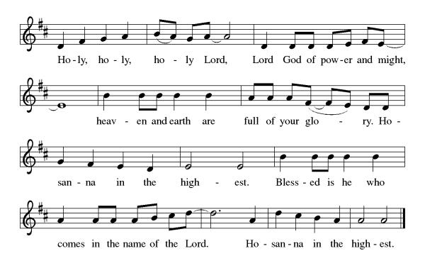

Thanksgiving at the Table

L: Holy, mighty and merciful Lord,
heaven and earth are full of your glory.
In great love you sent to us Jesus, your Son,
who reached out to heal the sick and suffering,
who preached good news to the poor,
and who, on the cross, opened his arms to all.
In the night in which he was betrayed,
our Lord Jesus took bread, and gave thanks;
broke it, and gave it to his disciples, saying:
Take and eat; this is my body, given for you.
Do this for the remembrance of me.

Again, after supper, he took the cup, gave thanks,
and gave it for all to drink, saying:
This cup is the new covenant in my blood,
shed for you and for all people for the forgiveness of sin.
Do this for the remembrance of me.

Remembering, therefore, his death,
resurrection, and ascension,
we await his coming in glory.

Pour out upon us the Spirit of your love,
O Lord, and unite the wills of all who share this heavenly food,
the body and blood of Jesus Christ, our Lord;
to whom, with you and the Holy Spirit,
be all honor and glory, now and forever.
A: Amen.

Lord's Prayer

L: Gathered into one by the Holy Spirit, let us pray as Jesus taught us,
A: Our Father, who art in heaven, hallowed be thy name, thy kingdom come, thy will be done, on earth as it is in heaven. Give us this day our daily bread; and forgive us our trespasses, as we forgive those who trespass against us; and lead us not into temptation but deliver us from evil. For thine is the kingdom and the power, and the glory, forever and ever. Amen.

Invitation to Communion

L: Our God calls us to do justice. May you find strength in God’s grace.

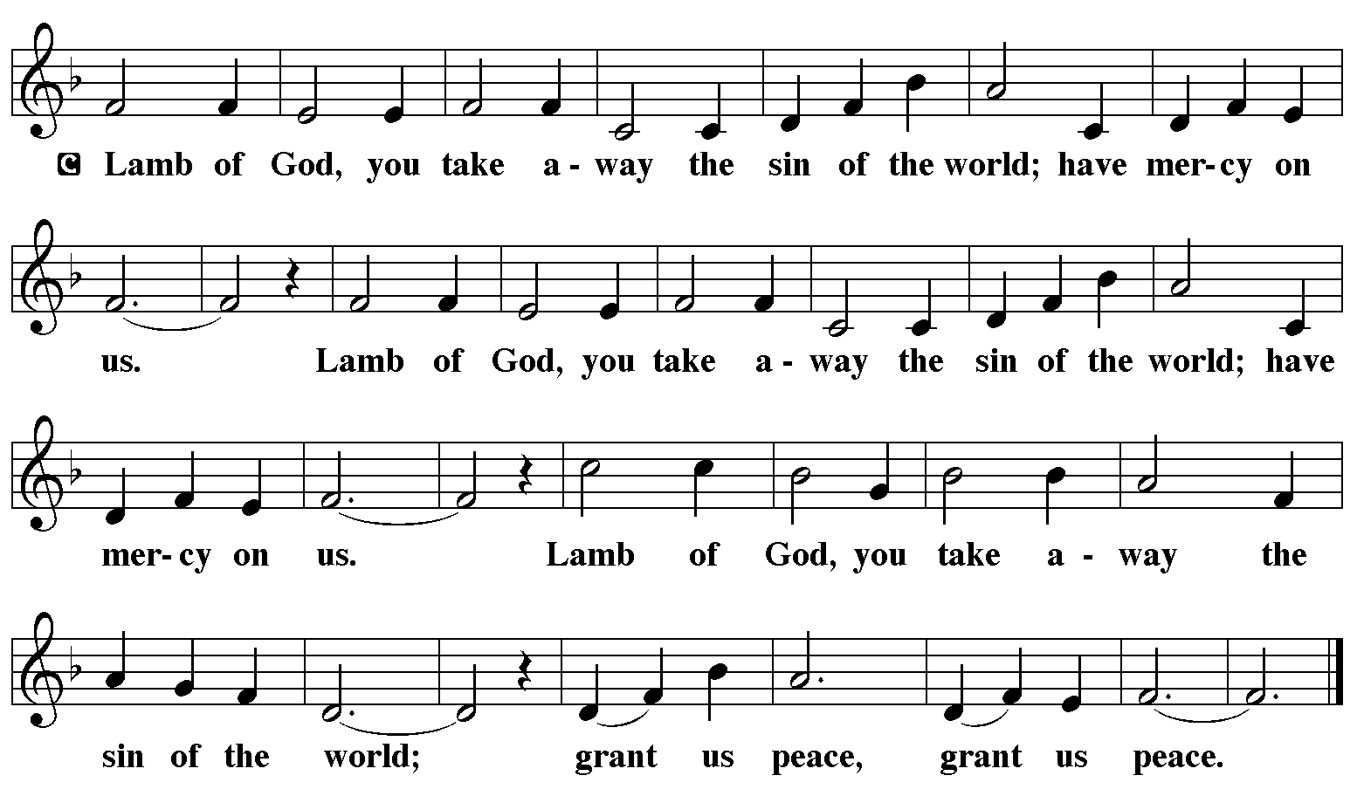

Communion Music Special Music

Communion Music One Bread, One Body ELW 496

Jessica:
Prayer after Communion

L: We thank you, gracious God, for loving all your family
with a mother’s care, and feeding us in a way our hearts
and souls can understand, with the saving body and
blood of Jesus Christ. Renew and enliven us by your
presence in this meal, that we may be your presence in
the world, through Jesus Christ, our Savior and Lord.

A: Amen.

Announcements

SENDING
Jessica:
Benediction

L: Our God calls us to do justice,
May you find strength in God’s grace.
Amen.
Christ Jesus calls us to love kindness.
May you find comfort in Christ’s gentleness.
Amen.
The Holy Spirit calls us to walk humbly with our triune God.
May you always find joy in God’s love and justice.
Amen.
Holy Trinity ☩ One God, bless you now and forever.
Amen.

Sending Hymn Sent Forth by God’s Blessing ELW 547

Dismissal

L: Rejoice and be glad in the light of God’s love! Let us go forth in peace to share the good news.
A: Thanks be to God.

Licensing information for this Worship Service: CCLI Copyright License A 2440181 9/30/2021 + Streaming License A 20530290 5/31/2022
Sundays and Seasons License Sundays and Seasons v.20200325.1254
Thank you to all those who contributed to today’s service: Lectors: Jeanne Rapp, Betsy Westergreen, Tami Putnam, Judy Sykes, Dawn Boitnott, Sue Curtiss, Carrie Lueker, Jessica Mills, Ushers: Marian Brown & Pat Lund, Musician: Sandy Erickson, Communion Prep: Marian Brown & Jill Rapp, Communion Asst: Julie Mehlberg & Mary Leach, Livestream: Louis Kehinde, Sound & Projection: Emma Johnson, Joel Rapp, Julie Mehlberg, John Mehlberg and Melissa Rapp, Hospitality; Dawn Boitnott & Jessica Mills, Counters: Mark Mackinson & Carrie Lueker.

