St. Paul Lutheran Church
Pontiac, IL
April 3, 2022
Fifth Sunday in Lent

Altar flowers for this morning were donated by Doug & Peggie Schneeman in memory of Don Schneeman’s passing 9 years ago.

The people of St. Paul gather to worship, reach out, and serve the Lord.

Welcome

Welcome to St. Paul Lutheran Church. Whether you have worshiped with us many times, or this is your first time, there is a place for you here. Your presence among us is a gift.

God’s Peace be with you.

Introduction to the Day
Introduction
Our God makes all things new. In the first reading God promises it. In the gospel Mary anticipates it, anointing Jesus’ feet with costly perfume in preparation for the day of his burial. In the second reading Paul recalls his transformation from the persecutor Saul into an apostle. In baptism, God’s new person (you!) rises daily from the deadly mire of trespasses and sins.

Prelude

GATHERING

Welcome to Worship

Prepare for Worship
Take, oh, Take Me as I Am – ELW 814
(Sing three times)

Take, oh, take me as I am;
Summon out what I shall be;
Set your seal upon my heart
And live in me.

Confession and Forgiveness
All may make the sign of the cross, the sign marked at baptism, as the presiding minister begins.
L: In the name of God,
who makes a way in the wilderness,
walks with us,
and guides us in our pilgrimage.
A: Amen.

L: Let us confess our sin in the presence of God and of one another.

Silence is kept for reflection.

L: Holy One,
A: we confess that we have wandered far from you:
we have not trusted your promises,
we have ignored your prophets in our own day,
we have squandered our inheritance of grace,
we have failed to recognize you in our midst.
Have mercy on us!
Forgive us and turn us again to you.
Teach us to follow in your ways,
assure us again of your love,
and help us to love our neighbor.
Amen.

L: Beloved in Christ,
the Word draws near to you,
and all who call out to God shall be saved.
In Jesus, God comes to you again and again
and gathers you under wings of love.
In ☩ Jesus’ name, your sins are forgiven.
God journeys with you and teaches you how to live in love.

A: Amen.

Gathering Hymns Change My Heart, O God ELW 801

Gathering Hymns Here I Am to Worship

Verse
Light of the world, You stepped down into darkness
Opened my eyes, let me see.
Beauty that made this heart adore You,
hope of a life spent with You.
Refrain
Here I am to worship, here I am to bow down,
Here I am to say that You’re my God.
You’re altogether lovely, altogether worthy,
Altogether wonderful to me.
Verse
King of all days, oh so highly exalted,
Glorious in heaven above.
Humbly You came to the earth You created,
All for love’s sake became poor
Refrain
Here I am to worship, here I am to bow down,
Here I am to say that You’re my God.
You’re altogether lovely, altogether worthy,
Altogether wonderful to me.
Tag
And I’ll never know how much it cost to see my sin upon that cross.
And I’ll never know how much it cost to see my sin upon that cross.
Refrain
Here I am to worship, here I am to bow down,
Here I am to say that You’re my God.
You’re altogether lovely, altogether worthy,
Altogether wonderful to me.

Greeting

L: The grace of our Lord Jesus Christ, the love of God, and the communion of the
Holy Spirit be with you all.
A: And also with you.

Prayer of the Day

L: Creator God, you prepare a new way in the wilderness, and your grace waters our desert. Open our hearts to be transformed by the new thing you are doing, that our lives may proclaim the extravagance of your love given to all through your Son, Jesus Christ, our Savior and Lord, who lives and reigns with you and the Holy Spirit, one God, now and forever.
A: Amen.

Children’s Message

WORD

First Reading – Isaiah 43: 16-21

L: A reading from Isaiah.

¹⁶Thus says the Lord,
who makes a way in the sea,
a path in the mighty waters,
¹⁷who brings out chariot and horse,
army and warrior;
they lie down, they cannot rise,
they are extinguished, quenched like a wick:
¹⁸Do not remember the former things,
or consider the things of old.
¹⁹I am about to do a new thing;
now it springs forth, do you not perceive it?
I will make a way in the wilderness
and rivers in the desert.
²⁰The wild animals will honor me,
the jackals and the ostriches;
for I give water in the wilderness,
rivers in the desert,
to give drink to my chosen people,
²¹the people whom I formed for myself
so that they might declare my praise.

L: Word of God, word of life.
A: Thanks be to God.

Psalm Reading- Psalm 126

L: A reading from Psalm.

¹When the Lord restored the fortunes of Zion,
then were we like those who dream.
²Then was our mouth filled with laughter, and our tongue with shouts of joy.
Then they said among the nations, “The Lord has done great things for them.”
³The Lord has done great things for us,
and we are glad indeed.
⁴Restore our fortunes, O Lord,
like the watercourses of the Negeb.
⁵Those who sowed with tears
will reap with songs of joy.
⁶Those who go out weeping, carrying the seed,
will come again with joy, shouldering their sheaves.

L: Holy Wisdom. Holy word.
A: Thanks be to God.

Second Reading – Philippians 3: 4b-14

L: A reading from Philippians.

[Paul writes:] ^{4b}If anyone else has reason to be confident in the flesh, I have more: ⁵circumcised on the eighth day, a member of the people of Israel, of the tribe of Benjamin, a Hebrew born of Hebrews; as to the law, a Pharisee; ⁶as to zeal, a persecutor of the church; as to righteousness under the law, blameless.
⁷Yet whatever gains I had, these I have come to regard as loss because of Christ. ⁸More than that, I regard everything as loss because of the surpassing value of knowing Christ Jesus my Lord. For his sake I have suffered the loss of all things, and I regard them as rubbish, in order that I may gain Christ ⁹and be found in him, not having a righteousness of my own that comes from the law, but one that comes through faith in Christ, the righteousness from God based on faith. ¹⁰I want to know Christ and the power of his resurrection and the sharing of his sufferings by becoming like him in his death, ¹¹if somehow I may attain the resurrection from the dead.
¹²Not that I have already obtained this or have already reached the goal; but I press on to make it my own, because Christ Jesus has made me his own. ¹³Beloved, I do not consider that I have made it my own; but this one thing I do: forgetting what lies behind and straining forward to what lies ahead, ¹⁴I press on toward the goal for the prize of the heavenly call of God in Christ Jesus.

L: Word of God, word of life.
A: Thanks be to God.

Please rise as you are able for the reading of the Holy Gospel.

Lenten Acclamation

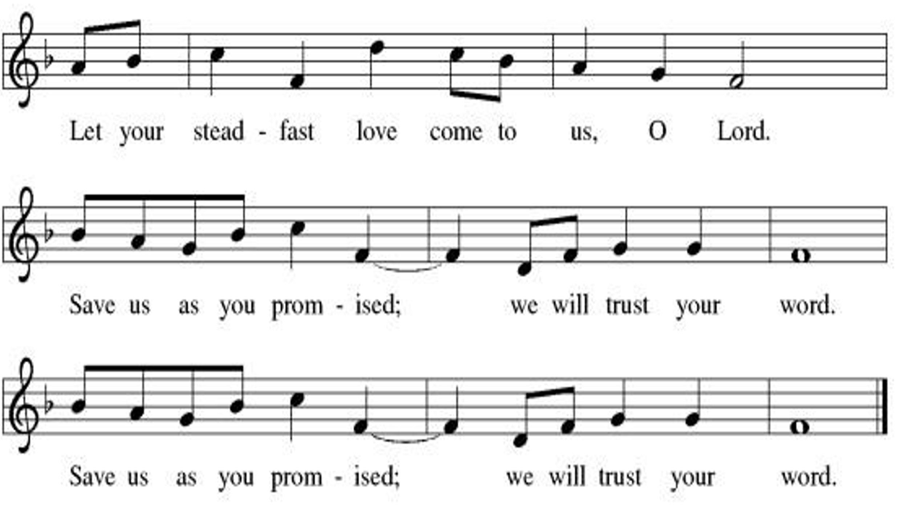

Gospel -John 12: 1-8

L: The Holy Gospel according to John.
A: Glory to you, O Lord.

¹Six days before the Passover Jesus came to Bethany, the home of Lazarus, whom he had raised from the dead. ²There they gave a dinner for him. Martha served, and Lazarus was one of those at the table with him. ³Mary took a pound of costly perfume made of pure nard, anointed Jesus’ feet, and wiped them with her hair. The house was filled with the fragrance of the perfume. ⁴But Judas Iscariot, one of his disciples (the one who was about to betray him), said, ⁵“Why was this perfume not sold for three hundred denarii and the money given to the poor?” ⁶(He said this not because he cared about the poor, but because he was a thief; he kept the common purse and used to steal what was put into it.) ⁷Jesus said, “Leave her alone. She bought it so that she might keep it for the day of my burial. ⁸You always have the poor with you, but you do not always have me.”

L: The gospel of the Lord.
A: Praise to you, O, Christ.

Sermon Pastor Jim Christian

Hymn of the Day Amazing Grace, How Sweet the Sound ELW 779

Apostle’s Creed
I believe in God, the Father Almighty, creator of heaven and earth. I believe in Jesus Christ, his only Son, our Lord. He was conceived by power of the Holy Spirit and born of the virgin Mary. He suffered under Pontius Pilate, was crucified, died, and was buried. He descended into hell. On the third day, he rose again. He ascended into heaven and is seated at the right hand of the Father. He will come again to judge the living and the dead. I believe in the Holy Spirit, the holy catholic church, the communion of saints, the forgiveness of sins, the resurrection of the body, and the life everlasting.
Amen.

Throughout our prayers, each petition ends “Merciful God,” The congregation is invited to respond, “receive our prayer.”

Sharing the Peace

L: The peace of Christ be with you always.
A: And also with you.

You are invited to share a sign of God’s peace with your neighbors by turning to the people near you saying, “Peace be with you.”

MEAL

All are welcome at Christ’s table.

Communion is distributed in front of the altar. The individual cups are filled with wine. The prepackaged cups are juice. If you prefer not to receive communion you may come forward with your hands crossed over your chest to receive a blessing or you may remain in your seat.

Offering

Offerings can also be sent by mail or given online. You can send a check to St. Paul Lutheran Church 210 Deerfield Rd Pontiac, IL 61764 or give online at stpaulpontiac.org

Offering Prayer

L: Extravagant God,
you have blessed us with the fullness of creation.
Now we gather at your feast
where you offer us the food that satisfies.
Take and use what we offer here, come among us,
and feed us with the body and blood of Christ,
in whose name we pray.
A: Amen.

Great Thanksgiving
L: The Lord be with you.
A: And also with you.
L: Lift up your hearts.
A: We lift them to the Lord.
L: Let us give thanks to the Lord our God.
A: It is right to give our thanks and praise.

Preface
L: It is indeed right, our duty and our joy,
that we should at all times and in all places
give thanks and praise to you, almighty and merciful God,
through our Savior Jesus Christ.
You call your people to cleanse their hearts
and prepare with joy for the paschal feast,
that, renewed in the gift of baptism,
we may come to the fullness of your grace.
And so, with all the choirs of angels,
with the church on earth and the hosts of heaven,
we praise your name and join their unending hymn:

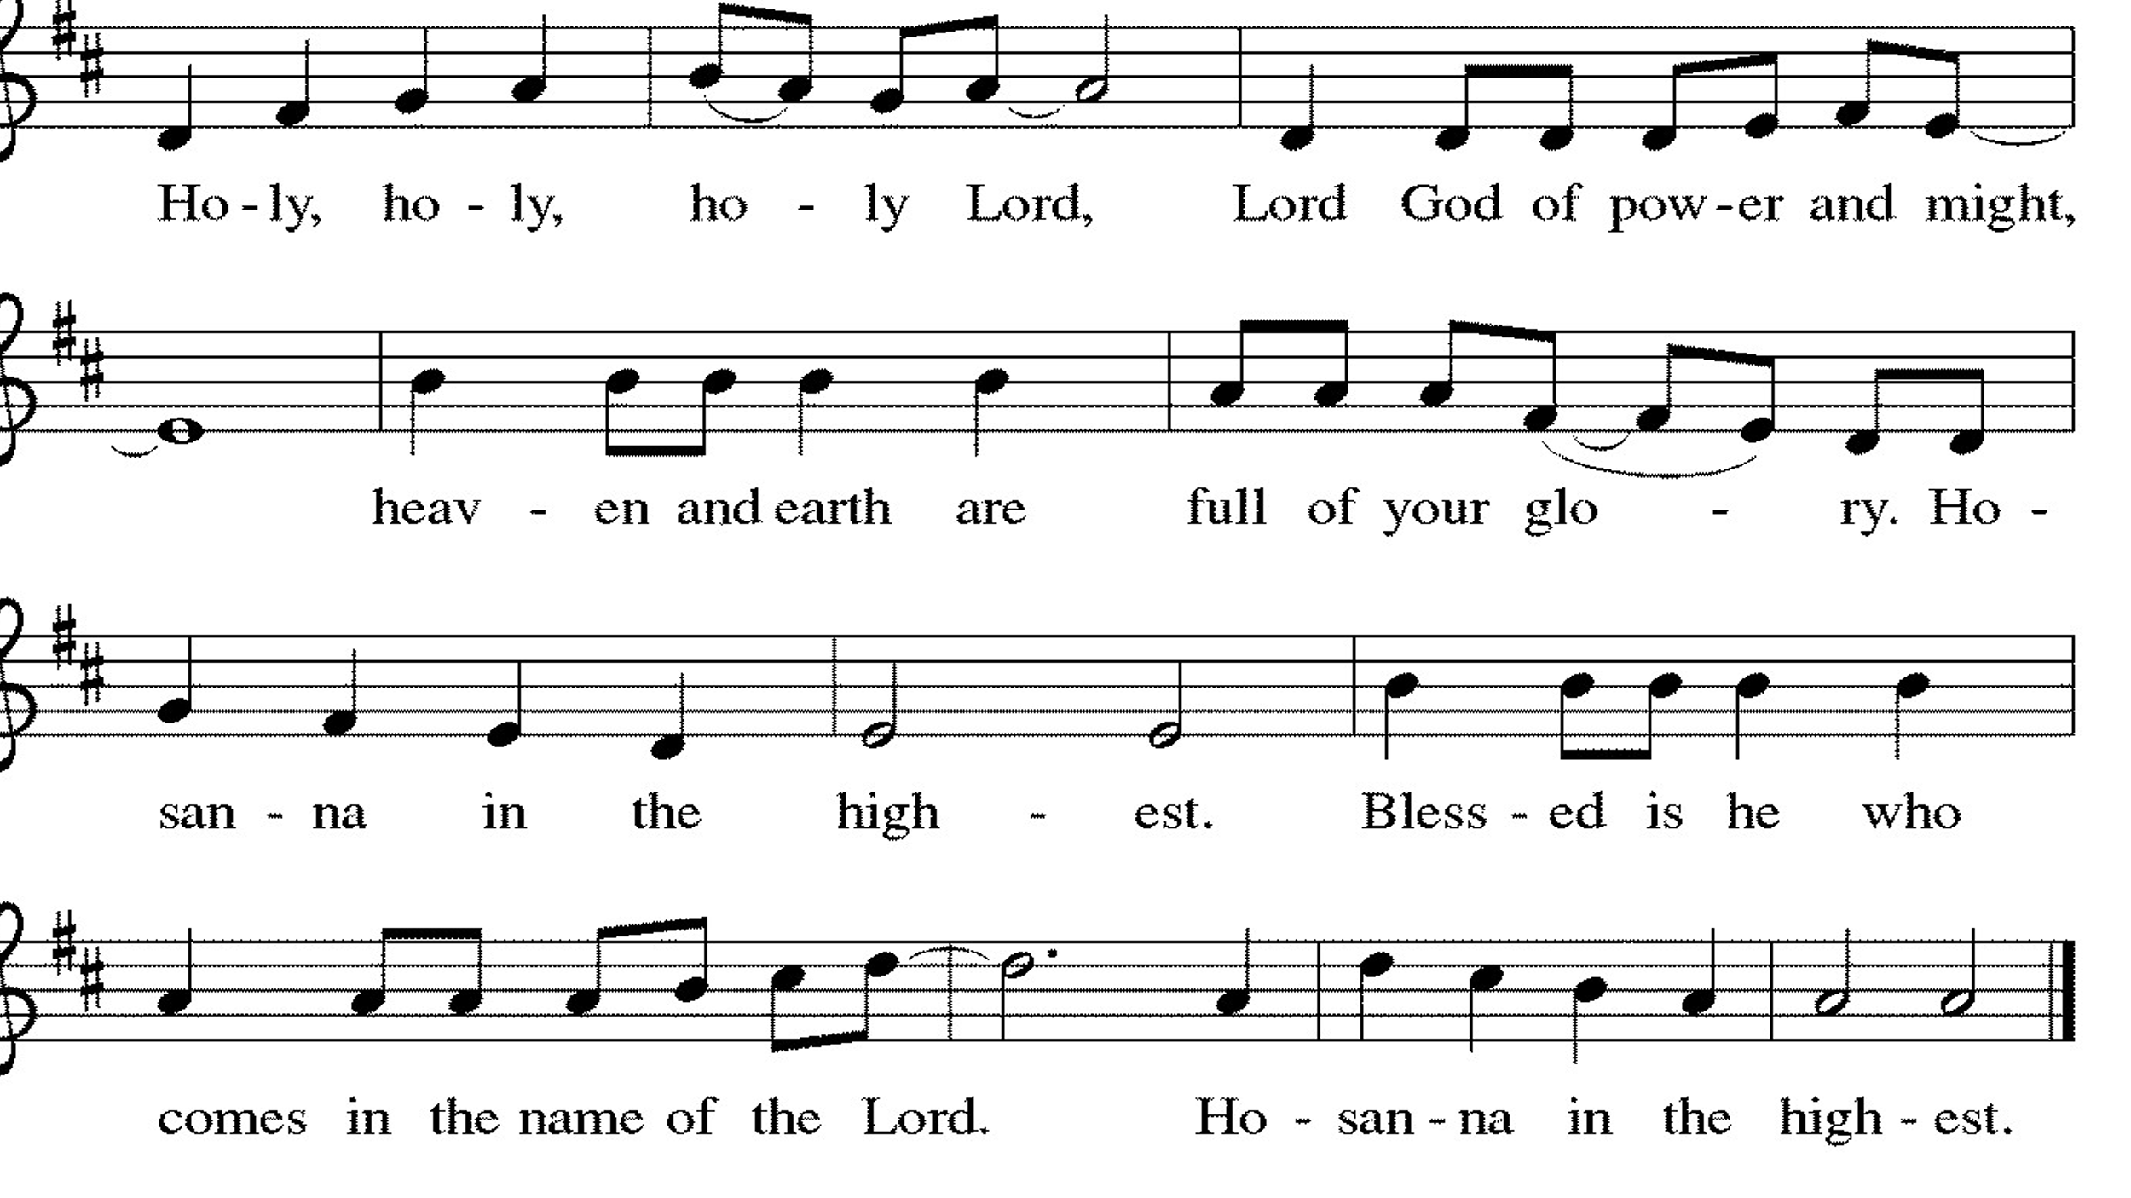

Thanksgiving at the Table

L: Blessed are you, O God of the universe.
Your mercy is everlasting
and your faithfulness endures from age to age.
Praise to you for creating the heavens and the earth.
Praise to you for saving the earth from the waters of the flood.
Praise to you for bringing the Israelites safely through the sea.
Praise to you for leading your people through the wilderness
to the land of milk and honey.
Praise to you for the words and deeds of Jesus, your anointed one.
Praise to you for the death and resurrection of Christ.
Praise to you for your Spirit poured out on all nations.

In the night in which he was betrayed,
our Lord Jesus took bread, and gave thanks;
broke it, and gave it to his disciples, saying:
Take and eat; this is my body, given for you.
Do this for the remembrance of me.

Again, after supper, he took the cup, gave thanks,
and gave it for all to drink, saying:
This cup is the new covenant in my blood,
shed for you and for all people for the forgiveness of sin.
Do this for the remembrance of me.

With this bread and cup
we remember our Lord’s passover from death to life
as we proclaim the mystery of faith:
Christ has died.
Christ is risen.
Christ will come again.

O God of resurrection and new life:
Pour out your Holy Spirit on us
and on these gifts of bread and wine.
Bless this feast.
Grace our table with your presence. Come, Holy Spirit.
Come, Holy Spirit.

Reveal yourself to us in the breaking of the bread.
Raise us up as the body of Christ for the world.
Breathe new life into us.
Send us forth,
burning with justice, peace, and love. Come, Holy Spirit.
Come, Holy Spirit.

With your holy ones of all times and places,
with the earth and all its creatures,
with sun and moon and stars,
we praise you, O God,
blessed and holy Trinity,
now and forever.
Amen.

Lord's Prayer

L: Gathered into one by the Holy Spirit, let us pray as Jesus taught us,
A: Our Father, who art in heaven, hallowed be thy name, thy kingdom come, thy will be done, on earth as it is in heaven. Give us this day our daily bread; and forgive us our trespasses, as we forgive those who trespass against us; and lead us not into temptation but deliver us from evil. For thine is the kingdom and the power, and the glory, forever and ever. Amen.

Invitation to Communion

L: Here is food and drink for the journey. Take and be filled.

Communion Video Reckless Love by Cory Asbury

Prayer After Communion
a blessing is given, a prayer follows

L: Blessed Jesus,
In this rich meal of grace,
you have fed us with your body, the bread of life.
Now send us forth to bear your life-giving hope
To a world in need.
A: Amen.

Announcements

SENDING

Blessing

L: You are children of God,
Anointed with the oil of gladness
and strengthened for the journey.

Almighty God,
Motherly, majestic, and mighty,
☩ bless you this day and always.
A: Amen.

Sending Hymn – Here I Am Lord – ELW 574
see music on final page

Dismissal

L: Go in peace. Jesus meets you on the way.
A: Thanks be to God.

Postlude

Licensing Information for this Worship Service:
CCLI Copyright License A 2440181 9/30/2021
Streaming License A 20530290 5/31/2022
Sundays and Seasons License v.20200325.1254

Thank you to all those who contributed to today’s service:

Lector: Sara Solberg
Ushers: Brad & Sara Solberg
Musician: Julie Mehlberg
Communion Prep: Sara Solberg
Communion Asst: Mark Mackinson & Judy Sykes
Hospitality: Sara Solberg & Pat Lund
Livestream: Louis Kehinde
Counters: Denny Leach & Cody Leach

