St. Paul Lutheran Church
Pontiac, IL
June 20, 2021
4th Sunday after Pentecost

We gather to worship, reach out, and serve the Lord.

Welcome

Welcome to St. Paul Lutheran Church. Whether you have worshipped with us many times, or this is your first time, there is a place for you here. Your presence among us is a gift.

God’s Peace be with you.

Introduction to the day
Introduction

Now is the acceptable time; now is the day of salvation! Now we are in the storm, the boat almost swamped; but Jesus is here now, and when we call him, he will calm the storm. Even the wind and waves listen to him as they would to their creator. We also listen to him and are called to believe in the power of God’s word in him, a power greater than all that we fear.

Prelude

GATHERING

Welcome to Worship

Confession and Forgiveness
All may make the sign of the cross, the sign marked at baptism, as the presiding minister begins.
L: Blessed be the Holy Trinity, ☩ one God,
The God of manna,
The God of miracles,
The God of mercy.
A: Amen.

L: Drawn to Christ and seeking God’s abundance,
Let us confess our sin.

Silence is kept for reflection.
L: God, our provider,
A: help us.
It is hard to believe there is enough to share.
We question your ways when they differ from the ways
of the world in which we live.
We turn to our own understanding
rather than trusting in you.
We take offense at your teachings and your ways.
Turn us again to you.
Where else can we turn?
Share with you the words of eternal life
and feed us for life in the world.
Amen.

L: Beloved people of God:
in Jesus, the manna from heaven,
you are fed and nourished.
By Jesus, the worker of miracles,
there is always more than enough.
Through Jesus ☩ the bread of life,
you are shown God’s mercy:
you are forgiven and loved into abundant life.
A: Amen.

Gathering Hymn Gather Us In ELW 532

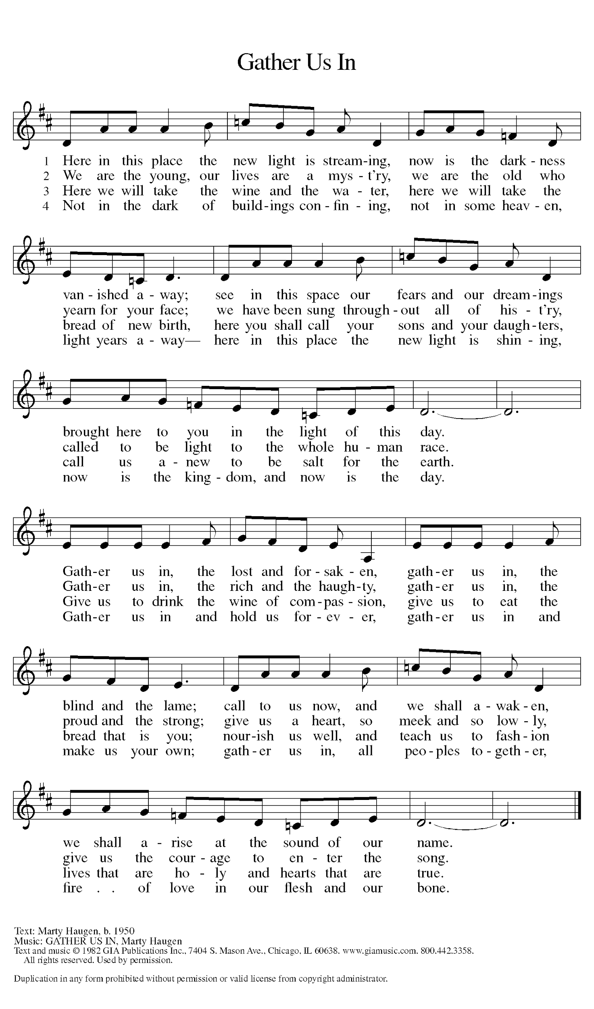

Greeting

L: The grace of our Lord Jesus Christ, the love of God, and the communion of the
Holy Spirit be with you all.
A: And also with you.

Prayer of the Day

L: O God of creation, eternal majesty, you preside over land and sea, sunshine and storm. By your strength pilot us, by your power preserve us, by your wisdom instruct us, and by your hand protect us, through Jesus Christ, our Savior and Lord.
A: Amen.

Children’s Message

WORD

First Reading – Job 38: 1-11

L: A reading from Job.
¹The Lord answered Job out of the whirlwind:
²“Who is this that darkens counsel by words without knowledge?
³Gird up your loins like a man,
I will question you, and you shall declare to me.
⁴“Where were you when I laid the foundation of the earth?
Tell me, if you have understanding.
⁵Who determined its measurements—surely you know!
Or who stretched the line upon it?
⁶On what were its bases sunk,
or who laid its cornerstone
⁷when the morning stars sang together
and all the heavenly beings shouted for joy?
⁸“Or who shut in the sea with doors
when it burst out from the womb?—
⁹when I made the clouds its garment,
and thick darkness its swaddling band,
¹⁰and prescribed bounds for it,
and set bars and doors,
¹¹and said, ‘Thus far shall you come, and no farther,
and here shall your proud waves be stopped?”

L: Word of God, word of life.
A: Thanks be to God.

Psalm Reading- Psalm 107: 1-3, 23-32

L: A reading from Psalm.

¹Give thanks to the Lord, for the Lord is good,
for God’s mercy endures forever.
²Let the redeemed of the Lord proclaim
that God redeemed them from the hand of the foe,
³gathering them in from the lands;
from the east and from the west, from the north and from the south.
²³Some went down to the sea in ships,
plying their trade in deep waters.
²⁴They beheld the works of the Lord,
God’s wonderful works in the deep.
²⁵Then God spoke, and a stormy wind arose,
which tossed high the waves of the sea.
²⁶They mounted up to the heavens and descended to the depths;
their souls melted away in their peril.
²⁷They staggered and reeled like drunkards,
and all their skill was of no avail.
²⁸Then in their trouble they cried to the Lord,
and you delivered them from their distress.
²⁹You stilled the storm to a whisper
and silenced the waves of the sea.
³⁰Then were they glad when it grew calm,
when you guided them to the harbor they desired.
³¹Let them give thanks to you, Lord, for your steadfast love
and your wonderful works for all people.
³²Let them exalt you in the assembly of the people;
in the council of the elders, let them sing hallelujah!

L: Holy Wisdom. Holy word.
A: Thanks be to God.

Second Reading – 2 Corinthians 6: 1-13

L: A reading from 2 Corinthians.

As we work together with him, we urge you also not to accept the grace of God in vain. ²For he says,
“At an acceptable time I have listened to you,
and on a day of salvation I have helped you.”
See, now is the acceptable time; see, now is the day of salvation! ³We are putting no obstacle in anyone’s way, so that no fault may be found with our ministry, ⁴but as servants of God we have commended ourselves in every way: through great endurance, in afflictions, hardships, calamities, ⁵beatings, imprisonments, riots, labors, sleepless nights, hunger; ⁶by purity, knowledge, patience, kindness, holiness of spirit, genuine love, ⁷truthful speech, and the power of God; with the weapons of righteousness for the right hand and for the left; ⁸in honor and dishonor, in ill repute and good repute. We are treated as impostors, and yet are true; ⁹as unknown, and yet are well known; as dying, and see—we are alive; as punished, and yet not killed; ¹⁰as sorrowful, yet always rejoicing; as poor, yet making many rich; as having nothing, and yet possessing everything.
¹¹We have spoken frankly to you Corinthians; our heart is wide open to you. ¹²There is no restriction in our affections, but only in yours. ¹³In return—I speak as to children—open wide your hearts also.

L: Word of God, word of life.
A: Thanks be to God.
Please rise as you are able for the reading of the Holy Gospel.

Gospel Acclamation

L: Alleluia. Now is the acceptable time, now is the day of salvation.

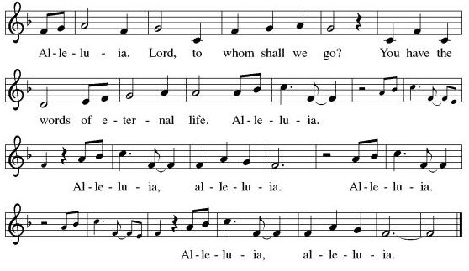

Mark 4: 35-41

L: The Holy Gospel according to Mark.
A: Glory to you, O Lord.

³⁵When evening had come, [Jesus said to the disciples,] “Let us go across to the other side.” ³⁶And leaving the crowd behind, they took him with them in the boat, just as he was. Other boats were with him. ³⁷A great windstorm arose, and the waves beat into the boat, so that the boat was already being swamped. ³⁸But he was in the stern, asleep on the cushion; and they woke him up and said to him, “Teacher, do you not care that we are perishing?” ³⁹He woke up and rebuked the wind, and said to the sea, “Peace! Be still!” Then the wind ceased, and there was a dead calm. ⁴⁰He said to them, “Why are you afraid? Have you still no faith?” ⁴¹And they were filled with great awe and said to one another, “Who then is this, that even the wind and the sea obey him?”

L: The gospel of the Lord.
A: Praise to you, O, Christ.

Sermon Pastor Mathew Berger

Hymn of the Day Lord Take my Hand and Lead Me ELW 767
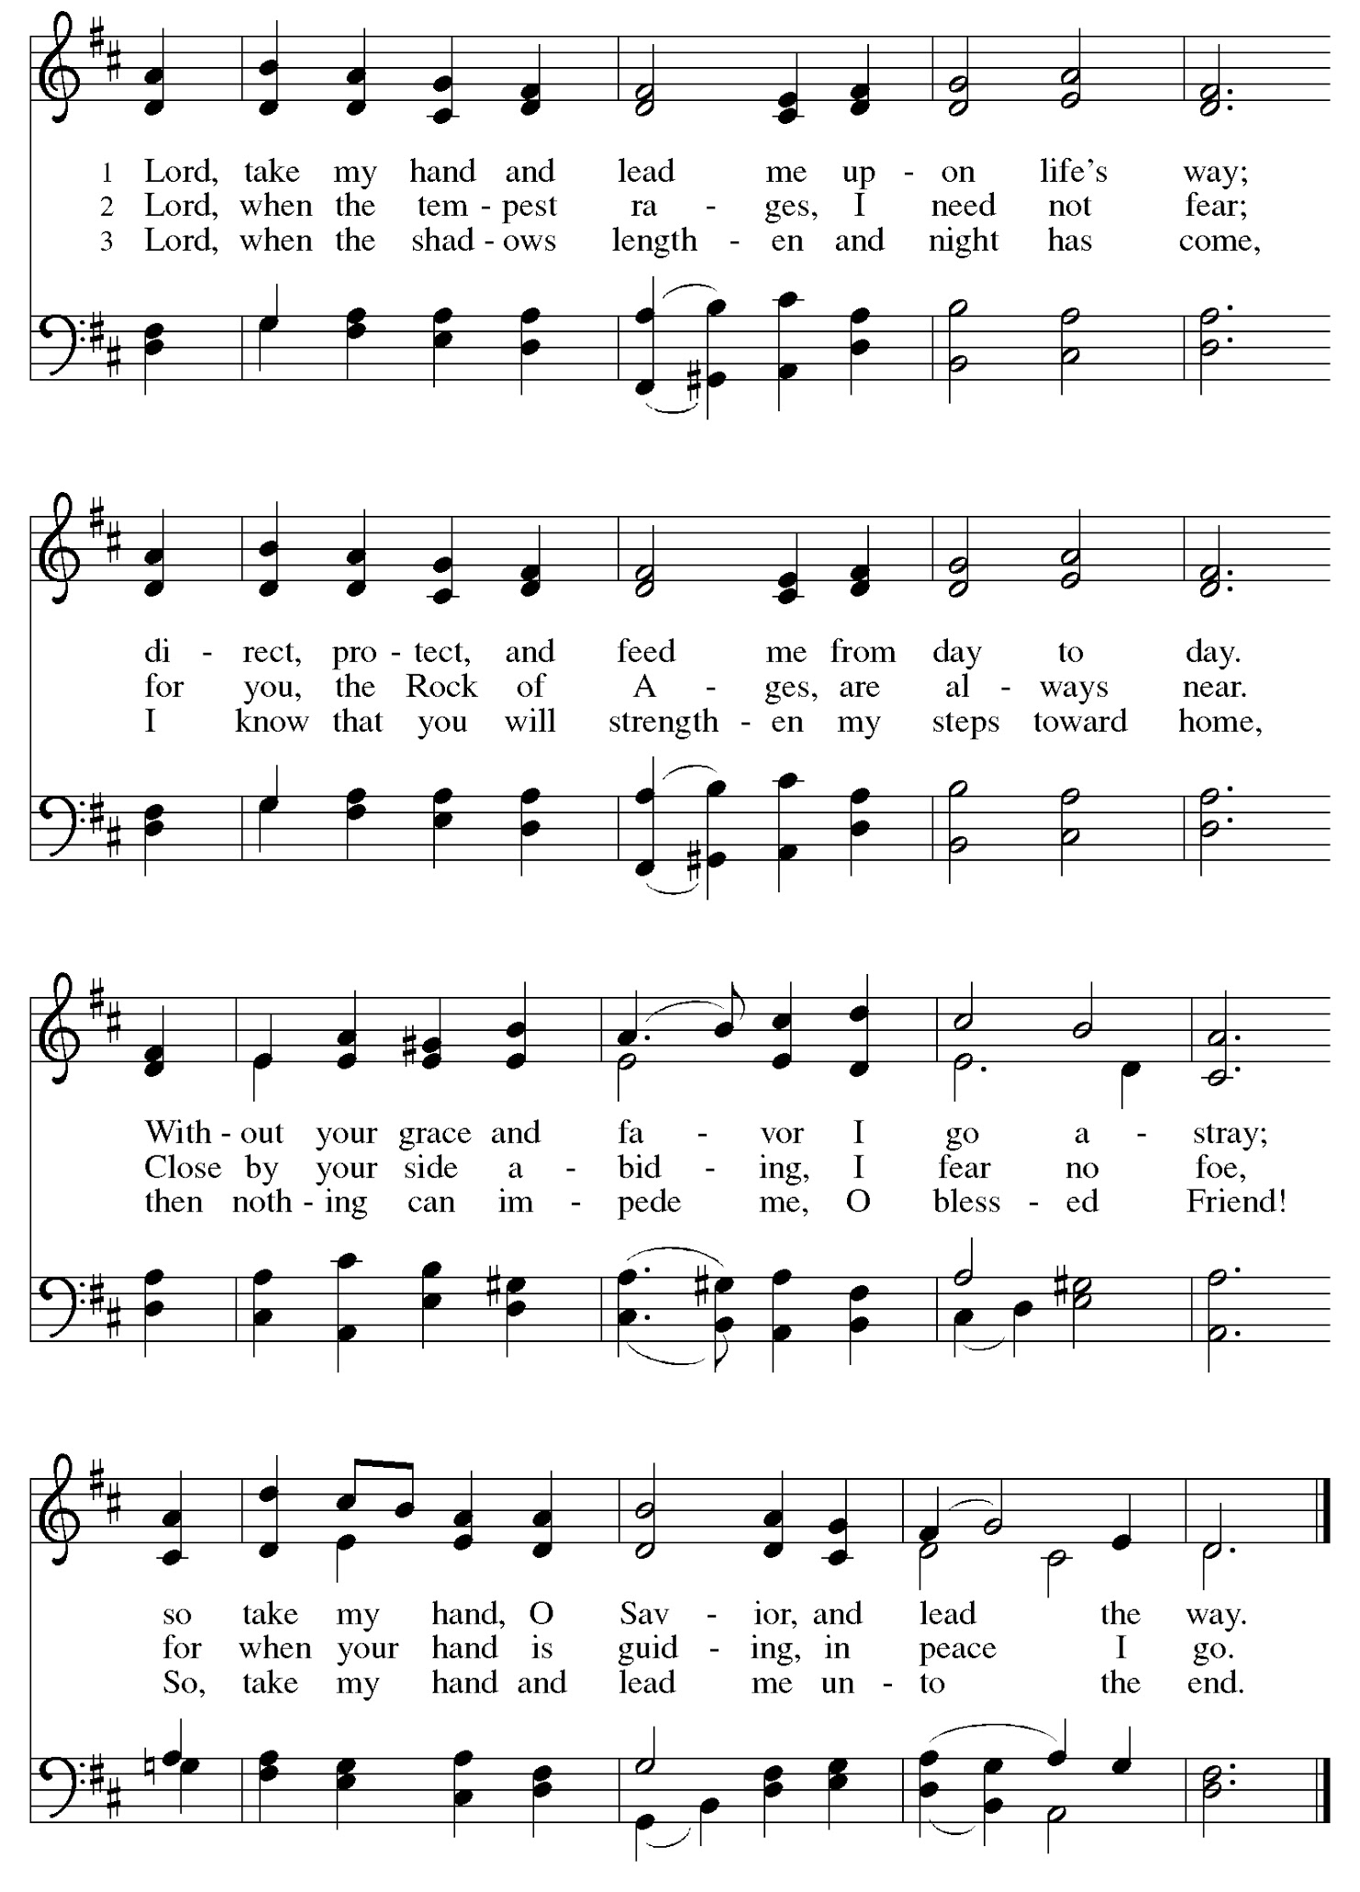

Apostles’ Creed

I believe in God, the Father almighty,
creator of heaven and earth.
I believe in Jesus Christ, God’s only Son, our Lord,
who was conceived by the Holy Spirit,
born of the virgin Mary,
suffered under Pontius Pilate,
was crucified, died, and was buried;
he descended to the dead.
On the third day he rose again;
he ascended into heaven,
he is seated at the right hand of the Father,
and he will come to judge the living and the dead.
I believe in the Holy Spirit,
the holy catholic church,
the communion of saints,
the forgiveness of sins,
the resurrection of the body,
and the life everlasting. Amen.

Prayers of Intercession

Throughout our prayers, each petition ends “Lord, in your mercy,” The congregation is invited to respond, “Hear our prayer.”

Sharing the Peace

L: The peace of Christ be with you always.
A: And also with you.

You are invited to share a sign of God’s peace with your neighbors by turning to the people near you sand saying, “Peace be with you.”

MEAL

All are welcome at Christ’s table.

Communion is distributed in front of the altar. The individual cups are filled with wine. The prepackaged cups are juice. If you prefer not to receive communion you may come forward with your hands crossed over your chest to receive a blessing or you may remain in your seat.

Offering

Offerings can be placed in the offering box at the back of the sanctuary, sent by mail or given online. You can send a check to St. Paul Lutheran Church 210 Deerfield Rd Pontiac, IL 61764 or give online at stpaulpontiac.org

Offertory Music Come to Jesus Chris Rice
special music, Cody Leach

Offering Prayer

L: Jesus, Bread of life,
You have set this table with your very self,
And called us the feast of plenty.
Gather what has been sown among us,
And strengthen us in this meal.
Make us to be what we receive here,
Your body for the life of the world.
A: Amen.
Great Thanksgiving
L: The Lord be with you.
A: And also with you.
L: Lift up your hearts.
A: We lift them to the Lord.
L: Let us give thanks to the Lord our God.
A: It is right to give our thanks and praise.

Preface
L: It is indeed right, our duty and our joy,
that we should at all times and in all places
give thanks and praise to you, almighty and merciful God,
through our Savior Jesus Christ.
Fulfilling the promise of the resurrection,
you pour out the fire of your Spirit,
uniting in one body people of every nation and tongue.
And so, with Mary Magdalene and Peter and all the witnesses of the resurrection,
with earth and sea and all their creatures,
and with angels and archangels, cherubim and seraphim,
we praise your name and join their unending hymn saying:

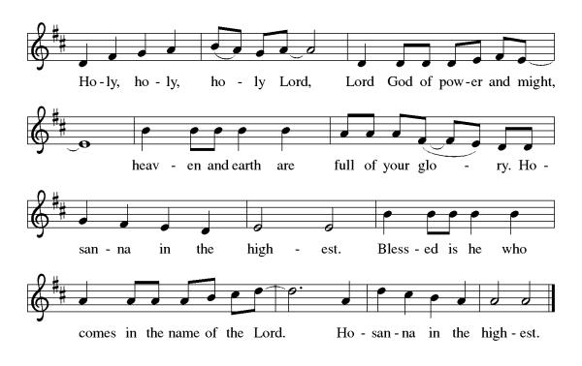

Thanksgiving at the Table

L: Blessed are you, O God of the universe.
Your mercy is everlasting
and your faithfulness endures from age to age.

Praise to you for creating the heavens and the earth.
Praise to you for saving the earth from the waters of the flood.
Praise to you for bringing the Israelites safely through the sea.
Praise to you for leading your people through the wilderness
to the land of milk and honey.
Praise to you for the words and deeds of Jesus, your anointed one.
Praise to you for the death and resurrection of Christ.
Praise to you for your Spirit poured out on all nations.

In the night in which he was betrayed,
our Lord Jesus took bread, and gave thanks;
broke it, and gave it to his disciples, saying:
Take and eat; this is my body, given for you.
Do this for the remembrance of me.

Again, after supper, he took the cup, gave thanks,
and gave it for all to drink, saying:
This cup is the new covenant in my blood,
shed for you and for all people for the forgiveness of sin.
Do this for the remembrance of me.

With this bread and cup
we remember our Lord’s passover from death to life
as we proclaim the mystery of faith:
Christ has died.
Christ is risen.
Christ will come again.

O God of resurrection and new life:
Pour out your Holy Spirit on us
and on these gifts of bread and wine.
Bless this feast.
Grace our table with your presence. Come, Holy Spirit.
Come, Holy Spirit.

Reveal yourself to us in the breaking of the bread.
Raise us up as the body of Christ for the world.
Breathe new life into us.
Send us forth,
burning with justice, peace, and love. Come, Holy Spirit.
Come, Holy Spirit.

With your holy ones of all times and places,
with the earth and all its creatures,
with sun and moon and stars,
we praise you, O God,
blessed and holy Trinity,
now and forever. Let the church say Amen.
A: Amen.

Lord's Prayer

L: Gathered into one by the Holy Spirit, let us pray as Jesus taught us,
A: Our Father, who art in heaven, hallowed be thy name, thy kingdom come, thy will be done, on earth as it is in heaven. Give us this day our daily bread; and forgive us our trespasses, as we forgive those who trespass against us; and lead us not into temptation but deliver us from evil. For thine is the kingdom and the power, and the glory, forever and ever. Amen.

Invitation to Communion

L: Here is the Lamb of God who takes away the sin of the world! Come to the table of mercy and
Joy.

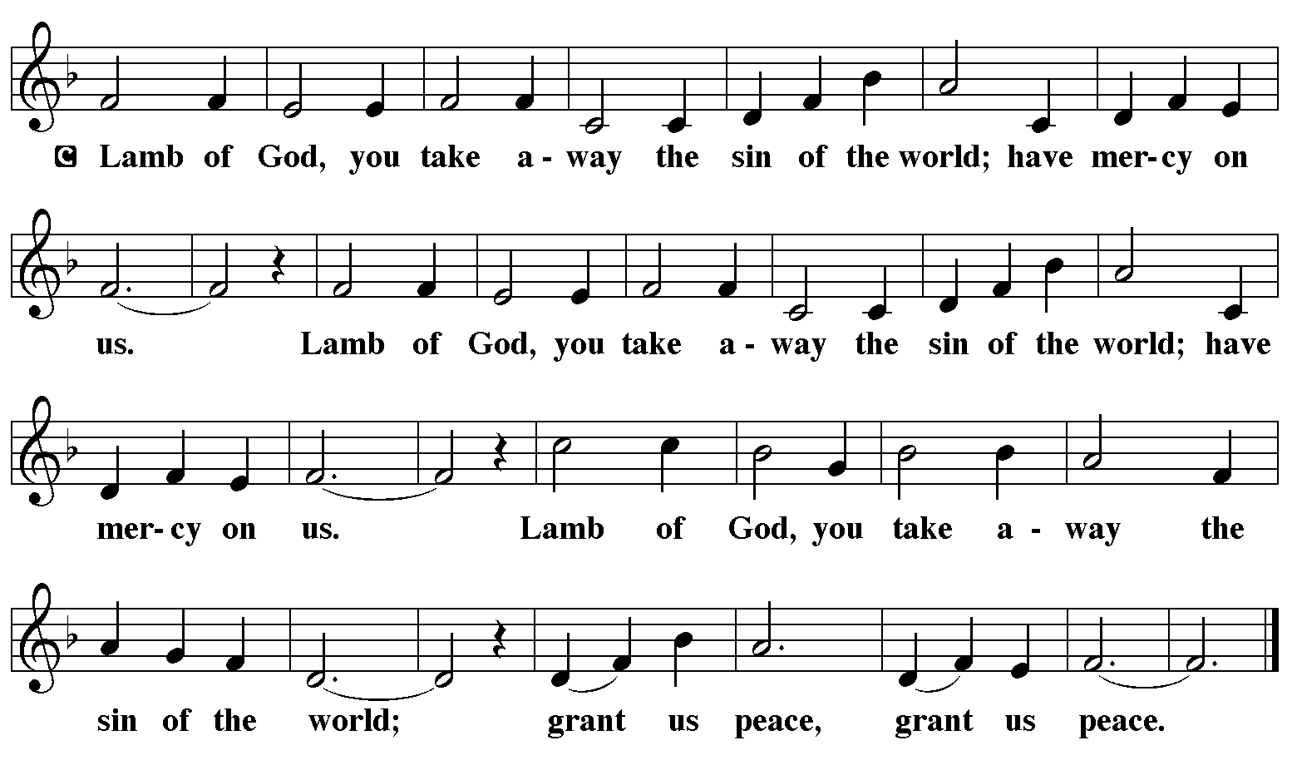

Communion Music Peace Be Still Hope Darst (video)

Communion Music Eat this Bread ELW 472
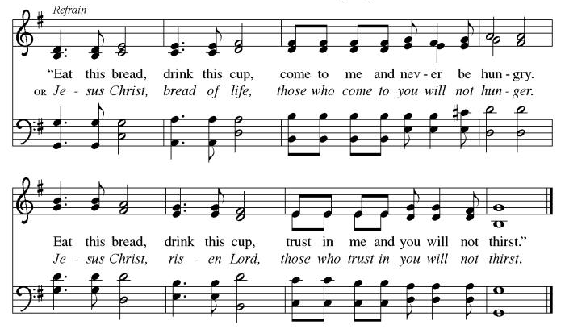

Prayer After Communion
a blessing is given, a prayer follows

L: Jesus, Bread of life,
We have received from your table
More than we could ask.
As you have nourished us in this meal,
Now strengthen us to love the world with your own life.
In your name we pray.
A: Amen.

Announcements

SENDING

Blessing

L: The blessing of God,
Who provides for us, feeds us, and journeys with us,
☩ be upon you now and forever.
A: Amen.

Sending Hymn My Life Flows on in Endless Song ELW 763
see music on final page

Dismissal

L: Go in peace. You are the body of Christ.
A: Thanks be to God.

Postlude

Licensing information for this Worship Service:
CCLI Copyright License A 2440181 9/30/2021 + Streaming License A 20530290 5/31/2022
Sundays and Seasons License Sundays and Seasons v.20200325.1254
Thank you to all those who contributed to today’s service: Worship Slides: Julie Mehlberg, Lector: Lucy Kehinde, Ushers: Mary & Denny Leach, Musician: Julie Mehlberg, Communion Prep: Jean Harrison & Ginger Bauknecht, Communion Asst.: Mary & Denny Leach, Livestream: Louis Kehinde, Sound: John Mehlberg.
