St. Paul Lutheran Church
Pontiac, IL
October 3, 2021
19th Sunday after Pentecost

Red bag offering will be collected this morning and donated to the Boys & Girls Club.

We gather to worship, reach out, and serve the Lord.

Welcome

Welcome to St. Paul Lutheran Church. Whether you have worshipped with us many times, or this is your first time, there is a place for you here. Your presence among us is a gift.

God’s Peace be with you.

Introduction to the day
Introduction

Today’s gospel combines a saying that makes many of us uncomfortable with a story we find comforting. Jesus’ saying on divorce is another of his rejections of human legislation in favor of the original intent of God’s law. Jesus’ rebuke of the disciples who are fending off the children should challenge us as well. What does it mean to receive the kingdom of God as a child does?

Prelude

GATHERING

Welcome to Worship

Confession and Forgiveness
All may make the sign of the cross, the sign marked at baptism, as the presiding minister begins.
L: Blessed be the Holy Trinity, ☩ one God,
whose teaching is life,
whose presence is sure,
and whose love is endless
A: Amen.

L: Let us confess our sins to the one who welcomes us with an open heart.

Silence is kept for reflection.
L: God, our comforter:
A: like lost sheep, we have gone astray.
We gaze upon abundance and see scarcity.
We turn our faces away from injustice and oppression.
We exploit the earth with our apathy and greed.
Free us from our sin, gracious God.
Listen when we call out to you for help.
Lead us by your love to love our neighbors as ourselves.
Amen.

L: All have sinned and fall short of the glory of God.
By the gift of grace in ☩ Christ Jesus, God makes you righteous.
Receive with glad hearts the forgiveness of all your sins.
A: Amen.

Gathering Hymn Blest Are They ELW 728

Greeting

L: The grace of our Lord Jesus Christ, the love of God, and the communion of the
Holy Spirit be with you all.
A: And also with you.

Prayer of the Day

L: Sovereign God, you have created us to live in loving community with one another. Form us for life that is faithful and steadfast, and teach us to trust like little children, that we may reflect the image of your Son, Jesus Christ, our Savior and Lord.
A: Amen.

Children’s Message

WORD

First Reading – Genesis 2: 18-24

L: A reading from Genesis.

¹⁸The Lord God said, “It is not good that the man should be alone; I will make him a helper as his partner.” ¹⁹So out of the ground the Lord God formed every animal of the field and every bird of the air, and brought them to the man to see what he would call them; and whatever the man called every living creature, that was its name. ²⁰The man gave names to all cattle, and to the birds of the air, and to every animal of the field; but for the man there was not found a helper as his partner. ²¹So the Lord God caused a deep sleep to fall upon the man, and he slept; then he took one of his ribs and closed up its place with flesh. ²²And the rib that the Lord God had taken from the man he made into a woman and brought her to the man. ²³Then the man said,
“This at last is bone of my bones
and flesh of my flesh;
this one shall be called Woman,
for out of Man this one was taken.”
²⁴Therefore a man leaves his father and his mother and clings to his wife, and they become one flesh.
L: Word of God, word of life.
A: Thanks be to God.

Psalm Reading- Psalm 8

L: A reading from Psalm.

¹O Lord our Lord,
how majestic is your name in all the earth!—
²you whose glory is chanted above the heavens out of the mouths of infants and children;
you have set up a fortress against your enemies, to silence the foe and avenger.
³When I consider your heavens, the work of your fingers,
the moon and the stars you have set in their courses,
⁴what are mere mortals that you should be mindful of them,
human beings that you should care for them?
⁵Yet you have made them little less than divine;
with glory and honor you crown them.
⁶You have made them rule over the works of your hands;
you have put all things under their feet:
⁷all flocks and cattle,
even the wild beasts of the field,
⁸the birds of the air, the fish of the sea,
and whatever passes along the paths of the sea.
⁹O Lord our Lord,
how majestic is your name in all the earth!

L: Holy Wisdom. Holy word.
A: Thanks be to God.

Second Reading – Hebrews 1: 1-4; 2: 5-12

L: A reading from Hebrews.

¹Long ago God spoke to our ancestors in many and various ways by the prophets, ²but in these last days he has spoken to us by a Son, whom he appointed heir of all things, through whom he also created the worlds. ³He is the reflection of God’s glory and the exact imprint of God’s very being, and he sustains all things by his powerful word. When he had made purification for sins, he sat down at the right hand of the Majesty on high, ⁴having become as much superior to angels as the name he has inherited is more excellent than theirs.
^{2:5}Now God did not subject the coming world, about which we are speaking, to angels. ⁶But someone has testified somewhere,
“What are human beings that you are mindful of them,
or mortals, that you care for them?
⁷You have made them for a little while lower than the angels;
you have crowned them with glory and honor,
⁸subjecting all things under their feet.”
Now in subjecting all things to them, God left nothing outside their control. As it is, we do not yet see everything in subjection to them,⁹but we do see Jesus, who for a little while was made lower than the angels, now crowned with glory and honor because of the suffering of death, so that by the grace of God he might taste death for everyone.
¹⁰It was fitting that God, for whom and through whom all things exist, in bringing many children to glory, should make the pioneer of their salvation perfect through sufferings. ¹¹For the one who sanctifies and those who are sanctified all have one Father. For this reason Jesus is not ashamed to call them brothers and sisters, ¹²saying,
“I will proclaim your name to my brothers and sisters,
in the midst of the congregation I will praise you.”.

L: Word of God, word of life.
A: Thanks be to God.
Please rise as you are able for the reading of the Holy Gospel.

Gospel Acclamation

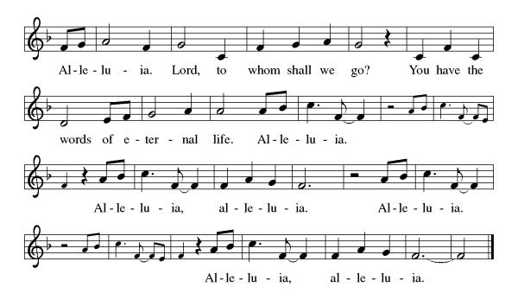
Mark 10: 2-16

L: The Holy Gospel according to Mark.
A: Glory to you, O Lord.

²Some Pharisees came, and to test [Jesus] they asked, “Is it lawful for a man to divorce his wife?” ³He answered them, “What did Moses command you?” ⁴They said, “Moses allowed a man to write a certificate of dismissal and to divorce her.” ⁵But Jesus said to them, “Because of your hardness of heart he wrote this commandment for you. ⁶But from the beginning of creation, ‘God made them male and female.’ ⁷‘For this reason a man shall leave his father and mother and be joined to his wife, ⁸and the two shall become one flesh.’ So they are no longer two, but one flesh. ⁹Therefore what God has joined together, let no one separate.”
¹⁰Then in the house the disciples asked him again about this matter. ¹¹He said to them, “Whoever divorces his wife and marries another commits adultery against her; ¹²and if she divorces her husband and marries another, she commits adultery.”
¹³People were bringing little children to him in order that he might touch them; and the disciples spoke sternly to them. ¹⁴But when Jesus saw this, he was indignant and said to them, “Let the little children come to me; do not stop them; for it is to such as these that the kingdom of God belongs. ¹⁵Truly I tell you, whoever does not receive the kingdom of God as a little child will never enter it.” ¹⁶And he took them up in his arms, laid his hands on them, and blessed them.

L: The gospel of the Lord.
A: Praise to you, O, Christ.

Sermon Pastor Mathew Berger

Hymn of the Day Build us up Lord ELW 670

Apostles’ Creed

I believe in God, the Father almighty,
creator of heaven and earth.
I believe in Jesus Christ, God’s only Son, our Lord,
who was conceived by the Holy Spirit,
born of the virgin Mary,
suffered under Pontius Pilate,
was crucified, died, and was buried;
he descended to the dead.
On the third day he rose again;
he ascended into heaven,
he is seated at the right hand of the Father,
and he will come to judge the living and the dead.
I believe in the Holy Spirit,
the holy catholic church,
the communion of saints,
the forgiveness of sins,
the resurrection of the body,
and the life everlasting. Amen.

Prayers of Intercession

Throughout our prayers, each petition ends “Lord, in your mercy.” The congregation is invited to respond, “hear our prayer.”

Sharing the Peace

L: The peace of Christ be with you always.
A: And also with you.

You are invited to share a sign of God’s peace with your neighbors by turning to the people near you saying, “Peace be with you.”

MEAL

All are welcome at Christ’s table.

Communion is distributed in front of the altar. The individual cups are filled with wine. The prepackaged cups are juice. If you prefer not to receive communion you may come forward with your hands crossed over your chest to receive a blessing or you may remain in your seat.

Offering

Offerings can also be sent by mail or given online. You can send a check to St. Paul Lutheran Church 210 Deerfield Rd Pontiac, IL 61764 or give online at stpaulpontiac.org

Offertory Music Special Music

Offering Prayer

L: God of abundance,
you cause streams to break forth in the desert
and manna to rain from the heavens.
Accept the gifts you have first given us.
Unite them with the offering of our lives
to nourish the world you love so dearly;
through Jesus Christ, our Savior and Lord.
A: Amen.

Great Thanksgiving
L: The Lord be with you.
A: And also with you.
L: Lift up your hearts.
A: We lift them to the Lord.
L: Let us give thanks to the Lord our God.
A: It is right to give our thanks and praise.

Preface
L: It is indeed right, our duty and our joy,
that we should at all times and in all places
give thanks and praise to you, almighty and merciful God,
through the great Shepherd of your flock, our Savior Jesus Christ;
who after his resurrection sent forth apostles
to preach the gospel and teach all nations,
and promised to be with them, even to the end of the age.
And so, with Thomas and Phillip, Junia and Paul, and the glorious company of the
Apostles, with the choirs of angels and all the hosts of heaven,
we praise your name and join their unending hymn:
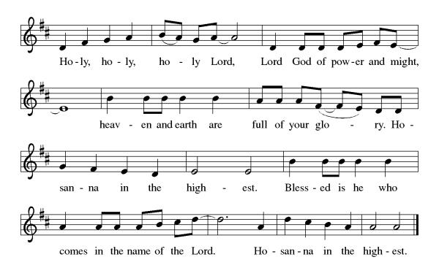
Thanksgiving at the Table

L: Holy, mighty and merciful Lord,
heaven and earth are full of your glory.
In great love you sent to us Jesus, your Son,
who reached out to heal the sick and suffering,
who preached good news to the poor,
and who, on the cross, opened his arms to all.

In the night in which he was betrayed,
our Lord Jesus took bread, and gave thanks;
broke it, and gave it to his disciples, saying:
Take and eat; this is my body, given for you.
Do this for the remembrance of me.

Again, after supper, he took the cup, gave thanks,
and gave it for all to drink, saying:
This cup is the new covenant in my blood,
shed for you and for all people for the forgiveness of sin.
Do this for the remembrance of me.

Remembering, therefore, his death,
resurrection, and ascension,
we await his coming in glory.

Pour out upon us the Spirit of your love,
O Lord, and unite the wills of all who share this heavenly food,
the body and blood of Jesus Christ, our Lord;
to whom, with you and the Holy Spirit,
be all honor and glory, now and forever.
A: Amen.

Lord's Prayer

L: Gathered into one by the Holy Spirit, let us pray as Jesus taught us,
A: Our Father, who art in heaven, hallowed be thy name, thy kingdom come, thy will be done, on earth as it is in heaven. Give us this day our daily bread; and forgive us our trespasses, as we forgive those who trespass against us; and lead us not into temptation but deliver us from evil. For thine is the kingdom and the power, and the glory, forever and ever. Amen.

Invitation to Communion

L: All who hunger and thirst, come. The table is ready.

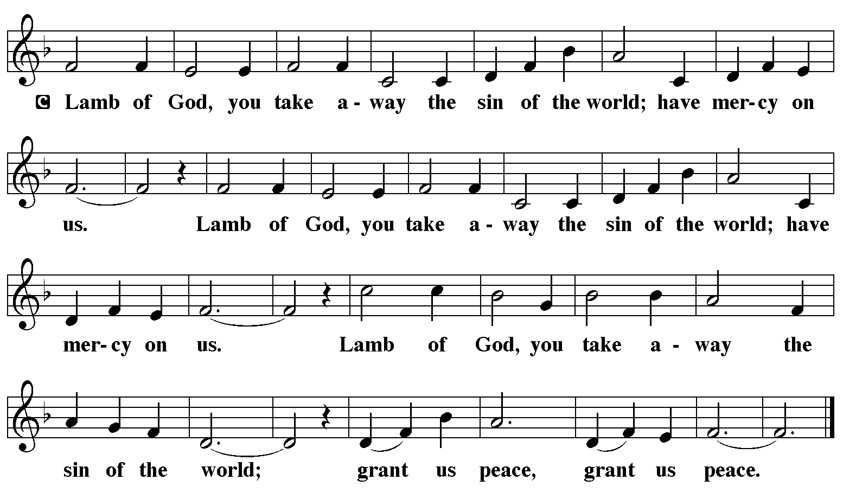

Communion Music Come to the Table Video

Communion Music Father, I Adore You W&P 37

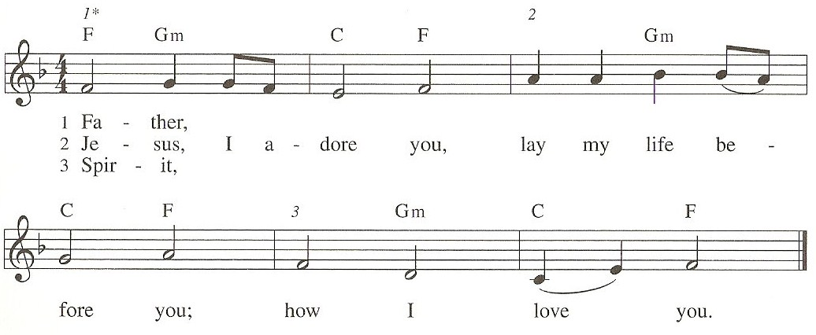

Prayer After Communion
a blessing is given, a prayer follows

L: Lord of life,
in the gift of your body and blood
you turn the crumbs of our faith into a feast of salvation.
Send us forth into the world with shouts of joy,
bearing witness to the abundance of your love
in Jesus Christ, our Savior and Lord.
A: Amen.

Announcements

SENDING

Blessing

L: People of God,
you are Christ’s body,
bringing new life to a suffering world.
The holy Trinity, ☩ one God,
bless you now and forever.
A: Amen.

Sending Hymn - Lord, I Lift your Name on High (sing twice) ELW 857
see music on final page

Dismissal

L: Go in peace. The living Word dwells in you.
A: Thanks be to God.

Postlude

Licensing information for this Worship Service:
CCLI Copyright License A 2440181 9/30/2021 + Streaming License A 20530290 5/31/2022
Sundays and Seasons License Sundays and Seasons v.20200325.1254
Thank you to all those who contributed to today’s service: Lector: Judy Sykes, Ushers: Mary & Denny Leach, Musician: Julie Mehlberg, Communion Prep: Jean Harrison & Ginger Bauknecht, Communion Asst: Mary & Denny Leach, Livestream: Louis Kehinde, Sound & Projection: Emma Johnson, Joel Rapp, Julie Mehlberg, John Mehlberg and Melissa Rapp, Hospitality; Mary Leach & Darla Dixon, Counters: Cody Leach & Carrie Lueker.

