St. Paul Lutheran Church
Pontiac, IL
June 13, 2021
3rd Sunday after Pentecost

“Red bag” offering will be collected this morning and will be donated to the Rowe cemetery.

We gather to worship, reach out, and serve the Lord.

Welcome

Welcome to St. Paul Lutheran Church. Whether you have worshipped with us many times, or this is your first time, there is a place for you here. Your presence among us is a gift.

God’s Peace be with you.

Introduction to the day
Introduction

The mustard seed becomes a great shrub that shelters the birds, recalling ancient images of the tree of life. We’d expect a cedar or a sequoia, but Jesus finds the power of God better imaged in a tiny, no-account seed. It’s not the way we expect divine activity to look. Yet the tree of life is here, in the cross around which we gather, the tree into which we are grafted through baptism, the true vine that nourishes us with its fruit in the cup we share. It may not appear all that impressive, but while nobody’s looking it grows with a power beyond our understanding.

Prelude

CONFESSION AND FORGIVENESS

All may make the sign of the cross, the sign marked at baptism, as the presiding minister begins.
L: Blessed be the Holy Trinity, ☩ one God,
The God of manna,
The God of miracles,
The God of mercy.
A: Amen.

L: Drawn to Christ and seeking God’s abundance,
Let us confess our sin.

Silence is kept for reflection.
L: God, our provider,
A: help us.
It is hard to believe there is enough to share.
We question your ways when they differ from the ways
of the world in which we live.
We turn to our own understanding
rather than trusting in you.
We take offense at your teachings and your ways.
Turn us again to you.
Where else can we turn?
Share with you the words of eternal life
and feed us for life in the world.
Amen.

L: Beloved people of God:
in Jesus, the manna from heaven,
you are fed and nourished.
By Jesus, the worker of miracles,
there is always more than enough.
Through Jesus ☩ the bread of life,
you are shown God’s mercy:
you are forgiven and loved into abundant life.
A: Amen.

Gathering Hymn Come Thou Fount of Every Blessing ELW 807

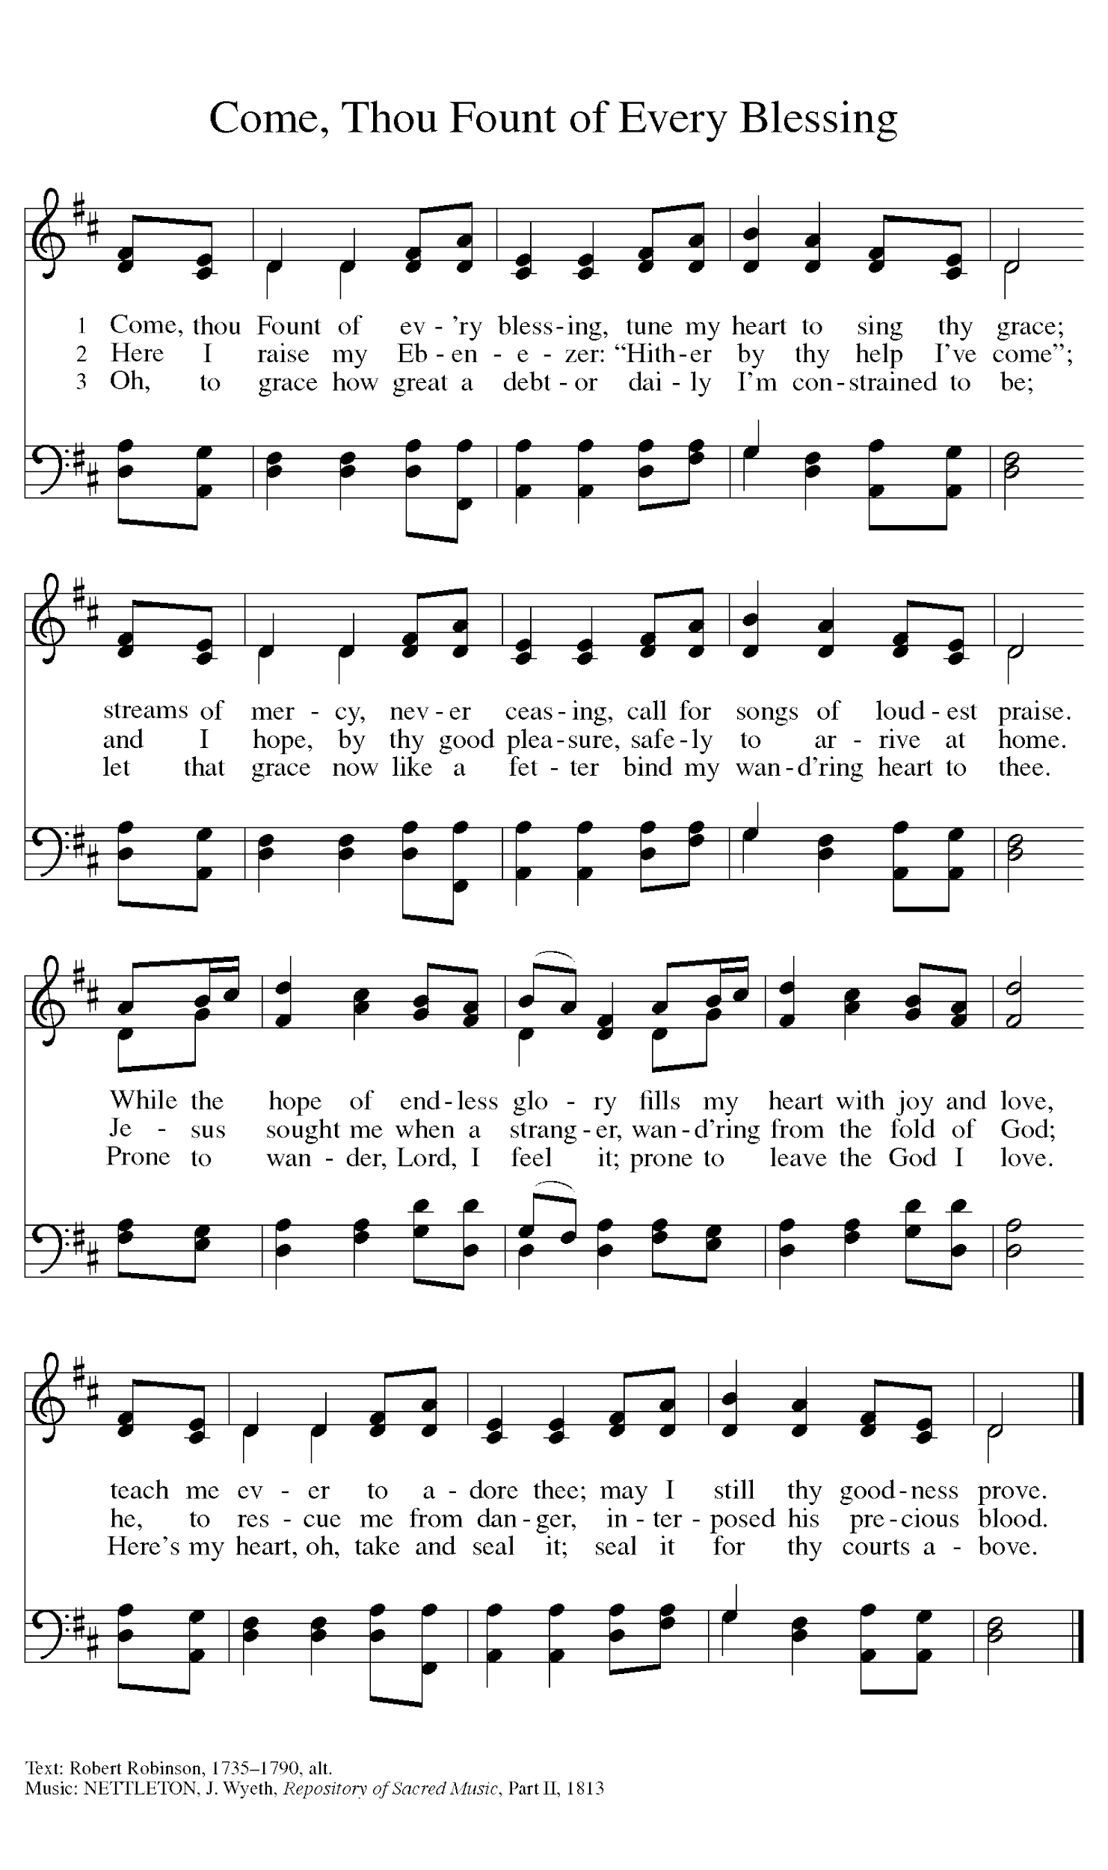

Greeting

L: The grace of our Lord Jesus Christ, the love of God, and the communion of the
Holy Spirit be with you all.
A: And also with you.

Prayer of the Day

L: O God, you are the tree of life, offering shelter to all the world. Graft us into yourself and nurture
our growth, that we may bear your truth and love to those in need, through Jesus Christ, our
Savior and Lord.
A: Amen.

Children’s Message

WORD

First Reading – Ezekiel 17: 22-24

L: A reading from Ezekiel.
²²Thus says the Lord God:
I myself will take a sprig
from the lofty top of a cedar;
I will set it out.
I will break off a tender one
from the topmost of its young twigs;
I myself will plant it
on a high and lofty mountain.
²³On the mountain height of Israel
I will plant it,
in order that it may produce boughs and bear fruit,
and become a noble cedar.
Under it every kind of bird will live;
in the shade of its branches will nest
winged creatures of every kind.
²⁴All the trees of the field shall know
that I am the Lord.
I bring low the high tree,
I make high the low tree;
I dry up the green tree
and make the dry tree flourish.
I the Lord have spoken;
I will accomplish it.

L: Word of God, word of life.
A: Thanks be to God.

Psalm Reading- Psalm 92: 1-4, 12-15

L: A reading from Psalm.

¹It is a good thing to give thanks to the Lord,
to sing praise to your name, O Most High;
²to herald your love in the morning
and your faithfulness at night;
³on the psaltery, and on the lyre,
and to the melody of the harp.
⁴For you have made me glad by your acts, O Lord;
and I shout for joy because of the works of your hands.
¹²The righteous shall flourish like a palm tree,
and shall spread abroad like a cedar of Lebanon.
¹³Those who are planted in the house of the Lord
shall flourish in the courts of our God;
¹⁴they shall still bear fruit in old age;
they shall be green and succulent;
¹⁵that they may show how upright the Lord is,
my rock, in whom there is no injustice.

L: Holy Wisdom. Holy word.
A: Thanks be to God.

Second Reading – 2 Corinthians 5: 6-10, 14-17

L: A reading from 2 Corinthians.

⁶So we are always confident; even though we know that while we are at home in the body we are away from the Lord—⁷for we walk by faith, not by sight. ⁸Yes, we do have confidence, and we would rather be away from the body and at home with the Lord. ⁹So whether we are at home or away, we make it our aim to please him. ¹⁰For all of us must appear before the judgment seat of Christ, so that each may receive recompense for what has been done in the body, whether good or evil.
[¹¹Therefore, knowing the fear of the Lord, we try to persuade others; but we ourselves are well known to God, and I hope that we are also well known to your consciences. ¹²We are not commending ourselves to you again, but giving you an opportunity to boast about us, so that you may be able to answer those who boast in outward appearance and not in the heart. ¹³For if we are beside ourselves, it is for God; if we are in our right mind, it is for you. ] ¹⁴For the love of Christ urges us on, because we are convinced that one has died for all; therefore all have died. ¹⁵And he died for all, so that those who live might live no longer for themselves, but for him who died and was raised for them.
¹⁶From now on, therefore, we regard no one from a human point of view; even though we once knew Christ from a human point of view, we know him no longer in that way. ¹⁷So if anyone is in Christ, there is a new creation: everything old has passed away; see, everything has become new!

L: Word of God, word of life.
A: Thanks be to God.

Please rise as you are able for the reading of the Holy Gospel.

Gospel Acclamation
(spoken responsively)

L: Alleluia. Welcome with meekness the implanted word
A: That has the power to save your souls. Alleluia.

Mark 4: 26-34

L: The Holy Gospel according to Mark.
A: Glory to you, O Lord.

²⁶[Jesus] said, “The kingdom of God is as if someone would scatter seed on the ground,²⁷and would sleep and rise night and day, and the seed would sprout and grow, he does not know how. ²⁸The earth produces of itself, first the stalk, then the head, then the full grain in the head. ²⁹But when the grain is ripe, at once he goes in with his sickle, because the harvest has come.”
³⁰He also said, “With what can we compare the kingdom of God, or what parable will we use for it? ³¹It is like a mustard seed, which, when sown upon the ground, is the smallest of all the seeds on earth; ³²yet when it is sown it grows up and becomes the greatest of all shrubs, and puts forth large branches, so that the birds of the air can make nests in its shade.”
³³With many such parables he spoke the word to them, as they were able to hear it; ³⁴he did not speak to them except in parables, but he explained everything in private to his disciples.

L: The gospel of the Lord.
A: Praise to you, O, Christ.

Sermon Pastor Mathew Berger

Hymn of the Day Borning Cry ELW 732
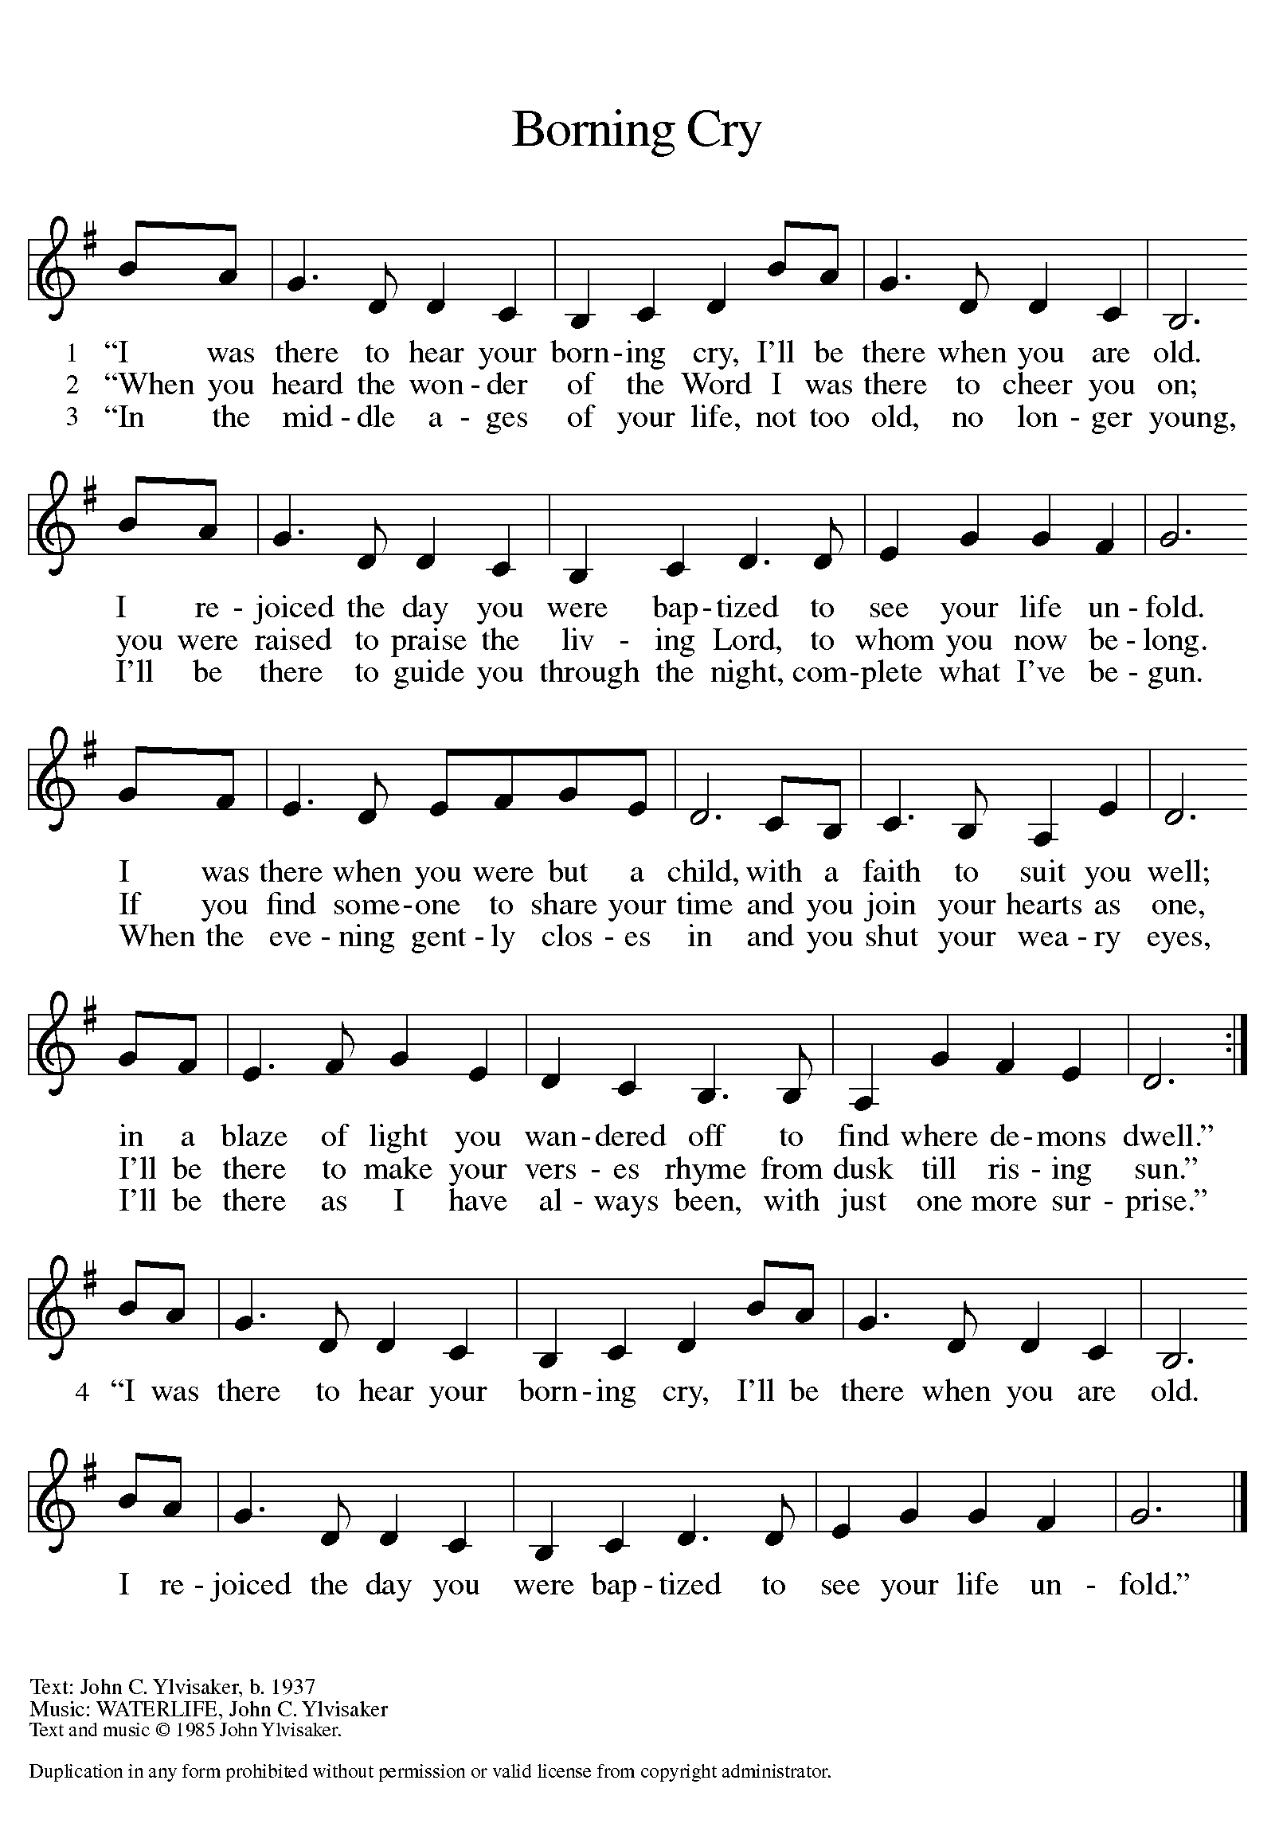

PRESENTATION OF WADE JACOB DIXON
God, who is rich in mercy and love, gives us a new birth into a living hope through the sacrament of baptism. By water and the Word, God delivers us from sin and death and raises us to new life in Jesus Christ. We are united with all the baptized in the one body of Christ, anointed with the gift of the Holy Spirit, and joined in God’s mission for the life of the world.

Sponsors: We present Wade Jacob Dixon for baptism.

L: Called by the Holy Spirit, trusting in the grace and love of God, do you desire to have Wade baptized into Christ?
R: We do.
L: As you bring Wade to receive the gift of baptism, you are entrusted with responsibilities:
To live with him among God's faithful people,
Bring him to the word of God and the holy supper,
Teach him the Lord's Prayer, the Creed, and the Ten Commandments,
Place in his hands the Holy Scriptures,
And nurture him in faith and prayer,
so that he may learn to trust God,
proclaim Christ through word and deed,
care for others and the world God made,
and work for justice and peace.
Do you promise to help Wade grow in the Christian faith and life?
R: We do.
L: Sponsors, do you promise to nurture Wade in the Christian faith as you are empowered by God's Spirit, and to help him live in the covenant of baptism and in communion with the church?
R: We do.
L: People of God, do you promise to support Wade and pray for him in is life in Christ?
A: We do.
PROFESSION OF FAITH
Please stand as you are able
L: I ask you to profess your faith in Christ Jesus, reject sin, and confess the faith of the church.
L: Do you renounce the devil and all the forces that defy God?
R: We renounce them.
L: Do you renounce the powers of this world that rebel against God?
R: We renounce them.
L: Do you renounce the ways of sin that draw you from God?
R: We renounce them.
L: Do you believe in God the Father?
R/A: I believe in God, the Father almighty,
creator of heaven and earth.
L: Do you believe in Jesus Christ, the Son of God?
R/A: I believe in Jesus Christ, God's only Son, our Lord,
who was conceived by the Holy Spirit,
born of the virgin Mary,
suffered under Pontius Pilate,
was crucified, died, and was buried;
he descended to the dead.
On the third day he rose again;
he ascended into heaven,
he is seated at the right hand of the Father,
and he will come to judge the living and the dead.
L: Do you believe in God the Holy Spirit?
R/A: I believe in the Holy Spirit,
the holy catholic church,
the communion of saints,
the forgiveness of sins,
the resurrection of the body,
and the life everlasting.
THANKSGIVING AT THE FONT
L: The Lord be with you.
A: And also with you.
L: Let us give thanks to the Lord our God.
A: It is right to give our thanks and praise.
L: Holy God, holy and merciful, holy and mighty, you are the river of life, you are the everlasting wellspring, you are the fire of rebirth.
Glory to you for oceans and lakes, for rivers and streams.
Honor to you for cloud and rain, for dew and snow.
Your waters are below us, around us, above us: our life is born in you.
You are the fountain of resurrection.

Praise to you for your saving waters:
Noah and the animals survive the flood,
Hagar discovers your well.
The Israelites escape through the sea,
and they drink from your gushing rock.
Naaman washes his leprosy away,
and the Samaritan woman will never be thirsty again.

At this font, holy God, we pray:
Praise to you for the water of baptism
and for your Word that saves us in this water.
Breathe your Spirit into all who are gathered here
and into all creation. Illumine our days.
Enliven our bones. Dry our tears.
Wash away the sin within us, and drown the evil around us.
Satisfy all our thirst with your living water,
Jesus Christ, our Savior, who lives and reigns with you
and the Holy Spirit, one God, now and forever.
A: Amen.

BAPTISM
L: Wade, I baptize you in the name of the Father,
and of the Son, and of the Holy Spirit.
You Have Put on Christ” is sung once by Pastor and then repeated by the Congregation.
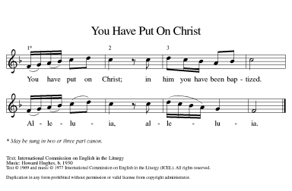

L: Let us pray.
We give you thanks, O God, that through water and the Holy Spirit you give your children new birth, cleanse them from sin, and raise them to eternal life. Sustain Wade with the gift of your Holy Spirit: the spirit of wisdom and understanding, the spirit of counsel and might, the spirit of knowledge and the fear of the Lord, the spirit of joy in your presence, both now and forever.
A: Amen.
L: Wade, child of God, you have been sealed by the Holy Spirit and marked with the cross of Christ forever.
WELCOME
L: Let your light so shine before others that they may see your good works and glorify God.
L: Let us welcome the newly baptized.
A: Wade, we welcome you into the body of Christ and into the mission we share: join us in giving thanks and praise to God and bearing God's creative and redeeming word to all the world.

Prayers of Intercession

Throughout our prayers, each petition ends “Lord, in your mercy,” The congregation is invited to respond, “Hear our prayer.”

Sharing the Peace

L: The peace of Christ be with you always.
A: And also with you.

You are invited to share a sign of God’s peace with your neighbors by saying or typing, “Peace be with you.”

MEAL

All are welcome at Christ’s table.

Communion is distributed in front of the altar. The individual cups are filled with wine. The prepackaged cups are juice. If you prefer not to receive communion you may come forward with your hands crossed over your chest to receive a blessing or you may remain in your seat.

Offering

Offerings can be placed in the offering box at the back of the sanctuary, sent by mail or given online. You can send a check to St. Paul Lutheran Church 210 Deerfield Rd Pontiac, IL 61764 or give online at stpaulpontiac.org

Offertory Music It is Well with my Soul Gerald Buckler

Offering Prayer

L: Jesus, Bread of life,
You have set this table with your very self,
And called us the feast of plenty.
Gather what has been sown among us,
And strengthen us in this meal.
Make us to be what we receive here,
Your body for the life of the world.
A: Amen.

Great Thanksgiving
L: The Lord be with you.
A: And also with you.
L: Lift up your hearts.
A: We lift them to the Lord.
L: Let us give thanks to the Lord our God.
A: It is right to give our thanks and praise.

Preface
L: It is indeed right, our duty and our joy,
that we should at all times and in all places
give thanks and praise to you, almighty and merciful God,
through our Savior Jesus Christ.
Fulfilling the promise of the resurrection,
you pour out the fire of your Spirit,
uniting in one body people of every nation and tongue.
And so, with Mary Magdalene and Peter and all the witnesses of the resurrection,
with earth and sea and all their creatures,
and with angels and archangels, cherubim and seraphim,
we praise your name and join their unending hymn saying:

A: Holy, holy, holy Lord,
Lord God of power and might,
heaven and earth are full of your glory
Hosanna in the highest,
Blessed is he who comes in the name of the Lord.
Hosanna in the highest.

Thanksgiving at the Table

L: Blessed are you, O God of the universe.
Your mercy is everlasting
and your faithfulness endures from age to age.

Praise to you for creating the heavens and the earth.
Praise to you for saving the earth from the waters of the flood.
Praise to you for bringing the Israelites safely through the sea.
Praise to you for leading your people through the wilderness
to the land of milk and honey.
Praise to you for the words and deeds of Jesus, your anointed one.
Praise to you for the death and resurrection of Christ.
Praise to you for your Spirit poured out on all nations.

In the night in which he was betrayed,
our Lord Jesus took bread, and gave thanks;
broke it, and gave it to his disciples, saying:
Take and eat; this is my body, given for you.
Do this for the remembrance of me.

Again, after supper, he took the cup, gave thanks,
and gave it for all to drink, saying:
This cup is the new covenant in my blood,
shed for you and for all people for the forgiveness of sin.
Do this for the remembrance of me.

With this bread and cup
we remember our Lord’s passover from death to life
as we proclaim the mystery of faith:
Christ has died.
Christ is risen.
Christ will come again.

O God of resurrection and new life:
Pour out your Holy Spirit on us
and on these gifts of bread and wine.
Bless this feast.
Grace our table with your presence. Come, Holy Spirit.
Come, Holy Spirit.

Reveal yourself to us in the breaking of the bread.
Raise us up as the body of Christ for the world.
Breathe new life into us.
Send us forth,
burning with justice, peace, and love. Come, Holy Spirit.
Come, Holy Spirit.

With your holy ones of all times and places,
with the earth and all its creatures,
with sun and moon and stars,
we praise you, O God,
blessed and holy Trinity,
now and forever. Let the church say Amen.
A: Amen.

Lord's Prayer

L: Gathered into one by the Holy Spirit, let us pray as Jesus taught us,
A: Our Father, who art in heaven, hallowed be thy name, thy kingdom come, thy will be done, on earth as it is in heaven. Give us this day our daily bread; and forgive us our trespasses, as we forgive those who trespass against us; and lead us not into temptation but deliver us from evil. For thine is the kingdom and the power, and the glory, forever and ever. Amen.

Invitation to Communion

L: Christ has set the table with more than enough for all. Come!

Communion Music O Most High Video
As the Grains of Wheat ELW 465
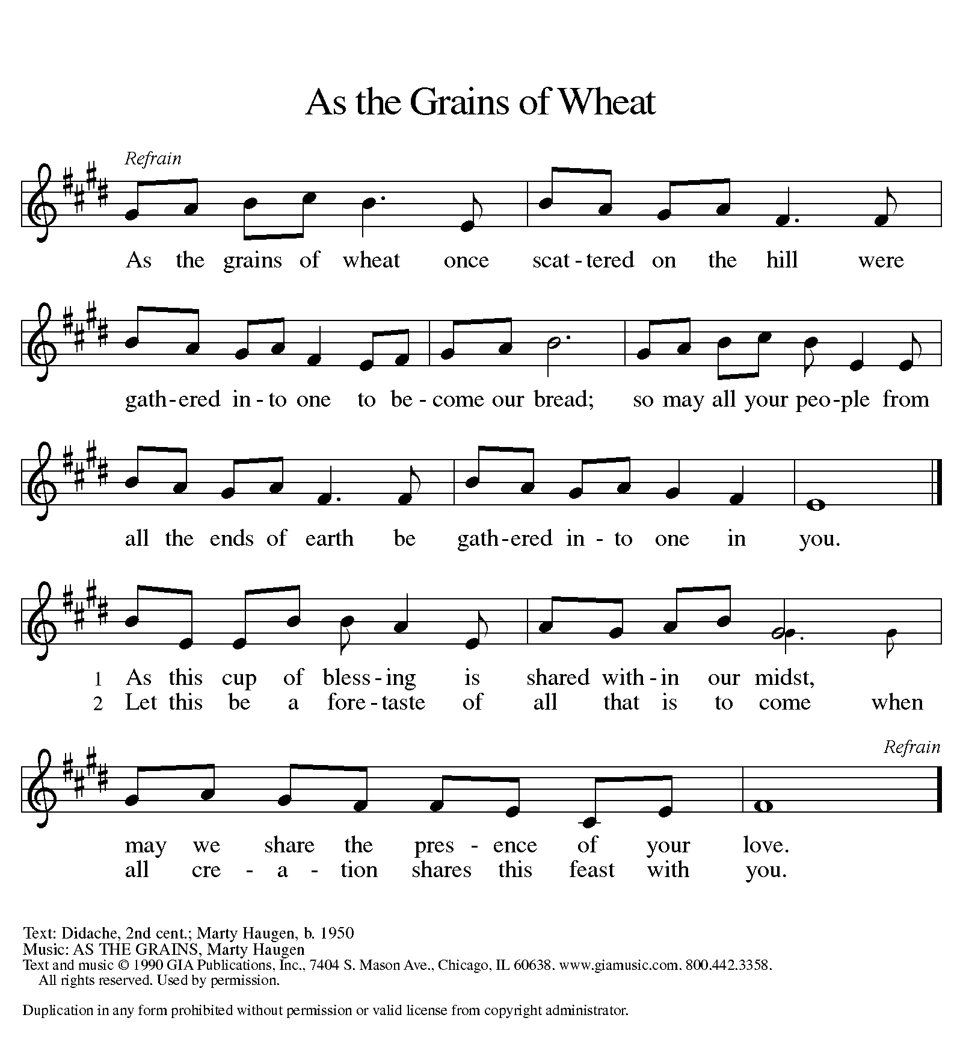

Prayer After Communion
a blessing is given, a prayer follows

L: Jesus, Bread of life,
We have received from your table
More than we could ask.
As you have nourished us in this meal,
Now strengthen us to love the world with your own life.
In your name we pray.
A: Amen.

Announcements

SENDING

Blessing

L: The blessing of God,
Who provides for us, feeds us, and journeys with us,
☩ be upon you now and forever.
A: Amen.

Sending Hymn Lord, Let my Heart Be Good Soil ELW 512

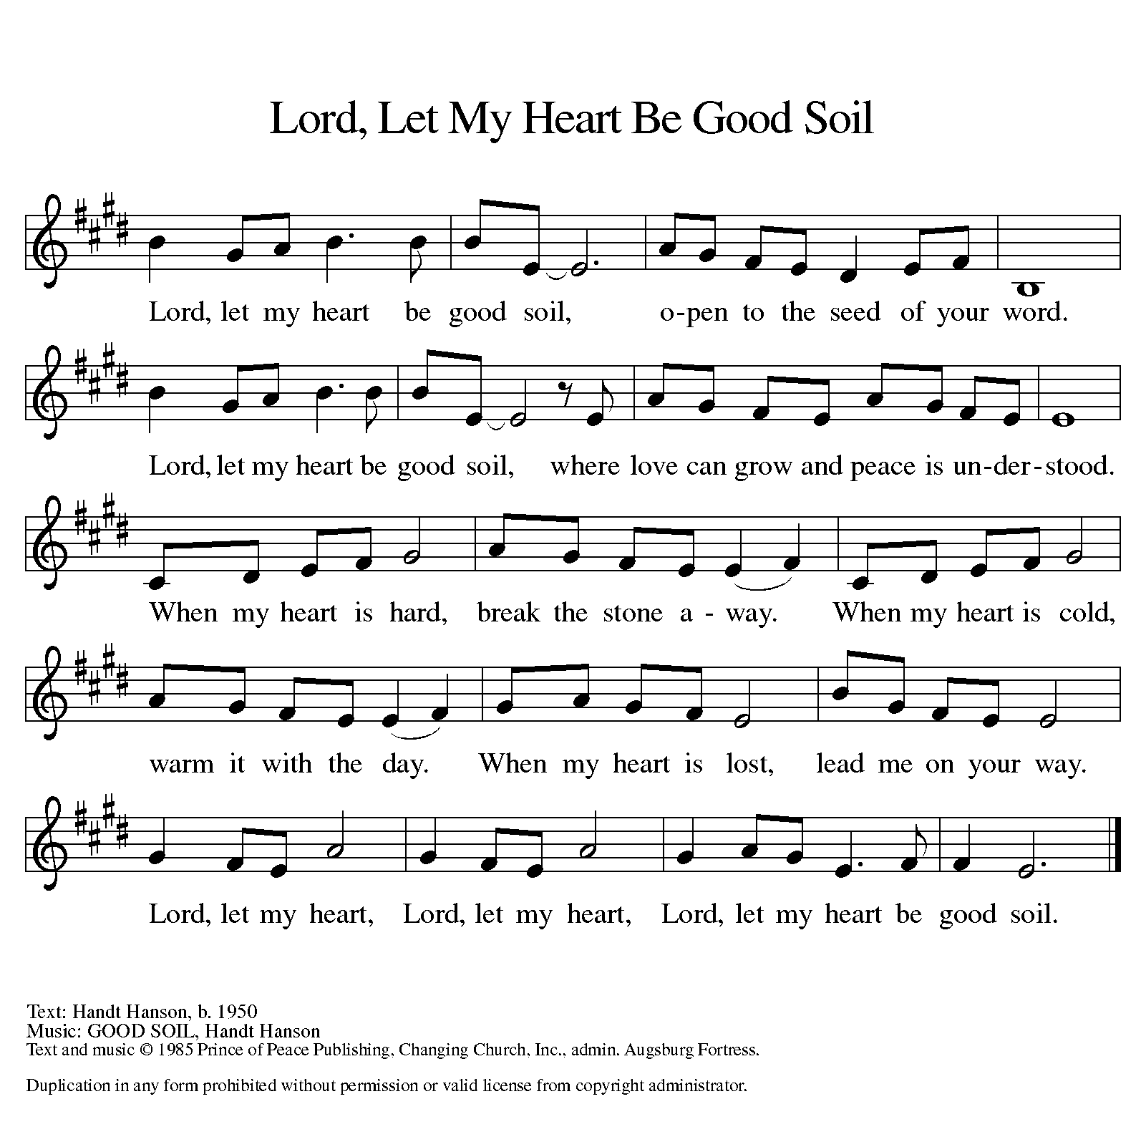

Dismissal

L: Go in peace. You are the body of Christ.
A: Thanks be to God.

Postlude

Licensing information for this Worship Service:
CCLI Copyright License A 2440181 9/30/2021 + Streaming License A 20530290 5/31/2022
Sundays and Seasons License Sundays and Seasons v.20200325.1254
Thank you to all those who contributed to today’s service: Worship Slides: Julie Mehlberg, Lector: Brad Solberg, Ushers: Marvin Miller, Musician: Sara Solberg, Communion Prep: Carol Thorson & Jeanne Rapp, Communion Asst.: Marvin Miller & Brad Solberg, Livestream: Louis Kehinde, Sound: John Mehlberg.

