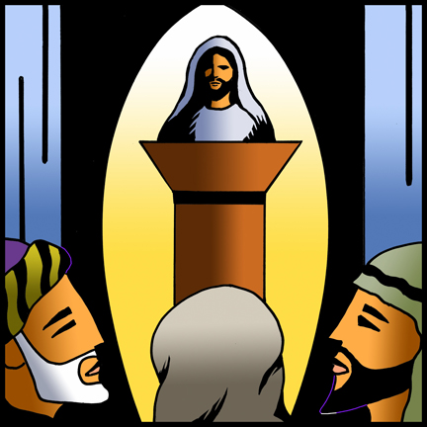

St. Paul Lutheran Church
Pontiac, IL
August 22, 2021
13th Sunday after Pentecost

Altar flowers were donated this week by Don & Mary Lou Bevers in memory of Alane Abry.

We gather to worship, reach out, and serve the Lord.

Welcome

Welcome to St. Paul Lutheran Church. Whether you have worshipped with us many times, or this is your first time, there is a place for you here. Your presence among us is a gift.

God’s Peace be with you.

Introduction to the day
Introduction

In today’s gospel many people take offense at Jesus’ invitation to eat his flesh and drink his blood; even many of Jesus’ disciples peel off. This is the backdrop in John’s gospel for Peter’s confession of faith. “To whom can we go?” asks Peter, in words we sometimes sing just before the gospel is read. “You have the words of eternal life.” In order to take such a stand, as Peter and Joshua did, Paul tells us to arm ourselves with the word of God. We pray in the Spirit that we might be bold ambassadors of the gospel.

Prelude I’m Gonna Walk on Home Ecumenical Quartet

GATHERING

Welcome to Worship

Confession and Forgiveness
All may make the sign of the cross, the sign marked at baptism, as the presiding minister begins.
L: Blessed be the Holy Trinity, ☩ one God,
the God of manna,
the God of miracles,
the God of mercy.
A: Amen.

L: Drawn to Christ and seeking God’s abundance,
let us confess our sin.

Silence is kept for reflection.
L: God, our provider,
A: help us.
It is hard to believe there is enough to share.
We question your ways when they differ from the ways
of the world in which we live.
We turn to our own understanding
rather than trusting in you.
We take offense at your teachings and your ways.
Turn us again to you.
Where else can we turn?
Share with us the words of eternal life
and feed us for life in the world.
Amen.

L: Beloved people of God:
in Jesus, the manna from heaven,
you are fed and nourished.
By Jesus, the worker of miracles,
there is always more than enough.
Through Jesus ☩ the bread of life,
you are shown God’s mercy:
you are forgiven and loved into abundant life.
A: Amen.

Gathering Hymn Here I am to Worship

Verse
Light of the world, You stepped down into darkness
Opened my eyes, let me see.
Beauty that made this heart adore You,
hope of a life spent with You.
Refrain
Here I am to worship, here I am to bow down,
Here I am to say that You’re my God.
You’re altogether lovely, altogether worthy,
Altogether wonderful to me.
Verse
King of all days, oh so highly exalted,
Glorious in heaven above.
Humbly You came to the earth You created,
All for love’s sake became poor
Refrain
Here I am to worship, here I am to bow down,
Here I am to say that You’re my God.
You’re altogether lovely, altogether worthy,
Altogether wonderful to me.
Tag
And I’ll never know how much it cost to see my sin upon that cross.
And I’ll never know how much it cost to see my sin upon that cross.
Refrain
Here I am to worship, here I am to bow down,
Here I am to say that You’re my God.
You’re altogether lovely, altogether worthy,
Altogether wonderful to me.

Greeting

L: The grace of our Lord Jesus Christ, the love of God, and the communion of the
Holy Spirit be with you all.
A: And also with you.

Prayer of the Day

L: Holy God, your word feeds your people with life that is eternal. Direct our choices and preserve us in your truth, that, renouncing what is false and evil, we may live in you, through your Son, Jesus Christ, our Savior and Lord.
A: Amen.

Children’s Message

WORD

First Reading – Joshua 24:1-2 a, 14-18

L: A reading from Joshua.

¹Then Joshua gathered all the tribes of Israel to Shechem, and summoned the elders, the heads, the judges, and the officers of Israel; and they presented themselves before God. ^{2a}And Joshua said to all the people, ¹⁴“Now therefore revere the Lord, and serve him in sincerity and in faithfulness; put away the gods that your ancestors served beyond the River and in Egypt, and serve the Lord. ¹⁵Now if you are unwilling to serve the Lord, choose this day whom you will serve, whether the gods your ancestors served in the region beyond the River or the gods of the Amorites in whose land you are living; but as for me and my household, we will serve the Lord.”
¹⁶Then the people answered, “Far be it from us that we should forsake the Lord to serve other gods; ¹⁷for it is the Lord our God who brought us and our ancestors up from the land of Egypt, out of the house of slavery, and who did those great signs in our sight. He protected us along all the way that we went, and among all the peoples through whom we passed; ¹⁸and the Lord drove out before us all the peoples, the Amorites who lived in the land. Therefore, we also will serve the Lord, for he is our God.”

L: Word of God, word of life.
A: Thanks be to God.
Psalm Reading- 34: 15-22

L: A reading from Psalm.

¹⁵The eyes of the Lord are upon the righteous,
and God’s ears are open to their cry.
¹⁶The face of the Lord is against those who do evil,
to erase the remembrance of them from the earth.
¹⁷The righteous cry, and the Lord hears them
and delivers them from all their troubles.
¹⁸The Lord is near to the brokenhearted
and saves those whose spirits are crushed.
¹⁹Many are the troubles of the righteous,
but the Lord delivers them from every one.
²⁰God will keep safe all their bones;
not one of them shall be broken.
²¹Evil will bring death to the wicked
and those who hate the righteous will be punished.
²²O Lord, you redeem the life of your servants,
and those who put their trust in you will not be punished.

L: Holy Wisdom. Holy word.
A: Thanks be to God.

Second Reading – Ephesians 6: 10-20

L: A reading from Ephesians.

¹⁰Be strong in the Lord and in the strength of his power. ¹¹Put on the whole armor of God, so that you may be able to stand against the wiles of the devil. ¹²For our struggle is not against enemies of blood and flesh, but against the rulers, against the authorities, against the cosmic powers of this present darkness, against the spiritual forces of evil in the heavenly places. ¹³Therefore take up the whole armor of God, so that you may be able to withstand on that evil day, and having done everything, to stand firm. ¹⁴Stand therefore, and fasten the belt of truth around your waist, and put on the breastplate of righteousness. ¹⁵As shoes for your feet put on whatever will make you ready to proclaim the gospel of peace. ¹⁶With all of these, take the shield of faith, with which you will be able to quench all the flaming arrows of the evil one. ¹⁷Take the helmet of salvation, and the sword of the Spirit, which is the word of God.
¹⁸Pray in the Spirit at all times in every prayer and supplication. To that end keep alert and always persevere in supplication for all the saints. ¹⁹Pray also for me, so that when I speak, a message may be given to me to make known with boldness the mystery of the gospel, ²⁰for which I am an ambassador in chains. Pray that I may declare it boldly, as I must speak.

L: Word of God, word of life.
A: Thanks be to God.
Please rise as you are able for the reading of the Holy Gospel.

Gospel Acclamation

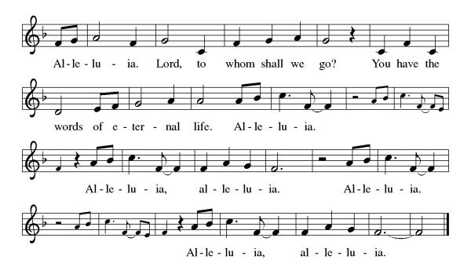

John 6: 56-69

L: The Holy Gospel according to John.
A: Glory to you, O Lord.

[Jesus said,] ⁵⁶“Those who eat my flesh and drink my blood abide in me, and I in them. ⁵⁷Just as the living Father sent me, and I live because of the Father, so whoever eats me will live because of me. ⁵⁸This is the bread that came down from heaven, not like that which your ancestors ate, and they died. But the one who eats this bread will live forever.” ⁵⁹He said these things while he was teaching in the synagogue at Capernaum.
⁶⁰When many of his disciples heard it, they said, “This teaching is difficult; who can accept it?” ⁶¹But Jesus, being aware that his disciples were complaining about it, said to them, “Does this offend you? ⁶²Then what if you were to see the Son of Man ascending to where he was before? ⁶³It is the spirit that gives life; the flesh is useless. The words that I have spoken to you are spirit and life. ⁶⁴But among you there are some who do not believe.” For Jesus knew from the first who were the ones that did not believe, and who was the one that would betray him. ⁶⁵And he said, “For this reason I have told you that no one can come to me unless it is granted by the Father.”
⁶⁶Because of this many of his disciples turned back and no longer went about with him. ⁶⁷So Jesus asked the twelve, “Do you also wish to go away?” ⁶⁸Simon Peter answered him, “Lord, to whom can we go? You have the words of eternal life. ⁶⁹We have come to believe and know that you are the Holy One of God.”

L: The gospel of the Lord.
A: Praise to you, O, Christ.

Sermon Pastor Mathew Berger

Hymn of the Day Borning Cry ELW 732

PRESENTATION OF LUKE, LACEY, AND THEO
God, who is rich in mercy and love, gives us a new birth into a living hope through the sacrament of baptism. By water and the Word, God delivers us from sin and death and raises us to new life in Jesus Christ. We are united with all the baptized in the one body of Christ, anointed with the gift of the Holy Spirit, and joined in God’s mission for the life of the world.

Sponsors: We present Luke, Lacey, and Theo for baptism.

L: Called by the Holy Spirit, trusting in the grace and love of God, do you desire to have Luke, Lacey, and Theo baptized into Christ?
R: We do.
L: As you bring Luke, Lacey, and Theo to receive the gift of baptism, you are entrusted with responsibilities:
To live with them among God's faithful people,
Bring them to the word of God and the holy supper,
Teach them the Lord's Prayer, the Creed, and the Ten Commandments,
Place in their hands the Holy Scriptures,
And nurture them in faith and prayer,
so that he may learn to trust God,
proclaim Christ through word and deed,
care for others and the world God made,
and work for justice and peace.
Do you promise to help Luke, Lacey, and Theo grow in the Christian faith and life?
R: We do.
L: Sponsors, do you promise to nurture Luke, Lacey, and Theo in the Christian faith as you are empowered by God's Spirit, and to help them live in the covenant of baptism and in communion with the church?
R: We do.
L: People of God, do you promise to support Luke, Lacey, and Theo and pray for them in their life in Christ?
A: We do.

PROFESSION OF FAITH
Please stand as you are able
L: I ask you to profess your faith in Christ Jesus, reject sin, and confess the faith of the church.
Do you renounce the devil and all the forces that defy God,
the powers of this world that rebel against God,
and the ways of sin that draw you from God?
R: We renounce them.

L: Do you believe in God the Father?
R/A: I believe in God, the Father almighty,
creator of heaven and earth.
L: Do you believe in Jesus Christ, the Son of God?
R/A: I believe in Jesus Christ, God's only Son, our Lord,
who was conceived by the Holy Spirit,
born of the virgin Mary,
suffered under Pontius Pilate,
was crucified, died, and was buried;
he descended to the dead.
On the third day he rose again;
he ascended into heaven,
he is seated at the right hand of the Father,
and he will come to judge the living and the dead.
L: Do you believe in God the Holy Spirit?
R/A: I believe in the Holy Spirit,
the holy catholic church,
the communion of saints,
the forgiveness of sins,
the resurrection of the body,
and the life everlasting.
THANKSGIVING AT THE FONT
L: The Lord be with you.
A: And also with you.
L: Let us give thanks to the Lord our God.
A: It is right to give our thanks and praise.
L: Holy God, holy and merciful, holy and mighty, you are the river of life, you are the everlasting wellspring, you are the fire of rebirth.
Glory to you for oceans and lakes, for rivers and streams.
Honor to you for cloud and rain, for dew and snow.
Your waters are below us, around us, above us: our life is born in you.
You are the fountain of resurrection.

Praise to you for your saving waters:
Noah and the animals survive the flood,
Hagar discovers your well.
The Israelites escape through the sea,
and they drink from your gushing rock.
Naaman washes his leprosy away,
and the Samaritan woman will never be thirsty again.

At this font, holy God, we pray:
Praise to you for the water of baptism
and for your Word that saves us in this water.
Breathe your Spirit into all who are gathered here
and into all creation. Illumine our days.
Enliven our bones. Dry our tears.
Wash away the sin within us, and drown the evil around us.
Satisfy all our thirst with your living water,
Jesus Christ, our Savior, who lives and reigns with you
and the Holy Spirit, one God, now and forever.
A: Amen.

BAPTISM
L: Luke, Lacey, and Theo, I baptize you in the name of the Father,
and of the Son, and of the Holy Spirit.
“You Have Put on Christ” is sung once by Pastor and then repeated by the Congregation.

L: Let us pray.
We give you thanks, O God, that through water and the Holy Spirit you give your children new birth, cleanse them from sin, and raise them to eternal life. Sustain Luke, Lacey, and Theo with the gift of your Holy Spirit: the spirit of wisdom and understanding, the spirit of counsel and might, the spirit of knowledge and the fear of the Lord, the spirit of joy in your presence, both now and forever.
A: Amen.
L: Luke, Lacey, and Theo, children of God, you have been sealed by the Holy Spirit and marked with the cross of Christ forever.
WELCOME
L: Let your light so shine before others that they may see your good works and glorify God.
L: Let us welcome the newly baptized.
A: Luke, Lacey, and Theo, we welcome you into the body of Christ and into the mission we share: join us in giving thanks and praise to God and bearing God's creative and redeeming word to all the world.

Prayers of Intercession

Throughout our prayers, each petition ends “Lord, in your mercy.” The congregation is invited to respond, “hear our prayer.”

Sharing the Peace

L: The peace of Christ be with you always.
A: And also with you.

You are invited to share a sign of God’s peace with your neighbors by turning to the people near you saying, “Peace be with you.”

MEAL

All are welcome at Christ’s table.

Communion is distributed in front of the altar. The individual cups are filled with wine. The prepackaged cups are juice. If you prefer not to receive communion you may come forward with your hands crossed over your chest to receive a blessing or you may remain in your seat.

Offering

Offerings can also be sent by mail or given online. You can send a check to St. Paul Lutheran Church 210 Deerfield Rd Pontiac, IL 61764 or give online at stpaulpontiac.org

Offertory Music Shine on Us Special Music

Offering Prayer

L: Jesus, Bread of life,
you have set this table with your very self,
and called us to the feast of plenty.
Gather what has been sown among us,
and strengthen us in this meal.
Make us to be what we receive here,
your body for the life of the world.
A: Amen.

Great Thanksgiving
L: The Lord be with you.
A: And also with you.
L: Lift up your hearts.
A: We lift them to the Lord.
L: Let us give thanks to the Lord our God.
A: It is right to give our thanks and praise.

Preface
L: It is indeed right, our duty and our joy,
that we should at all times and in all places
give thanks and praise to you, almighty and merciful God,
through the great Shepherd of your flock, our Savior Jesus Christ;
who after his resurrection sent forth apostles
to preach the gospel and teach all nations,
and promised to be with them, even to the end of the age.
And so, with Thomas and Phillip, Junia and Paul, and the glorious company of the
Apostles, with the choirs of angels and all the hosts of heaven,
we praise your name and join their unending hymn:
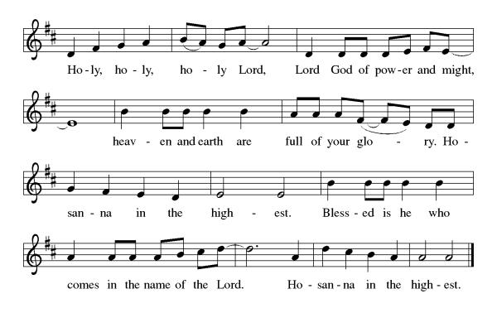
Thanksgiving at the Table

L: Holy, mighty and merciful Lord,
heaven and earth are full of your glory.
In great love you sent to us Jesus, your Son,
who reached out to heal the sick and suffering,
who preached good news to the poor,
and who, on the cross, opened his arms to all.

In the night in which he was betrayed,
our Lord Jesus took bread, and gave thanks;
broke it, and gave it to his disciples, saying:
Take and eat; this is my body, given for you.
Do this for the remembrance of me.

Again, after supper, he took the cup, gave thanks,
and gave it for all to drink, saying:
This cup is the new covenant in my blood,
shed for you and for all people for the forgiveness of sin.
Do this for the remembrance of me.

Remembering, therefore, his death,
resurrection, and ascension,
we await his coming in glory.

Pour out upon us the Spirit of your love,
O Lord, and unite the wills of all who share this heavenly food,
the body and blood of Jesus Christ, our Lord;
to whom, with you and the Holy Spirit,
be all honor and glory, now and forever.
A: Amen.

Lord's Prayer

L: Gathered into one by the Holy Spirit, let us pray as Jesus taught us,
A: Our Father, who art in heaven, hallowed be thy name, thy kingdom come, thy will be done, on earth as it is in heaven. Give us this day our daily bread; and forgive us our trespasses, as we forgive those who trespass against us; and lead us not into temptation but deliver us from evil. For thine is the kingdom and the power, and the glory, forever and ever. Amen.

Invitation to Communion

L: Christ has set the table with more than enough for all. Come!

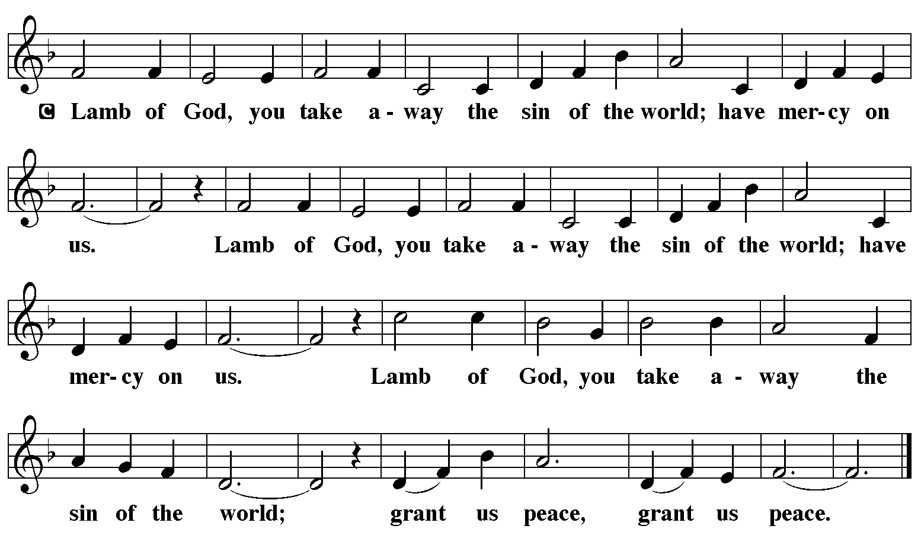

Communion Music Eat This Bread ELW 472

Communion Music Come as you Are Crowder video

Prayer After Communion
a blessing is given, a prayer follows

L: Jesus, Bread of life,
we have received from your table
more than we could ask.
As you have nourished us in this meal,
now strengthen us to love the world with your own life.
In your name we pray.
A: Amen.

Announcements

SENDING

Blessing of the Backpacks

Blessing

L: The blessing of God,
who provides for us, feeds us, and journeys with us,
☩ be upon you now and forever.
A: Amen.

Sending Hymn - Go Make Disciples ELW 540
see music on final page

Dismissal

L: Go in peace. You are the body of Christ.
A: Thanks be to God.

Postlude

Licensing information for this Worship Service:
CCLI Copyright License A 2440181 9/30/2021 + Streaming License A 20530290 5/31/2022
Sundays and Seasons License Sundays and Seasons v.20200325.1254
Thank you to all those who contributed to today’s service: Lector: Judy Sykes, Ushers: Mary & Denny Leach, Musician: Julie Mehlberg, Communion Prep: Jean Harrison & Ginger Bauknecht, Communion Asst: Mary & Denny Leach, Livestream: Louis Kehinde, Sound & Projection: Emma Johnson, Joel Rapp, Julie Mehlberg, John Mehlberg and Melissa Rapp, Hospitality: Sara Solberg, Counters: Jake Dixon & Marvin Miller, Ecumenical Quartet: Barb Tholen, Laura Ramseyer, Paul Brown, and Don Schiff.

