St. Paul Lutheran Church
Pontiac, IL
October 17, 2021
21st Sunday after Pentecost

We gather to worship, reach out, and serve the Lord.

Welcome

Welcome to St. Paul Lutheran Church. Whether you have worshipped with us many times, or this is your first time, there is a place for you here. Your presence among us is a gift.

God’s Peace be with you.

Introduction to the day

Introduction

Today’s gospel starts with disciples obsessing over who will be closest to Jesus, leading to Jesus teaching his followers about God’s take on importance and power. Here Jesus makes it explicit that the reversal of values in God’s community is a direct challenge to the values of the dominant culture, where wielding power over others is what makes you great. When we pray “your kingdom come” we are praying for an end to tyranny and oppression. We pray this gathered around the cross, a sign of great shame transformed to be the sign of great honor and service.

Prelude

GATHERING

Welcome to Worship

Confession and Forgiveness
All may make the sign of the cross, the sign marked at baptism, as the presiding minister begins.
L: Blessed be the Holy Trinity, ☩ one God,
whose teaching is life,
whose presence is sure,
and whose love is endless
A: Amen.

L: Let us confess our sins to the one who welcomes us with an open heart.

Silence is kept for reflection.
L: God, our comforter:
A: like lost sheep, we have gone astray.
We gaze upon abundance and see scarcity.
We turn our faces away from injustice and oppression.
We exploit the earth with our apathy and greed.
Free us from our sin, gracious God.
Listen when we call out to you for help.
Lead us by your love to love our neighbors as ourselves.
Amen.

L: All have sinned and fall short of the glory of God.
By the gift of grace in ☩ Christ Jesus, God makes you righteous.
Receive with glad hearts the forgiveness of all your sins.
A: Amen.

Gathering Hymn Come All You People ELW 819

Greeting

L: The grace of our Lord Jesus Christ, the love of God, and the communion of the
Holy Spirit be with you all.
A: And also with you.

Prayer of the Day

L: Sovereign God, you turn your greatness into goodness for all the peoples on earth. Shape us into willing servants of your kingdom, and make us desire always and only your will, through Jesus Christ, our Savior and Lord.
A: Amen.

Children’s Message

WORD

First Reading – Isaiah 53: 4-12

L: A reading from Isaiah.

⁴Surely he has borne our infirmities
and carried our diseases;
yet we accounted him stricken,
struck down by God, and afflicted.
⁵But he was wounded for our transgressions,
crushed for our iniquities;
upon him was the punishment that made us whole,
and by his bruises we are healed.
⁶All we like sheep have gone astray;
we have all turned to our own way,
and the Lord has laid on him
the iniquity of us all.
⁷He was oppressed, and he was afflicted,
yet he did not open his mouth;
like a lamb that is led to the slaughter,
and like a sheep that before its shearers is silent,
so he did not open his mouth.
⁸By a perversion of justice he was taken away.
Who could have imagined his future?
For he was cut off from the land of the living,
stricken for the transgression of my people.
⁹They made his grave with the wicked
and his tomb with the rich,
although he had done no violence,
and there was no deceit in his mouth.
¹⁰Yet it was the will of the Lord to crush him with pain.
When you make his life an offering for sin,
he shall see his offspring, and shall prolong his days;
through him the will of the Lord shall prosper.
¹¹Out of his anguish he shall see light;
he shall find satisfaction through his knowledge.
The righteous one, my servant, shall make many righteous,
and he shall bear their iniquities.
¹²Therefore I will allot him a portion with the great,
and he shall divide the spoil with the strong;
because he poured out himself to death,
and was numbered with the transgressors;
yet he bore the sin of many,
and made intercession for the transgressors.

L: Word of God, word of life.
A: Thanks be to God.

Psalm Reading- Psalm 91: 9-16

L: A reading from Psalm.

⁹Because you have made the Lord your refuge,
and the Most High your habitation,
¹⁰no evil will befall you,
nor shall affliction come near your dwelling.
¹¹For God will give the angels charge over you,
to guard you in all your ways.
¹²Upon their hands they will bear you up,
lest you strike your foot against a stone.
¹³You will tread upon the lion cub and viper;
you will trample down the lion and the serpent.
¹⁴I will deliver those who cling to me;
I will uphold them, because they know my name.
¹⁵They will call me, and I will answer them;
I will be with them in trouble; I will rescue and honor them.
¹⁶With long life will I satisfy them,
and show them my salvation.

L: Holy Wisdom. Holy word.
A: Thanks be to God.

Second Reading – Hebrews 5: 1-10

L: A reading from Hebrews.

¹Every high priest chosen from among mortals is put in charge of things pertaining to God on their behalf, to offer gifts and sacrifices for sins. ²He is able to deal gently with the ignorant and wayward, since he himself is subject to weakness; ³and because of this he must offer sacrifice for his own sins as well as for those of the people. ⁴And one does not presume to take this honor, but takes it only when called by God, just as Aaron was.
⁵So also Christ did not glorify himself in becoming a high priest, but was appointed by the one who said to him,
“You are my Son,
today I have begotten you”;
⁶as he says also in another place,
“You are a priest forever,
according to the order of Melchizedek.”
⁷In the days of his flesh, Jesus offered up prayers and supplications, with loud cries and tears, to the one who was able to save him from death, and he was heard because of his reverent submission. ⁸Although he was a Son, he learned obedience through what he suffered; ⁹and having been made perfect, he became the source of eternal salvation for all who obey him, ¹⁰having been designated by God a high priest according to the order of Melchizedek.

L: Word of God, word of life.
A: Thanks be to God.
Please rise as you are able for the reading of the Holy Gospel.

Gospel Acclamation

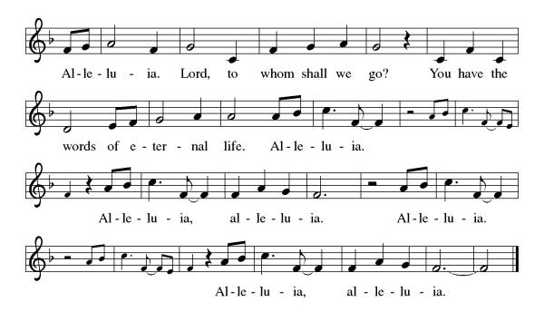

Mark 10: 35-45

L: The Holy Gospel according to Mark.
A: Glory to you, O Lord.

³⁵James and John, the sons of Zebedee, came forward to him and said to him, “Teacher, we want you to do for us whatever we ask of you.” ³⁶And he said to them, “What is it you want me to do for you?” ³⁷And they said to him, “Grant us to sit, one at your right hand and one at your left, in your glory.” ³⁸But Jesus said to them, “You do not know what you are asking. Are you able to drink the cup that I drink, or be baptized with the baptism that I am baptized with?” ³⁹They replied, “We are able.” Then Jesus said to them, “The cup that I drink you will drink; and with the baptism with which I am baptized, you will be baptized; ⁴⁰but to sit at my right hand or at my left is not mine to grant, but it is for those for whom it has been prepared.”
⁴¹When the ten heard this, they began to be angry with James and John. ⁴²So Jesus called them and said to them, “You know that among the Gentiles those whom they recognize as their rulers lord it over them, and their great ones are tyrants over them. ⁴³But it is not so among you; but whoever wishes to become great among you must be your servant, ⁴⁴and whoever wishes to be first among you must be slave of all. ⁴⁵For the Son of Man came not to be served but to serve, and to give his life a ransom for many.”

L: The gospel of the Lord.
A: Praise to you, O, Christ.

Sermon Pastor Trudy Foote

Hymn of the Day Lord, Whose Love in Humble Service ELW 712

Apostles’ Creed

I believe in God, the Father almighty,
creator of heaven and earth.
I believe in Jesus Christ, God’s only Son, our Lord,
who was conceived by the Holy Spirit,
born of the virgin Mary,
suffered under Pontius Pilate,
was crucified, died, and was buried;
he descended to the dead.
On the third day he rose again;
he ascended into heaven,
he is seated at the right hand of the Father,
and he will come to judge the living and the dead.
I believe in the Holy Spirit,
the holy catholic church,
the communion of saints,
the forgiveness of sins,
the resurrection of the body,
and the life everlasting. Amen.

Prayers of Intercession

Throughout our prayers, each petition ends “Hear us, O God.” The congregation is invited to respond, “Your mercy is great.”

Sharing the Peace

L: The peace of Christ be with you always.
A: And also with you.

You are invited to share a sign of God’s peace with your neighbors by turning to the people near you saying, “Peace be with you.”

MEAL

All are welcome at Christ’s table.

Communion is distributed in front of the altar. The individual cups are filled with wine. The prepackaged cups are juice. If you prefer not to receive communion you may come forward with your hands crossed over your chest to receive a blessing or you may remain in your seat.

Offering

Offerings can also be sent by mail or given online. You can send a check to St. Paul Lutheran Church 210 Deerfield Rd Pontiac, IL 61764 or give online at stpaulpontiac.org

Offertory Music Instrumental

Offering Prayer

L: God of abundance,
you cause streams to break forth in the desert
and manna to rain from the heavens.
Accept the gifts you have first given us.
Unite them with the offering of our lives
to nourish the world you love so dearly;
through Jesus Christ, our Savior and Lord.
A: Amen.

Great Thanksgiving
L: The Lord be with you.
A: And also with you.
L: Lift up your hearts.
A: We lift them to the Lord.
L: Let us give thanks to the Lord our God.
A: It is right to give our thanks and praise.

Preface
L: It is indeed right, our duty and our joy,
that we should at all times and in all places
give thanks and praise to you, almighty and merciful God,
through the great Shepherd of your flock, our Savior Jesus Christ;
who after his resurrection sent forth apostles
to preach the gospel and teach all nations,
and promised to be with them, even to the end of the age.
And so, with Thomas and Phillip, Junia and Paul, and the glorious company of the
Apostles, with the choirs of angels and all the hosts of heaven,
we praise your name and join their unending hymn:
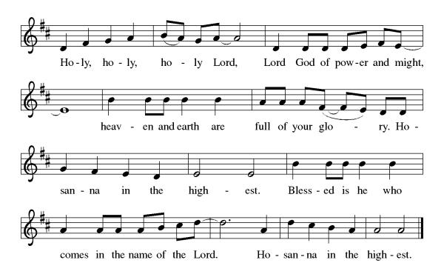
Thanksgiving at the Table

L: Holy, mighty and merciful Lord,
heaven and earth are full of your glory.
In great love you sent to us Jesus, your Son,
who reached out to heal the sick and suffering,
who preached good news to the poor,
and who, on the cross, opened his arms to all.

In the night in which he was betrayed,
our Lord Jesus took bread, and gave thanks;
broke it, and gave it to his disciples, saying:
Take and eat; this is my body, given for you.
Do this for the remembrance of me.

Again, after supper, he took the cup, gave thanks,
and gave it for all to drink, saying:
This cup is the new covenant in my blood,
shed for you and for all people for the forgiveness of sin.
Do this for the remembrance of me.

Remembering, therefore, his death,
resurrection, and ascension,
we await his coming in glory.

Pour out upon us the Spirit of your love,
O Lord, and unite the wills of all who share this heavenly food,
the body and blood of Jesus Christ, our Lord;
to whom, with you and the Holy Spirit,
be all honor and glory, now and forever.
A: Amen.

Lord's Prayer

L: Gathered into one by the Holy Spirit, let us pray as Jesus taught us,
A: Our Father, who art in heaven, hallowed be thy name, thy kingdom come, thy will be done, on earth as it is in heaven. Give us this day our daily bread; and forgive us our trespasses, as we forgive those who trespass against us; and lead us not into temptation but deliver us from evil. For thine is the kingdom and the power, and the glory, forever and ever. Amen.

Invitation to Communion

L: All who hunger and thirst, come. The table is ready.

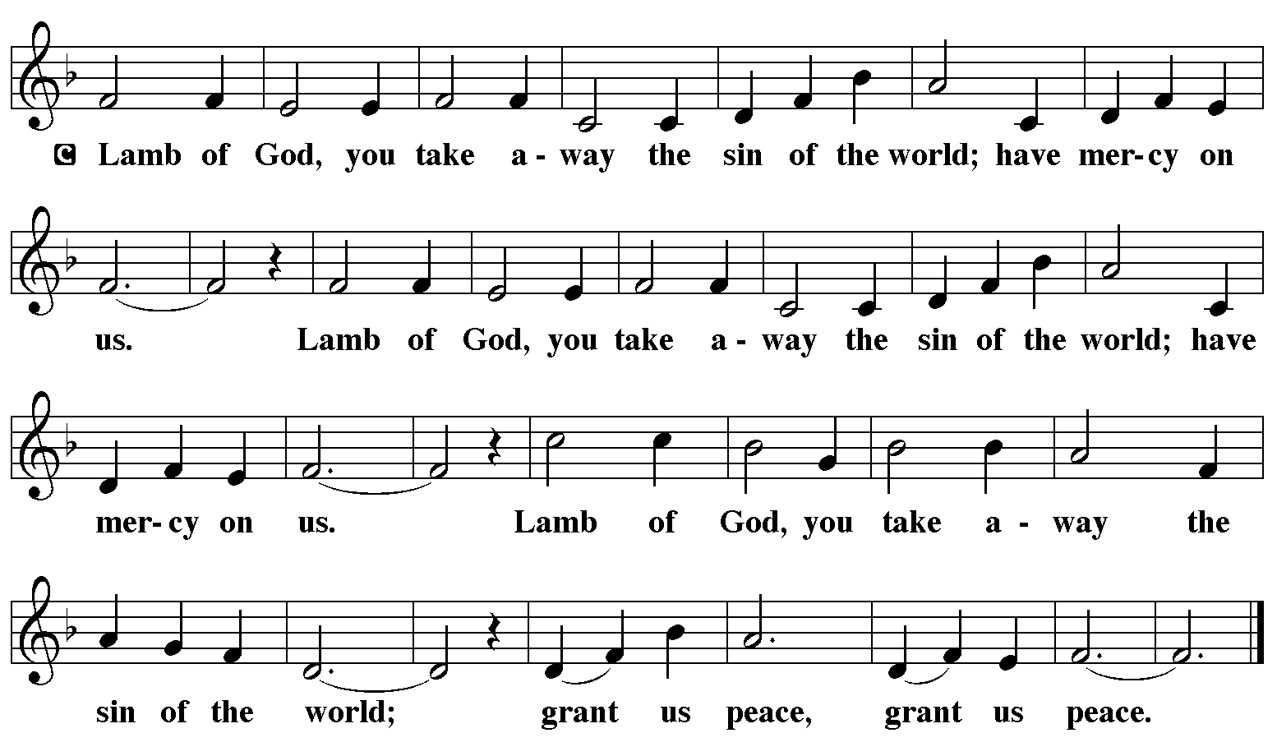

Communion Music Grace is Not Earned – by Kate Simmonds Video

Communion Music Taste and See ELW 493

Prayer After Communion
a blessing is given, a prayer follows

L: Lord of life,
in the gift of your body and blood
you turn the crumbs of our faith into a feast of salvation.
Send us forth into the world with shouts of joy,
bearing witness to the abundance of your love
in Jesus Christ, our Savior and Lord.
A: Amen.

Announcements

SENDING

Blessing

L: People of God,
you are Christ’s body,
bringing new life to a suffering world.
The holy Trinity, ☩ one God,
bless you now and forever.
A: Amen.

Sending Hymn – Go Make Disciples – ELW 540
see music on final page

Dismissal

L: Go in peace. The living Word dwells in you.
A: Thanks be to God.

Postlude

Licensing information for this Worship Service:
CCLI Copyright License A 2440181 9/30/2021 + Streaming License A 20530290 5/31/2022
Sundays and Seasons License Sundays and Seasons v.20200325.1254
Thank you to all those who contributed to today’s service: Lector: Nathan Joerndt, Usher: Mark Mackinson, Musician: Sandy Erickson, Communion Prep: Mary & Denny Leach, Communion Asst: Becky Edinger & Kris Lambert, Livestream: Louis Kehinde, Sound & Projection: Emma Johnson, Joel Rapp, Julie Mehlberg, John Mehlberg and Melissa Rapp, Hospitality; Julie Mehlberg & Kris Lambert, Counters: Marvin Miller & Mark Mackinson.

