St. Paul Lutheran Church
Pontiac, IL
October 24, 2021
22nd Sunday after Pentecost

We gather to worship, reach out, and serve the Lord.

Welcome

Welcome to St. Paul Lutheran Church. Whether you have worshipped with us many times, or this is your first time, there is a place for you here. Your presence among us is a gift.

God’s Peace be with you.

Introduction to the day

Introduction

Can we pray the way Bartimaeus prays? People try to hush him up because by addressing Jesus as “Son of David” he is making a politically dangerous claim that Jesus is the rightful king. Could our prayers ever be heard as a threat to unjust powers that be? Bartimaeus won’t give up or go away quietly, but repeats his call for help more loudly. Do we ask so boldly? And are our prayers an honest answer to Jesus’ question, “What do you want me to do for you?”

Prelude

GATHERING

Welcome to Worship

Confession and Forgiveness
All may make the sign of the cross, the sign marked at baptism, as the presiding minister begins.
L: Blessed be the Holy Trinity, ☩ one God,
whose teaching is life,
whose presence is sure,
and whose love is endless
A: Amen.

L: Let us confess our sins to the one who welcomes us with an open heart.

Silence is kept for reflection.
L: God, our comforter:
A: like lost sheep, we have gone astray.
We gaze upon abundance and see scarcity.
We turn our faces away from injustice and oppression.
We exploit the earth with our apathy and greed.
Free us from our sin, gracious God.
Listen when we call out to you for help.
Lead us by your love to love our neighbors as ourselves.
Amen.

L: All have sinned and fall short of the glory of God.
By the gift of grace in ☩ Christ Jesus, God makes you righteous.
Receive with glad hearts the forgiveness of all your sins.
A: Amen.

Gathering Hymn Word of God Speak Mercy Me

Verse 1:
I’m finding myself at a loss for words,
And the funny thing is, it’s okay
The last thing I need is to be heard,
But to hear what you would say

Refrain:
Word of God, speak
Would you pour down like rain,
Washing my eyes to see your majesty
To be still and know that you’re in this place
Please let me stay and rest in your holiness
Word of God speak

Verse 2:
I’m finding myself in the midst of you,
Beyond the music, beyond the noise
All that I need is to be with you,
And in the quiet, hear your voice (refrain)

Greeting

L: The grace of our Lord Jesus Christ, the love of God, and the communion of the
Holy Spirit be with you all.
A: And also with you.

Prayer of the Day

L: Eternal light, shine in our hearts. Eternal wisdom, scatter the darkness of our ignorance. Eternal compassion, have mercy on us. Turn us to seek your face, and enable us to reflect your goodness, through Jesus Christ, our Savior and Lord.
A: Amen.

Children’s Message

WORD

First Reading – Jeremiah 31: 7-9

L: A reading from Jeremiah.

⁷Thus says the Lord:
Sing aloud with gladness for Jacob,
and raise shouts for the chief of the nations;
proclaim, give praise, and say,
“Save, O Lord, your people,
the remnant of Israel.”
⁸See, I am going to bring them from the land of the north,
and gather them from the farthest parts of the earth,
among them the blind and the lame,
those with child and those in labor, together;
a great company, they shall return here.
⁹With weeping they shall come,
and with consolations I will lead them back,
I will let them walk by brooks of water,
in a straight path in which they shall not stumble;
for I have become a father to Israel,
and Ephraim is my firstborn.

L: Word of God, word of life.
A: Thanks be to God.

Psalm Reading- Psalm 126

L: A reading from Psalm.

¹When the Lord restored the fortunes of Zion,
then were we like those who dream.
²Then was our mouth filled with laughter, and our tongue with shouts of joy.
Then they said among the nations, “The Lord has done great things for them.”
³The Lord has done great things for us,
and we are glad indeed.
⁴Restore our fortunes, O Lord,
like the watercourses of the Negeb.
⁵Those who sowed with tears
will reap with songs of joy.
⁶Those who go out weeping, carrying the seed,
will come again with joy, shouldering their sheaves.

L: Holy Wisdom. Holy word.
A: Thanks be to God.

Second Reading – Hebrews 7: 23-28

L: A reading from Hebrews.

²³The former priests were many in number, because they were prevented by death from continuing in office; ²⁴but he holds his priesthood permanently, because he continues forever. ²⁵Consequently he is able for all time to save those who approach God through him, since he always lives to make intercession for them.
²⁶For it was fitting that we should have such a high priest, holy, blameless, undefiled, separated from sinners, and exalted above the heavens. ²⁷Unlike the other high priests, he has no need to offer sacrifices day after day, first for his own sins, and then for those of the people; this he did once for all when he offered himself. ²⁸For the law appoints as high priests those who are subject to weakness, but the word of the oath, which came later than the law, appoints a Son who has been made perfect forever.

L: Word of God, word of life.
A: Thanks be to God.
Please rise as you are able for the reading of the Holy Gospel.

Gospel Acclamation

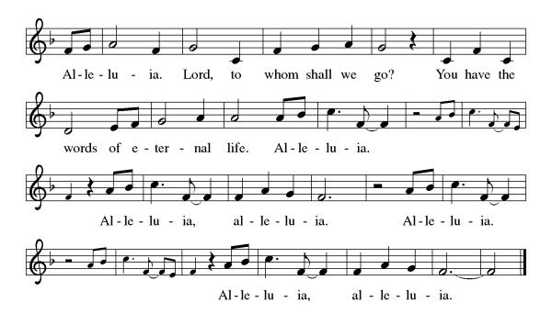

Mark 10: 46-52

L: The Holy Gospel according to Mark.
A: Glory to you, O Lord.

⁴⁶As [Jesus] and his disciples and a large crowd were leaving Jericho, Bartimaeus son of Timaeus, a blind beggar, was sitting by the roadside. ⁴⁷When he heard that it was Jesus of Nazareth, he began to shout out and say, “Jesus, Son of David, have mercy on me!” ⁴⁸Many sternly ordered him to be quiet, but he cried out even more loudly, “Son of David, have mercy on me!” ⁴⁹Jesus stood still and said, “Call him here.” And they called the blind man, saying to him, “Take heart; get up, he is calling you.” ⁵⁰So throwing off his cloak, he sprang up and came to Jesus. ⁵¹Then Jesus said to him, “What do you want me to do for you?” The blind man said to him, “My teacher, let me see again.” ⁵²Jesus said to him, “Go; your faith has made you well.” Immediately he regained his sight and followed him on the way.

L: The gospel of the Lord.
A: Praise to you, O, Christ.

Sermon Pastor Mathew Berger

Hymn of the Day O Christ Your Heart, Compassionate ELW 722

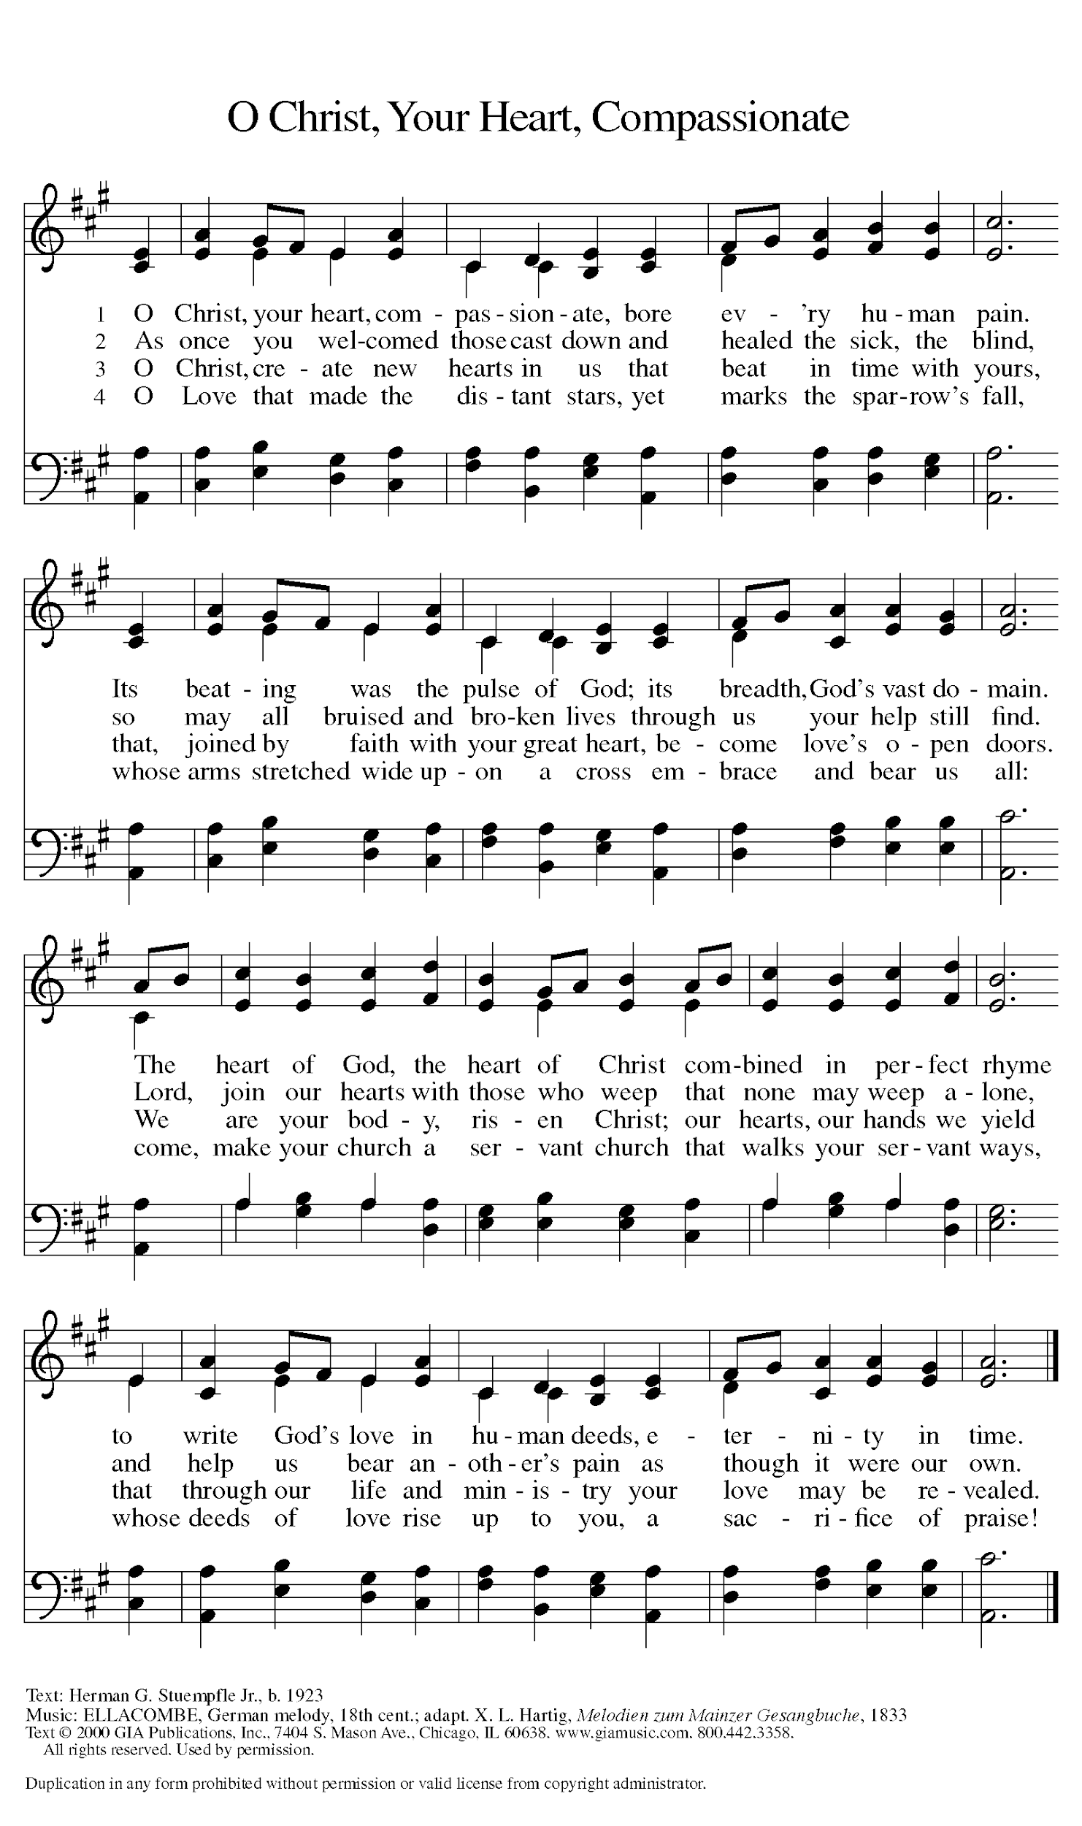
Apostles’ Creed

I believe in God, the Father almighty,
creator of heaven and earth.
I believe in Jesus Christ, God’s only Son, our Lord,
who was conceived by the Holy Spirit,
born of the virgin Mary,
suffered under Pontius Pilate,
was crucified, died, and was buried;
he descended to the dead.
On the third day he rose again;
he ascended into heaven,
he is seated at the right hand of the Father,
and he will come to judge the living and the dead.
I believe in the Holy Spirit,
the holy catholic church,
the communion of saints,
the forgiveness of sins,
the resurrection of the body,
and the life everlasting. Amen.

Prayers of Intercession

Throughout our prayers, each petition ends “Hear us, O God.” The congregation is invited to respond, “Your mercy is great.”

Sharing the Peace

L: The peace of Christ be with you always.
A: And also with you.

You are invited to share a sign of God’s peace with your neighbors by turning to the people near you saying, “Peace be with you.”

MEAL

All are welcome at Christ’s table.

Communion is distributed in front of the altar. The individual cups are filled with wine. The prepackaged cups are juice. If you prefer not to receive communion you may come forward with your hands crossed over your chest to receive a blessing or you may remain in your seat.

Offering

Offerings can also be sent by mail or given online. You can send a check to St. Paul Lutheran Church 210 Deerfield Rd Pontiac, IL 61764 or give online at stpaulpontiac.org

Offertory Music Special Music

Offering Prayer

L: God of abundance,
you cause streams to break forth in the desert
and manna to rain from the heavens.
Accept the gifts you have first given us.
Unite them with the offering of our lives
to nourish the world you love so dearly;
through Jesus Christ, our Savior and Lord.
A: Amen.

Great Thanksgiving
L: The Lord be with you.
A: And also with you.
L: Lift up your hearts.
A: We lift them to the Lord.
L: Let us give thanks to the Lord our God.
A: It is right to give our thanks and praise.

Preface
L: It is indeed right, our duty and our joy,
that we should at all times and in all places
give thanks and praise to you, almighty and merciful God,
through the great Shepherd of your flock, our Savior Jesus Christ;
who after his resurrection sent forth apostles
to preach the gospel and teach all nations,
and promised to be with them, even to the end of the age.
And so, with Thomas and Phillip, Junia and Paul, and the glorious company of the
Apostles, with the choirs of angels and all the hosts of heaven,
we praise your name and join their unending hymn:
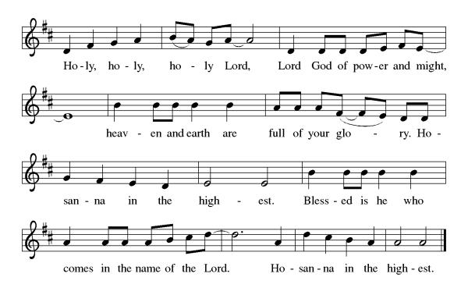
Thanksgiving at the Table

L: Holy, mighty and merciful Lord,
heaven and earth are full of your glory.
In great love you sent to us Jesus, your Son,
who reached out to heal the sick and suffering,
who preached good news to the poor,
and who, on the cross, opened his arms to all.

In the night in which he was betrayed,
our Lord Jesus took bread, and gave thanks;
broke it, and gave it to his disciples, saying:
Take and eat; this is my body, given for you.
Do this for the remembrance of me.

Again, after supper, he took the cup, gave thanks,
and gave it for all to drink, saying:
This cup is the new covenant in my blood,
shed for you and for all people for the forgiveness of sin.
Do this for the remembrance of me.

Remembering, therefore, his death,
resurrection, and ascension,
we await his coming in glory.

Pour out upon us the Spirit of your love,
O Lord, and unite the wills of all who share this heavenly food,
the body and blood of Jesus Christ, our Lord;
to whom, with you and the Holy Spirit,
be all honor and glory, now and forever.
A: Amen.

Lord's Prayer

L: Gathered into one by the Holy Spirit, let us pray as Jesus taught us,
A: Our Father, who art in heaven, hallowed be thy name, thy kingdom come, thy will be done, on earth as it is in heaven. Give us this day our daily bread; and forgive us our trespasses, as we forgive those who trespass against us; and lead us not into temptation but deliver us from evil. For thine is the kingdom and the power, and the glory, forever and ever. Amen.

Invitation to Communion

L: All who hunger and thirst, come. The table is ready.

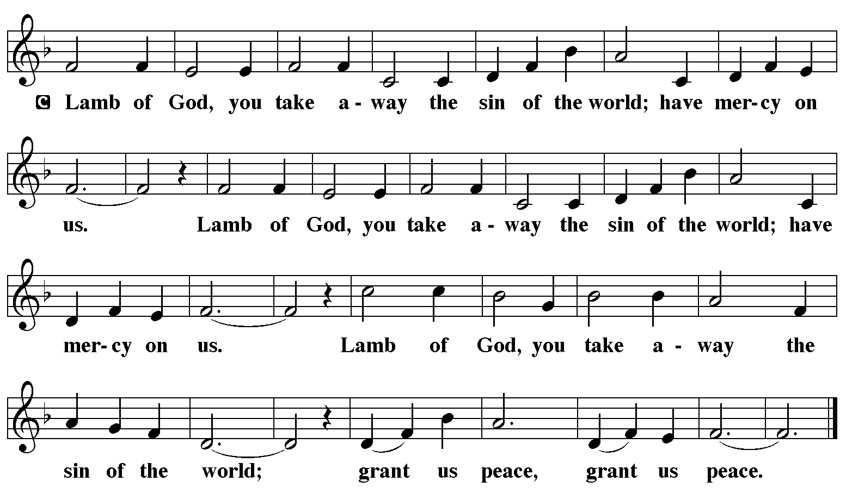

Communion Music Remembrance Matt Maher Video

Communion Music Here is Bread ELW 483

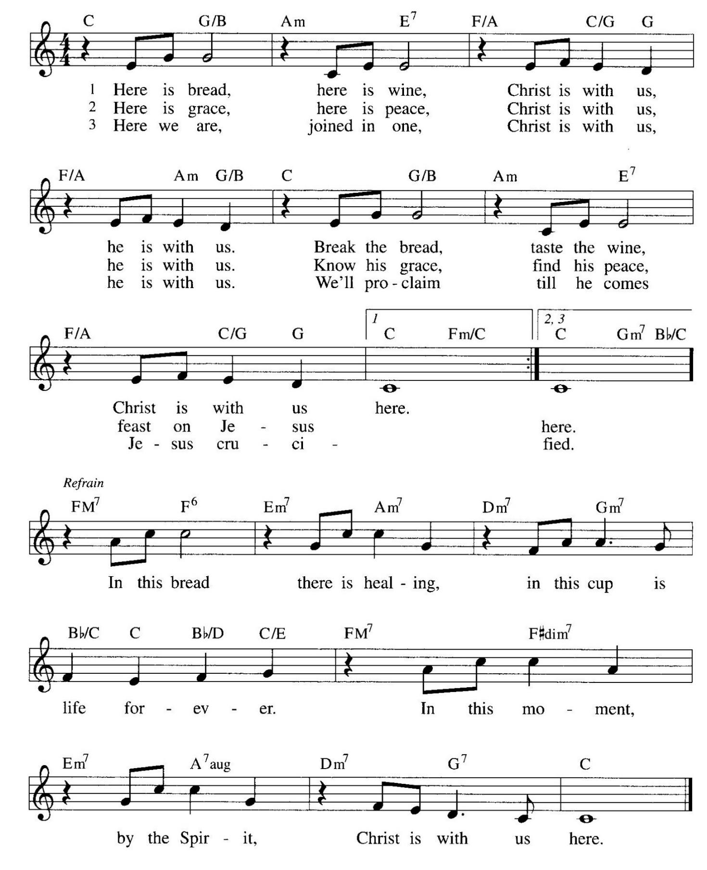

Prayer After Communion
a blessing is given, a prayer follows

L: Lord of life,
in the gift of your body and blood
you turn the crumbs of our faith into a feast of salvation.
Send us forth into the world with shouts of joy,
bearing witness to the abundance of your love
in Jesus Christ, our Savior and Lord.
A: Amen.

Announcements

SENDING

Presentation and Blessing of the Blankets

Blessing

L: People of God,
you are Christ’s body,
bringing new life to a suffering world.
The holy Trinity, ☩ one God,
bless you now and forever.
A: Amen.

Sending Hymn – We Are Called-ELW 720
see music on final page

Dismissal

L: Go in peace. The living Word dwells in you.
A: Thanks be to God.

Postlude

Licensing information for this Worship Service:
CCLI Copyright License A 2440181 9/30/2021 + Streaming License A 20530290 5/31/2022
Sundays and Seasons License Sundays and Seasons v.20200325.1254
Thank you to all those who contributed to today’s service: Lector: Sara Solberg, Usher: Sandy Erickson, Musician: Julie Mehlberg, Communion Prep: Julie Mehlberg & Kris Lambert, Communion Asst: Brad & Sara Solberg, Livestream: Louis Kehinde, Sound & Projection: Emma Johnson, Joel Rapp, Julie Mehlberg, John Mehlberg and Melissa Rapp, Hospitality; Darla Dixon & Mary Leach, Counters: Jake Dixon & Jean Harrison.

