St. Paul Lutheran Church
Pontiac, IL
December 13, 2020
Third Sunday of Advent

Flowers were donated by Sandy Erickson in celebration of Advent and in honor of Carol Thorson’s birthday.
“Red bag” offering will be collected and donated to “Local Needy Families”.

We gather to worship, reach out, and serve the Lord.

Welcome

Welcome to St. Paul Lutheran Church. Whether you have worshipped with us many times, or this is your first time, there is a place for you here. Your presence among us is a gift.

God’s Peace be with you,
Pastor Mathew
Contact Pastor Mathew
Cell: 815-200-9256
Email: pastormathewberger@gmail.com
Friday is Pastor Mathew’s day off.

Introduction to the day
Introduction
“Rejoice always,” begins the reading from 1 Thessalonians. Isaiah and the psalmist make clear that God is turning our mourning into laughter and shouts of joy. “All God’s children got a robe,” go the words of a spiritual. It is not so much a stately, formal, pressed outfit as it is a set of party clothes, clothes we are happy to wear. We receive that robe in baptism, and in worship, we gather for a foretaste of God’s party.

GATHERING

Confession and Forgiveness
All may make the sign of the cross, the sign marked at baptism, as the presiding minister begins.
Blessed be God, Father, ☩ Son, and Holy Spirit,
whose forgiveness is sure
and whose steadfast love endures forever.
Amen.

Together let us honestly and humbly confess
that we have not lived as God desires.
Silence is kept for reflection.
Loving and forgiving God,
we confess that we are held captive by sin.
In spite of our best efforts, we have gone astray. We have not welcomed the stranger;
we have not loved our neighbor;
we have not been Christ to one another.
Restore us, O God.
Wake us up and turn us from our sin.
Renew us each day in the light of Christ. Amen.

People of God, hear this glad news:
by God’s endless grace
your sins are forgiven, and you are free—
free from all that holds you back
and free to live in the peaceable realm of God.
May you be strengthened in God’s love,
☩ comforted by Christ’s peace,
and accompanied with the power of the Holy Spirit.
Amen.

Lighting of the Advent Wreath

“Come Now, O Prince of Peace” – to be sung during lighting of the wreath- Sing first 3 verses

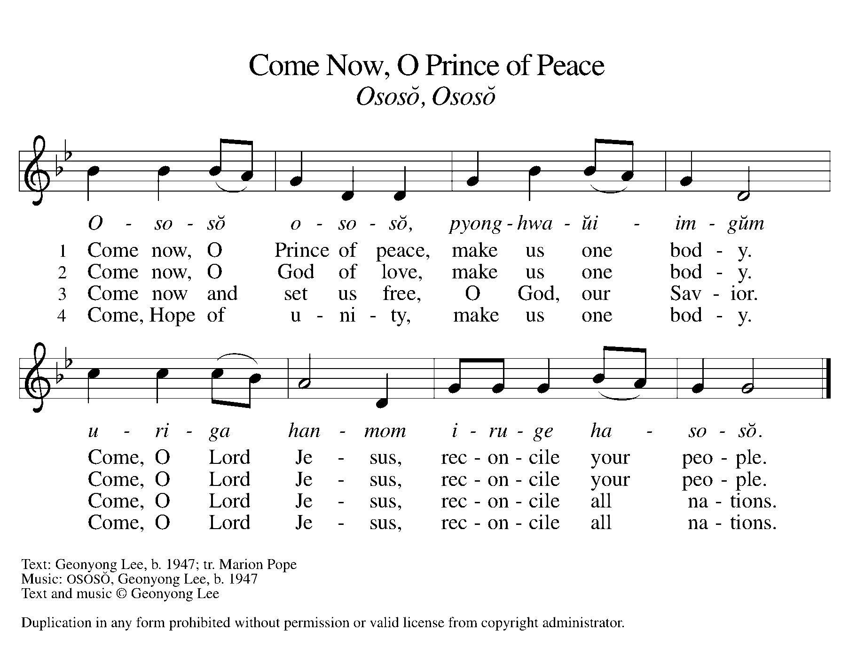

Greeting

L: The grace of our Lord Jesus Christ, the love of God, and the communion of the
Holy Spirit be with you all.
A: And also with you.

Prayer of the Day

Stir up the wills of your faithful people, Lord God, and open our ears to the word of your prophets, that, anointed by your Spirit, we may testify to your light, through Jesus Christ, our Savior and Lord, who lives and reigns with you and the Holy Spirit, one God, now and forever.
Amen.

Children’s Message

WORD

Reading – Isaiah 61: 1-4, 8-11

L: A reading from Isaiah.

¹The spirit of the Lord God is upon me,
because the Lord has anointed me;
he has sent me to bring good news to the oppressed,
to bind up the brokenhearted,
to proclaim liberty to the captives,
and release to the prisoners;
²to proclaim the year of the Lord’s favor,
and the day of vengeance of our God;
to comfort all who mourn;
³to provide for those who mourn in Zion—
to give them a garland instead of ashes,
the oil of gladness instead of mourning,
the mantle of praise instead of a faint spirit.
They will be called oaks of righteousness,
the planting of the Lord, to display his glory.
⁴They shall build up the ancient ruins,
they shall raise up the former devastations;
they shall repair the ruined cities,
the devastations of many generations.
⁸For I the Lord love justice,
I hate robbery and wrongdoing;
I will faithfully give them their recompense,
and I will make an everlasting covenant with them.
⁹Their descendants shall be known among the nations,
and their offspring among the peoples;
all who see them shall acknowledge
that they are a people whom the Lord has blessed.
¹⁰I will greatly rejoice in the Lord,
my whole being shall exult in my God;
for he has clothed me with the garments of salvation,
he has covered me with the robe of righteousness,
as a bridegroom decks himself with a garland,
and as a bride adorns herself with her jewels.
¹¹For as the earth brings forth its shoots,
and as a garden causes what is sown in it to spring up,
so the Lord God will cause righteousness and praise
to spring up before all the nations.

L: Word of God, Word of life.
A: Thanks be to God.

Psalm Reading- Psalm 126

L: A reading from Psalm.

¹When the Lord restored the fortunes of Zion,
then were we like those who dream.
²Then was our mouth filled with laughter, and our tongue with shouts of joy.
Then they said among the nations, “The Lord has done great things for them.”
³The Lord has done great things for us,
and we are glad indeed.
⁴Restore our fortunes, O Lord,
like the watercourses of the Negeb.
⁵Those who sowed with tears
will reap with songs of joy.
⁶Those who go out weeping, carrying the seed,
will come again with joy, shouldering their sheaves.

L: Holy Wisdom. Holy Word.
A: Thanks be to God.

1 Thessalonians 5: 16-24

A reading from 1 Thessalonians.

⁶Rejoice always, ¹⁷pray without ceasing, ¹⁸give thanks in all circumstances; for this is the will of God in Christ Jesus for you. ¹⁹Do not quench the Spirit. ²⁰Do not despise the words of prophets, ²¹but test everything; hold fast to what is good; ²²abstain from every form of evil.
²³May the God of peace himself sanctify you entirely; and may your spirit and soul and body be kept sound and blameless at the coming of our Lord Jesus Christ. ²⁴The one who calls you is faithful, and he will do this.

L: Word of God, Word of life.
A: Thanks be to God.

Please rise as you are able for the reading of the Holy Gospel.

Gospel Acclamation
(spoken responsively)

L: Alleluia. I am sending my messenger before you,
A: Who will prepare your way before you. Alleluia.

Gospel–John 1: 6-8, 19-28

L: The Holy Gospel according to John.
A: Glory to you, O Lord.

⁶There was a man sent from God, whose name was John. ⁷He came as a witness to testify to the light, so that all might believe through him. ⁸He himself was not the light, but he came to testify to the light.
¹⁹This is the testimony given by John when the Jews sent priests and Levites from Jerusalem to ask him, “Who are you?” ²⁰He confessed and did not deny it, but confessed, “I am not the Messiah.” ²¹And they asked him, “What then? Are you Elijah?” He said, “I am not.” “Are you the prophet?” He answered, “No.” ²²Then they said to him, “Who are you? Let us have an answer for those who sent us. What do you say about yourself?” ²³He said,
“I am the voice of one crying out in the wilderness, ‘Make straight the way of the Lord,’ ”
as the prophet Isaiah said.
²⁴Now they had been sent from the Pharisees. ²⁵They asked him, “Why then are you baptizing if you are neither the Messiah, nor Elijah, nor the prophet?” ²⁶John answered them, “I baptize with water. Among you stands one whom you do not know, ²⁷the one who is coming after me; I am not worthy to untie the thong of his sandal.” ²⁸This took place in Bethany across the Jordan where John was baptizing.

L: The gospel of the Lord.
A: Praise to you, O, Christ.

Sermon Pastor Mathew Berger

Hymn of the Day “On Jordan’s Bank the Baptist’s Cry” ELW 249

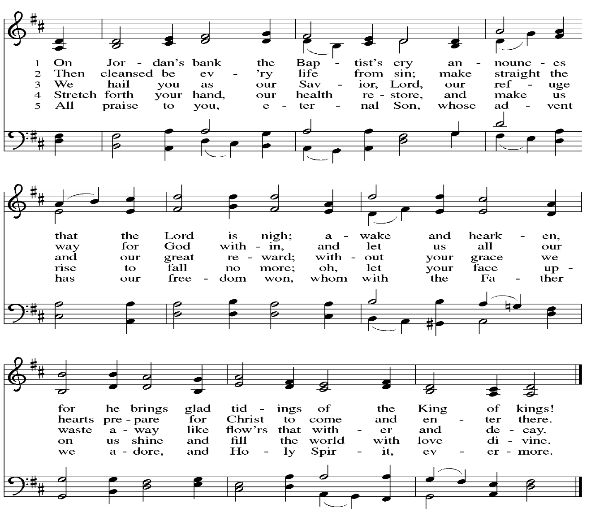

Apostle’s Creed
I believe in God, the Father Almighty, creator of heaven and earth. I believe in Jesus Christ, his only Son, our Lord. He was conceived by power of the Holy Spirit and born of the virgin Mary. He suffered under Pontius Pilate, was crucified, died, and was buried. He descended into hell. On the third day, he rose again. He ascended into heaven and is seated at the right hand of the Father. He will come again to judge the living and the dead. I believe in the Holy Spirit, the holy catholic church, the communion of saints, the forgiveness of sins, the resurrection of the body, and the life everlasting.
Amen.

Prayers of Intercession

Each petition ends “Hear us, O God.” The congregation is invited to respond, “your mercy is great.”

Sharing the Peace

L: The peace of Christ be with you always.
A: And also with you.

You are invited to share a sign of God’s peace with your neighbors by saying or typing, “Peace be with you.”

Offerings can be given by mail or online. You can send a check to St. Paul Lutheran Church 210 Deerfield Rd Pontiac, IL 61764. You can give online at http://www.stpaulpontiac.org/

Offering Prayer

L: Generous God,
You have created all that is,
And you provide for us in every season.
Bless all that we offer,
That through these gifts the world will receive your blessing.
In the name of Jesus, Emmanuel, we pray.
A: Amen.

Great Thanksgiving
L: The Lord be with you.
A: And also with you.
L: Lift up your hearts.
A: We lift them to the Lord.
L: Let us give thanks to the Lord our God.
A: It is right to give our thanks and praise.

Preface
L: It is indeed right, our duty and our joy,
that we should at all times and in all places
give thanks and praise to you, almighty and merciful God,
through our Savior Jesus Christ;
you comforted your people with the promise of the Redeemer,
through whom you will also make all things new in the day when
he comes to judge the world in righteousness. And so, with all the
choirs of angels, with the church on earth and the hosts of heaven,
we praise your name and join their unending hymn:

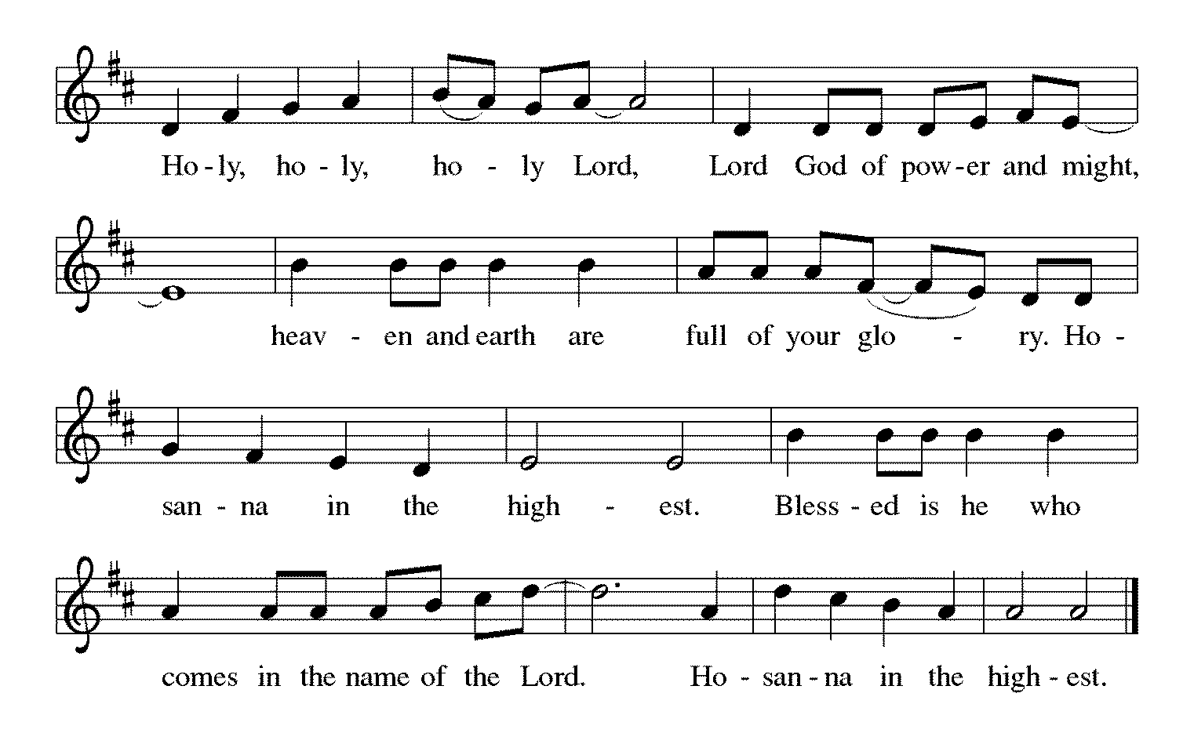

Words of Institution

In the night in which he was betrayed,
our Lord Jesus took bread, and gave thanks;
broke it, and gave it to his disciples, saying:
Take and eat; this is my body, given for you.
Do this for the remembrance of me.
Again, after supper, he took the cup, gave thanks,
and gave it for all to drink, saying:
This cup is the new covenant in my blood,
shed for you and for all people for the forgiveness of sin.
Do this for the remembrance of me.

Lord's Prayer

L: Gathered into one by the Holy Spirit, let us pray as Jesus taught us,
A: Our Father, who art in heaven, hallowed be thy name, thy kingdom come, thy will be done, on earth as it is in heaven. Give us this day our daily bread; and forgive us our trespasses, as we forgive those who trespass against us; and lead us not into temptation but deliver us from evil. For thine is the kingdom and the power, and the glory, forever and ever. Amen.

Invitation to Communion

L: Even as we watch and wait, Christ is here. Come, eat and drink.

Sending Hymn “People, Look East” ELW 249

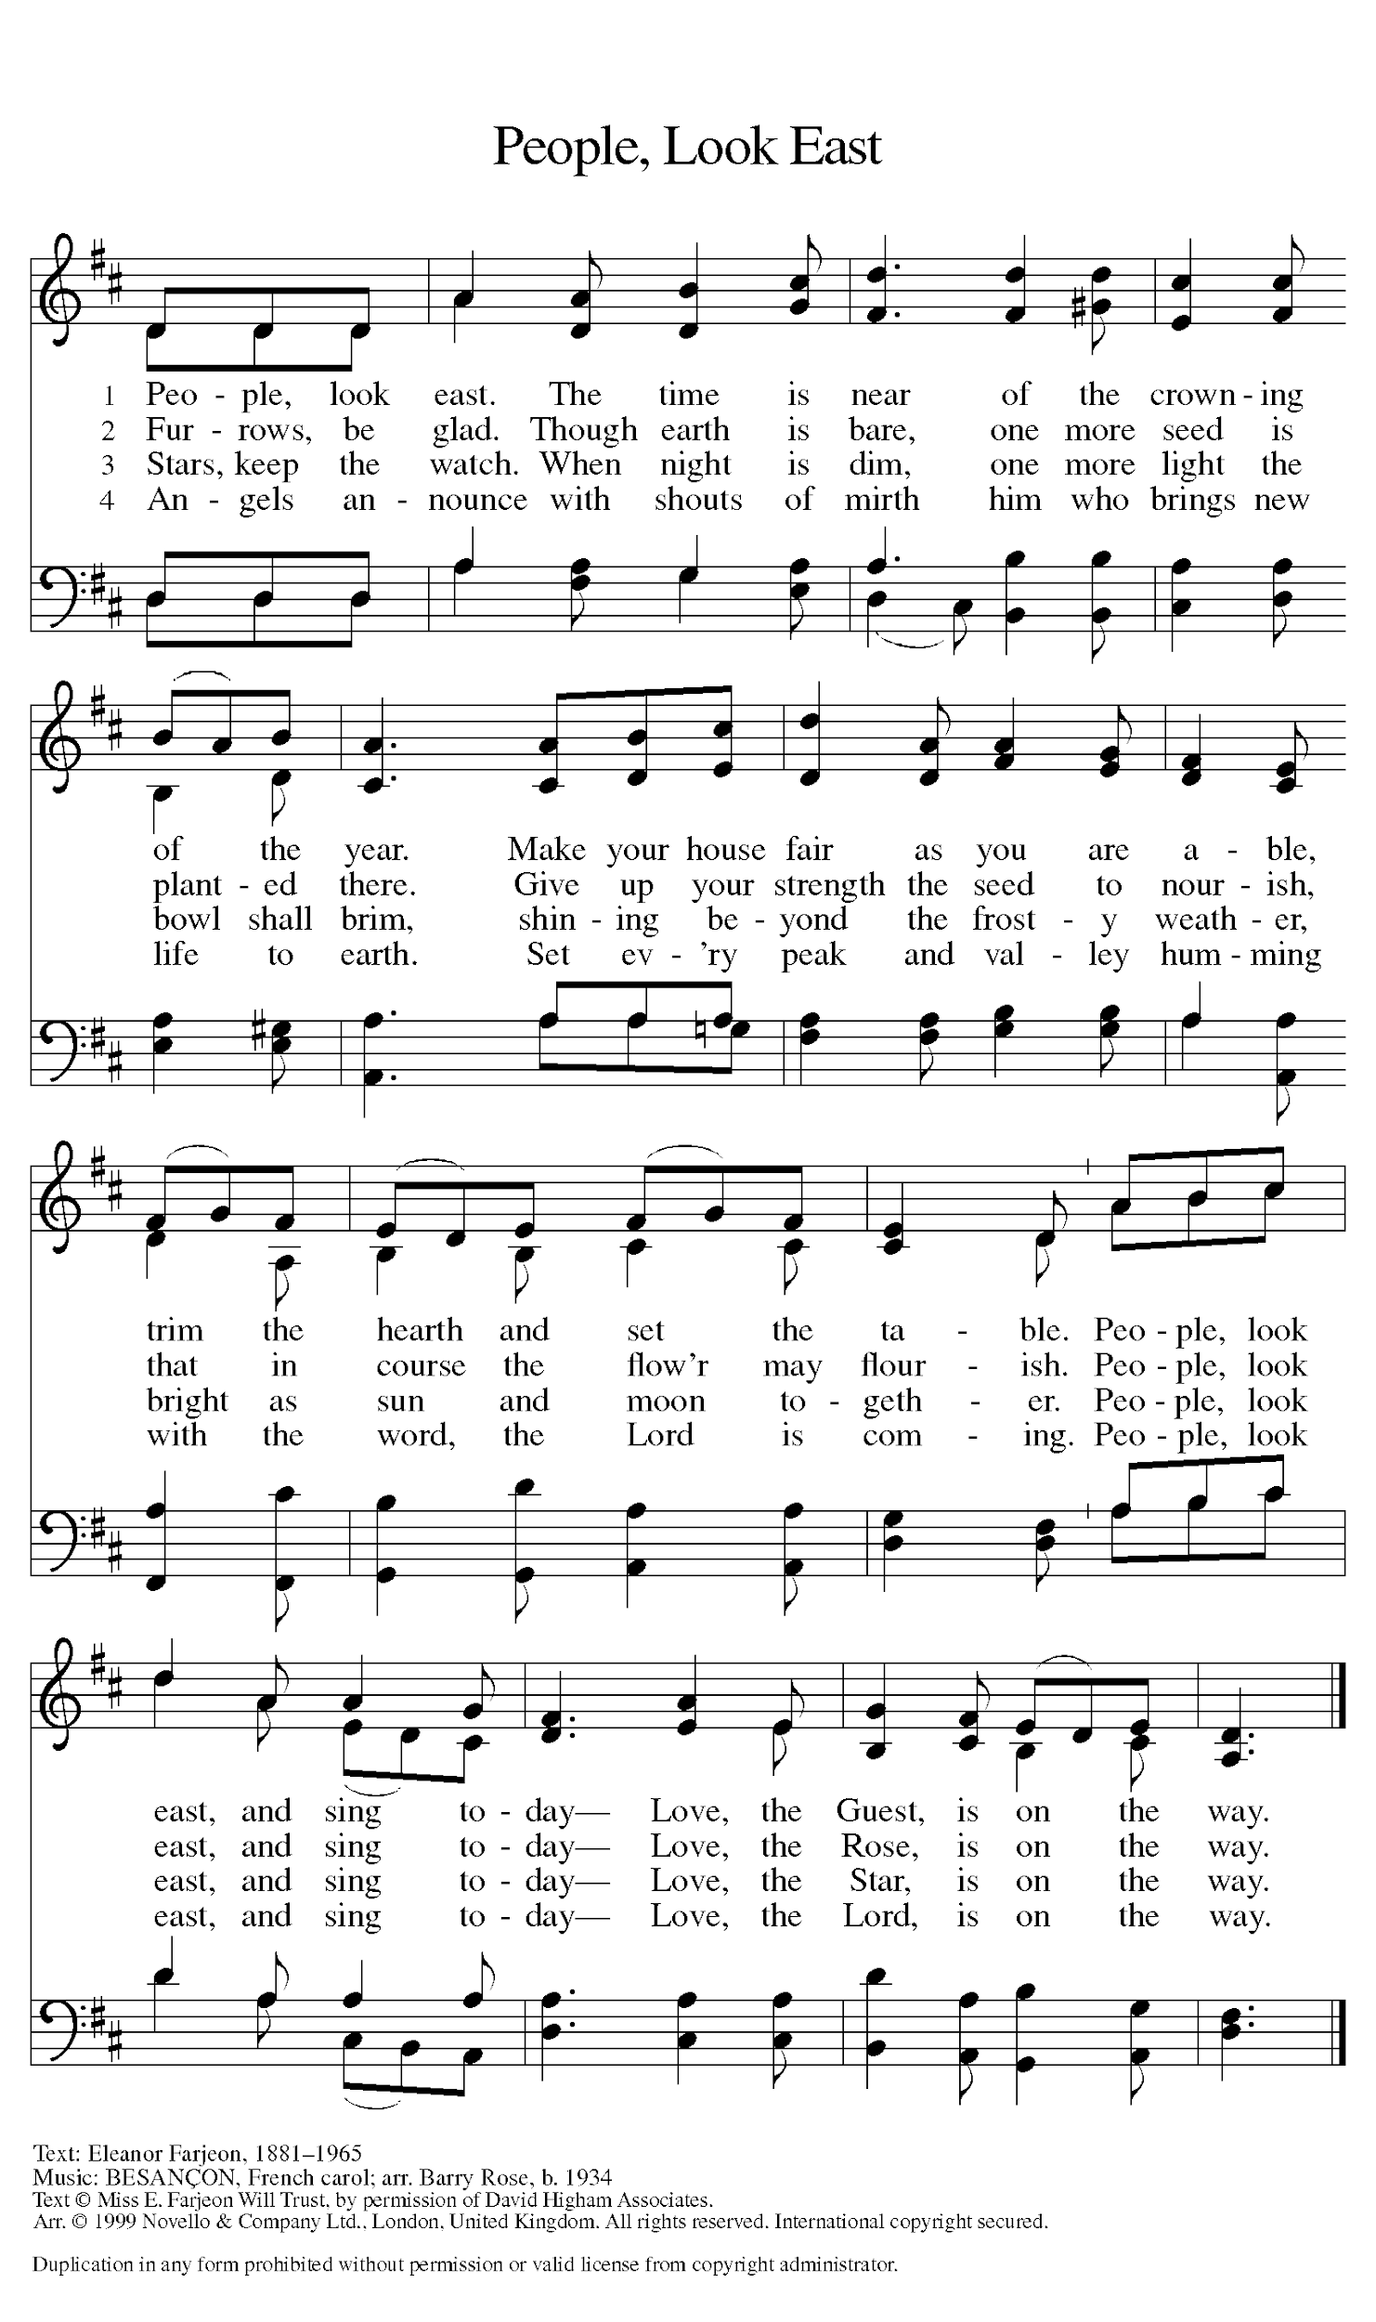
Announcements

SENDING

Benediction
L: The Creator of the stars bless your Advent waiting,
The long-expected Savior fill you with love,
The unexpected Spirit guide your journey,
☩ now and forever.
A: Amen.

Postlude

Our livestream ends with a postlude, you are invited to come to the church parking lot to receive communion.

Licensing information for this Worship Service:
CCLI Copyright License A 2440181 9/30/2020 + Streaming License A 20530290 5/31/2021
Sundays and Seasons License Sundays and Seasons v.20200325.1254
Thank you to all those who contributed to today’s service: Worship Slides: Julie Mehlberg, Musician: Julie Mehlberg Lector:

