St. Paul Lutheran Church
Pontiac, IL
December 20, 2020
Fourth Sunday of Advent

We gather to worship, reach out, and serve the Lord.

Welcome

Welcome to St. Paul Lutheran Church. Whether you have worshipped with us many times, or this is your first time, there is a place for you here. Your presence among us is a gift.

God’s Peace be with you,
Pastor Mathew
Contact Pastor Mathew
Cell: 815-200-9256
Email: pastormathewberger@gmail.com
Friday is Pastor Mathew’s day off.

Introduction to the day
Introduction

God keeps the promise made to David to give him an everlasting throne. The angel tells Mary that God will give David’s throne to her son Jesus. She is perplexed by Gabriel’s greeting and by the news of her coming pregnancy, but she is able still to say, “Count me in.” We who know that Jesus is called king only as he is executed still find it a mystery hard to fathom, but with Mary today we hear the news of what God is up to and say, “Count us in.”

GATHERING

Confession and Forgiveness
All may make the sign of the cross, the sign marked at baptism, as the presiding minister begins.
Blessed be God, Father, ☩ Son, and Holy Spirit,
whose forgiveness is sure
and whose steadfast love endures forever.
Amen.

Together let us honestly and humbly confess
that we have not lived as God desires.
Silence is kept for reflection.
Loving and forgiving God,
we confess that we are held captive by sin.
In spite of our best efforts, we have gone astray. We have not welcomed the stranger;
we have not loved our neighbor;
we have not been Christ to one another.
Restore us, O God.
Wake us up and turn us from our sin.
Renew us each day in the light of Christ. Amen.

People of God, hear this glad news:
by God’s endless grace
your sins are forgiven, and you are free—
free from all that holds you back
and free to live in the peaceable realm of God.
May you be strengthened in God’s love,
☩ comforted by Christ’s peace,
and accompanied with the power of the Holy Spirit.
Amen.

Lighting of the Advent Wreath

“Come Now, O Prince of Peace” – to be sung during lighting of the wreath- Sing all 4 verses

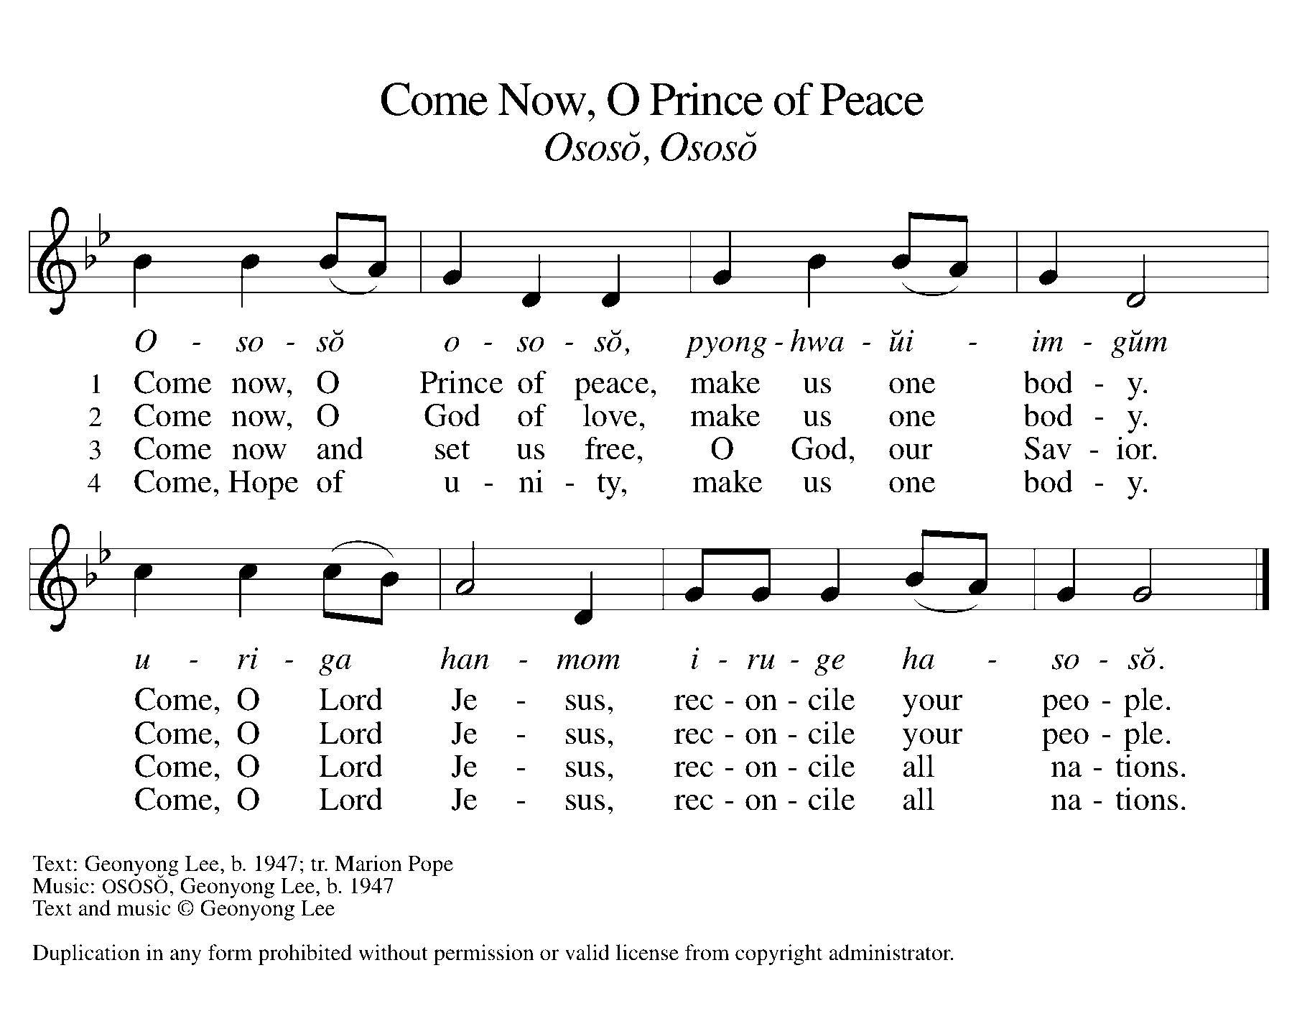

Greeting

L: The grace of our Lord Jesus Christ, the love of God, and the communion of the
Holy Spirit be with you all.
A: And also with you.

Prayer of the Day

Stir up your power, Lord Christ, and come. With your abundant grace and might, free us from sin that would obstruct your mercy, that willingly we may bear your redeeming love to all the world, for you live and reign with the Father and the Holy Spirit, one God, now and forever.
Amen.

Children’s Message

WORD

Reading – 2 Samuel 7: 1-11, 16

L: A reading from Samuel.

¹Now when the king was settled in his house, and the Lord had given him rest from all his enemies around him, ²the king said to the prophet Nathan, “See now, I am living in a house of cedar, but the ark of God stays in a tent.” ³Nathan said to the king, “Go, do all that you have in mind; for the Lord is with you.”
⁴But that same night the word of the Lord came to Nathan: ⁵Go and tell my servant David: Thus says the Lord: Are you the one to build me a house to live in? ⁶I have not lived in a house since the day I brought up the people of Israel from Egypt to this day, but I have been moving about in a tent and a tabernacle. ⁷Wherever I have moved about among all the people of Israel, did I ever speak a word with any of the tribal leaders of Israel, whom I commanded to shepherd my people Israel, saying, “Why have you not built me a house of cedar?” ⁸Now therefore thus you shall say to my servant David: Thus says the Lord of hosts: I took you from the pasture, from following the sheep to be prince over my people Israel; ⁹and I have been with you wherever you went, and have cut off all your enemies from before you; and I will make for you a great name, like the name of the great ones of the earth. ¹⁰And I will appoint a place for my people Israel and will plant them, so that they may live in their own place, and be disturbed no more; and evildoers shall afflict them no more, as formerly, ¹¹from the time that I appointed judges over my people Israel; and I will give you rest from all your enemies. Moreover, the Lord declares to you that the Lord will make you a house. ¹⁶Your house and your kingdom shall be made sure forever before me; your throne shall be established forever.

L: Word of God, Word of life.
A: Thanks be to God.

Psalm Reading- Luke 1: 46b-55

L: A reading from Luke.

^{46b}My soul proclaims the greatness of the Lord,
⁴⁷my spirit rejoices in God my Savior,
⁴⁸for you, Lord, have looked with favor on your lowly servant.
From this day all generations will call me blessed:
⁴⁹you, the Almighty, have done great things for me
and holy is your name.
⁵⁰You have mercy on those who fear you,
from generation to generation.
⁵¹You have shown strength with your arm
and scattered the proud in their conceit,
⁵²casting down the mighty from their thrones
and lifting up the lowly.
⁵³You have filled the hungry with good things
and sent the rich away empty.
⁵⁴You have come to the aid of your servant Israel,
to remember the promise of mercy,
⁵⁵the promise made to our forbears,
to Abraham and his children forever.

L: Holy Wisdom. Holy Word.
A: Thanks be to God.

Romans 16: 25-27
A reading from Romans.

²⁵Now to God who is able to strengthen you according to my gospel and the proclamation of Jesus Christ, according to the revelation of the mystery that was kept secret for long ages ²⁶but is now disclosed, and through the prophetic writings is made known to all the Gentiles, according to the command of the eternal God, to bring about the obedience of faith—²⁷to the only wise God, through Jesus Christ, to whom be the glory forever! Amen.

L: Word of God, Word of life.
A: Thanks be to God.

Please rise as you are able for the reading of the Holy Gospel.

Gospel Acclamation
(spoken responsively)

L: Alleluia. Here I am, the servant of the Lord.
A: Let it be with me according to your word. Alleluia.

Gospel–Luke 1: 26-38

L: The Holy Gospel according to Luke.
A: Glory to you, O Lord.

²⁶In the sixth month the angel Gabriel was sent by God to a town in Galilee called Nazareth, ²⁷to a virgin engaged to a man whose name was Joseph, of the house of David. The virgin’s name was Mary. ²⁸And he came to her and said, “Greetings, favored one! The Lord is with you.” ²⁹But she was much perplexed by his words and pondered what sort of greeting this might be. ³⁰The angel said to her, “Do not be afraid, Mary, for you have found favor with God. ³¹And now, you will conceive in your womb and bear a son, and you will name him Jesus. ³²He will be great, and will be called the Son of the Most High, and the Lord God will give to him the throne of his ancestor David. ³³He will reign over the house of Jacob forever, and of his kingdom there will be no end.” ³⁴Mary said to the angel, “How can this be, since I am a virgin?” ³⁵The angel said to her, “The Holy Spirit will come upon you, and the power of the Most High will overshadow you; therefore the child to be born will be holy; he will be called Son of God. ³⁶And now, your relative Elizabeth in her old age has also conceived a son; and this is the sixth month for her who was said to be barren. ³⁷For nothing will be impossible with God.” ³⁸Then Mary said, “Here am I, the servant of the Lord; let it be with me according to your word.” Then the angel departed from her.

L: The gospel of the Lord.
A: Praise to you, O, Christ.

Sermon Pastor Mathew Berger

Hymn of the Day “My Soul Proclaims Your Greatness” ELW 251

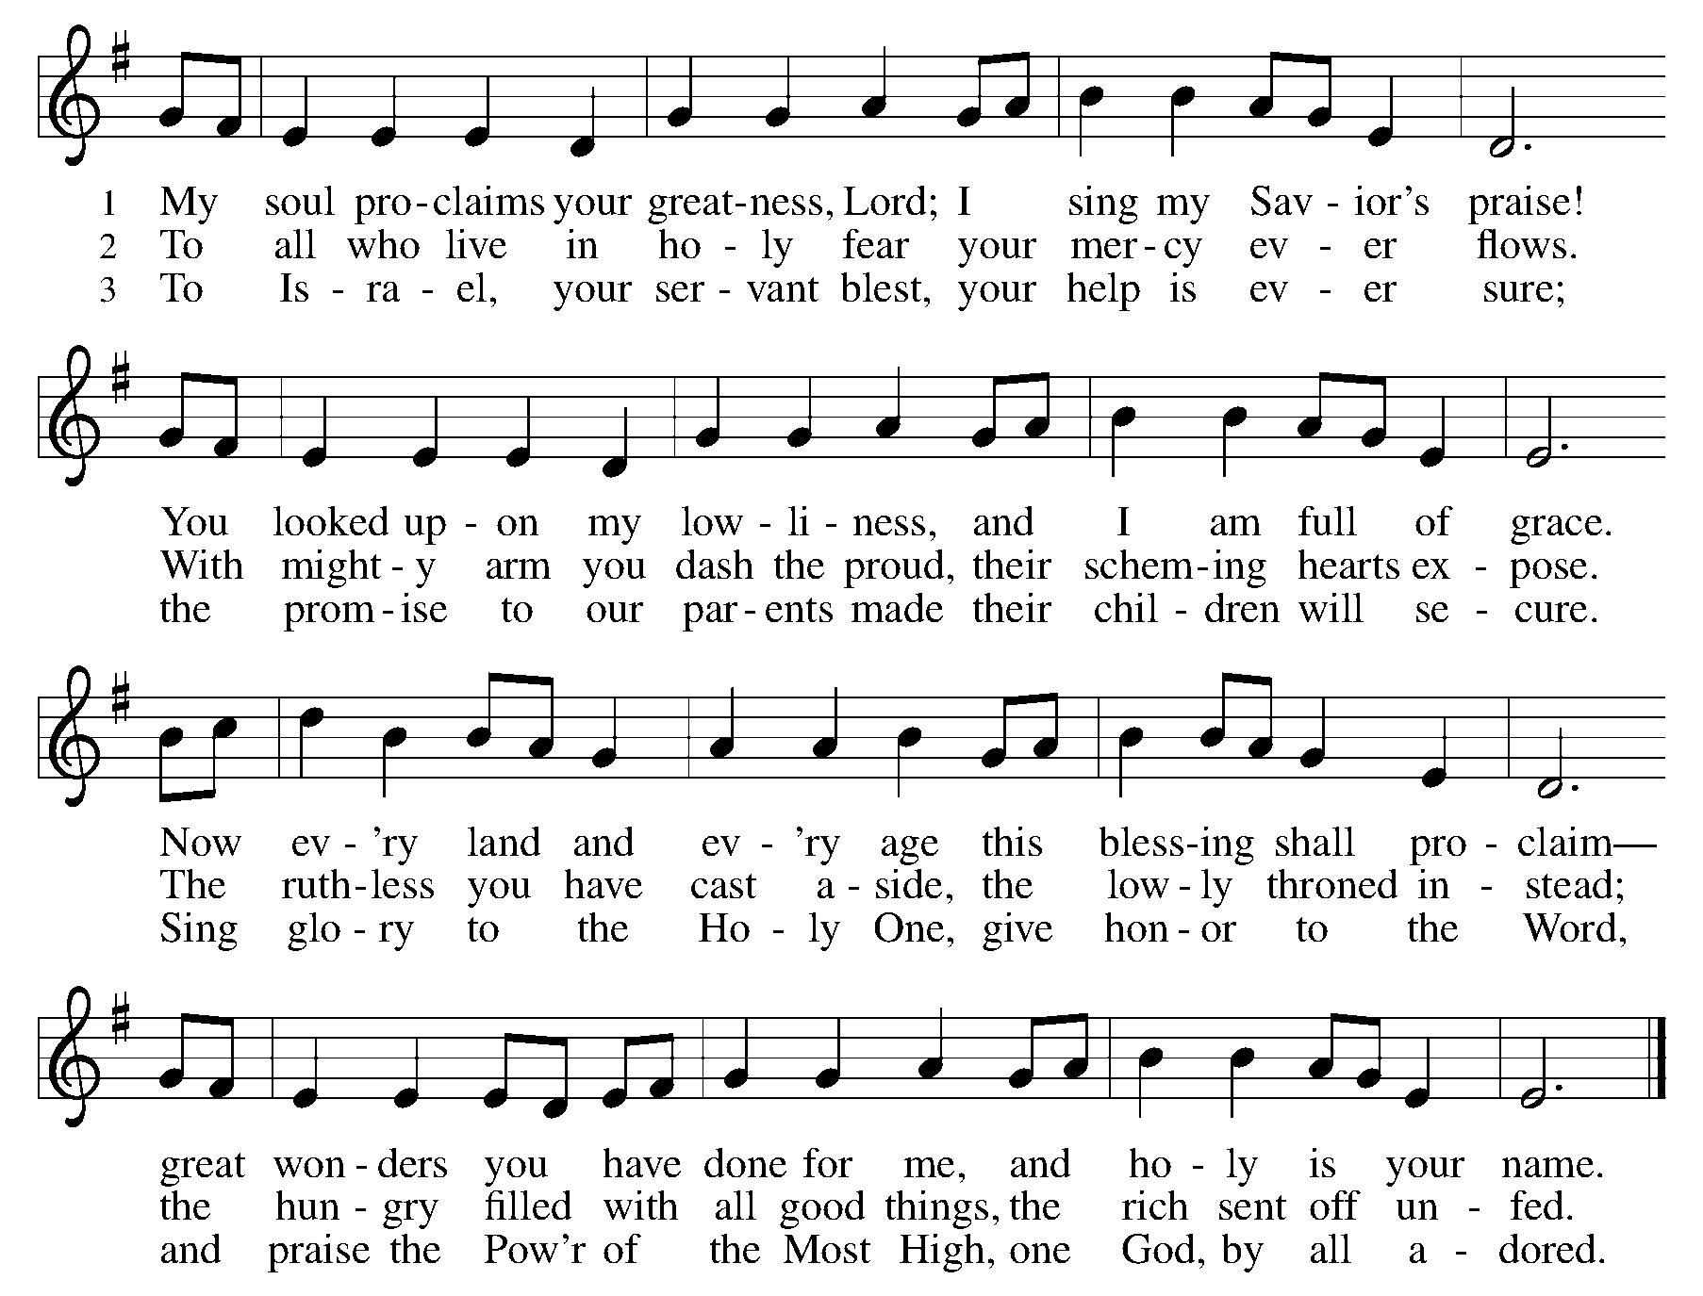

Apostle’s Creed
I believe in God, the Father Almighty, creator of heaven and earth. I believe in Jesus Christ, his only Son, our Lord. He was conceived by power of the Holy Spirit and born of the virgin Mary. He suffered under Pontius Pilate, was crucified, died, and was buried. He descended into hell. On the third day, he rose again. He ascended into heaven and is seated at the right hand of the Father. He will come again to judge the living and the dead. I believe in the Holy Spirit, the holy catholic church, the communion of saints, the forgiveness of sins, the resurrection of the body, and the life everlasting.
Amen.

Prayers of Intercession

Each petition ends “Hear our prayer, O God.” The congregation is invited to respond, “Come and save us soon.”

Sharing the Peace

L: The peace of Christ be with you always.
A: And also with you.

You are invited to share a sign of God’s peace with your neighbors by saying or typing, “Peace be with you.”

Offerings can be given by mail or online. You can send a check to St. Paul Lutheran Church 210 Deerfield Rd Pontiac, IL 61764. You can give online at http://www.stpaulpontiac.org/

Offering Prayer

L: Generous God,
You have created all that is,
And you provide for us in every season.
Bless all that we offer,
That through these gifts the world will receive your blessing.
In the name of Jesus, Emmanuel, we pray.
A: Amen.

Great Thanksgiving
L: The Lord be with you.
A: And also with you.
L: Lift up your hearts.
A: We lift them to the Lord.
L: Let us give thanks to the Lord our God.
A: It is right to give our thanks and praise.

Preface
L: It is indeed right, our duty and our joy,
that we should at all times and in all places
give thanks and praise to you, almighty and merciful God,
through our Savior Jesus Christ;
you comforted your people with the promise of the Redeemer,
through whom you will also make all things new in the day when
he comes to judge the world in righteousness. And so, with all the
choirs of angels, with the church on earth and the hosts of heaven,
we praise your name and join their unending hymn:

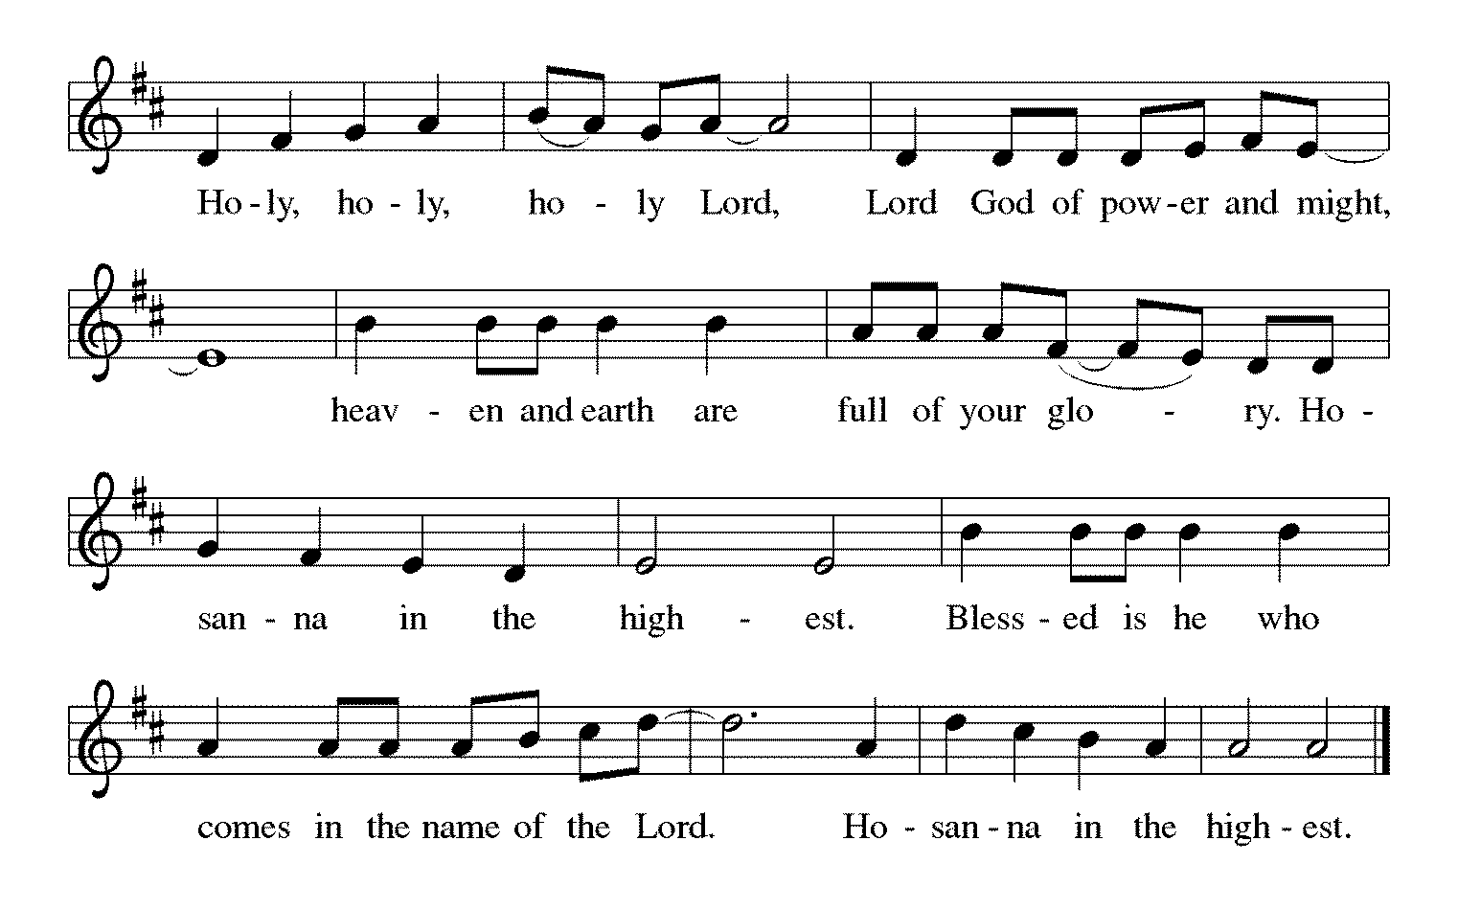

Words of Institution

In the night in which he was betrayed,
our Lord Jesus took bread, and gave thanks;
broke it, and gave it to his disciples, saying:
Take and eat; this is my body, given for you.
Do this for the remembrance of me.
Again, after supper, he took the cup, gave thanks,
and gave it for all to drink, saying:
This cup is the new covenant in my blood,
shed for you and for all people for the forgiveness of sin.
Do this for the remembrance of me.

Lord's Prayer

L: Gathered into one by the Holy Spirit, let us pray as Jesus taught us,
A: Our Father, who art in heaven, hallowed be thy name, thy kingdom come, thy will be done, on earth as it is in heaven. Give us this day our daily bread; and forgive us our trespasses, as we forgive those who trespass against us; and lead us not into temptation but deliver us from evil. For thine is the kingdom and the power, and the glory, forever and ever. Amen.

Invitation to Communion

L: Even as we watch and wait, Christ is here. Come, eat and drink.

Sending Hymn “The Angel Gabriel from Heaven Came” ELW 265
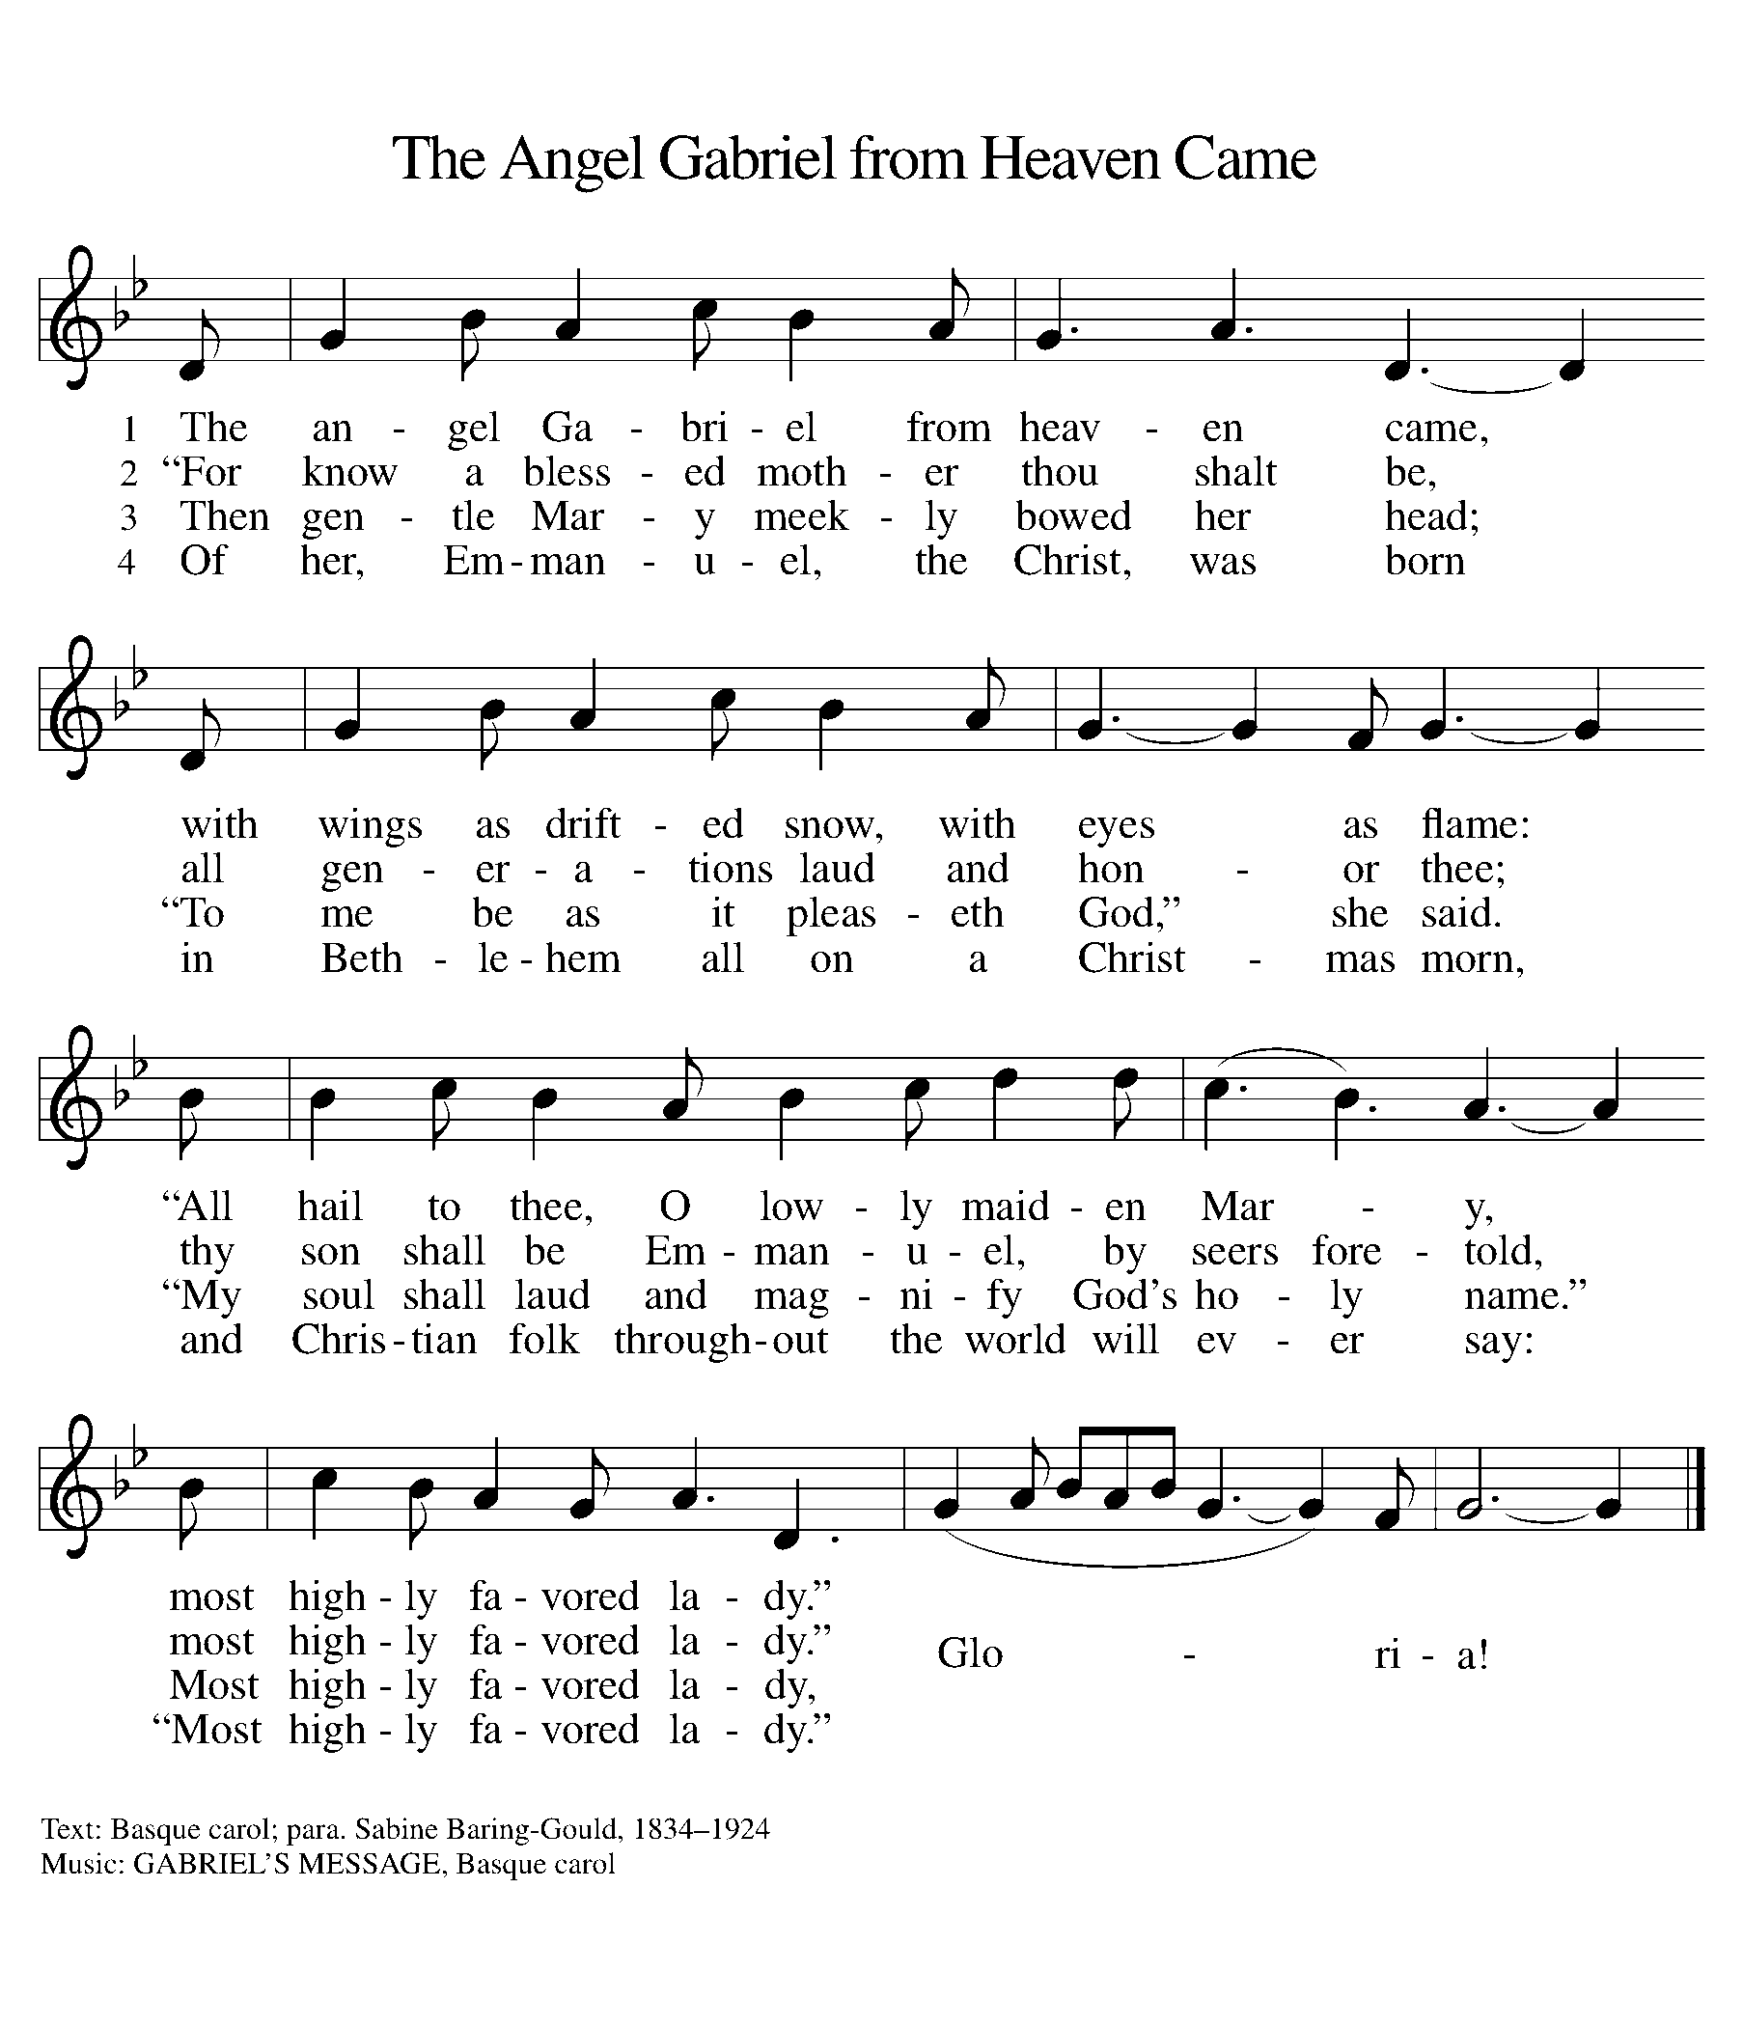

Announcements

SENDING

Benediction
L: The Creator of the stars bless your Advent waiting,
The long-expected Savior fill you with love,
The unexpected Spirit guide your journey,
☩ now and forever.
A: Amen.

Postlude

Our livestream ends with a postlude, you are invited to come to the church parking lot to receive communion.

Licensing information for this Worship Service:
CCLI Copyright License A 2440181 9/30/2020 + Streaming License A 20530290 5/31/2021
Sundays and Seasons License Sundays and Seasons v.20200325.1254
Thank you to all those who contributed to today’s service: Worship Slides: Julie Mehlberg, Musician: Sandy Erickson, Livestream: Louis Kehinde, Sound: John Mehlberg

