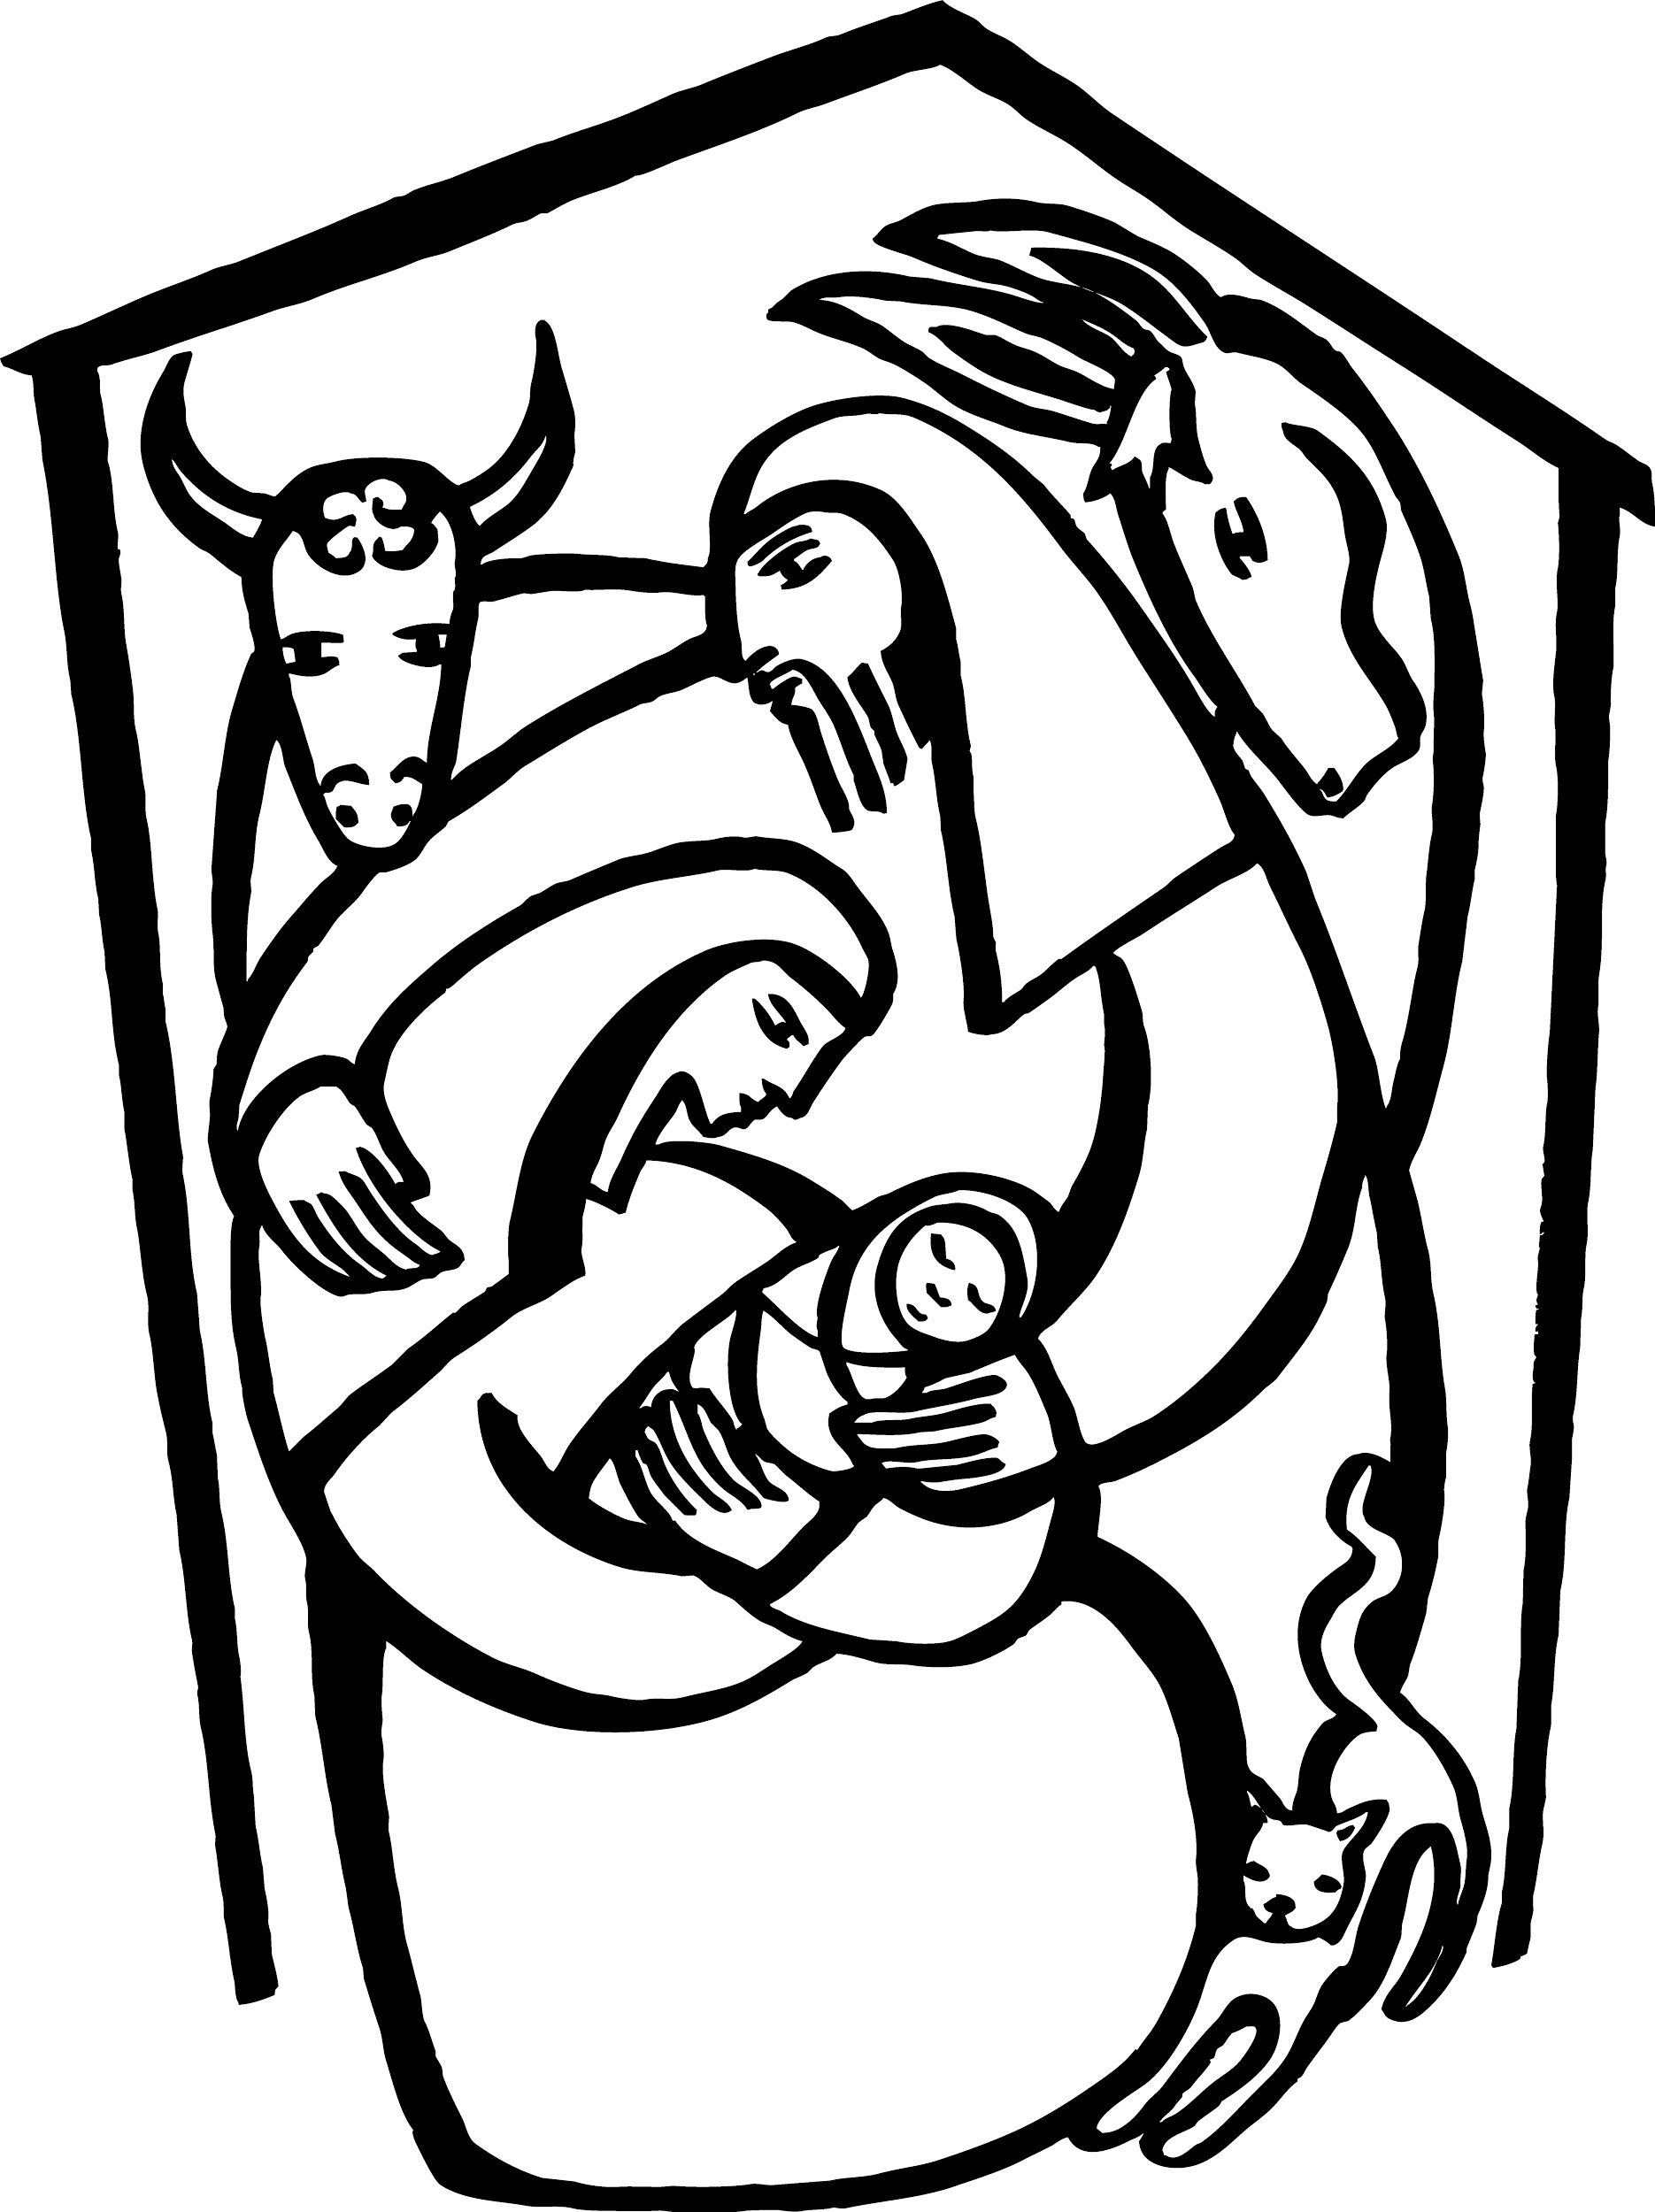
St. Paul Lutheran Church
Pontiac, IL
December 24, 2020
Nativity of our Lord
Christmas Eve

We gather to worship, reach out, and serve the Lord.

Welcome

Welcome to St. Paul Lutheran Church. Whether you have worshipped with us many times, or this is your first time, there is a place for you here. Your presence among us is a gift.

Contact Pastor Mathew
Cell: 815-200-9256
Email: pastormathewberger@gmail.com
Pastor Mathew will be on vacation Dec. 28 through Jan. 4

Introduction to worship

In winter’s deepest night, we welcome the light of the Christ child. Isaiah declares that the light of the long-promised king will illumine the world and bring endless peace and justice. Paul reminds us that the grace of God through Jesus Christ brings salvation to all people. The angels declare that Jesus’ birth is good and joyful news for everyone, including lowly shepherds. Filled with the light that shines in our lives, we go forth to share the light of Christ with the whole world.

PLEASE TUNE YOUR RADIO TO 91.1 FM FOR TONIGHT’S SERVICE

GATHERING

Confession and Forgiveness
All may make the sign of the cross, the sign marked at baptism, as the presiding minister begins.

L: Blessed be the holy Trinity, ☩ one God,
who was in the beginning,
who makes a dwelling among us,
who covers us with justice and mercy.
A: Amen.

L: Let us confess our sin in the presence of God and of one another.
Silence is kept for reflection.
L: God of goodness and lovingkindness,

A: we confess that we have sinned against you
and our neighbors.
We have turned away from your invitation to new life.
We have turned away from the lowly and downtrodden.
In your abundant mercy, forgive us our sins,
those we know and those known only to you,
for the sake of the one who came to live among us,
Jesus Christ, our Savior. Amen.
L: Hear the good news of peace and salvation!
God forgives us all our sins,
not through our own work,
but through ☩ Jesus Christ, made known to all people.
With all who come to the manger,
rejoice in this amazing gift of grace.
A: Amen.

Gathering Hymn O Come, All Ye Faithful ELW 283

1 O come, all ye faithful,
joyful and triumphant!
O come ye, O come ye to Bethlehem;
come and behold him,
born the king of angels:

Refrain
O come, let us adore him,
O come, let us adore him,
O come, let us adore him,
Christ the Lord!

2 The highest, most holy,
light of light eternal,
born of a virgin, a mortal he comes;
Son of the Father
now in flesh appearing! Refrain

3 Sing, choirs of angels,
sing in exultation,
sing, all ye citizens of heaven above!
Glory to God
in the highest: Refrain

4 Yea, Lord, we greet thee,
born this happy morning;
Jesus, to thee be glory giv'n!
Word of the Father,
now in flesh appearing: Refrain

Greeting

L: The grace of our Lord Jesus Christ, the love of God, and the communion of the
Holy Spirit be with you all.
A: And also with you.

Prayer of the Day

Stir up your power, Lord Christ, and come. With your abundant grace and might, free us from sin that would obstruct your mercy, that willingly we may bear your redeeming love to all the world, for you live and reign with the Father and the Holy Spirit, one God, now and forever. Amen.

Children’s Message

WORD
Reading – Isaiah 9: 2-7

L: A reading from Isaiah.
²The people who walked in darkness
have seen a great light;
those who lived in a land of deep darkness—
on them light has shined.
³You have multiplied the nation,
you have increased its joy;
they rejoice before you
as with joy at the harvest,
as people exult when dividing plunder.
⁴For the yoke of their burden,
and the bar across their shoulders,
the rod of their oppressor,
you have broken as on the day of Midian.
⁵For all the boots of the tramping warriors
and all the garments rolled in blood
shall be burned as fuel for the fire.
⁶For a child has been born for us,
a son given to us;
authority rests upon his shoulders;
and he is named
Wonderful Counselor, Mighty God,
Everlasting Father, Prince of Peace.
⁷His authority shall grow continually,
and there shall be endless peace
for the throne of David and his kingdom.
He will establish and uphold it
with justice and with righteousness
from this time onward and forevermore.
The zeal of the Lord of hosts will do this.

L: Word of God, Word of life.
A: Thanks be to God.

Psalm Reading- Psalm 96

L: A reading from Psalm.

¹Sing to the Lord a new song;
sing to the Lord, all the earth.
²Sing to the Lord, bless the name of the Lord;
proclaim God’s salvation from day to day.
³Declare God’s glory among the nations
and God’s wonders among all peoples.
⁴For great is the Lord and greatly to be praised,
more to be feared than all gods.
⁵As for all the gods of the nations, they are but idols;
but you, O Lord, have made the heavens.
⁶Majesty and magnificence are in your presence;
power and splendor are in your sanctuary.
⁷Ascribe to the Lord, you families of the peoples,
ascribe to the Lord honor and power.
⁸Ascribe to the Lord the honor due the holy name;
bring offerings and enter the courts of the Lord.
⁹Worship the Lord in the beauty of holiness;
tremble before the Lord, all the earth.
¹⁰Tell it out among the nations: “The Lord is king!
The one who made the world so firm that it cannot be moved will judge the peoples with
equity.”
¹¹Let the heavens rejoice, and let the earth be glad;
let the sea thunder and all that is in it; let the field be joyful and all that is therein.
¹²Then shall all the trees of the wood shout for joy at your coming, O Lord,
for you come to judge the earth.
¹³You will judge the world with righteousness
and the peoples with your truth.

L: Holy Wisdom. Holy Word.
A: Thanks be to God.

Hymn A Hallelujah Christmas Song

A couple came to Bethlehem A star shown bright up in the east
Expecting child, they searched the inn To Bethlehem, the wisemen three
To find a place for You were coming soon Came many miles and journeyed long for you
There was no room for them to stay And to the place at which you were
So in a manger filled with hay Their frankincense and gold and myrrh
God's only Son was born, oh Hallelujah They gave to you and cried out Hallelujah
Hallelujah Hallelujah
The shepherds left their flocks by night
To see this baby wrapped in light
A host of angels led them all to You
It was just as the angels said
You’ll find him in a manger bed
Immanuel and Savior, Hallelujah
Hallelujah

Gospel Acclamation
(spoken responsively)

L: Alleluia. I am bringing you good news of great joy for all the people.
A: To you is born this day in the city of David a Savior, who is the Messiah, the Lord. Alleluia.

Gospel–Luke 2: 1-14, [15-20]

L: The Holy Gospel according to Luke.
A: Glory to you, O Lord.

In those days a decree went out from Emperor Augustus that all the world should be registered. ²This was the first registration and was taken while Quirinius was governor of Syria. ³All went to their own towns to be registered. ⁴Joseph also went from the town of Nazareth in Galilee to Judea, to the city of David called Bethlehem, because he was descended from the house and family of David. ⁵He went to be registered with Mary, to whom he was engaged and who was expecting a child. ⁶While they were there, the time came for her to deliver her child. ⁷And she gave birth to her firstborn son and wrapped him in bands of cloth, and laid him in a manger, because there was no place for them in the inn.
⁸In that region there were shepherds living in the fields, keeping watch over their flock by night. ⁹Then an angel of the Lord stood before them, and the glory of the Lord shone around them, and they were terrified. ¹⁰But the angel said to them, “Do not be afraid; for see—I am bringing you good news of great joy for all the people: ¹¹to you is born this day in the city of David a Savior, who is the Messiah, the Lord. ¹²This will be a sign for you: you will find a child wrapped in bands of cloth and lying in a manger.” ¹³And suddenly there was with the angel a multitude of the heavenly host, praising God and saying,
¹⁴“Glory to God in the highest heaven,
and on earth peace among those whom he favors!”
[¹⁵When the angels had left them and gone into heaven, the shepherds said to one another, “Let us go now to Bethlehem and see this thing that has taken place, which the Lord has made known to us.” ¹⁶So they went with haste and found Mary and Joseph, and the child lying in the manger. ¹⁷When they saw this, they made known what had been told them about this child; ¹⁸and all who heard it were amazed at what the shepherds told them. ¹⁹But Mary treasured all these words and pondered them in her heart. ²⁰The shepherds returned, glorifying and praising God for all they had heard and seen, as it had been told them.]

L: The gospel of the Lord.
A: Praise to you, O, Christ.

Sermon Pastor Mathew Berger

Hymn of the Day On Christmas Night ELW 274

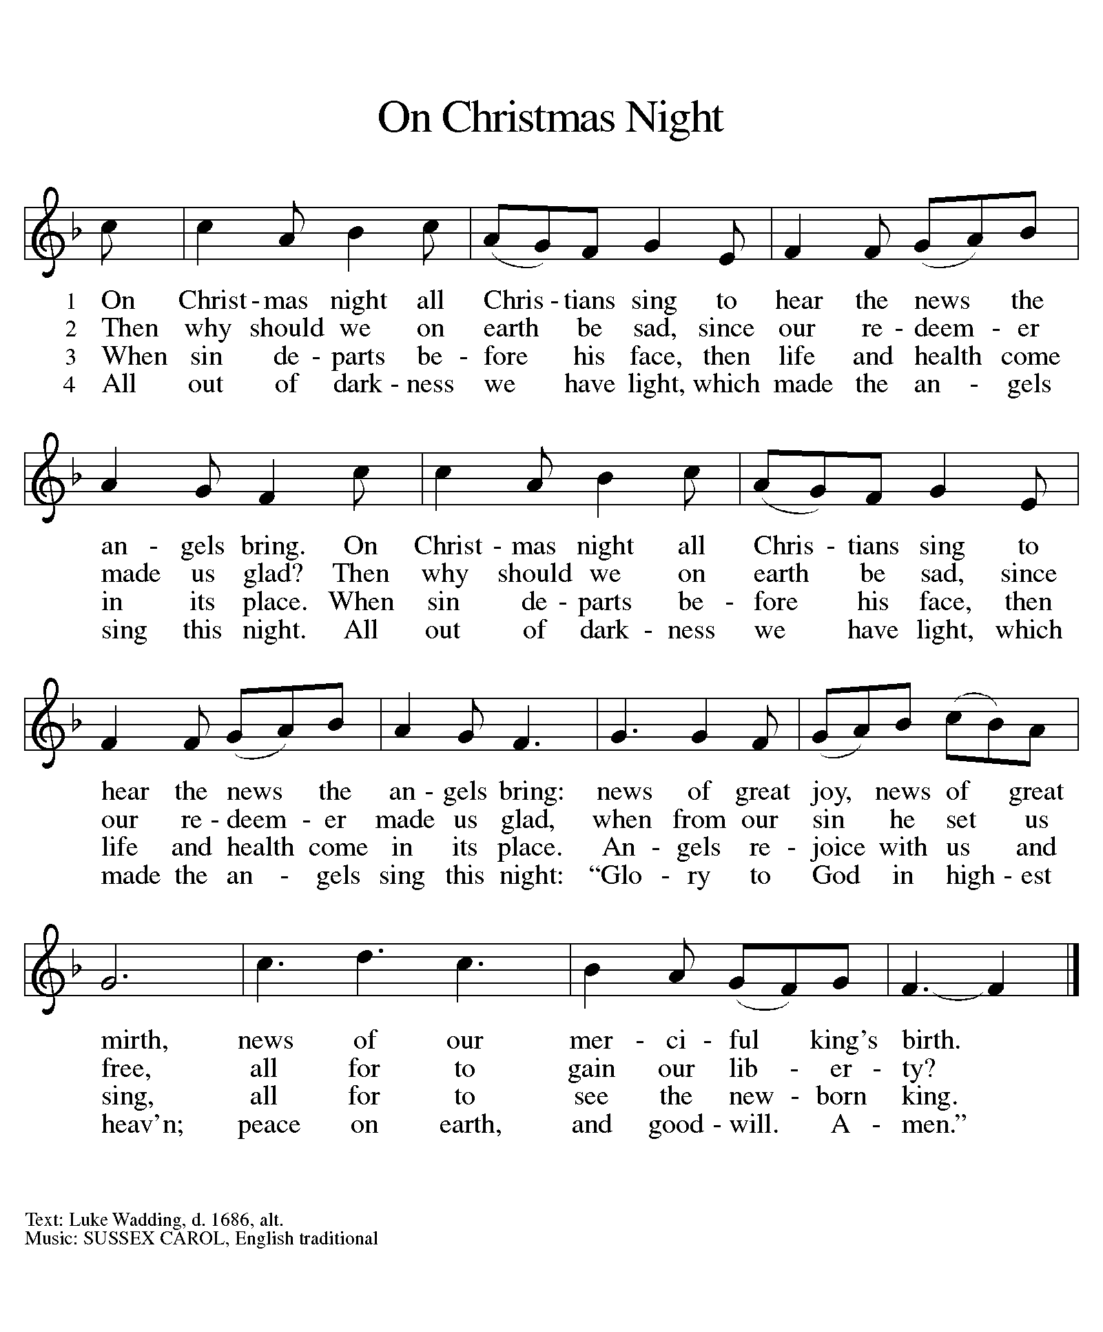

NICENE CREED
L: Let us confess our faith in the words of the Nicene Creed.

A: We believe in one God, the Father, the Almighty,
maker of heaven and earth, of all that is, seen and unseen.
We believe in one Lord, Jesus Christ, the only Son of God,
eternally begotten of the Father, God from God,
Light from Light, true God from true God,
begotten, not made, of one Being with the Father; through him all things were made.
For us and for our salvation he came down from heaven,
was incarnate of the Holy Spirit and the virgin Mary and became truly human.
For our sake he was crucified under Pontius Pilate; he suffered death and was buried.
On the third day he rose again in accordance with the scriptures;
he ascended into heaven and is seated at the right hand of the Father.
He will come again in glory to judge the living and the dead,
and his kingdom will have no end.

We believe in the Holy Spirit, the Lord, the giver of life,
who proceeds from the Father and the Son,
who with the Father and the Son is worshiped and glorified,
who has spoken through the prophets.
We believe in one holy catholic and apostolic church.
We acknowledge one baptism for the forgiveness of sins.
We look for the resurrection of the dead, and the life of the world to come. Amen.

Prayers of Intercession

Each petition ends “Hear us, O God.” The congregation is invited to respond, “Your mercy is great.”

Sharing the Peace

L: The peace of Christ be with you always.
A: And also with you.

You are invited to share a sign of God’s peace with your neighbors by honking your horn or waving to the people near you.

Offerings can also be given online at stpaulpontiac.org

Offering Prayer

L: Generous God,
You came to us as one unknown,
Bringing joy and salvation to the earth.
Nourish us at your banquet table,
That with all who welcome your birth
We may proclaim your peace,
Revealed in Jesus Christ, our Savior.
A: Amen.

Offering Music “Christmas Offering” Casting Crowns

Great Thanksgiving
L: The Lord be with you.
A: And also with you.
L: Lift up your hearts.
A: We lift them to the Lord.
L: Let us give thanks to the Lord our God.
A: It is right to give our thanks and praise.

Preface
L: It is indeed right, our duty and our joy,
that we should at all times and in all places
give thanks and praise to you, almighty and merciful God,
through our Savior Jesus Christ;
you comforted your people with the promise of the Redeemer,
through whom you will also make all things new in the day when
he comes to judge the world in righteousness. And so, with all the
choirs of angels, with the church on earth and the hosts of heaven,
we praise your name and join their unending hymn:

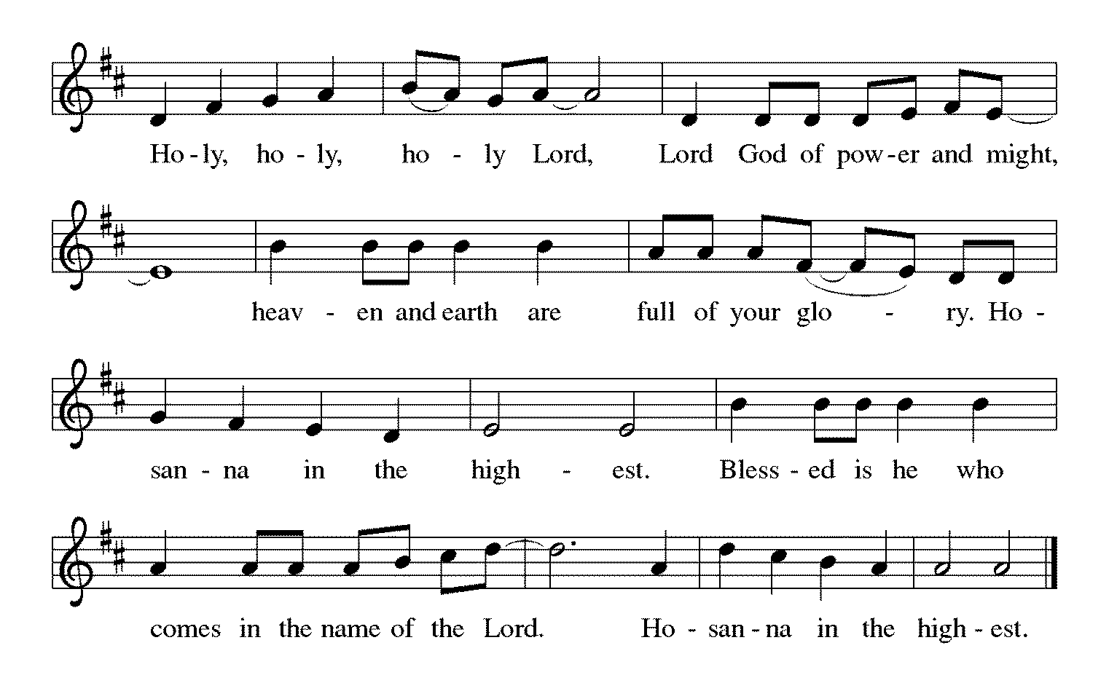
Words of Institution

In the night in which he was betrayed,
our Lord Jesus took bread, and gave thanks;
broke it, and gave it to his disciples, saying:
Take and eat; this is my body, given for you.
Do this for the remembrance of me.
Again, after supper, he took the cup, gave thanks,
and gave it for all to drink, saying:
This cup is the new covenant in my blood,
shed for you and for all people for the forgiveness of sin.
Do this for the remembrance of me.

Lord's Prayer

L: Gathered into one by the Holy Spirit, let us pray as Jesus taught us,
A: Our Father, who art in heaven, hallowed be thy name, thy kingdom come, thy will be done, on earth as it is in heaven. Give us this day our daily bread; and forgive us our trespasses, as we forgive those who trespass against us; and lead us not into temptation but deliver us from evil. For thine is the kingdom and the power, and the glory, forever and ever. Amen.

Invitation to Communion

L: The Word is revealed in a manger, in simple bread and wine. Come meet Christ in this meal.

You are welcome to receive communion, the elements will be brought to your car. If you would prefer not to receive communion please cross your arms over your chest to receive a blessing.

Communion Song “Hope Beyond All Hope” Alana Levandowski

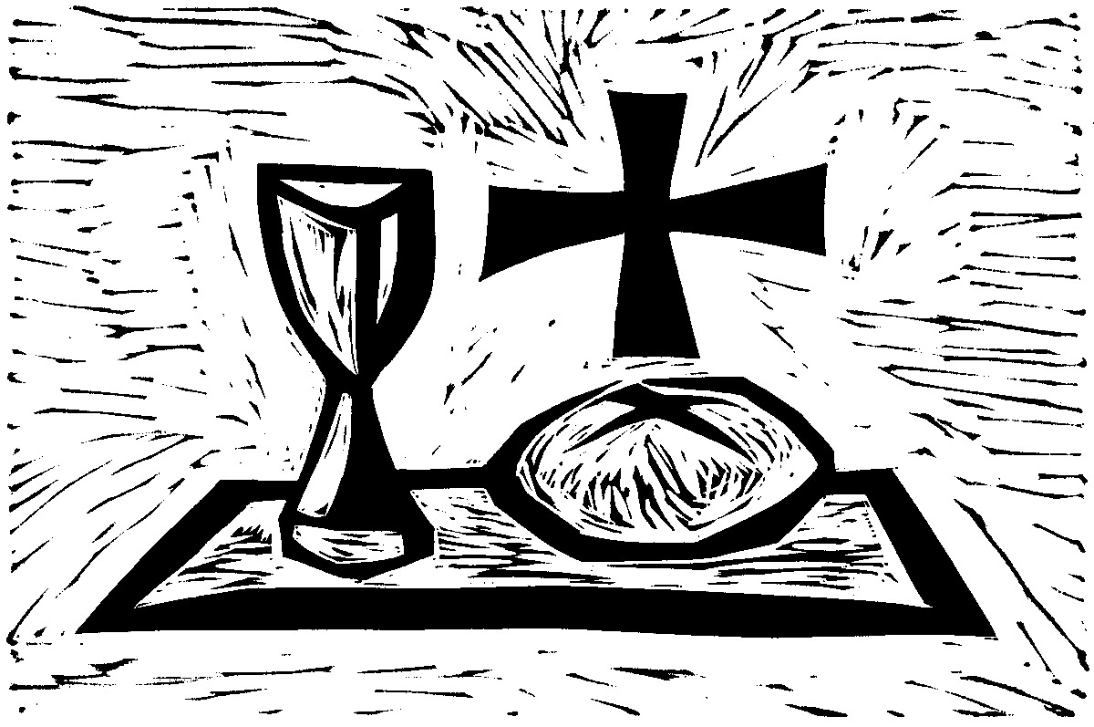

Communion Hymn Hark the Herald Angels Sing ELW 270 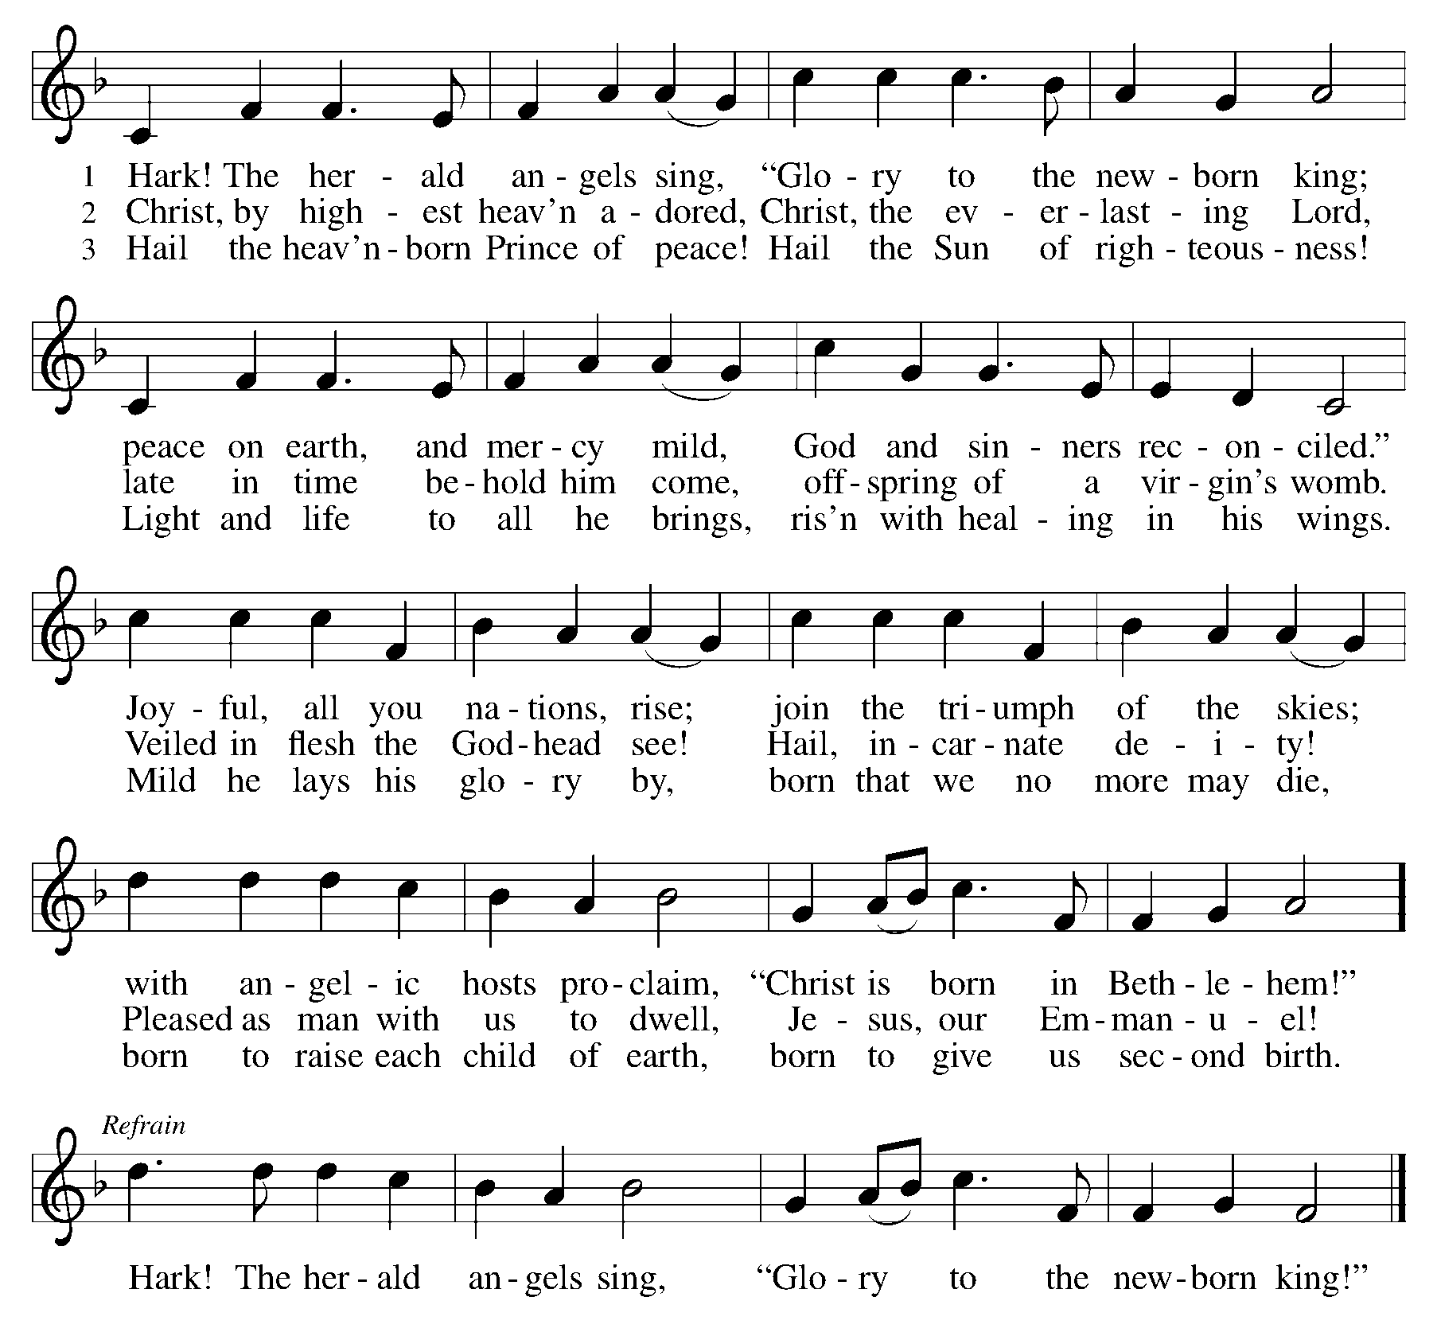

Communion Hymn It Came Upon the Midnight Clear ELW 282

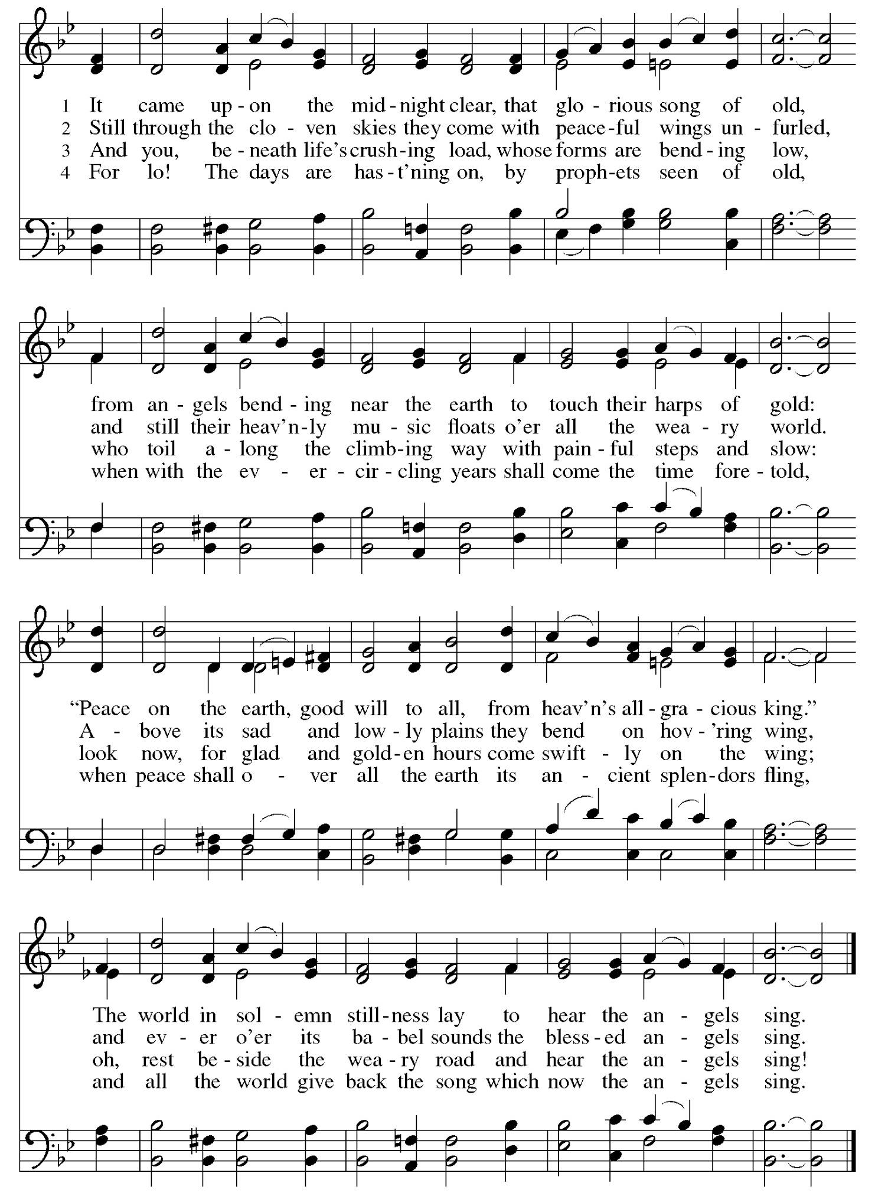
Prayer After Communion

L: We give you thanks, gracious God,
That you have once again fed us from your very self
With the body and blood of Christ.
Through this mystery, send us forth
To proclaim your promise to a world in need,
Through the same Jesus Christ, our Savior.
A: Amen.

Sending Hymn Silent Night ELW 281

1 Silent night, holy night!
All is calm, all is bright
round yon virgin mother and child.
Holy Infant, so tender and mild,
sleep in heavenly peace,
sleep in heavenly peace.

2 Silent night, holy night!
Shepherds quake at the sight;
glories stream from heaven afar,
heav'nly hosts sing, alleluia!
Christ, the Savior, is born!
Christ, the Savior, is born!

3 Silent night, holy night!
Son of God, love's pure light
radiant beams from your holy face,
with the dawn of redeeming grace,
Jesus, Lord, at your birth,
Jesus, Lord, at your birth.
Text: Joseph Mohr, 1792-1849; tr. John F. Young, 1820-1885

SENDING

Benediction

L: The Lord now bless and keep you, God’s love in your increase. By God’s own
Face, with shining grace, grant you eternal peace.
To Father ☩ Son and Spirit, eternal one-in-three,
Be thanks and praise through all days, into eternity.

A: Amen.

Sending Hymn Joy to the World ELW 267

1 Joy to the world, the Lord is come!
Let earth receive her king;
let ev'ry heart prepare him room
and heav'n and nature sing,
and heav'n and nature sing,
and heav'n, and heav'n and nature sing.
2 Joy to the earth, the Savior reigns!
Let all their songs employ,
while fields and floods, rocks, hills,
and plains repeat the sounding joy,
repeat the sounding joy,
repeat, repeat the sounding joy.

3 No more let sin and sorrow grow
nor thorns infest the ground;
he comes to make his blessings flow
far as the curse is found,
far as the curse is found,
far as, far as the curse is found.

4 He rules the world with truth and grace
and makes the nations prove
the glories of his righteousness
and wonders of his love,
and wonders of his love,
and wonders, wonders of his love.

Text: Isaac Watts, 1674-1748

Dismissal

L: Go in peace. Share the gift of Jesus.
A: Thanks be to God.

Postlude

Licensing information for this Worship Service:
CCLI Copyright License A 2440181 9/30/2020 + Streaming License A 20530290 5/31/2021
Sundays and Seasons License Sundays and Seasons v.20200325.1254
Thank you to all those who contributed to tonight’s service!

Poinsettias were donated by:

Dawn Boitnott in memory of deceased family members
Marian Brown in memory of Ben Brown
Jeanne Rapp to the Glory of God
Ted and Ginger Bauknecht to the Glory of God
Pat Lund in honor of loved ones
Sandy Erickson in memory of Jim Erickson
Rosemary Sutton in memory of David & Patrick Sutton
Carol Thorson in memory of Oscar Thorson

