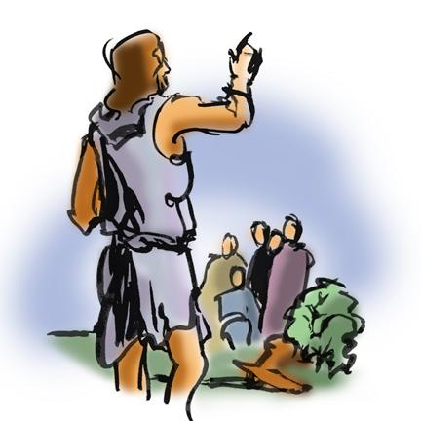
St. Paul Lutheran Church
Pontiac, IL
December 6, 2020
Second Sunday of Advent

Flowers were donated by Sandy Erickson in celebration of Advent and in honor of Carol Thorson’s birthday.

We gather to worship, reach out, and serve the Lord.

Welcome

Welcome to St. Paul Lutheran Church. Whether you have worshipped with us many times, or this is your first time, there is a place for you here. Your presence among us is a gift.

God’s Peace be with you,
Pastor Mathew
Contact Pastor Mathew
Cell: 815-200-9256
Email: pastormathewberger@gmail.com
Friday is Pastor Mathew’s day off.

Introduction to the day
Introduction
John calls people to repent, to clear the decks, to completely reorder their lives so that nothing gets in the way of the Lord’s coming. The reading from Isaiah gives the context for this radical call: the assurance of forgiveness that encourages us to repent; the promise that the coming one will be gentle with the little ones. Isaiah calls us all to be heralds with John, to lift up our voices fearlessly and say, “See, your God is coming!” We say it to one another in worship, in order to say it with our lives in a world in need of justice and peace.

GATHERING

Confession and Forgiveness
All may make the sign of the cross, the sign marked at baptism, as the presiding minister begins.
Blessed be God, Father, ☩ Son, and Holy Spirit,
whose forgiveness is sure
and whose steadfast love endures forever.
Amen.

Together let us honestly and humbly confess
that we have not lived as God desires.
Silence is kept for reflection.
Loving and forgiving God,
we confess that we are held captive by sin.
In spite of our best efforts, we have gone astray. We have not welcomed the stranger;
we have not loved our neighbor;
we have not been Christ to one another.
Restore us, O God.
Wake us up and turn us from our sin.
Renew us each day in the light of Christ. Amen.

People of God, hear this glad news:
by God’s endless grace
your sins are forgiven, and you are free—
free from all that holds you back
and free to live in the peaceable realm of God.
May you be strengthened in God’s love,
☩ comforted by Christ’s peace,
and accompanied with the power of the Holy Spirit.
Amen.

Lighting of the Advent Wreath

“Come Now, O Prince of Peace” – to be sung during lighting of the wreath- Sing 2 verses

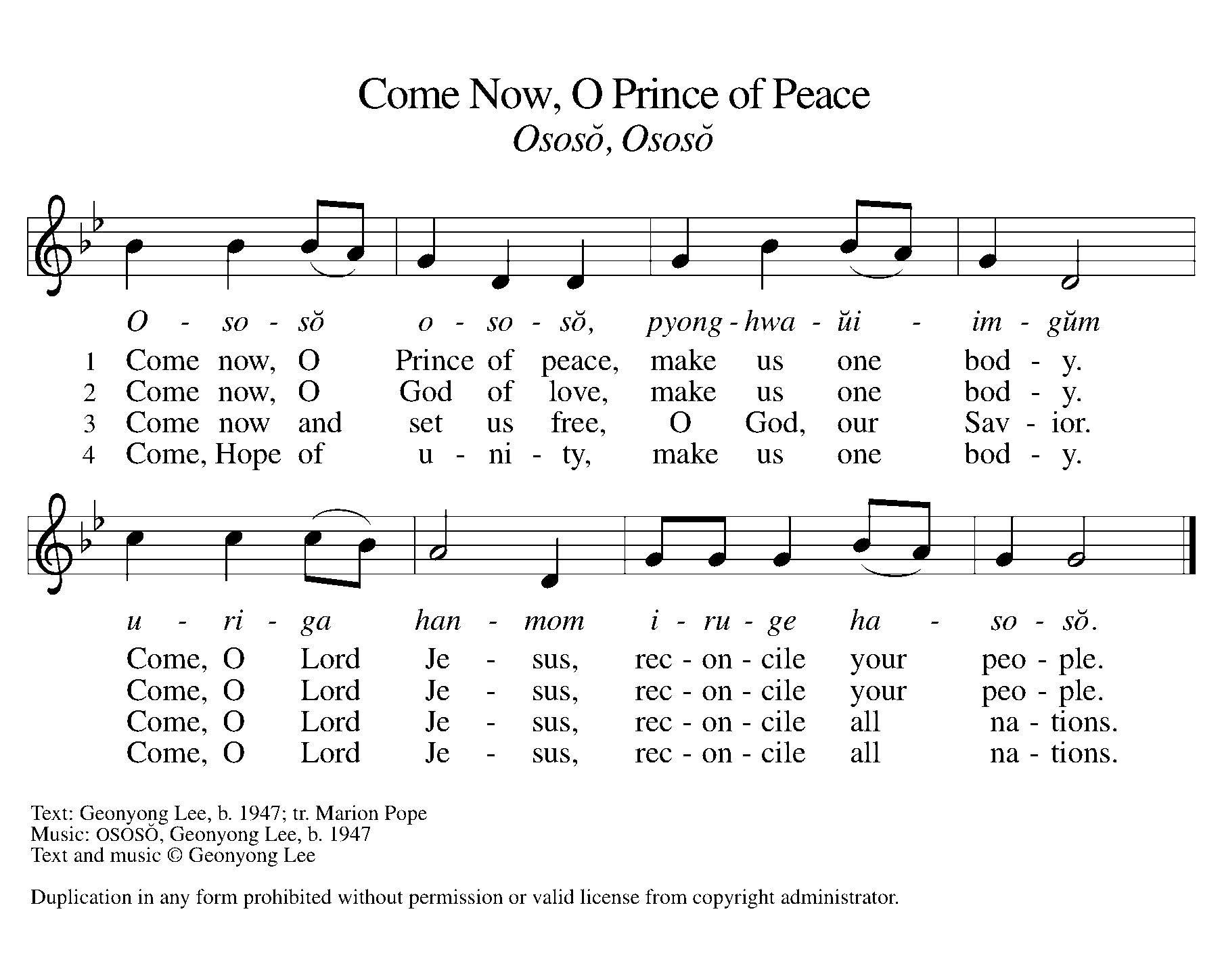

Greeting

L: The grace of our Lord Jesus Christ, the love of God, and the communion of the
Holy Spirit be with you all.
A: And also with you.

Prayer of the Day

Stir up our hearts, Lord God, to prepare the way of your only Son. By his coming strengthen us to serve you with purified lives; through Jesus Christ, our Savior and Lord, who lives and reigns with you and the Holy Spirit, one God, now and forever.
Amen.

Children’s Message

WORD

Reading – Isaiah 40: 1-11

L: A reading from Isaiah.

¹Comfort, O comfort my people,
says your God.
²Speak tenderly to Jerusalem,
and cry to her
that she has served her term,
that her penalty is paid,
that she has received from the Lord’s hand
double for all her sins.
³A voice cries out:
“In the wilderness prepare the way of the Lord,
make straight in the desert a highway for our God.
⁴Every valley shall be lifted up,
and every mountain and hill be made low;
the uneven ground shall become level,
and the rough places a plain.
⁵Then the glory of the Lord shall be revealed,
and all people shall see it together,
for the mouth of the Lord has spoken.”
⁶A voice says, “Cry out!”
And I said, “What shall I cry?”
All people are grass,
their constancy is like the flower of the field.
⁷The grass withers, the flower fades,
when the breath of the Lord blows upon it;
surely the people are grass.
⁸The grass withers, the flower fades;
but the word of our God will stand forever.
⁹Get you up to a high mountain,
O Zion, herald of good tidings;
lift up your voice with strength,
O Jerusalem, herald of good tidings,
lift it up, do not fear;
say to the cities of Judah,
“Here is your God!”
¹⁰See, the Lord God comes with might,
and his arm rules for him;
his reward is with him,
and his recompense before him.
¹¹He will feed his flock like a shepherd;
he will gather the lambs in his arms,
and carry them in his bosom,
and gently lead the mother sheep.

L: Word of God, Word of life.
A: Thanks be to God.

Psalm Reading- Psalm 85: 1-2, 8-13

L: A reading from Psalm.

¹You have been gracious to your land, O Lord;
you have restored the good fortune of Jacob.
²You have forgiven the iniquity of your people
and blotted out all their sins.
⁸I will listen to what the Lord God is saying;
for you speak peace to your faithful people and to those who turn their hearts to you.
⁹Truly, your salvation is very near to those who fear you,
that your glory may dwell in our land.
¹⁰Steadfast love and faithfulness have met together;
righteousness and peace have kissed each other.
¹¹Faithfulness shall spring up from the earth,
and righteousness shall look down from heaven.
¹²The Lord will indeed grant prosperity,
and our land will yield its increase.
¹³Righteousness shall go before the Lord
and shall prepare for God a pathway.

L: Holy Wisdom. Holy Word.
A: Thanks be to God.

2 Peter 3: 8-15a.

A reading from 2 Peter.

Do not ignore this one fact, beloved, that with the Lord one day is like a thousand years, and a thousand years are like one day. ⁹The Lord is not slow about his promise, as some think of slowness, but is patient with you, not wanting any to perish, but all to come to repentance. ¹⁰But the day of the Lord will come like a thief, and then the heavens will pass away with a loud noise, and the elements will be dissolved with fire, and the earth and everything that is done on it will be disclosed.
¹¹Since all these things are to be dissolved in this way, what sort of persons ought you to be in leading lives of holiness and godliness, ¹²waiting for and hastening the coming of the day of God, because of which the heavens will be set ablaze and dissolved, and the elements will melt with fire? ¹³But, in accordance with his promise, we wait for new heavens and a new earth, where righteousness is at home.
¹⁴Therefore, beloved, while you are waiting for these things, strive to be found by him at peace, without spot or blemish; ^{15a}and regard the patience of our Lord as salvation.

L: Word of God, Word of life.
A: Thanks be to God.
Please rise as you are able for the reading of the Holy Gospel.

Gospel Acclamation
(spoken responsively)

L: Alleluia. Prepare the way of the Lord.
A: All flesh shall see the salvation of God. Alleluia.

Gospel–Mark 1: 1-8

L: The Holy Gospel according to Mark.
A: Glory to you, O Lord.

¹The beginning of the good news of Jesus Christ, the Son of God.
²As it is written in the prophet Isaiah,
“See, I am sending my messenger ahead of you,
who will prepare your way;
³the voice of one crying out in the wilderness:
‘Prepare the way of the Lord,
make his paths straight,’ ”
⁴John the baptizer appeared in the wilderness, proclaiming a baptism of repentance for the forgiveness of sins. ⁵And people from the whole Judean countryside and all the people of Jerusalem were going out to him, and were baptized by him in the river Jordan, confessing their sins. ⁶Now John was clothed with camel’s hair, with a leather belt around his waist, and he ate locusts and wild honey. ⁷He proclaimed, “The one who is more powerful than I is coming after me; I am not worthy to stoop down and untie the thong of his sandals. ⁸I have baptized you with water; but he will baptize you with the Holy Spirit.”

L: The gospel of the Lord.
A: Praise to you, O, Christ.

Sermon Pastor Mathew Berger

Hymn of the Day “Comfort, Comfort Now My People” ELW 256

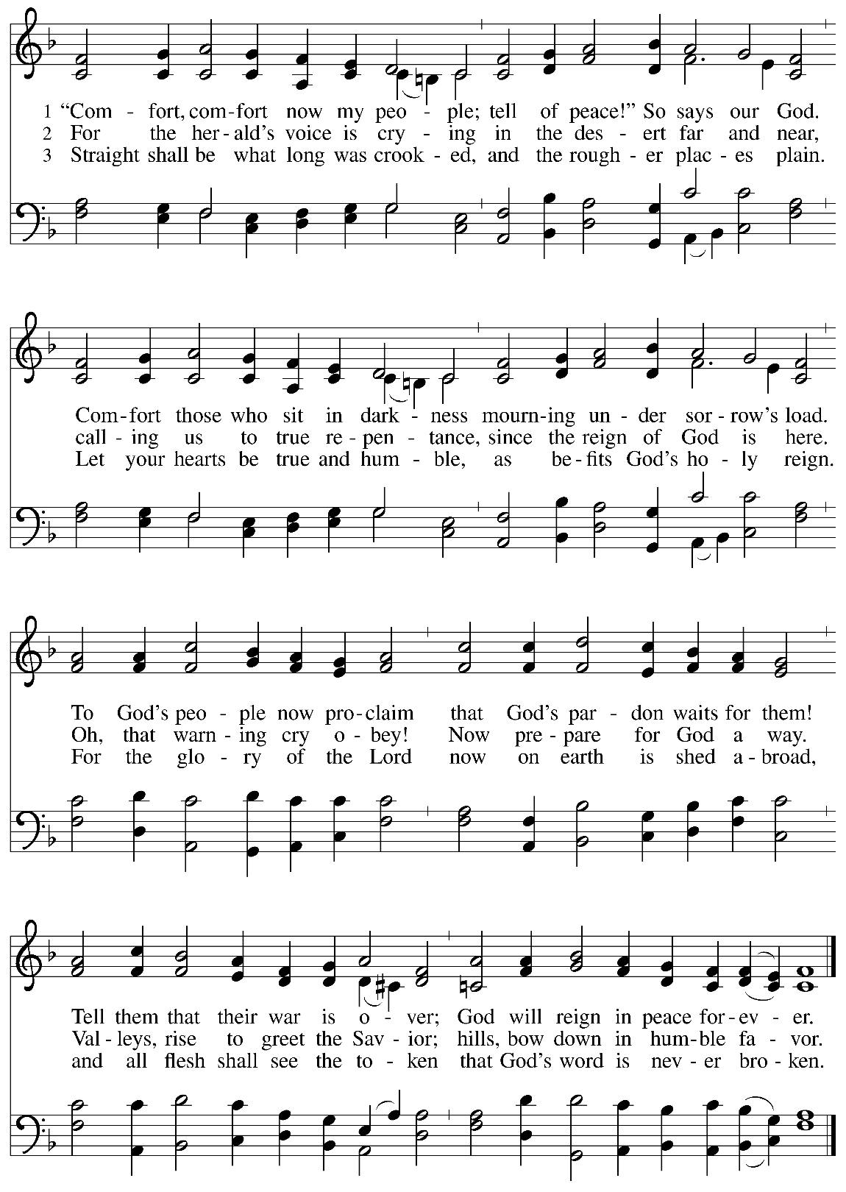

Apostle’s Creed
I believe in God, the Father Almighty, creator of heaven and earth. I believe in Jesus Christ, his only Son, our Lord. He was conceived by power of the Holy Spirit and born of the virgin Mary. He suffered under Pontius Pilate, was crucified, died, and was buried. He descended into hell. On the third day, he rose again. He ascended into heaven and is seated at the right hand of the Father. He will come again to judge the living and the dead. I believe in the Holy Spirit, the holy catholic church, the communion of saints, the forgiveness of sins, the resurrection of the body, and the life everlasting.
Amen.

Prayers of Intercession

Each petition ends “Hear us, O God.” The congregation is invited to respond, “your mercy is great.”

Sharing the Peace

L: The peace of Christ be with you always.
A: And also with you.

You are invited to share a sign of God’s peace with your neighbors by saying or typing, “Peace be with you.”

Offerings can be given by mail or online. You can send a check to St. Paul Lutheran Church 210 Deerfield Rd Pontiac, IL 61764. You can give online at http://www.stpaulpontiac.org/

Offering Prayer

L: Generous God,
You have created all that is,
And you provide for us in every season.
Bless all that we offer,
That through these gifts the world will receive your blessing.
In the name of Jesus, Emmanuel, we pray.
A: Amen.

Words of Institution

In the night in which he was betrayed,
our Lord Jesus took bread, and gave thanks;
broke it, and gave it to his disciples, saying:
Take and eat; this is my body, given for you.
Do this for the remembrance of me.
Again, after supper, he took the cup, gave thanks,
and gave it for all to drink, saying:
This cup is the new covenant in my blood,
shed for you and for all people for the forgiveness of sin.
Do this for the remembrance of me.

Lord's Prayer

L: Gathered into one by the Holy Spirit, let us pray as Jesus taught us,
A: Our Father, who art in heaven, hallowed be thy name, thy kingdom come, thy will be done, on earth as it is in heaven. Give us this day our daily bread; and forgive us our trespasses, as we forgive those who trespass against us; and lead us not into temptation but deliver us from evil. For thine is the kingdom and the power, and the glory, forever and ever. Amen.

Invitation to Communion

L: Even as we watch and wait, Christ is here. Come, eat and drink.

Sending Hymn “O Come, O Come, Emmanuel ELW 257

Announcements

SENDING

Benediction
L: The Creator of the stars bless your Advent waiting,
The long-expected Savior fill you with love,
The unexpected Spirit guide your journey,
☩ now and forever.
A: Amen.

Dismissal

L: Go in peace. Prepare the way of the Lord.
A: Thanks be to God.

Licensing information for this Worship Service:
CCLI Copyright License A 2440181 9/30/2020 + Streaming License A 20530290 5/31/2021
Sundays and Seasons License Sundays and Seasons v.20200325.1254
Thank you to all those who contributed to today’s service: Worship Slides: Julie Mehlberg, Lector: Nathan Joerndt

