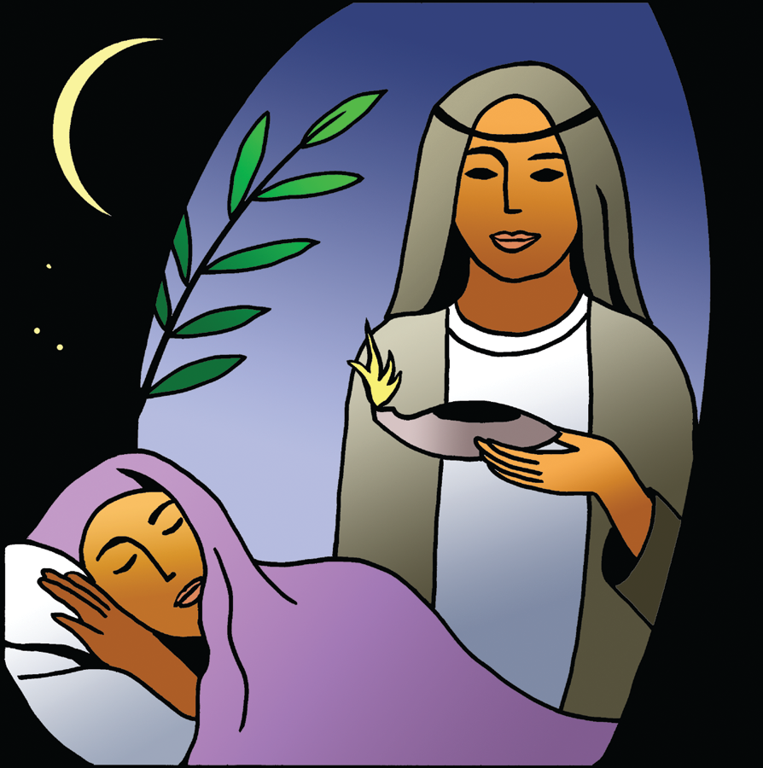
St. Paul Lutheran Church
Pontiac, IL
November 8, 2020
23rd Sunday after Pentecost

Flowers on the altar this morning were donated by Marian Brown in memory of loved ones. Today’s Red Bag offering will be collected and donated to “Cops and Kids”.

We gather to worship, reach out, and serve the Lord.

Welcome

Welcome to St. Paul Lutheran Church. Whether you have worshipped with us many times or this is your first time, there is a place for you here. Your presence among us is a gift.

God’s Peace be with you,
Pastor Mathew
Contact Pastor Mathew
Cell: 815-200-9256
Email: pastormathewberger@gmail.com
Friday is Pastor Mathew’s day off.

Introduction to the day
Introduction
Today the prophet Amos calls for justice to roll down like waters. Paul urges us to encourage one another with the promised coming of the Lord. Jesus tells the parable of the wise and foolish bridesmaids. Surrounded by the faithful of every time and place, we celebrate Christ’s coming in our midst in the word of life and the feast of victory—the marriage feast of the lamb.

GATHERING

Confession and Forgiveness
All may make the sign of the cross, the sign marked at baptism, as the presiding minister begins.
Blessed be the holy Trinity, ☩ one God,
In whose image we are made,
Who claims us and calls us beloved.
Silence is kept for reflection.

Holy One,
We confess that we are not awake for you.
We are not faithful in using your gifts.
We forget the least of our siblings.
We do not see your beautiful image in one another.
We are infected by sin
That divides your beloved community.
Open our hearts to your coming,
Open our eyes to see you in our neighbor,
Open our hands to serve your creation. Amen.

Beloved, we are God’s children,
and Jesus, our beloved, opens the door to us.
Through ☩ Jesus, you are forgiven,
By Jesus you are welcome,
In Jesus, you are called to rejoice!
Let us live in the promises prepared for us
From the foundation of the world.
Amen.

Greeting

L: The grace of our Lord Jesus Christ, the love of God, and the communion of the
Holy Spirit be with you all.
A: And also with you.

Prayer of the Day

O God of justice and love, you illumine our way through life with the words of your Son. Give us the light we need, and awaken us to the needs of others, through Jesus Christ, our Savior and Lord.
Amen.

Children’s Message

WORD

Reading – Amos 5: 18-24

L: A reading from Revelation.

¹⁸Alas for you who desire the day of the Lord!
Why do you want the day of the Lord?
It is darkness, not light;
¹⁹as if someone fled from a lion,
and was met by a bear;
or went into the house and rested a hand against the wall,
and was bitten by a snake.
²⁰Is not the day of the Lord darkness, not light,
and gloom with no brightness in it?
²¹I hate, I despise your festivals,
and I take no delight in your solemn assemblies.
²²Even though you offer me your burnt offerings and grain offerings,
I will not accept them;
and the offerings of well-being of your fatted animals
I will not look upon.
²³Take away from me the noise of your songs;
I will not listen to the melody of your harps.
²⁴But let justice roll down like waters,
and righteousness like an ever-flowing stream.

L: Word of God, Word of life.
A: Thanks be to God.

Reading – Psalm 70

A reading from Psalms.

¹Be pleased, O God, to deliver me;
O Lord, make | haste to help me.
²Let those who seek my life be put to shame and confounded;
let those who take pleasure in my misfortune draw back and be disgraced.
³Let those who say to me “Aha!” and gloat over me
turn back because of their shame.
⁴Let all who seek you rejoice and be glad in you;
let those who love your salvation say forever, “Great is the Lord!”
⁵But as for me, I am poor and needy; come to me quickly O God.
You are my helper and my deliverer; O Lord, do not tarry.

L: Holy Wisdom, Holy Word.
A: Thanks be to God.

Reading – Thessalonians 4: 13-18

A reading from Thessalonians.

¹³We do not want you to be uninformed, brothers and sisters, about those who have died, so that you may not grieve as others do who have no hope. ¹⁴For since we believe that Jesus died and rose again, even so, through Jesus, God will bring with him those who have died. ¹⁵For this we declare to you by the word of the Lord, that we who are alive, who are left until the coming of the Lord, will by no means precede those who have died. ¹⁶For the Lord himself, with a cry of command, with the archangel’s call and with the sound of God’s trumpet, will descend from heaven, and the dead in Christ will rise first. ¹⁷Then we who are alive, who are left, will be caught up in the clouds together with them to meet the Lord in the air; and so we will be with the Lord forever. ¹⁸Therefore encourage one another with these words.

L: Word of God, Word of life.
A: Thanks be to God.

Please rise as you are able for the reading of the Holy Gospel.

Gospel Acclamation
(spoken responsively)

L: Alleluia. Keep awake and be ready,
A: for you do not know on what day your Lord is coming. Alleluia.

Matthew 25: 1-13

L: The Holy Gospel according to Matthew.
A: Glory to you, O Lord.

“Then the kingdom of heaven will be like this. Ten bridesmaids took their lamps and went to meet the bridegroom. ²Five of them were foolish, and five were wise. ³When the foolish took their lamps, they took no oil with them; ⁴but the wise took flasks of oil with their lamps. ⁵As the bridegroom was delayed, all of them became drowsy and slept. ⁶But at midnight there was a shout, ‘Look! Here is the bridegroom! Come out to meet him.’ ⁷Then all those bridesmaids got up and trimmed their lamps. ⁸The foolish said to the wise, ‘Give us some of your oil, for our lamps are going out.’ ⁹But the wise replied, ‘No! there will not be enough for you and for us; you had better go to the dealers and buy some for yourselves.’ ¹⁰And while they went to buy it, the bridegroom came, and those who were ready went with him into the wedding banquet; and the door was shut. ¹¹Later the other bridesmaids came also, saying, ‘Lord, lord, open to us.’ ¹²But he replied, ‘Truly I tell you, I do not know you.’ ¹³Keep awake therefore, for you know neither the day nor the hour.”

L: The gospel of the Lord.
A: Praise to you, O, Christ.

Sermon Pastor Mathew Berger

Special Music

Apostle’s Creed
I believe in God, the Father Almighty, creator of heaven and earth. I believe in Jesus
Christ, his only Son, our Lord. He was conceived by power of the Holy Spirit and born
of the virgin Mary. He suffered under Pontius Pilate, was crucified, died, and was
buried. He descended into hell. On the third day, he rose again. He ascended into
heaven and is seated at the right hand of the Father. He will come again to judge the
living and the dead. I believe in the Holy Spirit, the holy catholic church, the communion
of saints, the forgiveness of sins, the resurrection of the body, and the life everlasting.
Amen

Prayers of Intercession

Each petition ends “Hear us, O God.” The congregation is invited to respond, “your mercy is great”.

Sharing the Peace

L: The peace of Christ be with you always.
A: And also with you.

You are invited to share a sign of God’s peace with your neighbors by saying or typing, “Peace be with you.”

Offerings can be given by mail or online. You can send a check to St. Paul Lutheran Church 210 Deerfield Rd Pontiac, IL 61764. You can give online at http://www.stpaulpontiac.org/

MEAL

Offering Prayer

L: God of all goodness,
Generations have turned to you,
Gathered around your table,
And shared your abundant blessings.
Number us among them
That, as we gather these gifts from your abundance,
And give thanks for your rich blessings,
We may feast upon your very self
And care for all that you have made,
Through Jesus Christ, our Sovereign and Servant.
A: Amen.

Words of Institution

In the night in which he was betrayed,
our Lord Jesus took bread, and gave thanks;
broke it, and gave it to his disciples, saying:
Take and eat; this is my body, given for you.
Do this for the remembrance of me.
Again, after supper, he took the cup, gave thanks,
and gave it for all to drink, saying:
This cup is the new covenant in my blood,
shed for you and for all people for the forgiveness of sin.
Do this for the remembrance of me.

Lord's Prayer

L: Gathered into one by the Holy Spirit, let us pray as Jesus taught us,
A: Our Father, who art in heaven, hallowed be thy name, thy kingdom come, thy will be done, on earth as it is in heaven. Give us this day our daily bread; and forgive us our trespasses, as we forgive those who trespass against us; and lead us not into temptation but deliver us from evil. For thine is the kingdom and the power, and the glory, forever and ever. Amen.

Invitation to Communion

L: There is a place for you at the banquet. Come and feast at Jesus’ table.

Prayer after Communion

L: Lord Jesus,
In this simple meal, you have set a banquet.
Sustain us on the journey,
Strengthen us to care for the least of your beloved children,
And give us glad and generous hearts
As we meet you on the way.
A: Amen.

Announcements

SENDING
Benediction

L: May the God of all creation,
In whose image we are made,
Who claims us and calls us beloved,
Who strengthens us for service,
Gives you reason to rejoice and be glad!

The blessing of God
Sovereign, ☩ Savior and Spirit,
Be with you today and always.

A: Amen.

Dismissal

L: Beloved of God, go in peace to love and serve the Lord.
A: Thanks be to God.

Licensing information for this Worship Service:
CCLI Copyright License A 2440181 9/30/2020 + Streaming License A 20530290 5/31/2021
Sundays and Seasons License Sundays and Seasons v.20200325.1254
Thank you to all those who contributed to today’s service: Worship Slides: Julie Mehlberg, Lector: John Mehlberg, Ushers: Marty Heller & Denny Leach.

